*v*

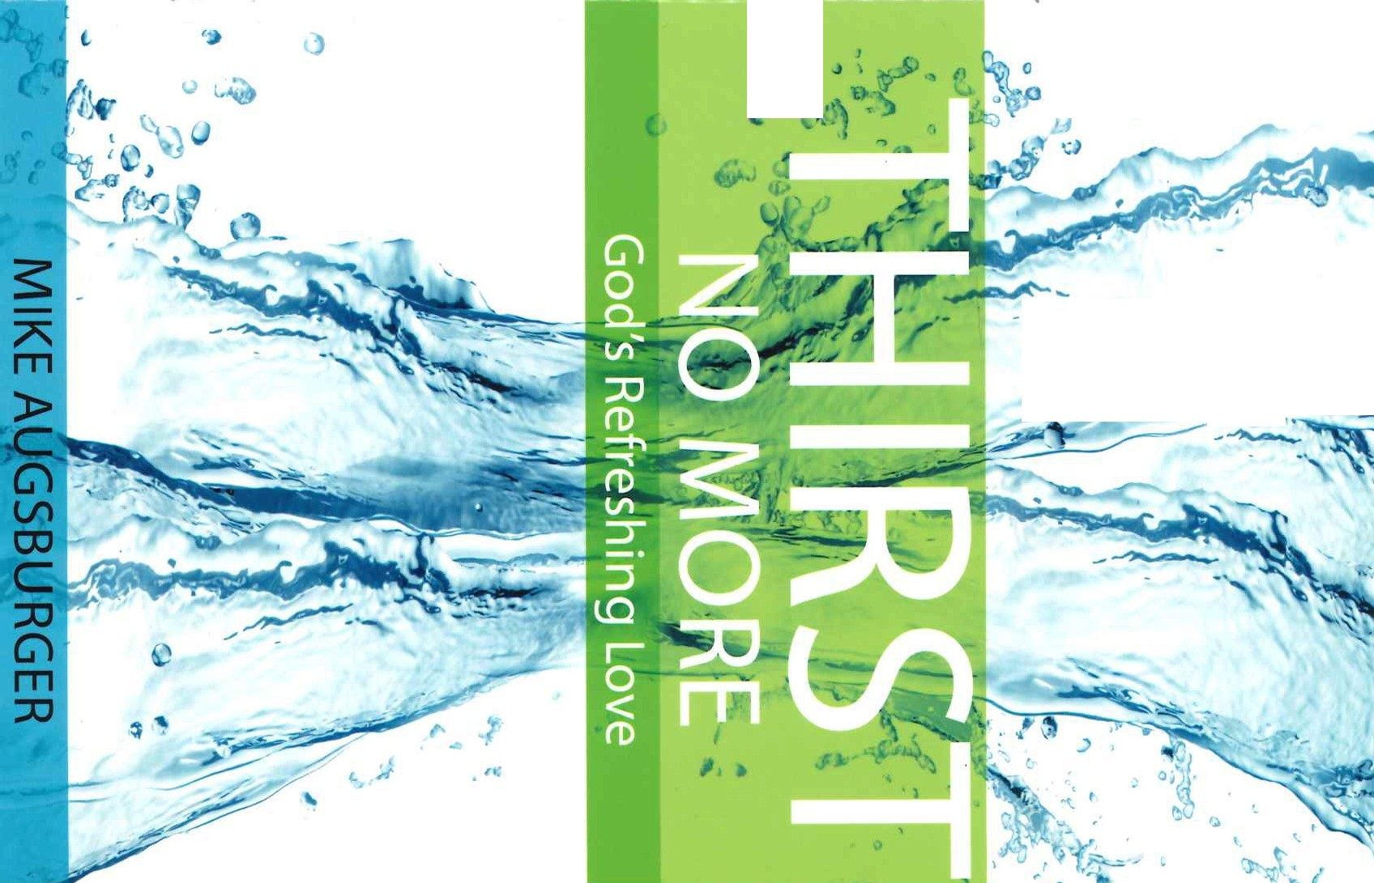

*�*� *"*

-

)

*,!O* {\

<

-/ ..

-

,





**NO MORE**

God's Refreshing Love

MIKE AUGSBURGER

**T** C REGULAR BAPTIST

**rmmPress**

THIRST NO MORE: GOD'S REFRESHING LOVE

© 2019 Regular Baptist Press RegularBaptistPress.org • 1-800-727-4440 Printed in the U.S.A. All rights reserved.

King James Version• RBP32118 • ISBN: 978-1-62940-894-1

**CONTENTS**

Introduction .............. , 5

Lesson 1 Snakebites, Sickness, and the Savior. 7

Lesson 2 The Greatest Gift Ever Given 17

Lesson 3 Never Thirst Again 27

Lesson 4 Painful Thirst 37

Lesson *5* Sharing the Joy 47

The Gospel. *5*6

Answer Key 57



# INTRODUCTION

WHAT'S THE MOST INTENSE thirst you've ever experienced? Some­ times in a desert people hallucinate and see mirages of water, Have you ever been that thirsty? Can you imagine what it was like for pioneers to traverse America, leaving the green, water-rich lands of the Midwest for the dry barrenness of the West? I've often thought about their plight and their dependence upon finding water for survival. No water source, no town or civilization. Water opened up new frontiers for towns and cities.

Biblical writers regularly used water as a metaphor for God's life-giving love. His love quenches our thirst, it washes over us, it refreshes our spirits! Because He loves us, He provides salvation. As water sustains life, so God's love initiates and sustains our spiritual lives. Where God's love flows, new spiritual life grows!

John IS:IJ states, "Greater love hath no man than this, that a man lay down his life for his friends." Jesus was describing His future action of laying down His life on a cross for the sin of humanity. That act of love is the greatest act of love ever beheld by the human eye. How far does this love reach? How deep can this love penetrate? How great a thirst can this love quench? In this Bible study, we will investigate sections of John*3* and4 and observe how God's love changes us, reaching the least to the greatest, the lowest to the highest. What new frontiers of your heart can God's love reach? Let's study together and discover how the intense thirst of our souls is ultimately quenched by the love of God.