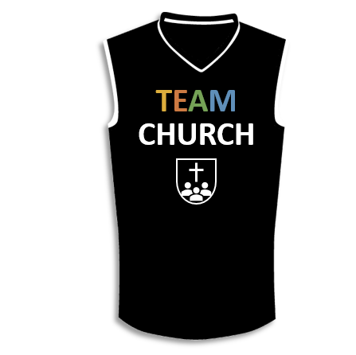

A picture containing thing, indoor

Description generated with high confidence

**Lesson 13**

I. Stewardship of Money (16:1–4)

A. Give ______________ (16:1, 2)

B. Give _______________ (16:2)

C. Give _____________________ (16:2)

D. Give _________________ (16:3, 4)

II. Stewardship of Opportunities (16:5–9)

A. Open ________ (16:5–9a)

B. _______________ (16:9b)

III. Stewardship of Testimony (16:10–24)

A. Paul’s ____________________ (16:10–18)

B. Paul’s _______________ (16:19–24)

**LESSON 1 • Purpose, practice, and problem**

©2017 Regular Baptist Press ⋅ May be copied for classroom use only.