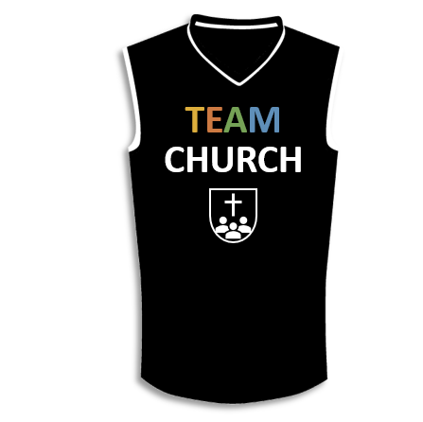

A picture containing thing, indoor

Description generated with high confidence

**Lesson 11**

I. A Priority Gift (14:1–5)

A. Its ____________ (14:1)

B. Its _______________ (14:2–5)

II. A Perspective about Tongues (14:6–12)

A. The clearly ___________ ________ (14:7–9)

B. The __________________ ____________ (14:10–12)

III. A Procedure to Follow (14:13–40)

A. _____________________ (14:13–28)

B. _______________ (14:29–40)

**LESSON 1 • Purpose, practice, and problem**

©2017 Regular Baptist Press ⋅ May be copied for classroom use only.