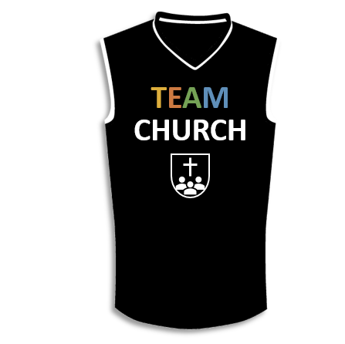

A picture containing thing, indoor

Description generated with high confidence

**Lesson 10**

I. The Bestowing of Spiritual Gifts (12)

A. Their ________ (12:1–10)

B. Their _________ (12:11)

C. Their ___________ (12:12–31)

II. The Best Spiritual Gift (13)

A. Love _________ (13:1–7)

B. Love ___________ (13:8–13)

**LESSON 1 • Purpose, practice, and problem**

©2017 Regular Baptist Press ⋅ May be copied for classroom use only.