

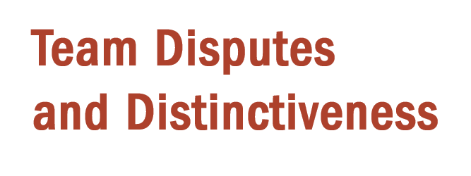A picture containing thing, indoor

Description generated with high confidence

**Lesson 6**

I. Resolving ____________ (6:1–11)

A. A ____________ practice (6:1–7a)

B. A ____________ principle (6:7b, 8)

C. A ____________ point (6:9–11)

II. Maintaining _______________________ (6:12–20)

A. Maintain godly _________ (6:12–18)

B. Maintain a godly ____________ (6:19, 20)

**LESSON 1 • Purpose, practice, and problem**

©2017 Regular Baptist Press ⋅ May be copied for classroom use only.