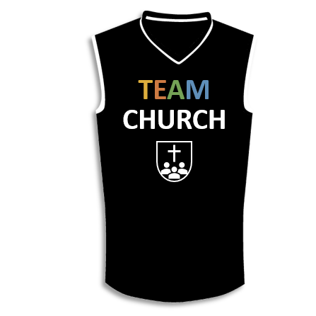

A picture containing thing, indoor

Description generated with high confidence

**Lesson 4**

I. God Will ____________ Faithful ___________ (4:1–5)

A. Steward’s _____________________ (4:1)

B. Steward’s _________________ (4:2)

C. Steward’s _________ (4:3–5)

II. Paul __________________ Faithful ___________ (4:9–13)

A. Paul’s ___________ (4:6)

B. Corinth’s _______________ (4:7, 8)

C. Apostolic ____________ (4:9–13)

III. Paul ____________ Faithful ___________ (4:14–21)

A. Paul’s _______________ (4:14)

B. Paul’s __________________ (4:15–17)

C. Paul’s __________________ (4:18–21)

**LESSON 1 • Purpose, practice, and problem**

©2017 Regular Baptist Press ⋅ May be copied for classroom use only.