In-Class Worksheet Under the Sun

Lesson 1—The Puzzle of Life
Ecclesiastes Overview
I. Authorship and Date
II. Structure
III. Purpose
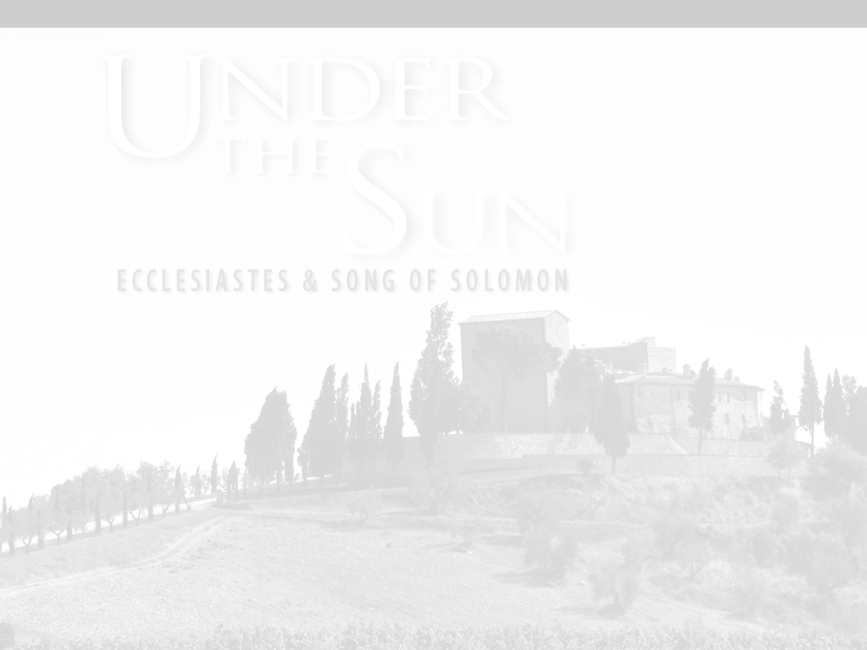
IV. Theme
V. Significance
© 2008 • Regular Baptist Press • Schaumburg, Illinois • May be copied for classroom use only.
In-Class Worksheet Under the Sun

Lesson 2—All Is Vanity under the Sun
Ecclesiastes 1:1–11
I. Title (Eccles. 1:1)
II. Thesis (Eccles. 1:2, 3)
A. _________ of life (v. 2)
B. _________ of life (v. 3)
III. Trial (Eccles. 1:4–11)
A. Evidence in _________ (vv. 4–8)
B. Evidence in ___________ (vv. 9–11)
© 2008 • Regular Baptist Press • Schaumburg, Illinois • May be copied for classroom use only.
In-Class Worksheet Under the Sun

Lesson 3—Searching for Meaning
Ecclesiastes 1:12—2:26
I. Explanation (Eccles. 1:12–15)
II. _______________ (Eccles. 1:16—2:11)
A. Wisdom (1:16–18)
B. Pleasure (2:1–11)
III. _______________ (Eccles. 2:12–23)
A. Of wisdom (2:12–17)
B. Of pleasure (2:18–23)
IV. _________________ (2:24–26)
© 2008 • Regular Baptist Press • Schaumburg, Illinois • May be copied for classroom use only.
In-Class Worksheet Under the Sun

Lesson 4—There Must Be Something Better
Ecclesiastes 3; 4
I. Principle (Eccles. 3:1–15)
A. ________ (3:1)
B. ____________________ (3:2–8)
C. _______________ (3:9–11)
D. _________________ (3:12–15)
II. Problems (Eccles. 3:16—4:16)
A. ______________ (3:16, 17)
B. ________ (3:18–22)
C. _______________ (4:1–3)
D. ______ (4:4–6)
E. _______________ (4:7–12)
F. _________ (4:13–16)
© 2008 • Regular Baptist Press • Schaumburg, Illinois • May be copied for classroom use only.
In-Class Worksheet Under the Sun

Lesson 5—Wisdom for the Walk
Ecclesiastes 5
I. Need for Sincerity before God (Eccles. 5:1–7)
A. Sincere ___________ (v. 1)
B. Sincere ________ (vv. 2–7)
II. Problem of _________ ______________ (Eccles. 5:8, 9)
III. Disadvantages of Riches (Eccles. 5:10–17)
A. The More We Have, the More We ______ (5:10)
B. The More We Have, the More We ________ (5:11)
C. The More We Have, the More We ________ (5:12)
D. The More We Have, the More We ______ ___ ______ (5:13–15)
E. The More We Have, the More We ________ _________ (5:16, 17)
IV. Exhortation to Enjoy Life (Eccles. 5:18–20)
© 2008 • Regular Baptist Press • Schaumburg, Illinois • May be copied for classroom use only.
In-Class Worksheet Under the Sun

Lesson 6—When Life Seems Unfair
Ecclesiastes 6:1—8:15
I. Prosperity Is ______________ (Eccles. 6:1–12)
A. ______________ (6:1, 2)
B. __________________ (6:3–6)
C. __________________ (6:7–9)
D. _________________ (6:10–12)
II. Problems Are _________________ (Eccles. 7:1–14)
III. Wisdom Is Good but ______ (Eccles. 7:15–29)
A. ________ of wisdom (7:15–18)
B. _________ of wisdom (7:19–22)
C. _________ of wisdom (7:23–29)
IV. _______________ Is Wise (Eccles. 8:1–15)
A. _________________ (8:1–3)
B. ___________ (8:4–8)
C. _________________ (8:9–14)
D. _________________ (8:15)
© 2008 • Regular Baptist Press • Schaumburg, Illinois • May be copied for classroom use only.
In-Class Worksheet Under the Sun

Lesson 7—Faith Confronts Futility
Ecclesiastes 8:16—10:20
I. Instruction (Eccles. 8:16—9:18)
A. Problem (8:16—9:6)
1. _________________ (8:16—9:1)
2. ______ (9:2, 3)
3. ________ (9:4–6)
B. Advice (9:7–10)
C. Warning (9:11–18)
1. Stay in touch with ___________ (9:11, 12)
2. The world does not always _______________ _________ (9:13–18)
II. Illustrations (Eccles. 10)
© 2008 • Regular Baptist Press • Schaumburg, Illinois • May be copied for classroom use only.
In-Class Worksheet Under the Sun

Lesson 8—Finding the Wise Life
Ecclesiastes 11; 12
I. Wisdom and ___________ (Eccles. 11:1–6)
II. Wisdom and ______________ (Eccles. 11:7–10)
III. Wisdom and _________________ (Eccles. 12:1–8)
IV. Wisdom and ____________ (Eccles. 12:9–14)
© 2008 • Regular Baptist Press • Schaumburg, Illinois • May be copied for classroom use only.
In-Class Worksheet Under the Sun

Lesson 9—Learning to Love
Song of Solomon Overview
I. Authorship and Date
II. Unity
III. Interpretation
A. _________________
B. ___________
C. ____________
D. ___________
IV. Purpose
V. Literature
VI. Theme and Outline
© 2008 • Regular Baptist Press • Schaumburg, Illinois • May be copied for classroom use only.
In-Class Worksheet Under the Sun

Lesson 10—Getting Started in Loving
Song of Solomon 1:1—2:3
I. Introduction (Song of Sol. 1:1)
II. Building Proper Love (Song of Sol. 1:2—2:3)
A. Appreciate good ______________ (1:2–4)
B. Build on legitimate _________ _________ (1:5–8)
C. Nurture by _________ (1:9–11)
D. Cultivate the ______________ of love (1:12–14)
E. Delight in _______________ (1:15—2:3)
© 2008 • Regular Baptist Press • Schaumburg, Illinois • May be copied for classroom use only.
In-Class Worksheet Under the Sun

Lesson 11—Moving toward Commitment
Song of Solomon 2:4—3:11
I. Passion and _________ (Song of Sol. 2:4–7)
II. God’s _________ (Song of Sol. 2:8–14)
III. Destructive ___________ (Song of Sol. 2:15–17)
IV. ______ (Song of Sol. 3:1–5)
V. _________ (Song of Sol. 3:6–11)
© 2008 • Regular Baptist Press • Schaumburg, Illinois • May be copied for classroom use only.
In-Class Worksheet Under the Sun

Lesson 12—Wedding and Beyond
Song of Solomon 4:1—6:13
I. Sensitivity _________________ Intimacy (Song of Sol. 4:1—5:1)
A. __________________ (4:1–11)
B. _________ (4:12–15)
C. Physical ____________ (4:16; 5:1a)
D. ____________ (5:1b)
II. Insensitivity ______________ Intimacy (Song of Sol. 5:2—6:13)
A. _________ (5:2–8)
B. ________ (5:9—6:3)
C. _________________ (6:4–13)
© 2008 • Regular Baptist Press • Schaumburg, Illinois • May be copied for classroom use only.
In-Class Worksheet Under the Sun

Lesson 13—Rejoicing in Togetherness
Song of Solomon 7:1—8:14
I. The ___________ of Marital Love (Song of Sol. 7:1–10)
II. The _________ of Marital Love (Song of Sol. 7:11—8:4)
III. The _________________ of Marital Love (Song of Sol. 8:5–14)
A. ______ of love (8:5)
B. ___________ in commitment (8:6, 7)
C. Prepared in _________ (8:8–12)
D. Pleasure of __________________ (8:13, 14)
© 2008 • Regular Baptist Press • Schaumburg, Illinois • May be copied for classroom use only.

