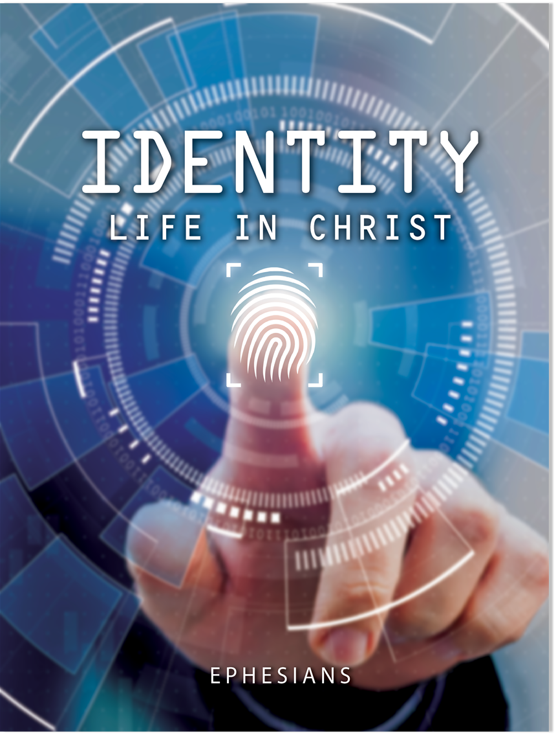
Lesson 1—Chosen and Grateful
Ephesians 1:1–5
I. Ephesians’ Setting and Purpose
A. Paul’s history with Ephesus
B. Ephesus’ obsession with Diana
C. Paul’s emphasis on life “in Christ”
II. Paul’s Personal Greeting (Eph. 1:1, 2)
III. Introduction to Life in Christ (Eph. 1:3–5)
A. God bestowed us with blessings (1:3)
B. God chose us to salvation (1:4)
C. God predestinated us to adoption (1:5)

© 2021 • Regular Baptist Press • Arlington Heights, Illinois • May be copied for classroom use only.
Lesson 2—Guaranteed Inheritance
Ephesians 1:6–14
I. Why God Blessed Us (Eph. 1:6)
II. How God Blessed Us (Eph. 1:7–14)
A. Redemption (1:7–10)
1. Its means (1:7b)
2. Its meaning (1:7c)
3. Its measure (1:7d–10)
B. Inheritance (1:11–14)
1. For the Jews (1:11, 12)
2. For the Gentiles (1:13, 14)

© 2021 • Regular Baptist Press • Arlington Heights, Illinois • May be copied for classroom use only
.Lesson 3—Praying for Change
Ephesians 1:15–23
I. The Character of Paul’s Prayer (Eph. 1:15, 16)
A. Informed (1:15)
B. Intercessory (1:16)
II. The Content of Paul’s Prayer (Eph. 1:17–23)
A. Spiritual resource (1:17)
B. Spiritual request (1:17)
C. Spiritual results (1:18–23)
1. Immediate result: Enlightenment (1:18)
2. Ultimate result: Knowledge (1:18–23)
a. Of the hope of His calling (1:18)
b. Of the riches of His inheritance (1:18)
c. Of the greatness of His power (1:19–23)

© 2021 • Regular Baptist Press • Arlington Heights, Illinois • May be copied for classroom use only.
Lesson 4—Saved to Work
Ephesians 2:1–10
I. Separation from Christ (Eph. 2:1–3)
A. Gentile separation (2:1, 2)
B. Jewish separation (2:3)
II. Union with Christ (Eph. 2:4–6)
A. God loved us through Christ (2:4)
B. God gave us life in Christ (2:5, 6)
III. Purposes of Union with Christ (Eph. 2:7–10)
A. To portray grace (2:7–9)
B. To produce good works (2:10)
© 2021 • Regular Baptist Press • Arlington Heights, Illinois • May be copied for classroom use only.
Lesson 5—Building Unity in Christ
Ephesians 2:11–22
I. Gentile Separation from Christ (Eph. 2:11, 12)
A. Heathen (2:11)
B. Without Christ (2:12)
C. Strangers (2:12)
II. Union in Christ (Eph. 2:13–22)
A. Person of peace (2:13, 14)
B. Program for peace (2:14–18)
C. Pictures of peace (2:19–22)
1. Fellow citizens (2:19)
2. Family members (2:19)
3. Building blocks (2:20, 21)
4. Holy temple (2:21, 22)

© 2021 • Regular Baptist Press • Arlington Heights, Illinois • May be copied for classroom use only.
Lesson 6—Mystery Revealed
Ephesians 3:1–13

I. Preface to the Mystery (Eph. 3:1–4)

A. Reception of the mystery (3:1–3)

B. Revelation of the mystery (3:3, 4)

C. Review of the definition of a mystery (3:5)
II. Content of the Mystery (Eph. 3:6)

A. Gentiles are fellow heirs

B. Gentiles are fellow members

C. Gentiles are fellow partakers
III. Minister of the Mystery (Eph. 3:7–9)

A. Paul’s attitude (3:7, 8)

B. Paul’s actions (3:8, 9)
IV. Reasons for the Mystery (Eph. 3:10–13)

A. Provide a lesson (3:10, 11)

B. Promote boldness (3:12, 13)

© 2021 • Regular Baptist Press • Arlington Heights, Illinois • May be copied for classroom use only.
Lesson 7—Life-changing Power
Ephesians 3:14–21
I. Continuation of Paul’s Prayer (Eph. 3:14, 15)

A. With retrospect (3:14)

B. With reverence (3:14, 15)
II. Content of Paul’s Prayer (Eph. 3:16–19)

A. The Spirit’s power (3:16)

B. The Son’s companionship and love (3:17–19)

C. The Father’s fullness (3:19)
III. Conclusion to Paul’s Prayer (Eph. 3:20, 21)

A. Confidence in God’s power (3:20)

B. Concern for God’s glory (3:21)

© 2021 • Regular Baptist Press • Arlington Heights, Illinois • May be copied for classroom use only.
Lesson 8—God’s Grace for Mutual Growth
Ephesians 4:1–16
I. Plea for Unity (Eph. 4:1–3)
A. Fulfill your calling (4:1)
B. Consider your approach (4:2, 3)
II. Pattern of Unity (Eph. 4:4–6)
A. One body (4:4)
B. One Spirit (4:4)
C. One hope (4:4)
D. One Lord (4:5)
E. One faith (4:5)
F. One baptism (4:5)
G. One God and Father of all (4:6)
III. Process for Unity (Eph. 4:7–16)
A. Gifts for the church (4:7–11)
B. Growth in the church (4:12–16)

© 2021 • Regular Baptist Press • Arlington Heights, Illinois • May be copied for classroom use only.
Lesson 9—Walk with Intention
Ephesians 4:17–32
I. The Wrong Way to Walk (Eph. 4:17–21)
A. Down a dark road (4:17–19)
B. Away from the light (4:20, 21)
II. The Right Way to Walk (Eph. 4:22–32)
A. Uprightly (4:22–29)
1. Put off the “old man” (4:22)
2. Renew your mind (4:23)
3. Put on the “new man” (4:24)
4. Demonstrate the new life (4:25–29)
B. Cautiously (4:30)
C. Gently (4:31, 32)

© 2021 • Regular Baptist Press • Arlington Heights, Illinois • May be copied for classroom use only.
Lesson 10—Walk in Love and Light
Ephesians 5:1–17
I. Walk in Love (Eph. 5:1–7)
A. Follow Christ’s sacrificial example (5:1, 2)
B. Resist the world’s sinful expressions (5:3, 4)
1. Immoral behavior (5:3)
2. Covetous desires (5:3)
3. Sinful speech (5:4)
C. Consider God’s coming wrath (5:5–7)
II. Walk in Light (Eph. 5:8–17)
A. Recognize your light (5:8)
B. Depend on the Spirit (5:9, 10)
C. Shine brightly to expose sin (5:11–14)
D. Buy up opportunities to shine (5:15–17)
© 2021 • Regular Baptist Press • Arlington Heights, Illinois • May be copied for classroom use only.
Lesson 11—Spirit-controlled Relationships
Ephesians 5:18–33
I. The Command to be Spirit Filled (Eph. 5:18–21)
A. Meaning of Spirit filling (5:18)
B. Results of Spirit filling (5:19–21)
1. Joy (5:19)
2. Thanksgiving (5:20)
3. Mutual submission (5:21)
II. The Spirit-controlled Marriage (Eph. 5:22–33)
A. The Spirit-controlled wife (5:22–24)
B. The Spirit-controlled husband (5:25–33)

© 2021 • Regular Baptist Press • Arlington Heights, Illinois • May be copied for classroom use only.
Lesson 12—Help for Home and Work
Ephesians 6:1–9
I. Parent-Child Relationships (Eph. 6:1–4)
A. Exhortations to children (6:1–3)
1. Obey your parents (6:1)
2. Honor your parents (6:2, 3)
B. Exhortations to parents (6:4)
1. Don’t provoke (6:4)
2. Train and admonish (6:4)
II. Servant-Master Relationships (Eph. 6:5–9)
A. Exhortations to servants (6:5–8)
1. Sincerely obey (6:5–7)
2. Expect reward (6:8)
B. Exhortations to masters (6:9)
1. Don’t threaten (6:9)
2. Remember your Master (6:9)
© 2021 • Regular Baptist Press • Arlington Heights, Illinois • May be copied for classroom use only.
Lesson 13—Stand and Fight!
Ephesians 6:10–24
I. Be Strong in the Lord (Eph. 6:10)
II. Put on the Armor of God (Eph. 6:11–17)
A. Purpose for the armor (6:11–13)
B. Pieces of the armor (6:14–17)
1. Belt of truth (6:14)
2. Breastplate of righteousness (6:14)
3. Sandals of peace (6:15)
4. Shield of faith (6:16)
5. Helmet of salvation (6:17)
III. Join the Battle (Eph. 6:17–24)
A. Pick up your sword (6:17)
B. Support your fellow soldiers (6:18–24)
© 2021 • Regular Baptist Press • Arlington Heights, Illinois • May be copied for classroom use only.

