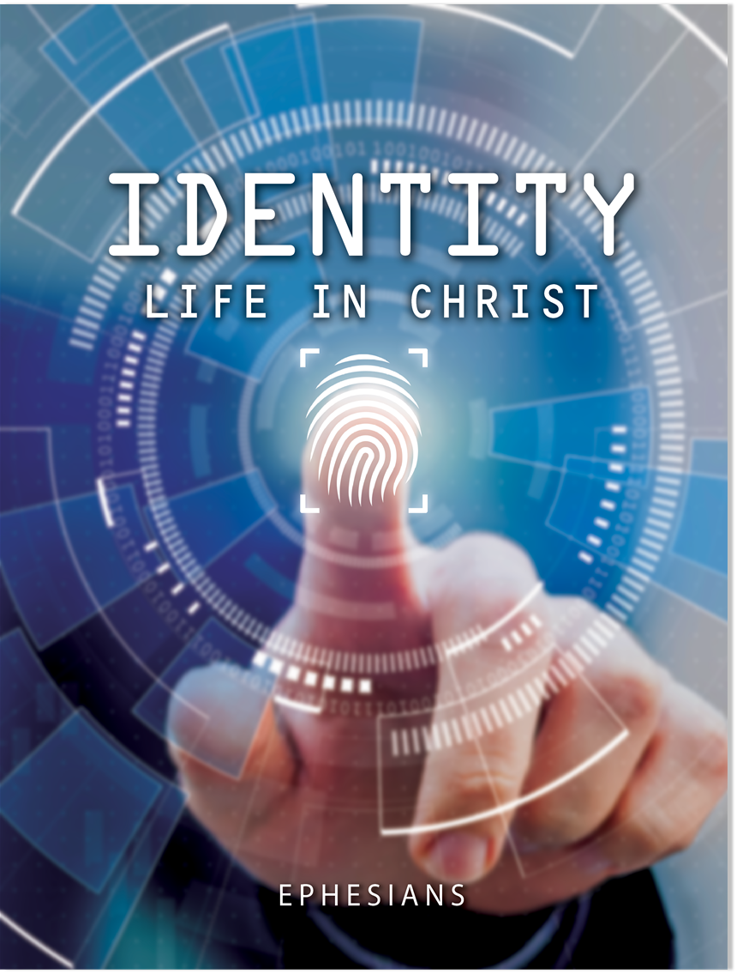
Lesson 1—Chosen and Grateful
Ephesians 1:1–5
I. Ephesians’ ___________ and ___________
A. Paul’s ___________ with Ephesus
B. Ephesus’ ______________ with ________
C. Paul’s emphasis on ______ “in _________”
II. Paul’s ____________ Greeting (Eph. 1:1, 2)
III. Introduction to Life in Christ (Eph. 1:3–5)
A. God bestowed us with ______________ (1:3)
B. God ________ us to ______________ (1:4)
C. God ____________________ us to ____________ (1:5)

© 2021 • Regular Baptist Press • Arlington Heights, Illinois • May be copied for classroom use only.
Lesson 2—Guaranteed Inheritance
Ephesians 1:6–14
I. _____ God Blessed Us (Eph. 1:6)
II. _____ God Blessed Us (Eph. 1:7–14)
A. _______________ (1:7–10)
1. Its ________ (1:7b)
2. Its ___________ (1:7c)
3. Its ___________ (1:7d–10)
B. _________________ (1:11–14)
1. For the ______ (1:11, 12)
2. For the ____________ (1:13, 14)

© 2021 • Regular Baptist Press • Arlington Heights, Illinois • May be copied for classroom use only
.Lesson 3—Praying for Change
Ephesians 1:15–23
I. The ______________ of Paul’s Prayer (Eph. 1:15, 16)
A. ____________ (1:15)
B. __________________ (1:16)
II. The ___________ of Paul’s Prayer (Eph. 1:17–23)
A. Spiritual ____________ (1:17)
B. Spiritual ___________ (1:17)
C. Spiritual ___________ (1:18–23)
1. Immediate result: ____________________ (1:18)
2. Ultimate result: ______________ (1:18–23)
a. Of the ______ of His ___________ (1:18)
b. Of the _________ of His _________________ (1:18)
c. Of the ______________ of His ________ (1:19–23)

© 2021 • Regular Baptist Press • Arlington Heights, Illinois • May be copied for classroom use only.
Lesson 4—Saved to Work
Ephesians 2:1–10
I. _______________ from Christ (Eph. 2:1–3)
A. ___________ separation (2:1, 2)
B. _________ separation (2:3)
II. ________ with Christ (Eph. 2:4–6)
A. God ________ us through Christ (2:4)
B. God gave us ______ in Christ (2:5, 6)
III. ____________ of Union with Christ (Eph. 2:7–10)
A. To ___________ ________ (2:7–9)
B. To ___________ ______ ________ (2:10)
© 2021 • Regular Baptist Press • Arlington Heights, Illinois • May be copied for classroom use only.
Lesson 5—Building Unity in Christ
Ephesians 2:11–22
I. ___________ _______________ from Christ (Eph. 2:11, 12)
A. ___________ (2:11)
B. Without _________ (2:12)
C. ______________ (2:12)
II. ________ in Christ (Eph. 2:13–22)
A. _________ of peace (2:13, 14)
B. ___________ for peace (2:14–18)
C. ____________ of peace (2:19–22)
1. _________ ____________ (2:19)
2. _________ ___________ (2:19)
3. ____________ _________ (2:20, 21)
4. ______ _________ (2:21, 22)

© 2021 • Regular Baptist Press • Arlington Heights, Illinois • May be copied for classroom use only.
Lesson 6—Mystery Revealed
Ephesians 3:1–13

I. ___________ to the Mystery (Eph. 3:1–4)

A. ______________ of the mystery (3:1–3)

B. _______________ of the mystery (3:3, 4)

C. _________ of the definition of a mystery (3:5)
II. ___________ of the Mystery (Eph. 3:6)

A. Gentiles are fellow ________

B. Gentiles are fellow ___________

C. Gentiles are fellow ______________
III. ____________ of the Mystery (Eph. 3:7–9)

A. Paul’s ____________ (3:7, 8)

B. Paul’s ___________ (3:8, 9)
IV. ___________ for the Mystery (Eph. 3:10–13)

A. Provide a _________ (3:10, 11)

B. Promote ____________ (3:12, 13)

© 2021 • Regular Baptist Press • Arlington Heights, Illinois • May be copied for classroom use only.
Lesson 7—Life-changing Power
Ephesians 3:14–21
I. __________________ of Paul’s Prayer (Eph. 3:14, 15)

A. With _______________ (3:14)

B. With ______________ (3:14, 15)
II. ___________ of Paul’s Prayer (Eph. 3:16–19)

A. The ____________ power (3:16)

B. The Son’s ____________________ and ______ (3:17–19)

C. The ____________ ____________ (3:19)
III. _______________ to Paul’s Prayer (Eph. 3:20, 21)

A. _______________ in God’s ________ (3:20)

B. ___________ for God’s ________ (3:21)

© 2021 • Regular Baptist Press • Arlington Heights, Illinois • May be copied for classroom use only.
Lesson 8—God’s Grace for Mutual Growth
Ephesians 4:1–16
I. ______ for Unity (Eph. 4:1–3)
A. ___________ your ___________ (4:1)
B. ____________ your ____________ (4:2, 3)
II. ___________ of Unity (Eph. 4:4–6)
A. One ______ (4:4)
B. One _________ (4:4)
C. One ______ (4:4)
D. One ______ (4:5)
E. One ________ (4:5)
F. One ___________ (4:5)
G. One _____ and _________ of all (4:6)
III. ___________ for Unity (Eph. 4:7–16)
A. _______ for the church (4:7–11)
B. _________ in the church (4:12–16)

© 2021 • Regular Baptist Press • Arlington Heights, Illinois • May be copied for classroom use only.
Lesson 9—Walk with Intention
Ephesians 4:17–32
I. The ________ Way to Walk (Eph. 4:17–21)
A. Down a ______ ______ (4:17–19)
B. Away from the ________ (4:20, 21)
II. The ________ Way to Walk (Eph. 4:22–32)
A. ______________ (4:22–29)
1. Put off the “_____ _____” (4:22)
2. ________ your ______ (4:23)
3. Put on the “_____ _____” (4:24)
4. Demonstrate the _____ ______ (4:25–29)
B. _______________ (4:30)
C. _________ (4:31, 32)

© 2021 • Regular Baptist Press • Arlington Heights, Illinois • May be copied for classroom use only.
Lesson 10—Walk in Love and Light
Ephesians 5:1–17
I. Walk in ______ (Eph. 5:1–7)
A. Follow Christ’s _________________ ___________ (5:1, 2)
B. Resist the world’s _________ _________________ (5:3, 4)
1. ___________ behavior (5:3)
2. ____________ desires (5:3)
3. _________ speech (5:4)
C. Consider God’s _________ ________ (5:5–7)
II. Walk in ________ (Eph. 5:8–17)
A. ______________ your light (5:8)
B. _________ on the ________ (5:9, 10)
C. Shine ____________ to expose ___ (5:11–14)
D. _____ up ____________________ to shine (5:15–17)
© 2021 • Regular Baptist Press • Arlington Heights, Illinois • May be copied for classroom use only.
Lesson 11—Spirit-controlled Relationships
Ephesians 5:18–33
I. The ___________ to be Spirit Filled (Eph. 5:18–21)
A. ___________ of Spirit filling (5:18)
B. ___________ of Spirit filling (5:19–21)
1. _____ (5:19)
2. __________________ (5:20)
3. _________ _______________ (5:21)
II. The Spirit-controlled ___________ (Eph. 5:22–33)
A. The Spirit-controlled ______ (5:22–24)
B. The Spirit-controlled ___________ (5:25–33)

© 2021 • Regular Baptist Press • Arlington Heights, Illinois • May be copied for classroom use only.
Lesson 12—Help for Home and Work
Ephesians 6:1–9
I. Parent-Child Relationships (Eph. 6:1–4)
A. Exhortations to ____________ (6:1–3)
1. ______ your ___________ (6:1)
2. ________ your _______ (6:2, 3)
B. Exhortations to ___________ (6:4)
1. ________ ___________ (6:4)
2. ________ and ____________ (6:4)
II. Servant-Master Relationships (Eph. 6:5–9)
A. Exhortations to servants (6:5–8)
1. ______________ obey (6:5–7)
2. Expect _________ (6:8)
B. Exhortations to masters (6:9)
1. Don’t ____________ (6:9)
2. ____________ your _________ (6:9)
© 2021 • Regular Baptist Press • Arlington Heights, Illinois • May be copied for classroom use only.
Lesson 13—Stand and Fight!
Ephesians 6:10–24
I. ___ _________ in the Lord (Eph. 6:10)
II. _____ ___ the Armor of God (Eph. 6:11–17)
A. ___________ for the armor (6:11–13)
B. _________ of the ________ (6:14–17)
1. ______ of ________ (6:14)
2. _________________ of ____________________ (6:14)
3. ___________ of ________ (6:15)
4. _________ of ________ (6:16)
5. _________ of ______________ (6:17)
III. ______ the Battle (Eph. 6:17–24)
A. ______ up your ________ (6:17)
B. ___________ your _________ ____________ (6:18–24)
© 2021 • Regular Baptist Press • Arlington Heights, Illinois • May be copied for classroom use only.

