J **1AM**



# Topic

**God's holiness**

# Theme

**God is holy and provides for both our positional and our practical holi­ ness.**

# Desired Learner Response

**The learner will allow God's presence to make a spiritual difference in his life.**

**Materials**

* Resources 1 and 1 2
* Food items with expirati on dates
* On e food item with no expiration date
* Stick y note s

**Atoner**

# Scripture Focus

**Exod. 35-40; Lev. 1-27**

# Summary

This lesson covers the record of the specific commands for the making and building of the tabernacle and the offerings and priesthood required to op­ erate the tabern acle in a holy manner. It also considers an instance in which priests acted in a manner contrary to God's commands. It ends with a section on Go d's comm ands to guide Israel as they managed their lives in response to Go d's presence with them.

**Outline**

1. **God's Place of Worship (Exod. 35-40)**
   1. God provided materials and artisans (35-39)
   2. Moses constructed the tabernacle (40:1- 33)
   3. God approved of the tabernacle (40:34- 38)
2. **God's Atoning Sacrifices (Lev. 1-7; 16)**

**Ill. God's Consecrated Priesthood (Lev. 8; 9)**

1. **God's Demand for Holiness (Lev. 10:1-11)**
   1. Nadab and Abihu offered profane fire (10:1)
   2. God judged Nadab and Abihu (10:2- 5)
   3. God instructed the priests (10:6- 20)
2. **God's Laws for Holy Living and Worship (Lev. 11-15; 17-27)**

#### Memory Verse

*"Speak unto all the congregation of the childr en of Israel, and say unto them,*

*Ye shall be holy: for I the LORD your God am holy"*

*(Leviticus 19:2).*

**79**

## One and Done

**ASK:** What daily task do you wish you could do just one more time and nev­ er have to do again? (Q1)

**ASK:** How would you respond to having to make sacrifices every day, being repeatedly covered in animal blood and guts? (Q2)

The sacrifices that priests were to make to atone for Israel's sin are detailed in the book of Leviticus. The sacrifices continued year after year. Christ's death on the cross was also for atonement of sin, but it was a once-for-all atonement. This lesson will examine the tabernacle, priesthood, and sacrifices that God put in place to provide atonement for Israel's sin.

## Shelf Life

Bring several food items with expiration dates on them . Cover the dates with sticky notes. Ask a learner to line up the items from first to expire to last to expire without looking at the dates. Ask the rest of the learners if they would make any changes to her arrangement. Make any changes they suggest and then read the expiration dates on the products to see if the group was right.

Display one of the following foods that have no expiration date: salt, rice, honey, vanilla extract, white vinegar, cornstarch, sugar, and maple syrup.

**ASK:** Where would you slot this food item in our lineup?

Explain that the food you added to the mix has no expiration date.

This lesson will examine God's provision for atonement in the Old Testa­ ment. We will find that the problem with the Old Testament sacrifices is that they all eventually expired. They had a relatively short shelf life when compared to Christ's final, once-for-all death on the cross.

**SEARCHING THE SCRIPTURES**

## God's Place of Worship (Exod. 35-40)

* 1. **God provided materials and artisans (35-39)**

After Israel's sin in making an idol, God gave the people an opportunity to give materials for the tabernacle's const ruction. Their giving was to be voluntary and heartfelt (Exod . 35:5, 29). As a result, more than enough was given to provide for the construction of the tabernacle (36:5- 7).

God also provided artisans to make the tabernacle furniture and the many pieces, fabrics, and coverings for the construction of the tabernacle. The artisans were specially equipped by God for making the furniture and weaving the fabrics (36:2). They were led by Bezalel, who personally oversaw the making of each piece

of furniture for the tabernacle (35:30-35). All of the work was done just as God had commanded (39:43).

* 1. **Moses constructed the tabernacle (40:1-33)**

Moses then oversaw the putting together of the tabernacle on the first day of the first month of the second year (40:17). The tabernacle was probably completed in about six months.

**READ:** Exodus 40:19-32. **ASK:** What phrase in these verses describes how the tabernacle was put together and furnished? (Q3) *As the LORD commanded Moses.*

God had been very specific in how to make, put together, and furnish the tabernacle. Moses took God's instructions seriously, leading in the actual con­ struction of the tabernacle himself. His involvement in the construction as Israel's leader showed the people that they were to serve God and take His commands seriously. They weren't Moses' people; they were God's people. No doubt Moses made sure no shortcuts were taken or details overlooked. He took the tabernacle seriously because he took God seriously. Moses' attention to detail was recorded in the Bible as a testimony to God's right to determine what Israel should believe and practice (cf. Exod. 25:40; Heb. 8:4, 5).

**READ:** Exodus 25:40; Hebrews 8:4, 5. **ASK:** How should God's expectations concerning His instructions help to shape our approach to His Word in gen­ eral? (Q4) *Since God expected Israel to follow His instructions exactly as He spelled them out, then He naturally expects us to follow all of His Word carefully.*

* 1. **God approved of the tabernacle (40:34-38)**

**READ:** Exodus 40:34. **ASK:** What indicated God's approval of how the taber­ nacle was constructed? (Q5) *He dwelt in the tabernacle.*

The tabernacle was constructed as a place for God's glory to dwell. When God indwelt the tabernacle, He in essence approved of how each part had been pre­ pared and put together. His people had followed His instructions meticulously.

When the tabernacle was complete, the glory of the Lord filled the taberna­ cle. Apparently God revealed His glory to the point that no one could enter the tabernacle, not even Moses (40:35). What kept Moses out was God's holiness. God is perfectly holy; He is totally set apart from sin. The picture of God alone in His tabernacle sets up the book of Leviticus. Leviticus presents God as the holy *Atoner* of sin. God provided atonement for sin based on unblemished sacrifices and then expected Israel to live up to His standard of holiness.

1. **God's Atoning Sacrifices (Lev. 1-7; 16)**

Once the tabernacle was in place, God communicated the various laws that would govern Israel's worship of Him through the Levites' priestly service. The book of Leviticus is predominantly about that service. Its name comes directly from the Latin Vulgate translation of the Bible. *Leviticus* is a Latin term that means *that which pertains to the Levites.*

God's cloud and pillar of fire over the tabernacle indicated whether Israel should stay or go as they journeyed. When the cloud moved, the people were to follow God wher­ ever He led them (Exod. 40:36-38).

God gave Moses the entire book of Leviticus during the first month of the sec­ ond year after the exodus from Egypt.

Leviticus starts with a description of each of the five sacrifices the priests were to administer on behalf of the people: the burnt, grain, peace, sin, and trespass offerings (Lev. 1- 7). God required all animal sacrifices to be without blemish (1:3; 3:1; 4:3; 5:15), meaning they were to have nothing obviously wrong with them.

And grain was to be offered without leaven, which was a symbol of sin (2:11). No animal is perfect, but those chosen for sacrifices were to at least have the appear­ ance of perfection. Atoning sacrifices had to be *without blemish* to be accepted by God. Eventually Christ would come as the final, perfect sacrifice for the atonement of sins . The animals sacrificed in the Old Testament were merely a shadow of His fin al, once-for-all sacrifice (Heb. 10:1- 10).

**READ:** Hebrews 10:1. **ASK:** What could the animal sacrifices never accom­ plish? (06) *They could not make perfect the person offering the sacrifice.*

The without -blemish requirement also showed that the innocent was dying on behalf of the guilty. The undeserving animal was the recipient of the deserv­ ing person's punishment. The death of the innocent for the guilty again pictured Christ's death for the guilty sinner (Rom. 5:6- 11).

Atonement for sin always requires bloodshed (Lev. 17:11; Heb. 9:22). The per­ son bringing the sacrifice would lay his hand on the animal's head and lean heav­ ily on it to identify with the animal (Lev. 1:4). The animal's blood was the n shed in the place of the person bringing the sacrifice . The animal's shed blood *atoned for* the person's sin. However, committing more sins brought the need for more sacri­ fices. There was no once-for-all sacrifice for sin in the tabernacle system.

**ASK:** How does the connection between sin and shed blood affect your understanding of the seriousness of sin? (07)

Along with the five daily sacrifices were the yearly sacrifices made by the high priest on the Day of Atonement (Lev. 16). On the Day of Atonement the high priest was to go to the tabernacle with a bullock and a ram, which he sacrificed for his sins and those of his family (16:6, 11). The priest also brought two goats and a ram, which he used on behalf of the people. He put off his normal priestly clothing, with its colors and embroidery and fringes, and put on robes of plain white linen (16:4). The high priest alone carried out the ritual; no one helped him (16:17). He went into the Holy of Holies only on this one day of the year, but he went in twice: once for himself and once for the people.

The two goats constituted one offering. The first was sacrificed as a sin offering (16:15). The priest confessed the sins of the nation on the head of the second goat, which was taken into a *land not inhabited - usually* an island or an inaccessible canyon - from which the animal could not return (16:20- 22). The sacrifice on the Day of Atonement had to happen every year (16:34).

The atoning sacrifices were not offered to secure the Israelites' salvation.

Salvation has always been by grace through faith in God. Isra el's atoning sacrifices served to cover their sins and thereby restore their fellowship with God. Of course the individual had to sincerely repent in order for the sacrifices to be accepted by God. Believers today don't need to offer sacrifices to take care of their daily sins.

Believers confess theirs sins to God, and He is faithful to forgive their sins based

on Christ's death on the cross (1 John 1:9).

Christ's death on the cross is the basis of our salvation. Christ paid the penalty for our sin once and for all. We accept His payment for our sins by faith (Rom. 5:1; Eph. 2:8, 9).

### God's Consecrated Priesthood (Lev. 8; 9)

Once the offerings were detailed, it was time for the consecration, or setting apart, of the priesthood. Moses gathered the congregation of the people before him and did as the Lord commanded. He washed Aaron and his sons (including Nadab and Abihu), anointed them with oil to set them apart for their priestly service, and clothed them in their priestly garments (Lev. 8:1- 13). Aaron and his sons then made an offering for themselves (Heb. 7:27) before making offerings to set apart the altar (Ex od. 8:14- 17). They.continued the process by offering a ram as a burnt offering of worship and consecration (Lev. 8:18 - 21). The final offering was another ram offered to install the priests in their offices (8:22- 29). Moses applied blood from the second ram to the priests' right ears, right thumbs, and right great toes (8:23, 24). Most likely this application of the blood symbolized the consecra­ tion of the priests to hear God, do His will, and walk in His ways. The priests were to give their lives to total obedience and service to the Lord.

The consecration of the priests continued for the next week. God demanded Aaron and his sons stay at the door of the tabernacle night and day for an entire week as part of their preparation to become priests (8:35). God was communicat­ ing to the priests and all of Israel the importance of being set apart for His service. The seriousness of God's command had to grow as each day passed in their week of consecration .

**READ:** Leviticus 8:35. **ASK:** How important was it for the priests to obey God's instructions? (08) *They would die if they didn't obey God*

The punishment for disobeying God's instruction to the priests was as severe as it could be. Certainly none of the priests, including Nadab and Abihu, would dare take lightly any of God's instructions regarding their priestly duties.

**READ:** Leviticus 8:36. **ASK:** How carefully did Aaron and his sons obey God's will? (09) *They did all the things that God commanded*

With death as the consequence for disobedience, none of the priests moved from the tabernacle. After the week was up, the priests conducted their first day of service before the Lord on behalf of the people of Israel (9:1- 22). The final official event of the first day of the priests' service included a miraculous display of God's presence.

**READ:** Leviticus 9:23, 24. **ASK:** If you were an Israelite watching the event, how do you think you would have responded to God's miraculous display of His presence? (010)

The priests had been obedient in their consecration ceremonies, and the Lord showed His presence on the first day of service in the tabernacle. All was going well until two priests decided to do things their way.

### God's Demand for Holiness (Lev.10:1-11)

* 1. **Nadab and Abihu offered profane fire (10:1)**

Nadab and Abihu, Aaron's two oldest sons, were fully aware of the importance of being set apart to God. They took part in the consecration procedures, and they had just spent a week of consecration in the tabernacle. They would be without excuse if they chose to deviate from God's laws regarding the sacrificial system and priesthood. Yet they offered incense to the Lord with strange, profane fire, meaning their incense offering was not acceptable to God (10:1). Perhaps Natl-

ab and Abihu offered the incense in the wrong way, at the wrong time, or in the wrong place.

**ASK:** Why do you think Nadab and Abihu offered profane fire to God? (Ql 1) *Perhaps they thought God wouldn't punish them because they were Aaron's privi­ leged sons, because God would certainly give them* a *second chance to please Him, or because they were doing something intended to please Him.*

We don't know exactly why Nadab's and Abihu's offerings weren't acceptable to God. But we do know that something they did violated God's command con ­ cerning offering incense.

Nadab and Abihu took God's clear commands lightly and failed to respect Him in their worship. They did what they wanted to do instead of what God had clearly told them to do. It is hard to imagine how they could conclude that God would be okay with their disobedience.

Nadab and Abihu violated God's holiness by their disobedience. They did not live separated unto the Lord. They lived according to their own rules, taking their service to God as priests either lightly or carelessly. Either way, they failed to take God's holiness seriously.

### God judged Nadab and Abihu (10:2-5)

After Nadab and Abihu disobeyed God's clear commands about offering in- cense to Him, God devoured them with fire (10:2).

**READ:** Leviticus 10:2. **ASK:** Do you think God's slaying of Aaron's sons was fair? Explain. (Ql 2)

Nadab and Abihu received such strict judgment from God because they ex­ pected their Holy God to accept their way of serving Him even though it violated His instructions.

**ASK:** Who were Nadab and Abihu really serving when they offered their incense? (Ql 3) *Themselves.*

God is never pleased when we disobey His clear will in an attempt to please Him. He wants us to have a deep appreciation and respect for His holiness.

The Israelites watched as Aaron's cousins carried the bodies of Nadab and Abihu through the camp (10:4, 5). No doubt those who actually saw the bodies stood in stunned silence.

**ASK:** How would such a scene have affected Israel's understanding of wor­ **ship? (Ql 4)** *The Israelites would have understood the seriousness of obeying God and respecting His holiness in their worship of Him.*

God didn't always act with such dramatic and quick judgment on His people, but this event was important in Israel's history. Israel was beginning the official priestly service, and God needed to show His people that His law was not up for personal interpretation. The deaths of Ananias and Sapphira for lying to the Holy Spirit at the early stages of the church is another example of God using strict judgment to reinforce the need for His own to respect Him in their worship and in their lives (Acts 5:1-11).

### God instructed the priests (to:6-20)

Moses told Aaron and his remaining sons neither to mourn for Nadab and Abihu nor to leave the tabernacle (10:6, 7). A priest's role was to worship God and not to mourn . The priests were God's representatives before the people. For them to mourn publically would have been a contradiction in the eyes of the people. God permitted Aaron and his family to mourn inwardly and privately.

In case Aaron missed the importance of what had just happened, God spoke directly to him (10:8, 9). He told him to refrain from mixing strong drink with tab­ ernacle service lest he die. The reason for this was twofold: to keep a distinction between what was holy and what was unholy and to teach the Children of Israel all of God's statutes. God wanted Aaron to understand fully the importance of respecting Him while worshiping Him.

Moses understood the need for the priests to be careful to respect God by obeying His instructions for the various sacrifices. When he made a careful inquiry into what Eleazar and Ithamar, Aaron's sons, were doing, he spotted an inconsistency (10:16- 18). Aaron gave an explanation for the inconsistency to Moses' satisfaction (10:19, 20).

God atoned for Israel's sin, but the atoning sacrifices had to be conducted according to His instructions. God is holy. Israel had to treat Him as such, or they would suffer the consequences of their sin.

### God's Laws for Holy Living and Worship (Lev. 11-15; 17-27)

The rest of the book of Leviticus gives God's laws for holy living and holy worship. The purification laws covered topics such as clean and unclean foods (11), the purification of women after childbirth (12), leprosy (13; 14), and bodily discharges (15). While this section of the book doesn't provide many devotional thoughts, it does help to communicate God's demands for pure and holy living.

The next section of Leviticus (17- 22) concerns more holy living laws about topics such as slaughtering beasts and sexual morality. Chapters 23- 25 provide for additional laws concerning the feasts, the care of the tabernacle, blasphemy, the Sabbath year, and the year of jubilee. The section on blasphemy (24:10- 16) includes an illustration of a man who blasphemed Go d. The man was stoned according to God's direction (24 :13-16). What a vivid illustration of the need for God's young nation to honor God's holy name.

**READ:** Leviticus 19:2. **ASK:** Why were the Israelites to be holy? (Ql 5) *Because God is holy.*

Chapter 26 is the conclu­ sion to Leviticus. Chap­ ter 27 could be viewed as an appendix, though it is as inspired as the rest of

**the Bible.**

God came to dwell with Israel. But for them to maintain fe llowship with Him, they needed to live holy lives (26:3, 11, 12). The last main section of Leviticus spells that out clearly (26). Israel would enjoy prosperity and safety in the Promised Land as they managed their lives according to God's law (26:3- 13). But they would experience disease, famine, attacks by wild beasts, and captivity for failing to manage their lives according to God's law (26:14-39). However, God would honor His covenant with them if they confessed their iniquity and humbled their uncir­ cumcised, or disloyal, hearts (26:40- 45).

The tabe rnacle, the priesthood, the sacrifices, and the laws for holy living were designed by God to guide Israel as they managed their lives with Him in their presence. He provided for their atonement of sin, but they needed to live accord­ ing to His directives to be pleasing to Him. Unfortunately Israel wandered often from the Lord. The next chapter in Israel's history is replete with doubt and fears instead of belief and faith .

**MAKING IT PERSONAL**

### Separated to Go d

**RESOURCE:** Display resource 12 to summarize God's atonement through sacrifices and through the cross as well as His continuing expectation that His followers live holy lives.

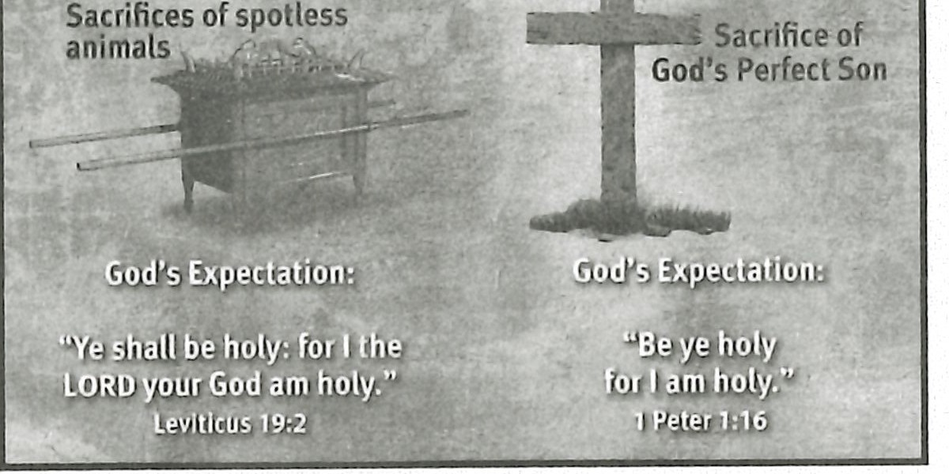

IT ffl L!M@llh@lf

**God's Year-by-year God's Once -for-all Provision for Sin Provision for Sin**

God has cleansed us believers from our sins and has declared us righteous. But that does not give us a license to do whatever we want. He expects us to live holy lives separated unto Him (1 Pet. 1:13- 19). God dwells in us in the Person of the Holy Spirit. We are His dwelling place now. And He gives us the power and grace to live pleasing to God.

**ASK:** How has learning about Israel's interaction with God in the tabernacle setting helped you appreciate God's presence in you? (Ql 6)

**ASK:** Is your life characterized by holy living? Are you growing spiritually? Challenge your learners to allow God's presence to make a spiritual differ­ ence in their lives. (Ql 7)

### Readily Approachable

God is now readily approachable through prayer, thanks to Christ's once-for­ all sacrifice on the cross. We can now enter boldly to God's throne of grace at any moment. Unfortunately many believers spend very little time at God's throne .

**ASK:** What might keep you from taking advantage of immediate access to God's throne? (Ql 8)

**ASK:** God longs to commune with you. What will you do to make time to commune with Him every day? (Ql 9)

### Summary and Memory Verse

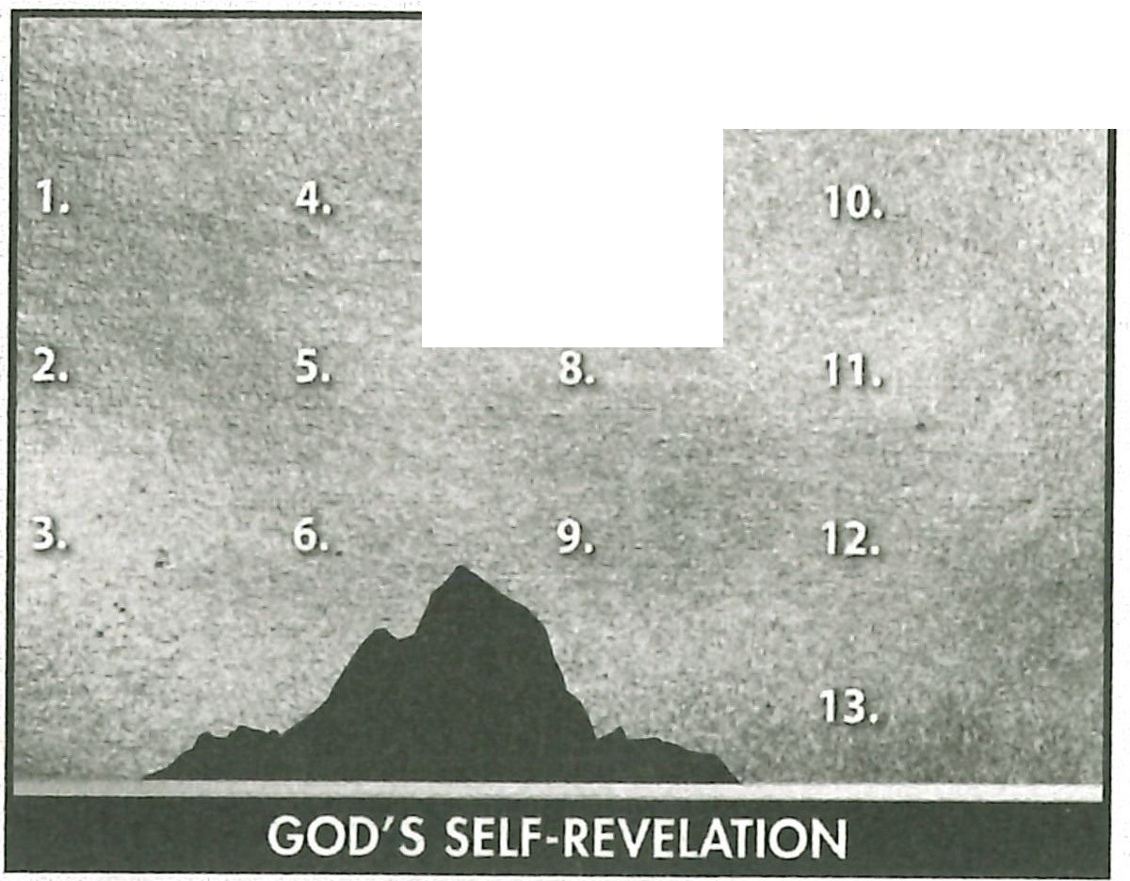

**1AM**

**RESOURCE:** Display resource 1. Add a summary statement about God's introduction of Himself in lesson 9 or use the following: I AM Atoner.

Encourage learners to memorize Leviticus 19:2. Give them an opportunity to say the verse in class next week.



# Topic

**God's gracious giving**

# Theme

**God is a gracious giver of blessings, and He is for believers.**

# Desired Learner Response

**The learner will recog­ nize that God is for him and will be content with his lot in life.**

#### Materials

* Resources 1, 3, and 13

**1AM**

**Gracious Giver**

# Scripture Focus

**Num. 1-14**

# Summary

This lesson will track Israel's movements from Sinai to the edge of the Prom­ ised Land . Israel 's discontentment with God leads to their eventual rejection of Him and the Promised Land. They failed to see that God was for them as a gracious giver of good blessings.

#### Outline

1. **God Provided for Israel (Num. 1-11)**
   1. God's blessing on Israel (1:1- 6 :21; 7-11)
   2. God's prayer for Israel (6:22- 27)
2. **Israel Complained (Num. 11:1- 3)**

**Ill. Israel Craved Meat (Num. 11:4-35)**

* 1. Israel's dissatisfaction (11=4-9)
  2. Moses' complaint (11:10- 15)
  3. Go d's response and judgment (11:16- 35)

1. **Miriam and Aaron Criticized Moses (Num. 12)**
2. **Israel Rejected God (Num. 13; 14)**
   1. Spying out the land (13:1- 24)
   2. Refusing the land (13:25- 14:38)

**Memory Verse** *"Wha t shall we then say to these things ? If God be for us, who can be against us? He that spared not his own Son, but delivered him up for us all,*

*how shall he not with him also freely give us all things ?" (Romans 8 :31,32).*

**88**