

Topic
God's glory

Theme
God is glorious in His justice, mercy, and grace in His dealings with humanity.

Desired Learner Response

The learner will consider how God's grace might be applied to his life.

Materials
- Resources 1, 10, and 11
- Handout 2 from resource CD

70
1AM

Glorious God

Scripture Focus
Exod. 24:1-34:28

Summary
This lesson covers Israel's ratification and subsequent rejection of the cove­ nant. God responded to Israel's breaking of His covenant with justice, mercy, and grace. All three of these attributes are part of His glorious name. God revealed His glory to Moses. Moses responded by worshiping Him.

Out line
- Ratification of the Covenant (Exod. 24)
  - God's covenant (24:1-8)
  - God's glorious presence (24:9-18)
  - Go d's dwelling place (25-31)

Rejection of the Covenant (Exod. 32:1-33:17)
  - Israel's idolatrous sin (32:1-6)
  - Moses' appeal to Go d's mercy (32:7-14)
  - Moses' execution of God's justice (32:15-29)
  - Moses' second appeal to God's mercy (32:30-32)
  - God's execution of His justice (32:33-33:6)
  - Moses' appeal to God's grace (33:7-17)

Ill. Revelation of the Covenant Ke eper (Exod. 33:18-34:28)
- God's revelation of His glory (33:18-34:9)
- Go d's demonstration of His glory (34:10-28)

Memory Verse "And the LORD passed by before him,and proclaimed, The LORD, The LORD God, merciful and gracious, longsuffering, and abundant in goodness and truth, keeping mercy for thousands ,forgiving iniquity and transgression and sin, and that will by no means clear the guilty" (Exodus 34:6,70).



Mayhem Ensues

GETTING STARTED

Complete the mad lib on handout 2 from the resource CD as a class. Follow the directions on the handout. Have the learners share stories about trouble ensuing when parents are away.
The Israelites made several bad decisions while Moses was away. They took charge and revealed the rebelliousness of their hearts. By contrast, God revealed His glory in response to Israel. God's glory is the focus of this lesson.

Inglorious Moments
Have the learners consider what they think is the most inglorious historical event to unfold in their lifetime. Give them a few minutes to think and then share their ideas.

ASK: What character qualities did people reveal at the inglorious moments you mentioned?

ASK: Were there any good character qualities displayed? Which ones?

The lesson for today reveals how God used a rather inglorious moment in Israel's history to reveal His glory to them.

SEARCHING THE SCRIPTURES


Ratification of the Covenant (Exod. 24)
Having already agreed to do all God had commanded (19:8), the people offi­ cially ratified their covenant with the Lord at Mount Sinai.

God's covenant (24:1-8)
God instructed Moses and his aides to come up to Him on Mount Sinai. But first they were to meet with Israel to ratify the covenant (24:1, 2). Moses commu­ nicated all the Lord's words and all His judgments (24:3). The people responded again with one voice saying, All the words which the LORD hath said will we do. Moses recorded all the words of the Lord and made an altar at the foot of Sinai. He also set up twelve pillars, one for each of the tribes of Israel (24:4). The young men Moses sent to offer burnt offerings and sacrifice peace offerings were firstborn sons who played the roles of priests until the Aaronic priesthood was in place (24:5).
Moses proceeded to officially ratify the covenant. He collected half of the blood from the sacrifices and put it in basins. He sprinkled blood on the altar and read the book of the covenant to the people. They again agreed to do all that God had commanded in the book (24:6, 7). Moses continued the ratification process by sprinkling the people with some of the blood from the sacrifices (24:8). Perhaps the people were represented by the twelve pillars. Practically speaking , sprinkling blood on over two million people would have been difficult to accomplish. Either

The content for the book of the covenant included all of God's instructions so far (Exod. 19- 23).

way, there was a clear connection between the sacrifice and the people. The blood on the people was a blood oath, meaning the people were bound to obey the Lord. The blood on the altar was a symbol of God's acceptance of the offering and the forgiveness He granted as a result. This prefigured Christ's shed blood on behalf of humanity (cf. Heb. 9:11- 15).
ASK: How would you describe Israel's relationship with God at this time? (Q3) They seemed ready to be loyal to Him and obey Him out of gratitude for all He had done for them.

God's glorious presence (24:9 - 18)
Moses and his aides, including Joshua, ascended Mount Sinai to meet with the Lord. As they went, they witnessed an appearance by God. Of course God was not there in all of His glory, for none of them could have survived such a revelation.
But they did get a glimpse of God standing on sapphire that was so pure it ap ­ peared to be something from Heaven (24:9, 10).
READ: Exodus 24:9, 10. ASK: How might you expect God's appearance to affect Aaron's understanding of God? (Q4) He should have had a reverence for God and a keen sense of the seriousness of God's command s.
God accepted the men and mercifully restrained His hand from striking the men dead. The men responded to God's revelation of His glory by eating a meal together, a common occurrence for the ratification of a covenant in those days (24:11).
God then called Moses and Joshua to go higher on the mountain, leaving the elders with Aaron and Hur. Moses eventually left Joshua, too, as he continued on up the mountain to meet with the Lord and receive the tablets on which God had written the Ten Commandments (24:12- 15). After six days, the Lord called
to Moses out of the cloud that accompanied His presence. To the people at the base of Mount Sinai, God's glory appeared on the mountain as a consuming fire (24:16 - 18; cf. 19:18).
ASK: What did God reveal about Himself by appearing to Israel as a consum­ ing fire? (QS) That they needed to revere Him and take His commands seriously or there would be consequences.

God's dwelling place (25-31)
God's plans for the tabernacle dominated His new revelation to Moses. The tabernacle was where God planned to dwell with Israel. Given its importance, God gave Moses specific instructions on how to build the tabernacle and what furniture to put in it. He told Moses about each loop, pole, section, and fabric that would make up the tabernacle . He even detailed how the furniture was to be made, beginning with the ark of the covenant and its accompanying mercy seat.
READ: Exodus 25:21, 22. ASK: Why was the mercy seat so important? (Q6)
God said He would dwell between the cherubim that were on the mercy seat.

The ark of the covenant was the place of atonement. Israel was accepted by God as a result of a substitute sacrifice. Their sins were covered, albeit temporarily. The sacrifices had to continue year after year. This temporary atonement for sins was a precursor to Christ 's final sacrifice for sins on the cross (Heb. 10:11, 12).
RESOURCE: Display resource 10 to show some of the details of the tabernacle.

READ: Exodus 25:40; 26:30. ASK: How important were the details God spelled out for Moses on Mount Sinai? (Q7) Extremely important. God expected Moses to follow the instructions exactly as He had laid them out.

I ,.,.....- (,
- _. . r., \_,.--_,·
?,'_-
..
-· . .
-
--

11!1
>
____ .,
.,. .·-, ,. -.

,.=,!" f'

_.i.i1, :. • '- , f i_
.,;:;;--. , I \ •f
{'f
w_.
;:_
·r,
f
-;;.-
,,.. • • - -

' .· .. -,,;·1-1-1,.1"',.
i. . ·;· -'' ''.t•j{};! \

-F"·'.. ; !:•::··.'°•-:.·•:·i·••i. ;;<;,-r•.'.- ,-.·..,: . ,._..: " ·.. •. JI-,--·-,
t1 ·,
)A. '.-' "·:?.....: , -

God was so specific about the tabernacle because it was Israel's means of approaching Him. Israel was to approach Him according to His plan. God's com­ munication of all the details was part of the reason Moses spent so much time on the mountain .
God ended His instructions on the tabernacle by repeating His command about keeping the Sabbath (31:12- 18). He reminded Moses about the connection between the Sabbath and God's week of creation (31:17). That connection remind­ ed Moses and eventually Israel that they served the creator of the universe. No other god could ever rival God the creator. For Israel to worship any other god would make no sense.
After noting that God inscribed the Ten Commandments on two tablets and gave them to Moses (31:18), the narrative switches to what Israel was doing at the base of Mount Sinai.

Rejection of the Covenant (Exod. 32:1-33:17)
    - Israel's idolatrous sin (32:1-6)
Moses had been away for forty days with no word on why he had been gone so long. The Israelites grew impatient. Instead of seeing the forty days as an indication of the seriousness of God's revelation, the Israelites saw the time as an indication of Moses' failure and God's apparent absence (32:1).
READ: Exodus 32:1. ASK: What might you conclude about Israel's belief in God, based on their decision to make an idol? (Q8) That they believed God was not serious about both His commands and the punishments for those who violated His commands.
It is hard to imagine how Israel could decide to make a god after witnessing all God had done for them in bringing them out of Egypt and supplying for their needs in the wilderness. It shows how prone their hearts were to wander from the Lord.
READ: Exodus 25:1-3, 8; 32:2, 3. ASK: What similarities do you notice in these verses? (Q9) They both call for a collection of gold: the first to use as part of the tabernacle, and the second to use to make a gold calf
The Israelites used their gold to make a golden calf. God planned to use that gold for His tabe rnacle. So instead of using the gold to help them worship God, Israel used it to make a god to worship. Remember that God knew their idolatrous
,·,F.. -;, ft. :.• ihill- ■- -- -

.._, \.• ..,

The word for gods (32:4) is in the plural but can be translated as god. The
singular rendering is most likely intended in refer­ ence to Israel's idol.
rebellion was going on while He was instructing Moses on the details of the tab­ ernacle. He revealed His plan for Israel's approach to Him while they turned from Him to serve an idol of their own making.
Aaron fashioned a gold calf with an engraving tool and presented it to the people as the god that had brought them out of Egypt (32:4). The calf was a sign of strength and fertility. So Aaron was reshaping Israel's understanding of God. He made an image to represent God and built an altar to worship the image. Aaron then proclaimed the next day as a feast day to the Lord (32:5). By doing so, Aaron claimed authority on how to worship the Lord. Following Aaron's lead, the people claimed authority to determine worship rituals too.
The next day all of Israel rose early and offered burnt offerings and peace of­ ferings. They then sat down to eat and drink. But this was no church potluck. The Israelites indulged their fleshly desires. The word play (32:6) can refer to conjugal caresses, perhaps indicating an improper sexual element. Their worship was gro­ tesque, a drunken orgy.
Israel already had the Ten Commandments. Those laws represented God's authority over them. By violating the second commandment, they were in essence rejecting God and His authority to order their lives. They no doubt thought such an arrangement would bring them endless freedom and frivolity. But they didn't understand that embracing idolatry was to embrace slavery to sin.
    - Moses' appeal to God's mercy (32:7-14)
Back on the mountain, Moses was standing with the Ten Commandments in his hands when God gave him an urgent command: Go, get thee down! (32:7). The Israel­ ites had corrupted themselves, and Moses needed to address the problem right away.
God told Moses what Israel had done. He then called the Israelites stijfnecked (32:9), meaning they refused to submit to His leadership. By contrast Israel was so eager to worship their idol and bow to its authority that they got up early in the morning to get a head start (32:6).
READ: Exodus 32:10. ASK: How serious was Israel's sin? (Ql O) Serious enough to warrant being completely wiped out by God
Motivated by His justice, God told Moses to let Him alone so He might con­ sume the Israelites in His wrath and raise up a great nation from Moses (32:10). Moses boldly interceded for the Israelites, appealing to God's mercy. Moses argued that Egypt would think God had brought His people into the wilderness just to kill them. Furthermore, God had promised the patriarchs that He would make them a great nation and give that nation land as an inheritance (32:11- 13).
God in His mercy relented of His decision to destroy Israel (32:14). He changed His course of action but not His character. He remained holy and just throughout His exchange with Moses.
    - Moses' execution of justice (32:15-29)
Moses headed down the mountain with the Ten Commandments in his hands (32:15, 16). Joshua joined him along the way. Joshua thought the noise coming from Israel's camp was the sound of war (32:17). Moses knew better. He told Joshua the

sound was singing. The volume was indicative of the Israelites' reckless abandon in worshiping their god.
When Moses arrived on the scene, he threw down the tablets in righteous anger. The broken tablets served to illustrate that Israel had broken God's com­ mands. Moses then took the idol, burned it, grounded it into powder, scattered it on the water, and made the Israelites drink it.
READ: Exodus 32:20. ASK: Why would Moses make the Israelites drink the remnants of their idol? (Ql 1) To show both the weakness of their god and their personal guilt before the true God
Perhaps even Aaron had to drink the idol-ridden water, for Moses asked Aaron why he had brought such great sin on the people (32:21). Aaron was in charge while Moses was gone. The idolatry happened on his watch.
Sensing his responsibility as Israel's leader in Moses' absence, Aaron first blamed the people for being set on evil. Aaron then made up a tale about how the idol came about, conveniently leaving out the part about him sculpting it (32:22- 24). According to Aaron, the idol made itself.
ASK: Why wouldn't Aaron admit his guilt? What would motivate him to lie? (Ql 2) Aaron likely wanted to escape responsibility for the idolatry so he could escape judgment and maintain his position of leadership with the people.
Aaron did what was convenient for himself when the Israelites asked for an idol. He let them have their way, failing to provide any restraint (32:25). But he turned on them after Moses came back to camp, taking none of the blame himself and lying to cover up his part in the sin.
ASK: How would you describe Aaron's actions in helping the people commit idolatry and then covering it up? (Ql 3) Perhaps immature, selfish, naive.
God was very angry with Aaron and would have destroyed him except for Moses' intercession (Deut. 9:20).
Moses stood at the entrance of the camp and asked those who were on the Lord's side to come to him. The sons of Levi did so. Moses had them go through the camp to kill their fellow Israelites who were still persisting in idolatrous wor­ ship . Three thousand died as a result (32:26- 28). The Levites were set apart for the Lord when they returned to Moses. Later God would appoint the Levites to be in charge of the tabernacle and all of its furnishings, dismantling and reassembling the tabernacle as necessary (cf. Num. 1:50- 53).
    - Moses' second appeal to God's mercy (32:30-32)
After such a terrible sin, God's people needed to be restored . The next day Moses approached God on their behalf.
The people had repented, but their sin needed to be atoned for. Moses told the people he was going to go to God to see if he could make atonement for their sin (Exod. 32:30). Moses returned to God and asked Him to forgive Israel's sin. If God was unwilling, then he asked that God would blot his name out of God's book (32:31, 32). Moses was offering himself as the ransom for Israel so they would not

...
'\. t ...

need to experience God's judgment. The book was perhaps God's record of those who had inherited eternal life (cf. Dan. 12:1). More likely it was the book that recorded the census, meaning Moses was willing to die on behalf of Israel. Either way, Moses was quite sincere in his desire to see Israel forgiven.
READ: Deuteronomy 9:18, 19. ASK: What did Moses do on behalf of Israel? (014)
He fasted for forty days, devoting his time to petitioning God's mercy on their behalf.

God's execu tion of His justice (32:33- 33:6)
God did not take Moses up on his offer to be the ransom for those who had sinned (Exod. 32:33). Moses could not stand in their place. God had to discipline Israel. He later sent a plague as part of the punishment for their idolatry (32:34, 35).
In addition, God said He would no longer lead Israel. Instead, an angel would go in His place (33:1, 2). God said He could not go with Israel because He would destroy them for being a stiff-necked people if He was with them (33:3). The people mourned when they heard God's decision (33:4- 6).

Mos e s' appeal to God's grace (33=7- 17)
God's relationship with Israel had changed. Moses moved his tent far outside the camp and met with God there (33:7). The separation between God and the people was a result of their sin. God's presence at Moses' tent was signified by the cloud. When the people saw God's presence with Mos es, they stood in the door­ ways of their tents and worshiped God (33:8- 11).
Understandably, Moses was nervous about God's decision not to go before Is­ rael as they went to the Promised Land. Moses appealed to Go d's grace and asked God to consider that the Israelites were His people. God responded by saying His presence would go with Moses (33:12- 14).
Moses went on to say that God's presence was what made Israel different from the rest of the nations . God again responded by saying He would go with Israel (33:15- 17).Israel didn't deserve God's presence, but God would go with them be­ cause He is gracious.

Revelation of the Covenant Ke e p e r (Exod. 33:18 - 34:28)
    - God's revelation of His glory (33:18- 34:9)
God's glory includes all He is: His justice in punishing Israel, His mercy in not destroying them, and His grace in agreeing to go with them to the Promised Land. Moses wanted to see God's glory manifested before him (33:18). But that would not be possible, for no one can see God's fullness and live (33:20). So God agreed to reveal some of His glory to Moses. He told Moses He would hide him with His hand while He passed by. When He removed His hand, Moses would see the afterglow of His glory (33:21- 23).
ASK: Why would it be important for Moses to catch a glimpse of God's glory?
(015) It was a physical representation of all that God is. It helped Moses understand God's character and the basis for God's relationship with Israel.

That God forgave Israel is evident in chapter 34. God had Moses make another set of tablets on which He would write the Ten Commandments. When God de­ scended on Sinai to write the Ten Commandments, He passed by Moses as He had promised and revealed His name (34:5). God's name is essentially synonymous with His glory.
READ: Exodus 34:5-7. ASK: What did God reveal about Himself? (Q16) He is merciful, gracious, long-suffering, abounding in goodness and truth. He keeps mercy for thousands, forgives sin, doesn't clear the guilty, and visits iniquity to the third and fourth generation.
What good came out of Israel's idolatry? It gave an opportunity for God to reveal His glorious name. In response to God's glory, Moses bowed his head and worshiped (34:8). Moses then petitioned God, asking Him once again to go among the people, to pardon their iniquity, and to take the people as His inheritance (34:9).

God's demonstration of His glory (34:10-28)
God demonstrated His glory by renewing His covenant with Israel. He reiter­ ated to Moses the stipulations of the covenant and inscribed the Ten Command­ ments on new tablets (34:10- 28).
Israel deserved to be wiped out because of their idolatry. They did experience repercussions from their sin as a result of God's justice, but God in His mercy didn't utterly destroy them. And by His grace He agreed to lead them.
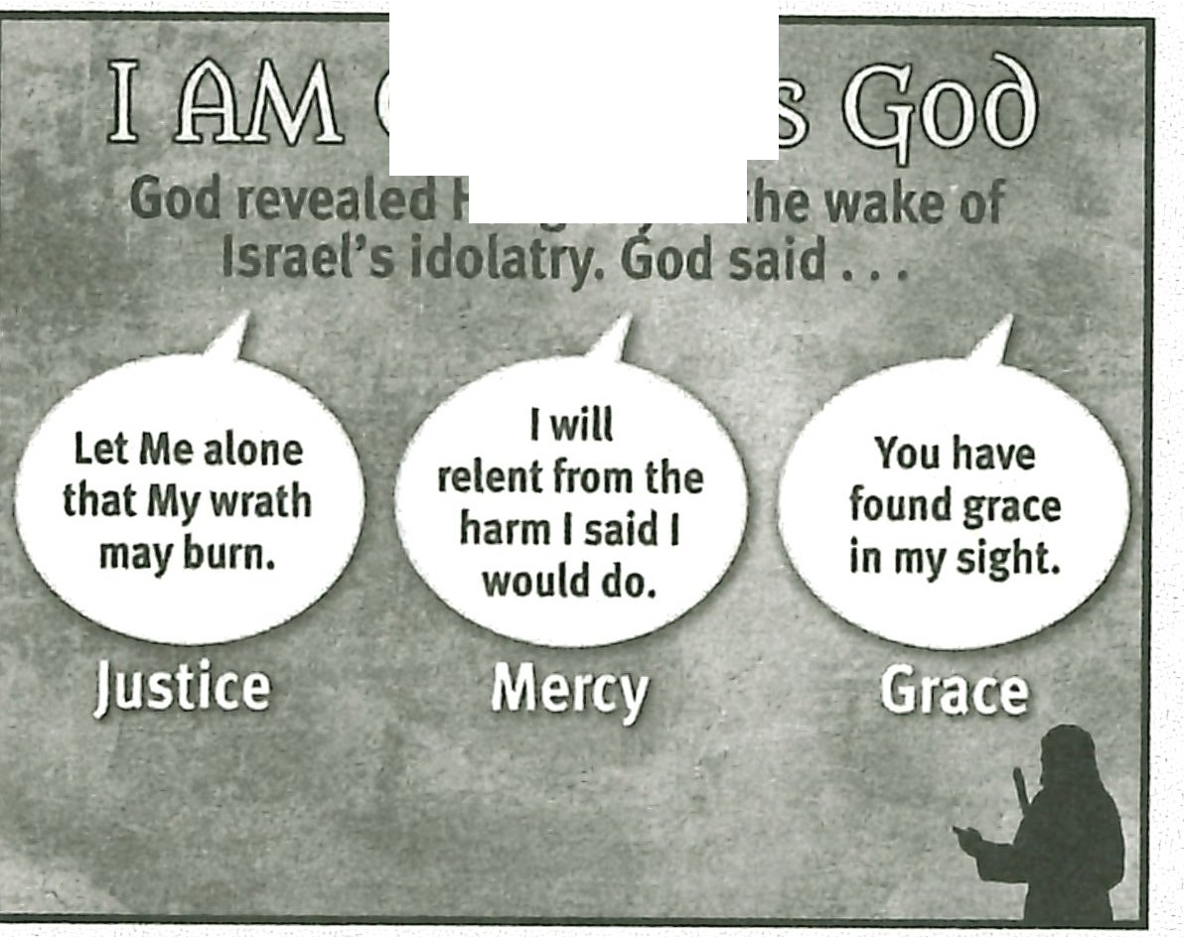RESOURCE: Display resource 11 to review God's communication of His glory.
ij ll@lfll@\Ql.
Hisglorv in

MAKING IT PERSONAL

God's Glory in Salvation
God's justice, mercy, and grace were evident when God sent His Son to die on the cross for our sins. Christ's death satisfied God's justice so He might withhold punishment for our sins by His mercy and provide eternal life by His grace.
ASK: How have you responded to God's glory? (Ql 7)

ASK: How should you respond to God's glory? (Ql 8)

God's Glory in Life
Every day we experience God's glory, especially His grace. God's grace com­ forts us when we have pain, strengthens us for the tasks He calls us to, and pro­ vides the power to overcome sin in our lives.
ASK: How has God's grace been seen in your life recently? (Q19)

ASK: For what pain, task, or sin might you need to ask God to show you His glorious grace? (Q20)

.., \. : ..,,

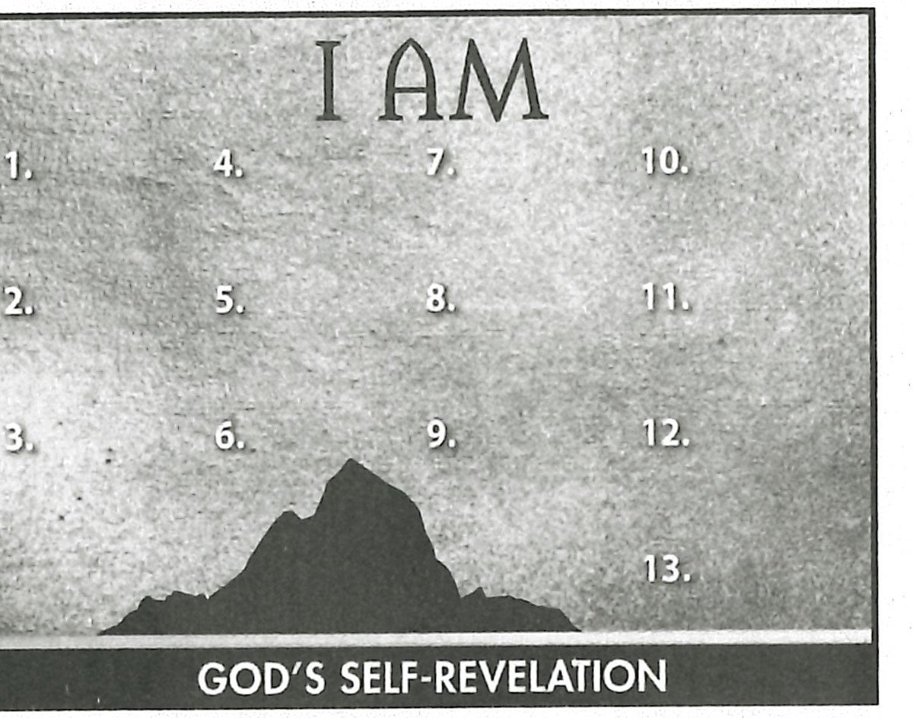
Summary and Memory Verses

RESOURCE: Display resource 1. Add a summary statement about God's introduction of Himself in lesson 8 or use the following: I AM Glorious God.
Encourage learners to memorize Exodus 34:6 and 7a . Give them an opportuni- ty to say the verses in class next week.

