

# Topic

**God's directives**

# Theme

**God is the source of direction on how to live rightly before Him.**

# Desired Learner Response

**The learner will evalu­ ate His motivation for obeying God, seeking to do so out of love and gratitude.**

### Materials

* Resources 1 . 3, 8, and 9
* Play-Doh

**1AM**

**Instructor**

# Scripture Focus

**Exod. 19:1-20:21**

# Summary

This lesson covers the Mosaic Covenant between God and the Children of Israel. It also examines the Ten Commandments. the beginning of Go d's long list of stipulations for enjoying the benefits of the Mosaic Covenant.

### Outline

1. **God's Covenant with Israel (Exod. 19:1- 8)**
   1. God's leadership (19:1- 4)
   2. God's conditions and blessings (19:5, 6)
   3. Israel 's response (19:7, 8)
2. **God's Stipulations for Covenant Blessing (Exod. 19:9-20:17)**
   1. Israel 's preparation (19:10- 15)
   2. God's arrival and warning (19:16- 25; 20:18- 21)

C. Go d's law (20:1-17)

* + 1. Israel 's relationship with God (20:1- 11)
    2. Israel 's relationship with others (20:12- 17)

**Memory Verses** *"Ye have seen what I did unt o the Egyptians, and how I bare you on eagl es' wings, and brought you unto myself Now therefore, if ye will obey my voi ce ind eed,*

*and keep my covenan t, then ye shall be* a *peculiar treasure un to me above* all *people: for* all *the earth is min e" (Exodus 19:4,5).*

**61**

## Simon Says

Play the game *Simon Says* with your learners. You will play the role of Simon. Your learners will obey your simple instructions but only if you say *Simons says* first. Those who obey an instruction not proceeded by *Simon says* are out.

**ASK:** How seriously did you take Simon's instructions?

**ASK:** By comparison, how seriously do you take God's instructions?

If we are honest, we all would admit we often disobey God's as if God were as inconsequential as Simon. This lesson shows that we need to have a respect for God that compels us to obey Him. Our love for God should motivate our obedience too.

## Directions for Inventions

Give each pair of learners a can of Play-Doh to share. Have the learners invent a product and make a model of it out of clay. Have them think of three warnings or instructions that would appear on the product's label. Give the learners five minutes to work. Ask a few to share their creations and share their instructions and warnings.

**ASK:** Why would it be appropriate for you to write the directions and warn­ ings for your product?

**ASK:** What might be some consequences of ignoring the instructions and warnings on your product?

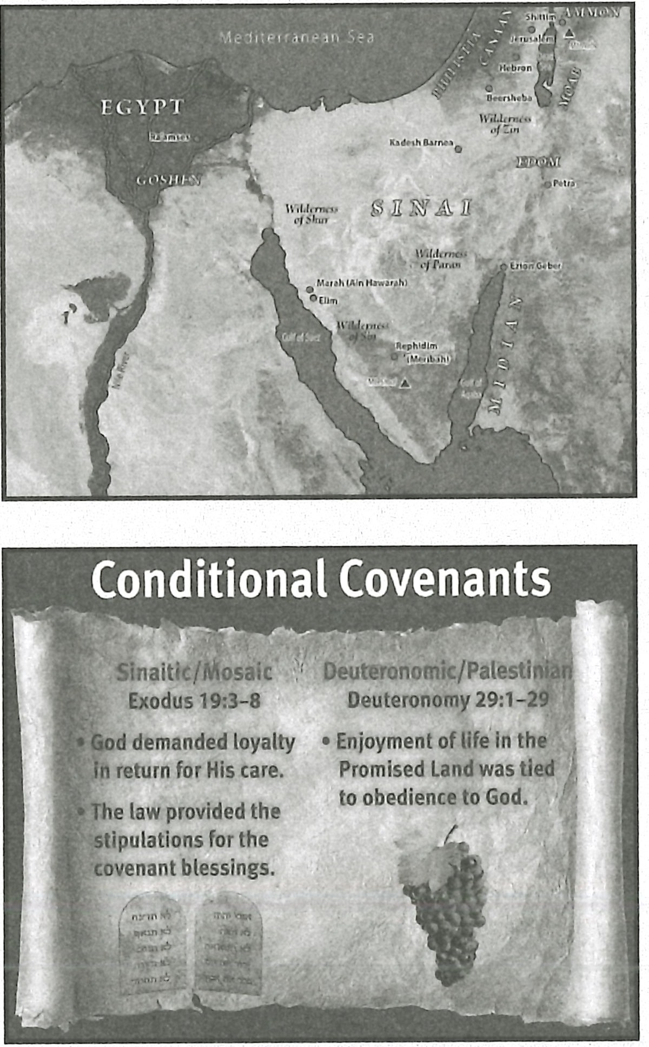God called Israel out of Egypt and made them His own. Shortly thereafter He gave them *instructions for use* and *warnings* so they could live in accordance with His desires. This lesson will examine the Ten Commandments, the most famous section of God's instructions for Israel's life after redemption .

## God's Covenant with Israel (Exod. 19:1-8)

**MAP:** Display resource 3 to show the location of Sinai, the place where God made a covenant with Israel.

Exodus 19:4- 6 is the Sinaitic/Mos aic Covenant between God and Israel. The covenant is conditional and temporal rather than unconditional and permanent like the Noahic (Gen. 9:8- 17) and Abrahamic (12:1-3) Covenants.

**RESOURCE:** Display resource 9 to show the basics of the Sinaitic/Mosaic Covenant.

1. **God's leadership (19:1- 4)**

God gave Moses a message for the *house of Jacob* and the *children of Israel* (19:3). The change in names shows the shift from Israel as a big family to Israel as a nation. Moses delivered God's message to the nation. It began with a summary of God's working with Israel so far. God used the image of a mother eagle encour­ aging her eaglets to get out of the nest and fly. In creation a mother eagle will stir up the nest and force her eaglets to learn to fly by carrying them on her wings. The eagle protects her young from falling until they are able to soar on their own.

In a sense Egypt was the Israelites' *nest .* They faced hardships in Egypt, but

they had their needs for food, water, and shelter met without interruption . They did not worry about feeding their families or having a place to call their own. God took the initiative to lead them out of their nest to force them to fly.

**ASK:** Why else might Israel long for Egypt when they faced tough circum­ stances? (Q3) *Goshen was their homeland. It was where they raised their kids and created memories. It represented all that was familiar to them.*

During their journey to the Promised Land, Israel longed for Egypt when life got hard, resenting God and questioning His motives (16:3). It is not hard to

imagine an eaglet resenting its mother for making it leave familiar surroundings to face something terrifying and completely unfamiliar . But learning to fly is so much better for the eagle than staying in the nest for the rest of its life. In the same way, the Israelites needed to learn to follow God's instructions for life. They needed to mature in their faith and learn to trust the Lord. We don't know how much God's analogy influenced Israel. Being compared to eaglets was not exactly flattering .

Israel should have at least realized that they had a time of learning ahead and that they had yet to learn to *fly.*

1. **God's conditions and blessings {19:5, 6)**

God continued His message to Israel by sharing three benefits the people would realize if they obeyed Him and kept His covenant with them. God said Israel would become *a peculiar treasure , a ldngdom of priests,* and *an holy nation* (19:5, 6).

**READ:** Exodus 19:5. **ASK:** What did Israel know about being treated as a special treasure by other people? Consider what life was like for Israelites in Egypt. (Q4) *Nothing. They had been abused, ridiculed, and even murdered by the Egyptians.*

God chose Israel to be His special *treasure.* That means Israel was valuable to God and that He had a purpose for the nation. But it was not as if God had to settle for Israel, a lowly people the other nations would have considered as a commodity rather than a nation. God could have selected any nation to be His people. After all, as their creator He owns all of them . God chose Israel over even Egypt with all of

its brilliant gold, massive structures, strong army, superior intellect, and incredible wealth. What a privilege and a responsibility for Israel, the newly liberated nation. Israel could also become a *ldngdom of priests.* God intended for every Israelite to show God's truth and blessings to the other nations. Other nations would learn about

God and His blessings through Israel as God's people lived for Him. Serving other gods and worshiping idols, however, would destroy Israel's role as a ldngdom of priests.

Finally, Israel had the opportunity to become a *holy nation.* To be *holy* means to be *set apart .* Israel was to be set apart to the Lord. God gave Israel specific in­ structions on what that set-apart-life would look like. As the people lived set apart to God, they would reflect His holiness.

Romans 6 :15- 23 makes the point that living in sin

is slavery to sin.

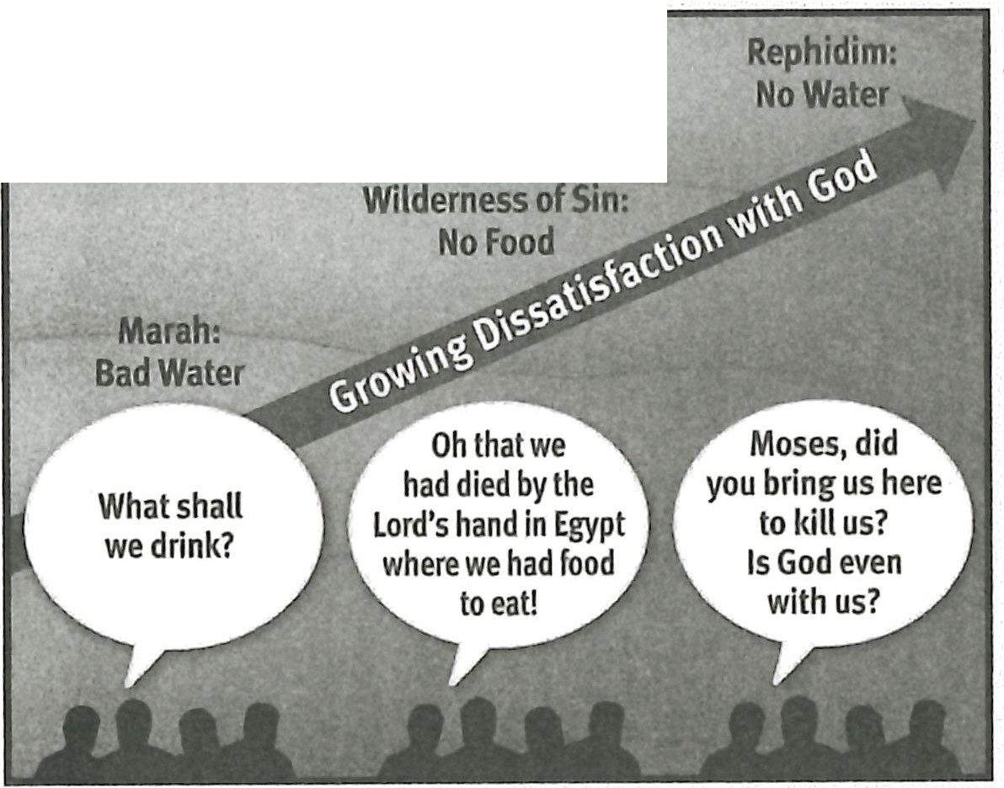

If-@;M lPir@WJI(Q)@;Ir

**READ:** Leviticus 11:44, 45; 20:26. **ASK:** Why did God want Israel to be holy? (QS) *Because He was holy and because He had separated them from other nations to be His.*

Israel was freed from Egypt, but they belonged to God. That meant they weren't free to do whatever they pleased. That actually would not have been free­ dom at all.

**ASK:** Why is being free to do whatever you desire not true freedom? (Q6)

*Living according to one's desires is to be* a *slave to those desires.*

The Israelites didn't free themselves of a master when they left Egypt; they sim­ ply changed masters. God was their new master. What an honor that was for Israel.

1. **Israel's response (19=7, 8)**

Moses called Israel's elders together and shared God's command with them.

Israel as a whole responded to God's words. They said, *All that the LORD hath spoken we will do* (Exod. 19:8). Since God had spoken only in generalities about His commands, Israel didn't see a reason for not agreeing to follow what He said. Little did they know that His law would be specific and life-encompassing. As immature people with a full understanding of neither God's character and ways nor their own limitations and sinfulness, the Israelites thought they could live in obedience to God. Their failures over the few months since leaving Egypt should have been clues to their inability to obey God without hesitation. Most likely their own impressions of what it would mean to obey God clouded their understanding of what obedience to God would actually require.

**RESOURCE:** Display resource 8 to review Israel's growing dissatisfaction with God as they followed His lead to Mount Sinai.

We might say that Israel's willingness to obey was akin to a teenager agreeing to do something for his father before the father actually tells him what he wants him to do. Answering the question *Will you do something for me?* doesn't take a lot of true commitment.

## God's Stipulations for Covenant Blessing (Exod. 19:9-20:17)

After hearing Moses' report about the people's response, God told Moses He was coming to him in a thick cloud and speaking so the people would be able to hear Him. The primary reason for this setup was to cause the people to believe Moses' words (19:9). It would be clear that the law was from God's mouth rather than Moses' mouth.

* + - * 1. **Israel's preparation (19:10-15)**

God instructed Moses in how the people were supposed to prepare for God's arrival on Mount Sinai. Moses was to consecrate the people and then have them wash their clothes (19:10). Washing their clothes pictured the cleansing that need­ ed to happen *inside* the Israelites. The removal of dirt would be respectful of God's holiness and illustrate their need to be clean, or holy, at the heart level when God arrived on the third day (19:11).

Moses was to set up a barrier around the base of the mountain to keep the people from even touching the mountain. Those who touched the mountain were to be put to death . God prescribed stones and arrows as the means of execution so the executioners would not have to touch the defiled violators' bodies. The long trumpet sound was the signal for the people to come near the mountain and for Moses to ascend it (19:12, 13).

Moses returned to the people and communicated all God's instructions, add­ ing that husbands were not to go near their wives for the three days prior to God's arrival (19:14, 15). The mandatory abstinence was a matter of further consecration. It is not an indication that the physical relationship between a husband and his wife was somehow sinful.

* + - * 1. **God's arrival and warning (19:16-25; 20:18-21)**

God arrived in a dramatic way, with thundering and lightning, a thick cloud, and a very loud trumpet. The people trembled (19:16, 17) and moved away from the mountain . They asked Moses to speak with them instead of God, fearing they would die if God spoke to them (20:18, 19). Moses, trembling himself at the coming of the Lord on the mountain (cf. Heb. 12:21), told the people not to fear death. God had come to test them and to teach them to respect Him (Exod. 20:20, 21).

Moses obediently ascended the mountain at God's request. Once Moses was there, God told him to return to the people and warn them once again about not breaking through the barrier to touch the mountain. Surprisingly, Moses ques­ tioned the necessity of warning the people once again. God insisted, so Moses went and did as He had said (19:21- 25).

**ASK:** Why would God insist on Moses returning to warn the people a sec­ ond time? (Q7) *Because they needed to understand the seriousness of the barrier between God and them.*

God specifically told Moses to warn the *priests* not to break through the

barrier. He was probably referring to the firstborn from each family who had been dedicated to God (13:2). The Aaronic priesthood had not been set up yet.

The three days of preparation, the washing of their clothes, the barrier on the mountain, the warnings, and the majestic arrival of the Lord on the mountain must have impressed on the Israelites that they were not like God. He was holy, and they were sinful.

**C. God's law (20:1-17)**

God gave the beginning of His law to Moses. The distance between Mount Si­ nai and the Children of Israel apparently kept the Israelites from hearing God give

the law to Moses well enough to understand it. But Israel knew it was from God. Moses later declared it to them (cf. Deut. 5:4, 5). The fact that *God* gave the instruc­ tions on how to live properly before Him is important. Israel would often rebel against God as their instructor. They either relied on their own decisions or they turned to false gods for instructions. The next lesson covers an example of Israel's egregious rebellion against God's instructions.

God's laws provided the primary stipulations for the Mosaic Covenant. As mentioned, the Mosaic Covenant was conditional and temporal. If Israel wanted God's blessings, then Israel was required to keep the laws. The Ten Command­ ments (cf. 5:7- 21), written on the two tables of stone by God Himself (Exod. 24:12; 31:18; 34:28), provided the heart of these covenantal requirements. The rest of the law (Exo d. 20 - 40; Lev. 1- 27; Num. 1:1- 10:10) provided additional requirements, all springing from the core Ten Commandments. The laws, then, are not require­ ments for us as New Testament believers because we are not partners in the Mosa­ ic Covenant. Besides, the old Mosaic Covenant is no longer operative (Heb. 8:6- 13).

It should also be noted that keeping the Ten Commandments or any of the

other parts of the law had nothing to do with salvation for the Israelites. Salvation has always been through faith, as it was with Abraham, who lived before the law of Moses (cf. Gen. 15:1- 6).

The Ten Commandments breaks into two sections. The first four commands have to do with Israel's relationship with God. The last six commands have to do with Israel's relationship with others.

**Israel's relationship with God (20:1-11)**

The first command begins with a reminder that God brought Israel out of Egypt, the *house of bondage* (20:2). This act of redemption was the basis for God's covenant with Israel. Obedience to the law was to be a response to God's redemp­ tion. So it makes sense that the Ten Commandments begin with God and how Israel was to live in relationship to H m. Israel was foremost not to have any other gods before God. This doesn't mean they could have other gods as long as He was their primary God. The command is exclusive. God was to be the one and only God they worshiped.

The second command prohibited the making of idols and bowing to them. God said He is a jealous God and would not tolerate any idol worship.

**READ:** Exodus 20:4-6. **ASK:** What was the connection between God's jealou­ **sy and His love for His people? (Q8)** *He was jealous because He loved them and wanted the best for them.*

Idol worship brought consequences on God's people. Those consequences could be felt for several generations. God wanted to bless His people instead of seeing them experience the consequences of idolatry.

The third command forbade taking the name of the Lord God in vain (20:7). God's name stood for His reputation . Israel was not to use God's name dishonest­ ly, such as in conjunction with a promise a person didn't intend to keep (cf. Lev. 19:12). Taking God's name in vain would also include using it for selfish reasons or personal gain. Connecting God's name with any evil purpose is obviously forbid­ den by this command too.

The fourth command was to remember the Sabbath day *to keep it holy* (Exod. 20:8). The Israelites kept the Sabbath *holy* by approaching the day differently than the rest of the week, treating it as a day to the Lord. No one, including servants and animals, was to work on the Sabbath (20:9, 10).

The pattern for Israel's week is based on God's six days of creative work and His one day of rest (20:11). So observing the Sabbath was a weekly reminder of God's work in creation. The Sabbath was also connected to the Exodus and served as a reminder of God's deliverance of Israel (Deut. 5:15).

**ASK:** Why would it be important for Israel to remember God's creation week? (Q9) *God's creation work sets Him apart from all other gods. It established His superiority and the need for Israel to serve Him alone.*

The work restriction did not mean Israel was supposed to be lazy and inactive on the Sabbath. They were to dedicate the day to spiritual service and observance . The Sabbath, then, was not a *me day* but a *God day.* This command was serious enough that the penalty for Sabbath violation was death (Exod. 31:15).

Remembering God's work of creation and His redemptive work on our behalf is important, but the official observance of the Sabbath passed away with the law of Moses. And the New Testament does not include a command to keep the Sab­ bath. Most believers today designate Sunday, in connection with Christ's resurrec­ tion, as a time for coming together to worship the Lord as a church, but the rules that governed the Sabbath don't apply to today's Sunday worship.

**ASK:** What three words would you use to summarize Israel's relationship with God based on the first four commands? (Q1O) *Perhaps* exclusive, serious, *and* ded icated.

**ASK:** What did God reveal about Himself through the first four commands? (Q11) *That He is the only true God; that He is* a *jealous God Who deserves complete devotion for His works of creation and redemption.*

**Israel's relationship with others (20:12-17)**

The rest of the commands regulated relationships among the Israelites. The fifth command is the only positively stated command of the remaining six. It is also the only one in the second set that is accompanied by a promise.

**READ:** Exodus 20:12. **ASK:** Why would honoring their parents lead to a long sojourn in the Promised Land? (Q12) *How children treated their parents would reflect how they treated God, the other authority in their lives. Honoring God would lead to His blessings and continuation in the Promised Land.*

The sixth command prohibited murder. This command was not a restriction on killing in general. The Israelites had already fought and defeated the Amale­ kites under God's direction (17:13), killing them with the sword. Self-defense and capital punishment are also not included in this command. The restriction was on taking someone's life unjustly. All human life is valuable, because every person is made in God's image (Gen. 9:6).

The seventh command told the Israelites not to commit adultery (Exod. 20:14).

God took a high view of the marriage relationship and the home in general by naming adultery as a capital crime (Lev. 20:10).

**ASK:** Why would strong marriages have been important for Israel's future? **(Ql 3)** *Strong marriages would have made the nation stronger as children learned loyalty and love from their pare nts. Those traits would carry over to their own rela­ tionships with God.*

A husband and wife made their marriage commitment before God. So commit­ ting adultery against one's spouse was also breaking one's commitment to God.

The eighth command prohibited stealing (Exod. 20:15).When an Israelite stole something, he was communicating to God either that he was not satisfied with what God had given him or that he didn't think he could find complete satisfaction in his relationship with God. Either way, stealing was highly offensive to God. Fur­ thermore, God had given each Israelite all he had. To steal was to take what God had personally given to someone else.

Telling a lie against a neighbor was prohibited in the ninth command (20:16). God actually required witnesses in a murder trial to also be the executioners (Deut. 17:6- 13),making it far less likely that a witness would lie against the defendant.

The final directive was a command against coveting (Exod. 20:17). An Israelite was not to covet his neighbor's house, wife, servants, animals, or anything else that belonged to his neighbor. Like stealing, coveting is an expression of dissatisfaction with how God has blessed people . The covetous person believes he could distribute blessings better than God. Contentment is the opposite of covetousness.

**ASK:** What three words would you use to summarize Israel's relationship with one another based on the final six commands? (Ql 4) *Perhaps respectful, loving, and honest.*

**ASK:** What did God reveal about Himself through the final six commands?

(Ql 5) *That He is loving, true, and sovereign .*

## Everyone Is Guilty

The Ten Commandments bring guilt. Jesus made this even clearer when He pointed out that the person who hates someone is guilty of murder and the man with lustful thoughts is guilty of adultery (Matt. 5:21, 22, 27, 28). While the Ten Commandments show a person that he is sinful, they are powerless to solve the sin problem . But praise God for salvation from our sins! Through Christ our guilt is all gone. We stand righteous before the Lord.

Encourage learners to share a short testimony of their salvation from sin. Have other learners praise God for salvation.

## Motivated by Gratefulness and Love

The Ten Commandments are not for believers today. They were specifically for Israel as stipulations for the Mosaic Covenant. Nine of the commandments are repeated in some form in the New Testament, but not as stipulations for receiving God's blessings. The church obeys God's commands in the New Testament out

of love and gratitude for God. This is called grace living. God has been faithful to provide for us in the New Testament all the directives we need for living pleasing to Him . He has been faithful to lead us in the way we should go and to provide the grace we need to grow along the way (2 Peter 1:2- 4) .

**ASK:** Why do you obey God? (Q16)

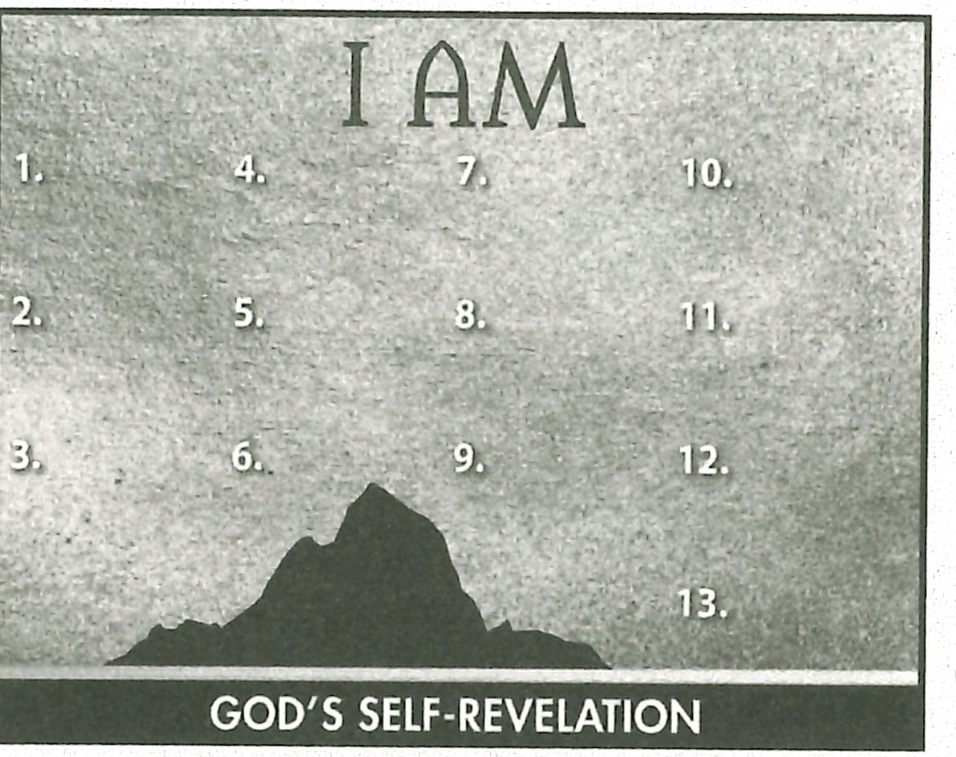**ASK:** How might obeying God out of love and gratitude for Him change your perspective on your relationship with God? (Q17)

## Summary and Memory Verses

**RESOURCE:** Display resource 1. Add a summary statement about God's introduction of Himself in lesson 7 or use the following: I AM Instructor.

Encourage learners to memorize Exodus 19:4 and 5. Give them an opportunity to say the verses in class next week.



# Topic

**God's glory**

# Theme

**God is glorious in His justice, mercy, and grace in His dealings with humanity.**

# Desired Learner Response

**The learner will consider how God's grace might be applied to his life.**

### Materials

* Resources 1 , 10, and 11
* Handout 2 from resource CD

## 70

**1AM**

**Glorious God**

# Scripture Focus

**Exod. 24:1-34:28**

# Summary

This lesson covers Israel 's ratification and subsequent rejection of the cove­ nant. God responded to Israel 's breaking of His covenant with justice, mercy, and grace. All three of these attributes are part of His glorious name. God reve aled His glory to Moses. Moses responded by worshiping Him.

**Outline**

1. **Ratification of the Covenant (Exod. 24)**
   1. God's covenant (24:1- 8)
   2. God's glorious presence (24:9- 18)
   3. Go d's dwelling place (25-31)
2. **Rejection of the Covenant (Exod. 32:1-33:17)**
   1. Israel 's idolatrous sin (32:1- 6)
   2. Moses' appeal to God's mercy (32:7-14)
   3. Moses' execution of God's justice (32:15- 29)
   4. Moses' second appeal to God's mercy (32:30- 32)
   5. God's execution of His justice (32:33- 33:6)
   6. Moses' appeal to God's grace (33:7- 17)

**Ill. Revelation of the Covenant Keeper (Exod. 33:18-34:28)**

1. God's revelation of His glory (33:18- 34 :9)
2. God's demonstration of His glory (34:10- 28)

**Memory Verse** *"And the LORD passed by before him, and proclaimed , The LORD, The LORD God, merciful and graciou s, longsu ffering , and abundant in goodness and truth, keeping mercy for thousands ,forgiving iniquity and transgression and sin, and that will by no means clear the guilty" (Exodus 34:6,70) .*