

**Topic**

**God's provision**

**Theme**

**God wants us to humble ourselves before Him and trust Him to provide for our needs in His time.**

**Desired Learner Response**

**The learner will trust God for grace and guid­ ance in times of need.**

**Materials**

* Resources 1, 3, and 8

**52**

**1AM**

Provider

**Scripture Focus**

**Exod. 15:22- 17:16**

**Summary**

This lesson covers God's supply for Israel's needs as they began their journey as a freed nation. But the lesson is more importantly about the Israelites ' hearts. God used the basic need for water and food at Marah, Meribah, and Rephidim to reveal the sinfulness of their hearts.

**Outline**

1. **Test at Marah (Exod. 15:22- 27)**
   1. Israel complained (15:22-24)
   2. God provided a solution (15:25a)
   3. God gave an ordinance (15:25b-27)
      1. Immediate significance
      2. Future significance
2. **Test in the De sert of Sin (Exod. 16)**
   1. Israel complained (16:1-3)
   2. God provided a solution (16:4-15)
   3. God gave limitations (16:16- 30)
      1. Israel disobeyed the regulation concerning leftovers (16:16-21)
      2. Israel disobeyed the regulation concerning the Sabbath (16:22- 30)
   4. God provided a witness (16:31- 36)

**Ill. Test at Reph idim (Exod. 17:1- 7)**

1. Israel complained (17:1- 4)
2. God provided a solution (17:5-7)

**Memory Verse**

*"Do all things without murmurings and disputings: That ye may be blameless and harmles s, the sons of God, without rebuke,*

*in the midst of a crooked and perverse na tion , among whom ye shine as lights in the world" (Philippians 2:14, 15).*



# GETTING STARTED

If I **Were in Charge**

**ASK:** If you were in charge of all the circumstances surrounding your life, what circumstances from this past week would you have changed? (Ql)

**ASK:** What might be some indicators that we wish we were in charge of the circumstances of our lives? (Q2) *We complain, get angry, become depressed, or procrastinate.*

The Israelites expected God to make their lives comfortable after they left Egypt and crossed the Red Sea. Instead, God repeatedly led them to places where they suffered need. Their responses exposed their power struggle against God.

This lesson will help us see our need to humble ourselves before God and to trust Him to provide for our needs in His time.

## Inflection Communication

Have learners ask the following question using different inflections to com­ municate different attitudes: Where's dinner? Suggest they say it with a tone of expectation and then with a tone of complaint.

**ASK:** What does the expectant tone communicate? *Gratitude and encouragement.*

**ASK:** What does the complaining inflection communicate? *Disappointment and criticism.*

Israel had great expectations of God when they began journeying through the wilderness. They demanded He lead them according to those expectations. And their tone reflected that demanding attitude. This lesson will help us see our need to humble ourselves before God.

# SEARCHING THE SCRIPTURES

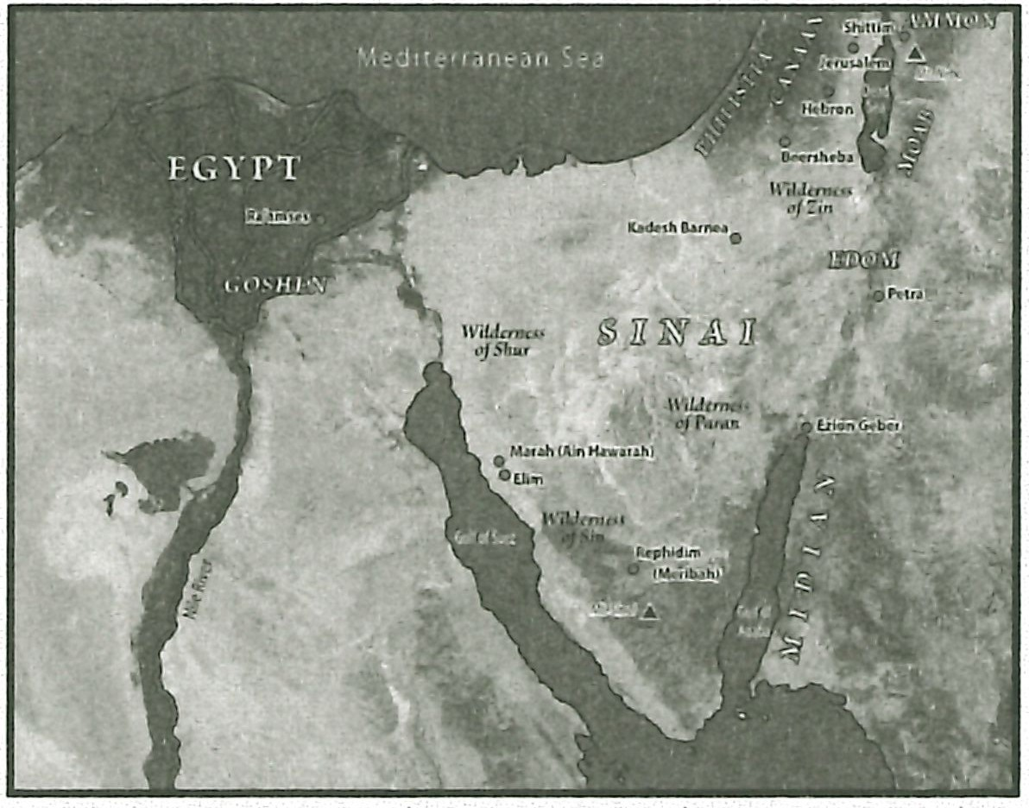Perhaps the Israelites thought life would never be hard again after God freed them from Egypt. They praised God for how He gloriously delivered them from Pharaoh's army. But their praise and adoration to God were not an indication that Israel was fully devoted to following Him. God had some tests for Israel that would reveal the true nature of their hearts.

1. **Test at Marah (Exod. 15:22-27)**

**MAP:** Display resource 3 to show the places Israel stopped as they journeyed into the wilderness.

* 1. **Israel complained (15:22-24)**

Moses led Israel into the wilderness of Shur, heading south along the Gulf

of Suez for three days. They didn't find any drinking water along the way (15:22). Eventually they came to Marah, probably modem-day Ain Hawarah, where they found undrinkable, bitter water (15:23). The water at Ain Hawarah today is indeed salty and bitter.

Going without water for three days, finding water, and then discovering that the water is undrinkable is hard to handle both physically and emotionally. The Is­ raelites asked Moses, *What shall we drink?* That is a legitimate question. But Israel murmured as they asked the question.

**READ:** Exodus 15:24. **ASK:** Why is whining a sin? (Q3) *Complaining is the same as telling God He is not doing His job right . The complainer thinks he could handle the situation better than God did.*

The Israelites' complaint is understandable from a human perspective, but from God's perspective there is no such thing as an understandable, excusable sin.

**ASK:** Why do hardships often cause people to complain against God? (Q4) *People think the hardships signify that God does not care about them or that He has something against them. They consider the hardships as God personal attacks on them.*

When God brought the Israelites out of Egypt, His goal wasn't to make their lives as comfortable as possible. Instead He wanted them to have a heart for Him. So He led them to places of need on purpose. The needs exposed the true nature of their hearts.

**READ:** Deuteronomy 8:2, 3. **ASK:** What did God want the Israelites to learn **from experiencing needs? (QS)** *That they needed to humble themselves before Him and to trust His guidance, believing He would provide for their needs in His tim e.*

God brought the Israelites to points of helplessness to help them understand that He was directing their steps with purpose.

It is ironic that Israel worried about having no drinking water just days after God had used millions of gallons of water to utterly destroy Egypt's army. God had demonstrated His absolute power over nature; they had even sung about it. In ad­ dition, they had witnessed God tum the Nile River into blood. If God displayed the power to do such grand miracles in nature, then He could certainly change bitter water into drinking water.

* 1. **God provided a solution (t5:25a)**

Moses heard the people's murmuring and turned to God for help. God showed Moses a tree and told him to throw it into the well to make the water palatable (15:25a). Some like to speculate about what kind of tree God selected and whether it had some qualities that would naturally make the water pleasant. But the tree was really just a prop, not unlike Moses' sta ff. It represented God's presence and power before the people.

Notice that God was patient with Israel. He didn't jump on them for their lack of faith. He didn't go into a tirade about how much He had done for them to get them to Marah. He was very gracious to them instead. He provided for their needs despite their murmuring.

* 1. **God gave an ordinance (15:25b-27)**

## Immediate significance

After graciously providing water for His people, God made a *statute and an ordinance* for Israel (15:25b, 26). The statute and ordinance would *test* the Israelites and reveal their hearts as they journeyed through the wilde rness.

**READ:** Exodus 15:25b, 26. **ASK:** What would Israel need to believe about God in order to obey His voice? (Q6) *That He is the one true God Who stays true to His word*

**ASK:** What reasons did Israel have for believing that God was the one true God Who stays true to His word? (Q7) *They were carrying Joseph's bones with them as* a *testimony of God's remembrance of them. They had seen God miraculous­ ly deliver them, doing exactly what He had said He would do each time.*

God's ordinance was a conditional promise to Israel. If they were diligent to heed God's voice, obey His commandments, and keep all His statutes, then God would not put on them any of the *diseases* that He had put on the Egyptians. The mention of *diseases* is not a general reference to illnesses of any kind. God did not promise Israel perfect health if they obeyed Him. The word *diseases* probably in­ cluded the plagues God had brought on the Egyptians, especially the boils, as well as any other disease God intentionally used to chasten His people (Deut. 28:27 - 29, 60, 61). The conditional promise is that God would refrain from sending devastat­

ing, widespread diseases on Israel if they observed His commands. They would still get sick, but those illnesses would not be part of God's chastening.

**READ:** Deuteronomy 28:58-61. **ASK:** What would be some indicators that God was chastening His people with diseases? *(QB) The diseases would be widespread, long-lasting, and devastating.*

God then identified Himself as the *LORD that healeth thee* (Exod. 15:26) in the sense that if Israel responded to His chastening, He would remove the diseases He had brought on them as a result of their disobedience.

## Future significance

God brought the plagues on Egypt so Pharaoh would let God's people go. But He also brought the plagues to address Egypt's refusal to acknowledge that all their blessings had come from Him rather than from their false gods. God clearly said that He wanted Egypt to know Him as Yahweh (cf. 7:5, 17; 8:22). Consequently all of the plagues directly affected either Egypt's abundance or its well-being. And all of them challenged Egypt's gods. Yet most of the Egyptians, including Pharaoh, defied God during the course of the plagues. They refused to recognize Yahweh

as the One Who had blessed their land so richly. Israel then witnessed the subse­ quent devastation God brought on Egypt.

God wanted Israel to rely on Him for their needs. Having them witness the plagues and travel through the wilderness would show them that He was reliable and trustworthy. Once they settled in the Promised Land, they would have an abundance of food and water. They would become like the Egyptians with good

Remember that the seven-year famine at the time of Joseph enriched

Egypt and gave the nation a prominent standing in the world that propelled it forward as a world leader for years to come (Gen.

47:13- 20).

cropland and many natural resources. Their temptation in the Promised Land would not be to complain about a lack of food or water; their temptation would be to serve and credit other gods for all the abundance *God* had provided for them.

God warned Israel not to let that happen (Duet. 4:15- 24; 12:29- 32).

The *queen of heaven* is probably a reference to the goddess Ash toreth. She was the goddess of fertility. Artemis , men- tioned in the New Testa­ ment as Diana, is a Greek goddess associated with Ashtoreth (Acts 19:21- 41).

**READ:** Deuteronomy 28:45-47. **ASK:** What did God expect from Israel once they were in the Promised Land? (09) *He expected them to obey His commands and to serve Him with joy and gladness for the abundance of everything He had given to them.*

God went on to warn Israel about failing to obey and serve Him (Duet. 28: 49- 57). If they did, another nation would invade them, eat their crops, and consume their abundance. Israel would be left without any food at all. In fact, they would become so desperate while under siege that they would eat their own children . Once in captivity they would be hungry, thirsty, and lacking their basic needs (28:48). Is­ rael didn't heed these warning once they were in the Promised Land. Both Israel and Judah were eventually taken into captivity by Assyria and Babylon respectively.

Even after Babylon took Judah captive, the Jews left in the land as a remnant did not trust God. Some of them wanted to flee to Egypt for safety. They feared Babylon would return to take them captive too. The prophet Jeremiah warned them that they would suffer famine and pestilence if they fled to Egypt (Jer. 42:18- 22). The remnant rebelled against God despite the warning and claimed they would be safe if they burned incense to the *queen of heaven,* a false goddess of fertility (44:15- 17).They even credited the *queen of heaven* with providing for their needs while they were

in Judah (44 :17). And they wrongly blamed their service to God for the Babylonian captivity (44:18). So God sent Babylon to overrun Egypt and bring all the calamities on the Jewish remnant that Jeremiah had prophesied would come on them (44:30).

Whether Israel worshiped God in the Promised Land would partly depend on whether they humbled themselves to trust God to provide for their needs. So it makes sense that God began Israel's journey through the wilderness at Marah where He exposed their lack of trust in Him and their thirst for control over th eir own lives. He wanted them to turn to Him and worship Him as their provider of needs even in the midst of their needs. They wanted a god whom they could con­

trol and to whom they could dictate. They wanted to serve a god who would never lead them to a place of need.

**READ:** Exodus 15:27. **ASK:** How would you expect Israel to respond to God for leading them to Elim, a place with plenty of drinking water? (Ql 0) *They shoul d have been overjoyed and thankful to God for His provision in the wilde rness.*

There is no record of Israel saying thanks to God for the provision of water at Elim (15:27). That would have been the right response. If they had rejoiced in the Lord, no doubt Moses would have included that in his record, especially sand­ wiched between such glaring examples of a lack of trust in God.

**ASK:** What is true of the hearts of those who fail to thank God for providing for their needs? (Ql 1) *Perhaps they feel entitled to have their needs met or they expect God to always act in their best interest.*

## Test in the Desert of Sin (Exod. 16)

After God's provision of water at Marah and Elim, we might expect the Israel­ ites to respond to God with trust the next time they had a need.

* 1. **Israel complained (16:1-3)**

God tested Israel again in the Wilderness of Sin between Elim and Mount Si­ nai. The entire congregation complained to Moses and Aaron, saying it would have been better if the Lord had killed them in Egypt, where at least they had meat and bread to eat (16:1-3). How silly to prefer a full belly over life! But that is a testimony to how much Israel wanted to control God and have Him bend to their dictates.

Israel obviously had selective memory. They remembered only that they had had full bellies in Egypt. They forgot that they were worked to the point of ex­ haustion. They forgot about the unrealistic demands the Egyptians put on them. Or how the Egyptians killed their firstborn boys. They forgot they were slaves!

And even more unbelievably, they were ungrateful for all the miracles God had wrought to free them from slavery. Had Israel's heart changed? No.

* 1. **God provided a solution (16:4-15)**

God patiently provided for the Israelites again. He rained down bread, called manna, for them to gather in the morning. In the evening He brought quail for them to catch and eat.

Moses and Aaron were careful to point out to the Israelites that their com­ plaints were against God (16:7, 8). They were right in doing so. The Israelites should have recognized just how offensive their complaining was to God.

Through this provision of food God expected His people to know that He is the *LORD your God* (16:12). As such, He should have been responded to with humility and worship (cf. Deut. 8:2, 3). Instead they maintained their desire for God to serve them according to their wishes.

* 1. **God gave limitations (16:16-30)**

Along with the provision of food, God gave specific regulations to test the Isra­ elites to see if they would obey Him.

## Israel disobeyed the regulation concerning leftovers (16:16- 21)

The first regulation was simple: God forbade Israel from leaving any leftover manna in their tents overnight. If they did, the manna would stink and be filled with worms. Acting like toddlers who disobey despite clear instructions, some of the Isra­ elites kept leftovers overnight. They awoke to the rank smell of rotting manna.

**READ:** Exodus 16:19-21. **ASK:** Why would God want the Israelites to throw out their leftovers every evening? What lesson was He trying to teach them? (Ql 2) *That He would provide for their daily bread and that they were to live accord­ ing to His commands.*

This blatant disobedience showed that Israel was in a power struggle with God for control of their circumstances. They wanted God to bend to their desires. So they tested Him by collecting more manna than He had commanded them to collect.

## Israel disobeyed the regulation concerning the Sabbath (16:22-30)

God's second regulation seemed to violate His first one. On the sixth day of the week the Israelites were to gather twice as much manna so they would have something to eat on the Sabbath (16:22-26). Not surprisingly some of the Israelites went hungry when they got up on the Sabbath to gather manna and found none (16:27). Again, they wanted God to serve them and conform to their desires. In do­ ing so they didn't realize that by disobeying the second time they were essentially doing the opposite of what they had done the first time, a true testimony to their power-hungry hearts.

The Lord asked Moses how long the people would refuse to keep His com­ mandments and laws, clearly indicating their problem was a heart problem. The people rebelled against God by *purposefully* disobeying His regulations. Lack of communication was not the problem; hunger and thirst for power was.

## God provided a witness (16:31-36)

The provision of manna was a watershed moment for Israel and their rela tion­ ship with God. It proved that God would care for their daily needs. God instructed Moses to gather some of the manna and keep it as a testimony of His faithfulness to Israel in the wilde rness. Future generations would observe the manna and know that God is the provider of needs.

## Test at Rephidim (Exod.17:1-7)

By now we might expect Israel to be ready to humbly submit to God. After all, they are getting bread and meat every day. God tested them one more time to see what their hearts might reveal.

## Israel complained (17:1-4)

The Israelites set out from the Wilderness of Sin and came to Rephidim where they found no water to drink. This was different from the first test where there was at least water present, albeit undrinkable.

**READ:** Exodus **17:1-4.ASK:** What evidence is there that the Israelites actually trusted God less at Rephidim? (Q13) *They made demands of Moses and then threatened to stone him to death.*

The people's complaints at Rephidim provided the third witness about the condition of their hearts. There was no doubt that they were proud and de­ manding rather than humble and grateful. They still were in a power struggle against God. They wanted Him to conform to their desires and to follow their timi ng.

## God provided a solution (17:5-7)

Once again, God provided water for the Israelites. Moses took the rod he used to tum the Nile into blood and struck a rock. God caused water to flow from the rock so Israel could quench their thirst (17:5-7).

The last statement of verse 7 is very telling: *they tempted the LORD, saying, Is the LORD among us, or not?* (17:7). By this question about God's presence, the Isra­ elites again revealed that they expected God to serve them according to their ex­ pectations of Him. Since they kept facing needs, they wondered if God was actual­

ly with them. Their needs made them question God's presence. They expected God to provide for their needs instantly and according to their liking. They would have learned this expectation from watching the Egyptians interact with their gods. The Egyptians conducted themselves in such a way as to try to control and coerce their gods in order to have comfortable, easy lives. But God cannot be controlled and coerced. The three tests in the wilderness revealed Israel's lack of humility before Him. They fought God for control and for the right to determine how life would go down for them in the wilderness.

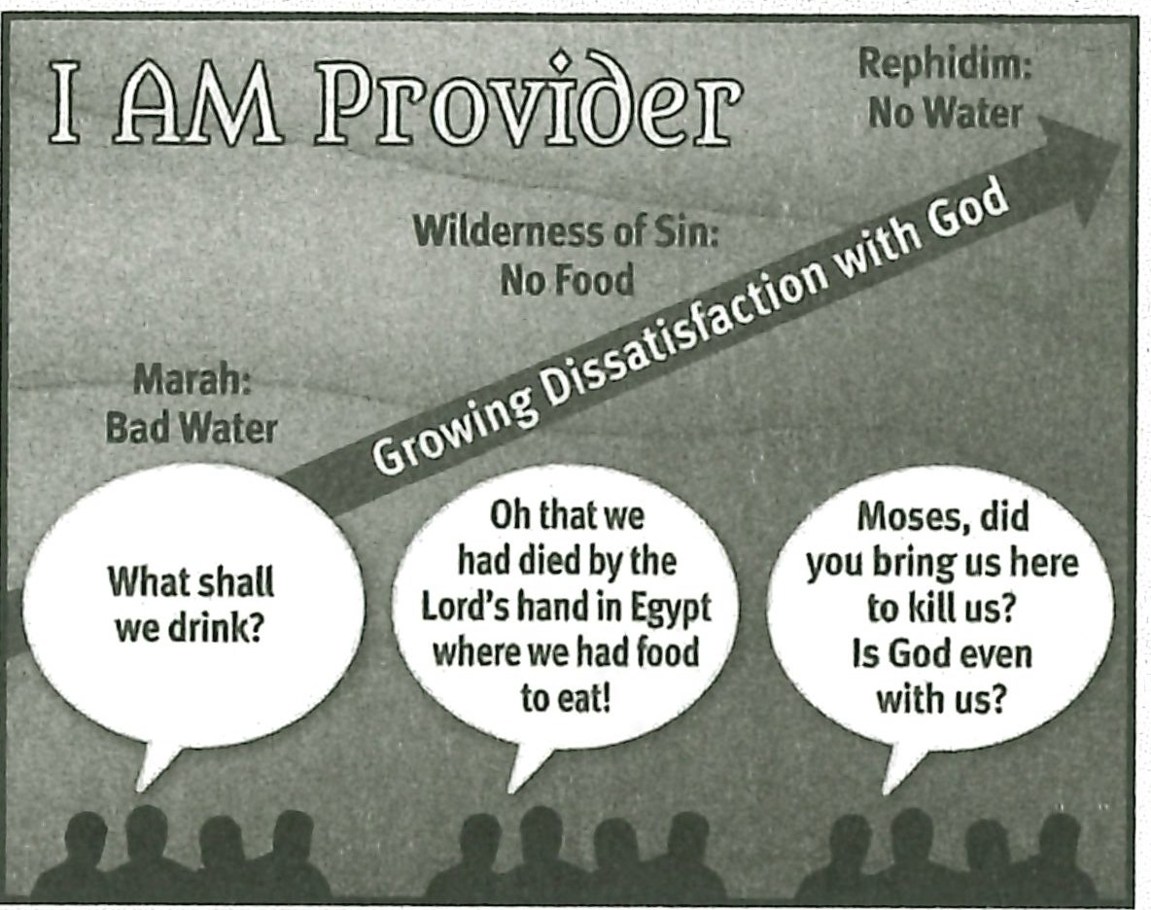**RESOURCE:** Display resource 8 to review Israel's growing dissatisfaction with God.

**ASK: Based on Israel's short track record in the wilderness, would you say they deserved to be delivered from Egypt? Explain. (Q14)**

**ASK: Why would God deliver such a rebellious, hard-hearted, doubtful, demanding, power-hungry people from slavery? (Ql 5)** *Because He is faithful to His promises; because He loved humanity and would one day provide for their salvation through* a *descendant of Israel.*

God established that Israel was rebellious and power hungry. His next stop in leading His people would be Mount Sinai, the place where He would continue to reveal Himself to His people by illustrating His holiness and by giving them a law to obey.

# MAKING IT PERSONAL

**Why Complain?**

If we were able to run our own little worlds, we would make sure we never felt a need or went without. With that expectation as part of our thinking, we are tempted to conclude that there is something wrong with God when we do have a

need. Why doesn't He give us a job right now? Why didn't He keep me from getting sick? Why did He stand by while I got in a car accident? Asking such questions in a spirit of complaining is sinful. The complaint reveals a lack of trust in God as well as a lack of humble submission to Him.

**ASK:** What circumstances in your life do you find yourself complaining about? (Ql 6)

**ASK:** What is the root cause of your complaints? What does your complaint reveal about your relationship with God? (Ql 7)

## Our Greatest Need

Our greatest need is never the emptiness of our wallets or our stomachs; it is always what is lacking in our hearts. Our needs present us with opportunities to humble ourselves before God and to declare our trust in Him. Instead of focusing on what we would do to change our circumstances if we were in control of our lives, we should be trusting in God's grace to sustain us and in His wisdom to guide us. God may not choose to take away our physical or financial needs, but He will help us respond to them with humility and trust in Him.

**ASK:** Ask God to help you trust Him in the midst of your needs. (Q18)

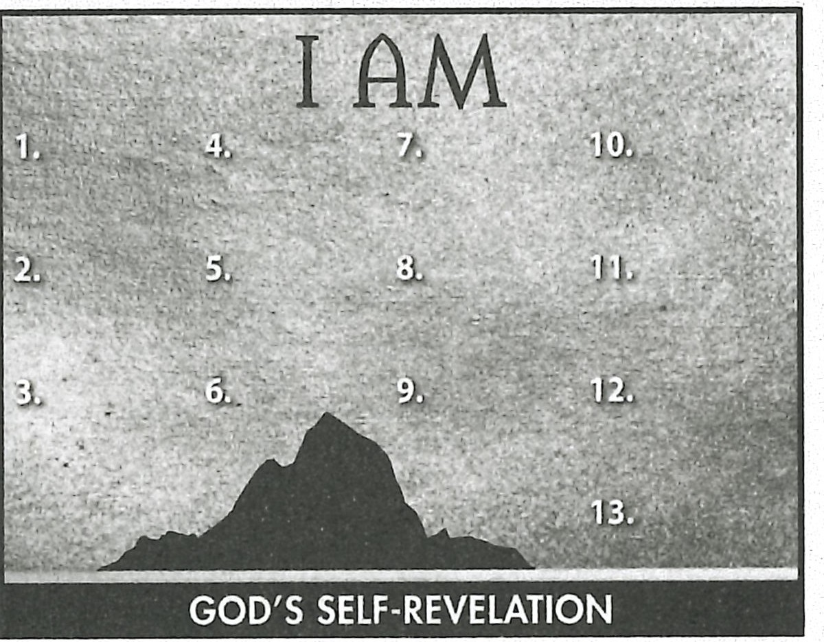**ASK:** Praise God for His sustaining grace and guidance in the midst of your needs. (Q19)

## Summary and Memory Verses

**RESOURCE:** Display resource 1. Add a summary statement about God's introduction of Himself in lesson 6 or use the following: I AM Provid er.

Encourage learners to memorize Philippians 2:14 and 15. Give them an oppor- tunity to say the verses in class next week.