# i 1AM Leader



### Topic

**God's trustworthiness**

### Theme

**God is worthy of our trust as our leader no matter our circumstances.**

### Desired Learner Response

**The learner will consider how he might become more sensitive to God's leading.**

##### Materials

* Resources 1 , 3, and 7
* Plastic army men
* Clear tub
* Pitcher of water
* Markers
* Paper

### Scripture Focus

**Exod. 13:17-15:21**

### Summary

This lesson covers God's intentional leading of the Israelites to the Red Sea, where they would be trapped and unable to run. God wanted them to witness His miraculous victory over the Egyptians so they would learn to trust His leading .

##### Outline

1. **God Led Israel (Exod. 13:17-14:31)**
   1. With wisdom (13:17- 22)
   2. With purpose (14:1-18)
   3. With power (14:19-31)
      1. Protective power (14:19, 20)
      2. Providing power (14:21- 31)
2. **Israel Learned about God (Exod. 15:1-21)**
   1. He is strong and unmatched (15:1- 12)
   2. He is able to fulfill His promises (15:13-21)

##### Memory Verse

*"Who is like unto thee,* 0 *LORD, among the gods? who is like thee, glorious in holiness,fearful in praises, doing wonders?"*

*(Exodus 15 :11).*

**43**

## GETTING STARTED

#### Ways to Beat a Tiny Army

Give one plastic army man to each learner. Have learners devise a way to defeat the army man. Give some of them an opportunity to demonstrate what they might do to defeat the tiny soldier challenging them .

Set up several plastic army men in a clear tub and pour water over the top of them to defeat them. God looked on the army of Egypt and defeated them with even more ease than it would take us to defeat an army of tiny soldiers. That is the kind of God Israel had the privilege of following. The events in the lesson for today will help us see God as Israel's leader.

#### The Battle of the Yellow Ford

Organize the learners into groups of five or six. Give each group a set of markers and some paper. Have them depict on a piece of paper what they think happened at the Battle of the Yellow Ford. Don't give them any clues about the battle. See what they come up with. Have them share their pictures after five or six minutes.

At the real Battle of the Yellow Ford in 1598, Irish defenders under Hugh O'Neill ambushed and defeated an English force of four thousand. (Obviously the battle had nothing to do with the Ford Motor Company!) The battle put Ireland out of English control for a while. It also escalated the war between Ireland and England, spreading the Irish rebe llion. England considered the battle a military disaster, since its troops didn't expect to lose to the Irish . Other famous military disasters include the Battle of Waterloo (Napoleon's disaster against Anglo-Prus­ sian forces) and the Battle of Little Bighorn (Lieutenant Colonel George Custer's disaster against Native Am ericans) .

The account in this lesson could be called Pharaoh's disaster. The king of Egypt dared to attack a nation of slaves and lost. This battle helps us understand God's wise and purposeful guidance .

## SEARCHING THE SCRIPTURES

1. **God Led Israel (Exod. 13:17-14:31)**
   1. **With wisdom (13:17-22)**

**READ:** Exodus 13:17. **ASK:** What wise decision did God make in leading the Children of Israel? (Q3) *Israel was not ready for war, so God led them away from the land of the Philistines.*

God knew that when Israel faced an enemy and saw what it meant to bat- tle a well-equipped army, they would turn tail and run for Egypt. For them , the

prospect of having to fight an aggressive foe like the Philistines would have made living in Egypt as a slave an attractive alternative. So God wisely led Israel around by *the way of the wilderness of the Red Sea* (13:18). It seemed as if God was being extra careful not to frighten the Israelites into returning to Egypt, but God wasn't

trying to avoid leading His people into the path of an enemy. Instead, God wanted to put the Israelites in a position where *running* was not an option when they did face an enemy. This became apparent when they reached their destination, which was, from a purely human perspective, an unlikely place to camp (14:2).

Meanwhile, in honor of Joseph's oath, Moses took Joseph's bones with him as the Israelites left Egypt (13:19).

**READ:** Exodus 13:19. **ASK:** What did the long-awaited removal of Joseph's bones from Egypt convey about God? (Q4) *That He had been faithful to His people during their entire sojourn in Egypt.*

Carrying the embalmed Joseph out of Egypt showed that God is faithful to His word. God visited the Israelites just as Joseph had predicted nearly four hundred years earlier (Gen. 50:25). The long history of God's faithfulness should have en­ couraged the Israelites as they left Egypt.

**READ:** Exodus 13:20-22. **ASK:** Why would God be so visually obvious in leading the Israelites in the way they should go? (Q5) *So they would know He was with them and so they could be assured that wherever He led them was exactly where He wanted them to be.*

The Israelites could not become lost. The cloud and pillar of fire were impos­ sible to miss. God could not have been any more obvious in His leading of His people. He wanted them to know that *He* was directing their path all the time. His presence never left them.

God knew His people perfectly. He understood the lessons they needed to learn. And their greatest need after their deliverance from Egypt was to learn to trust Him. So He wisely brought them to a place where they were forced to turn to Him for help.

* 1. **With purpose (14:1-18)**

In relation to Israel, God showed *wisdom* in His leading. In relation to Egypt, He showed *purpose.* He disclosed His purpose for His leading to Moses, who then told the people of Israel (14:1-4). No one was in the dark about God's purpose for His leading.

**READ:** Exodus 14:1-4. **ASK:** Why did God lead His people to turn and camp between Migdal and the sea? (Q6) *So God could receive glory from Pharaoh and his army; so Egypt would know that God is Yahweh, the LORD.*

Moses related to the people that Pharaoh would think that, confused, they had become trapped by the Red Sea. God would then harden his heart to come after the Israelites so God could be victorious over the Egyptians. This was all part of God's larger plan to reveal Himself to Egypt as Yahweh (cf. 7:5, 17; 8:22). That sounds like a great plan. Apparently the Israelites went along with it as they followed God to Pi Hahiroth.

God's plan began to fall into place when Pharaoh's men informed him that the people of Israel had fled. Perhaps Pharaoh had given them a prescribed path to take on their three -day journey into the wilderness to worship God. The deviation

from that plan would have signaled trouble . As He said He would, God hardened Pharaoh's heart to pursue the Israelites and bring them back to Egypt as slaves. The Israelites would have been vital to Egypt 's attempt to recover from the dev­ astating plagues. Pharaoh took all of the chariots he could immediately muster, including his six hundred best, and caught up to the Israelites who were still camping by the Red Sea (14:5- 9).

The Israelites thought they were trapped and doomed, so they cried out to God

(14:10-12).

**READ:** Exodus 14 :10- 12 . **ASK:** Wou ld you say Israel's cry to God was based on faith? Explain. (Q7) *No, becau se in the same breath that they used to cry out to God, they com plained to M oses abo ut leading them out of Egypt to die.*

Il fffi/M ® @Ir

This would not be the last time the Israelites accused Moses of leading them out of Egypt to die. They would do so over and over again, revealing each time that they still needed to learn to trust God.

Where was God when Israel cried out to Him and then accused Moses of leading them astray? He was still in *front* of the Israelites in His position as their leader. His role had not changed. The Israelites simply didn't see a way to continue to follow Him because of the Red Sea. Even though God had specifically told them that He would lead them to teach Egypt about His position as Yahweh, the Israelites acted as if God and Moses had lost all control of their lives. They let their limited understand­ ing of their circumstances dictate whether they thought God was trustworthy.

Moses, limited in his understanding of God's plan, told the people not to be afraid and to *stand still, and see the salvation of the LORD* (14:13).Good advice? Yes, except standing still was not part of God's plan. The Lord would *fight* for Israel, but not as they thought He would (14:14). The cloud was still in front of the Chil­ dren of Israel for a reason. God expected the Israelites to follow Him.

God asked Moses why he cried out to Him as if what to do was not clear. God then simply told Moses to tell the people to *go forward* (14:15). After all, that is where the cloud still resided. *What are you waiting for? Follow Me,* God essentially said. He was still leading them even though they could not yet see the path along the floor of the Red Sea.

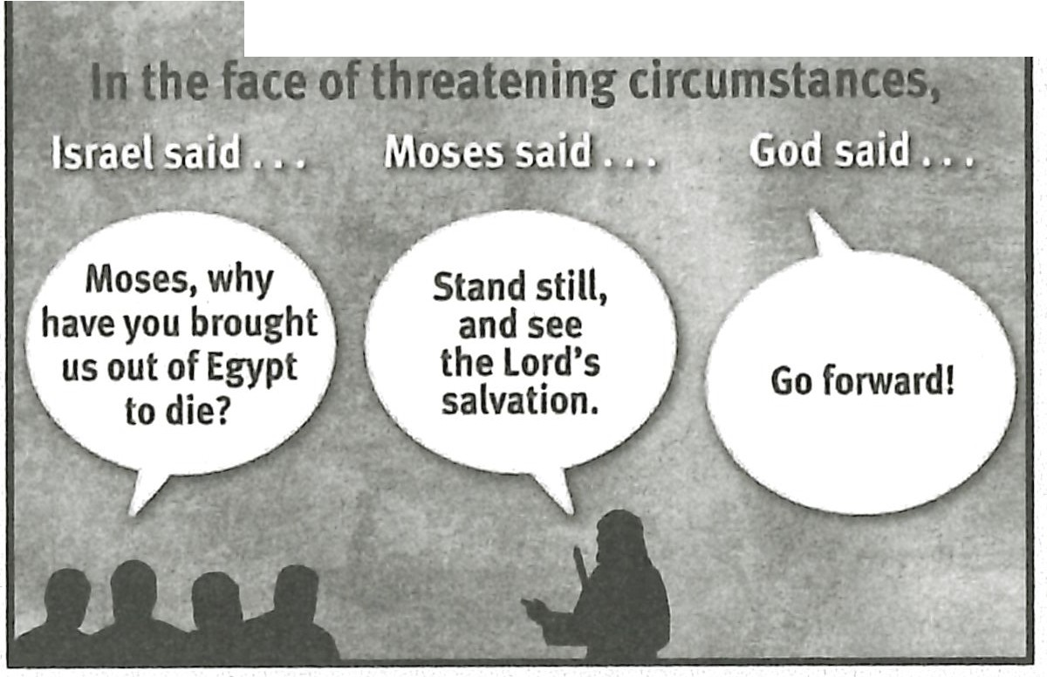**RESOURCE:** Display resource 7 as a review of how the people, Moses, and God all responded to the threatening circumstances in leaving Egypt.

**READ:** Exodus 14:1 5. **ASK:** How would you have responded to God's instruc­ tions to go forward through the Red Sea? (QB)

God then told Moses the rest of His plan. He would make a way for the Israel­ ites to follow His lead. Moses was to lift his rod, stretch his hand out over the sea, and divide it so the Children of Israel could cross on dry land. Pharaoh and his army would follow them so God could overcome them (14:16, 17).

God ends this section by repeating His *purpose* for leading the Israelites to

the Red Sea: *The Egyptians shall know that I am the LORD, when I have gotten me honour upon Pharaoh, upon his chariots, and upon his horsemen* (14:18).

* 1. **With power (14:19-31)**

After leading the Israelites with wisdom and purpose, God then displayed His awesome power both to protect Israel and to provide for their deliverance.

* + 1. **Protective power (14:19, 20)**

The *angel of God* moved to a position of defense (14:19). The identity of the *angel of God* is most likely the divine Angel of the Lord (cf. 3:21). God's movement showed Israel that He had their back.

When God moved to behind the Israelites, He provided them with light to see through the night (14:20). God's light illumined the path for the Israelites. In that sense the pillar of fire was still leading the Israelites and showing them where to go. At the same time God caused the pillar of cloud to block out all light for the Egyp­ tians. They couldn't have advanced to engage the Israelites if they had wanted to.

**ASK:** What should the people have said to God once He moved to protect them and shed light on the path He had for them? (09) *They needed to ask for forgiveness for not trusting Him to take care of them when their circumstances looked hopeless.*

* + 1. **Providing power (14:21-31)**

God used a strong east wind to part the Red Sea, creating a wall of water on both sides of the path through the sea. He also dried out the sea floor making it easier for the Israelites to cross swiftly throughout the night (14:21, 22). How amazed the Israel­ ites must have been to see God's power on display all around them.

Pharaoh directed his army to take the path the Israelites had taken. When his army was between the sea walls, God looked down on him through the pillar of fire and cloud and caused the chariots to bog down and become useless (14:23- 25).

**READ:** Psalm 77:16-19. **ASK:** What other details does this passage give about God's attack on the Egyptian army in the Red Sea? (01 O) *God brought heavy rain, lightning, and an earthquake.*

**READ:** Exodus 14:25. **ASK:** Which direction did the Egyptian army run once they realized God was fighting for Israel? (011) *Back toward Egypt. They aban­ doned the pursuit.*

God did not let the Egyptian army get away. He instructed Moses to stretch his hand over the sea. When the first light of dawn appeared, the sea returned to its normal depth. Pharaoh's army was crushed under the tremendous speed and weight of the water rushing back to fill the valley God had created in the sea (14:26- 28).

**READ:** Exodus 14:30, 31. **ASK:** How did God's illustration of His delivering power affect the Israelites? (012) *They feared the Lord and believed both the Lord and Moses.*

Israel had all the reasons they would need to have confidence in the Lord and in His leader, Moses. The crossing of the Red Sea became one of the most referred to

events in Israel's history. God used it as a benchmark for His relationship with Israel. It is no wonder that Moses and the Israelites spent time capturing the event in the form of a song. That song reveals the truths they learned about God that day.

#### Israel Learned about God (Exod. 15:1-21)

**ASK:** What two truths about God might you put into a song about His deliv­ erance of Israel from the Egyptian army? (Ql 3)

Israel learned that God is strong, unmatched, and able to carry out His promis­ es. They burst forth in a song of praise to God.

* 1. **He is strong and unmatched (15:1-12)**

The first part of Moses' song looks back at what God had just done for Israel (15:1-12). That section of the song includes two full strophes and part of another. The first strophe (15:1b-5) begins with a confession about God. Though all of Israel was singing the song, each individual sang from his personal perspective and communicated his confession directly with God (15:1, 2).

The Israelites understood God's role as their strength and protection. They also understood that God had been fulfilling this role since the time of their fa­ thers, a reference to the patriarchs (15:2).

**READ:** Exodus 15:2. **ASK:** What were some of the implications of each Israel­ ite recognizing God as his personal God? (Ql 4) *Each person was responsible to know, worship, and obey God.*

The people picked up on the importance of the name *Yahweh* in their song (15:3). God had emphasized His name throughout His interaction with them and the Egyptians (cf. 7:5, 17; 8:22). What God did for them helped them understand what it meant for *Yahweh* to be their God. As a result of God's actions, they be­ lieved He would be near them and would be active in their lives.

The first strophe ends with a narration of what God did to the Egyptian army (15:4, 5). As Yahweh, God drowned Pharaoh's army, making the soldiers sink to *the bottom as a stone.*

The second strophe (15:6- 10) continues a reflection on what God had just done for Israel. God's *right hand* is a central focus of this strophe. God's *right hand* is a poetic way of referring to His *omnipotence.* God can do whatever He pleases with His *right hand.* As the Israelites observed God's actions, God's *right hand* became *glorious in power,* meaning it became illustrative of what God is capable of doing. Specifically, the Lord *dashed in pieces the enemy* (15:6). The crushing weight of the

water returning to its normal depth probably would have been strong enough to tear the bodies of the Egyptian soldiers apart. When the soldiers rose up against the Lord, God tore them down in the greatness of His majesty and consumed them by His wrath (15:7).

**ASK:** Suppose two people are fighting. One can use his hands to fight, while the other is limited to breathing air through his nose as his offensive attack. What would you predict would happen? (Ql 5)

Moses helped convey the ridiculousness of the Egyptian army's claims. Egypt had said the soldiers would destroy Israel with their hands. But God defeated them so easily that it was as if He simply used the breath of His nostrils to win the

fight (15:8- 10). God's *breath* is a reference to the mighty wind that divided the Red Sea and then caused it to return to normal (cf. 14:21).

Based on God's defeat of the Egyptian army with just His breath, the third stro­ phe (15:11-16a) begins with a rhetorical question: *Who is like unto thee,* 0 *LORD, among the gods?* The understood answer is *no one.*

**READ:** Exodus 15:11. **ASK:** Why was it so important for Israel to know that there was no other god like Yahweh? (Ql 6) *Because they would be tempted to follow after other gods, especially when Israel entered the Promised Land.*

God's *holiness* is what made Him different from all the other gods (15:11). As holy, He always does what is right. So Israel could always trust Him. They did not have to worry that one day God would turn evil and destroy them without

a just cause. Other nations had gods that required child sacrifices in order to be appeased. Of course all those gods were false. But the anxiety felt by those who worshiped those gods was real.

The third strophe includes another reference to God's hand (15:12). God ex­ tended it, and the earth swallowed up the Egyptians. The rest of the third strophe looks forward to God's future dealings with Israel.

* 1. **He is able to fulfill His promises (15:13-21)**

Israel stood on the east side of the Red Sea. Their ties with Egypt had been cut. There was no easy path back. God wanted the sea as a barrier between them and Egypt to help the Israelites think about their future in the Promised Land instead of their past in Egypt.

The third strophe continues by declaring that God would successfully lead the Israelites to the Promised Land, called the *holy habitation* (15:13). The crossing of the Red Sea made Israel confident that the Lord would guide them, His redeemed, by His mercy and strength (15:13). Such confidence in the Lord's leading embold­ ened the Israelites. Instead of cowering from the prospect of fighting the Philis­ tines in Philistia *(Palestina)* (cf. 13:17), they said the Philistines would be the ones anguishing once the report of the Red Sea crossing spread (15:14). The same would hold for the chiefs of Edom, the mighty men of Moab, and the inhabitants of Ca­ naan. They would be dismayed, tremble, and melt away as they faced the great­ ness of God's arm (15:15, 16). Israel's enemies would be *as still as a stone,* meaning they would be helpless in facing the Lord.

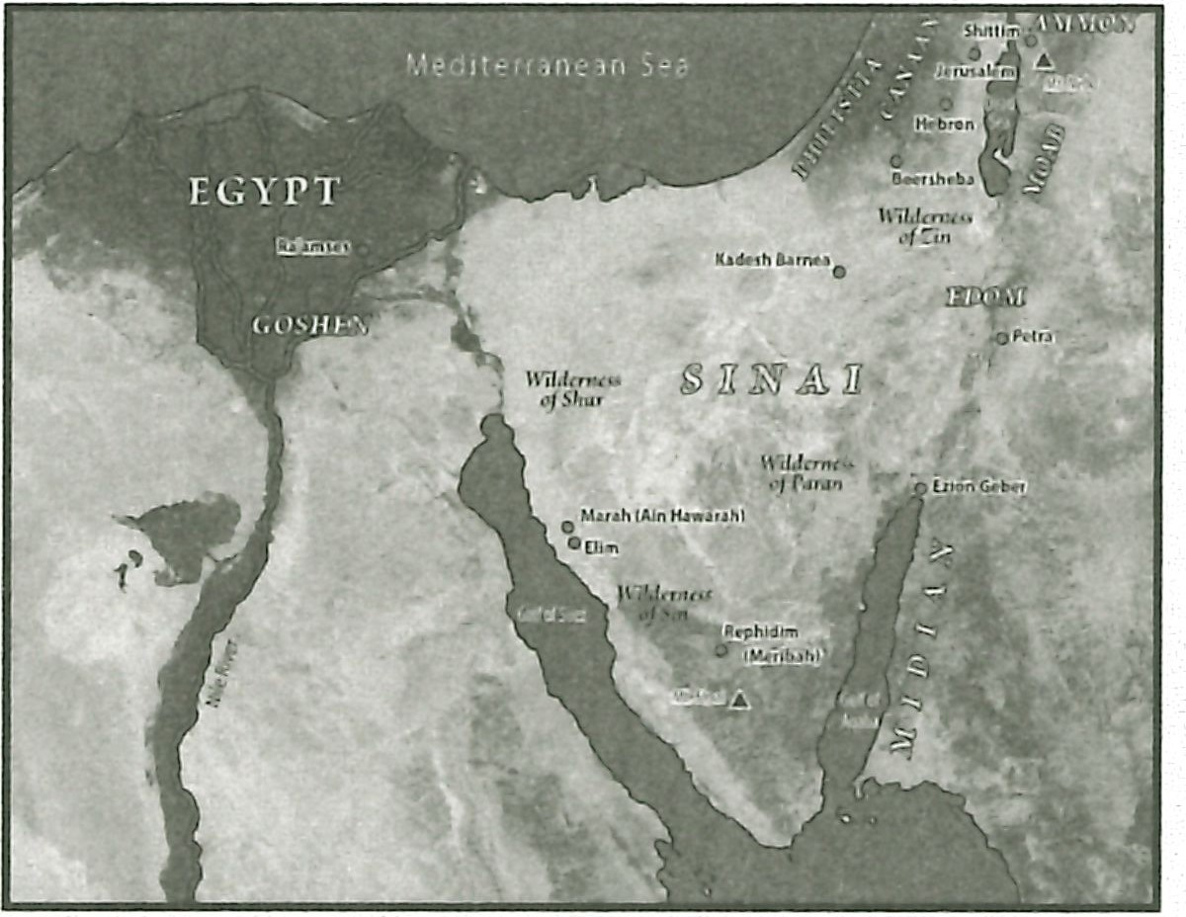**MAP:** Display resource 3 to show the location of Philistia, Edom, Moab, and Canaan.

The comparison of Israel's enemies to a stone marks the end of the third stro­ phe. The first two strophes also ended with a mention of rock or lead (15:5, 10). The fourth strophe continues Israel's prospect of crossing over to the Promised Land as God's redeemed (15:16b). Israel's hope for entering and taking the Promised Land rested fully on the Lord. Verse 17 lists all that the Lord would do to make posses­ sion of the land possible. That anticipation of God's leadership in bringing Israel into the land is right on. Psalm 44 gives the perspective of Israelites in the land long after it had been conquered. It affirms what was still a hope in Exodus 15:17.

**READ:** Psalm 44 :1- 8. **ASK:** What message about the conque st of the P_rom­ ised Land did the forefathers pass on to future generati ons? (Ql 7) *They told how the Lord's arm had brought them into the land and given them victory. All of the credit went to the Lord.*

The Promised Land was not only for Israel, but it was also the place God would choose to dwell with men (Ex od. 15:17). At first He did so in the tabernacle and then in the temple. Eventually Christ will reign on earth during the Millen­ nium (cf. Rev. 20: 4). And finally Christ will reign forever in the presence of all

the redeemed on a new earth (cf. Rev. 21:22- 27). Truly *the Lord shall reign for ever*

*and ever* (Exod. 15:18).

Both the interlude of narrative (15:19) and Miriam's song (15:21) recap what the Lord did for Israel. The focus is on the Lord's work. Miriam's song was sung by women as an antiphonal response, meaning they sung the song at the end of each strophe.

##### God's Leading in My Life

Having God's pillar of cloud and fire lead us through life might sound appeal­ ing to us since it would indicate exactly when and where we are to go. But remem­ ber that we as believers have God in us in the Person of the Holy Spirit, a much better Guide than a pillar of cloud and fire. The Holy Spirit can convict, assure, strengthen, and enable us for the way God has for us. If we have not done much to strengthen the Spirit's ministry in our lives, we may not think much of the Holy Spirit's leading . We become more attentive to the Spirit's leading when we spend time in His Word and commune with God in prayer.

**ASK:** How aware are you ofthe Spirit's leading in your life? (Ql 8)

**ASK:** What could you do to sharpen your attention to His leading? (Ql 9)

God still leads us with wisdom and purpo se. We sh ould never question God's lead ing. He knows what He is doing. We can always trust Him even when our circumstan ces don't make sense.

##### Go Forward!

While camped between the Red Sea and the Egyptians, Israel forgot that God was still leading them. They feared the Egyptians instead of trusting God through their circumstances.

**ASK:** When have you complained to God about your circumstances? (Q20)

**ASK:** What might *going forward* look like in your sit uati on? (Q21)

#### Summary and Memory Verse

**RESOURCE:** Display resource 1. Add a summary statement about God's introduction of Himself in lesson 5 or use the following: I AM Leader.

Encourage learners to memorize Exodus 15:11. Give them an opportunity to say the verse in class next week.



### Topic

**God's provision**

### Theme

**God wants us to humble ourselves before Him and trust Him to provide for our needs in His time.**

### Desired Learner Response

**The learner will trust God for grace and guid­ ance in times of need.**

##### Materials

* Resources 1 , 3, and 8

**52**

**1AM**

# Provider

### Scripture Focus

**Exod. 15:22-17:16**

### Summary

This lesson covers Go d's supply for Israel's needs as they began their journey as a freed nation. But the lesson is more importantly about the Israelites' hearts . God used the basic need for water and food at Marah, Meribah, and Rephidim to reveal the sinfulness of their hearts.

##### Outline

1. **Test at Marah (Exod. 15:22-27)**
   1. Israel complained (15:22- 24)
   2. God provided a solution (15:25a)
   3. God gave an ordinance (15:2 5b- 27)
      1. Immediate significance
      2. Future significance
2. **Test in the Desert of Sin (Exod. 16)**
   1. Israel complained (16:1- 3)
   2. God provided a solution (16=4-15)
   3. God gave limitations (16:16- 30)
      1. Israel disobeyed the regulation concerning leftovers (16:16- 21)
      2. Israel disobeyed the regulation concerning the Sabbath (16:22-30)
   4. God provided a witness (16:31- 36)

**IIL Test at Rephidim (Exod. 17:1-7)**

1. Israel complained (17:1- 4)
2. God provided a solution (17:5- 7)

##### Memory Verse

*"Do all things without murmurings and disputings : That ye may be blameless and harmless, the sons of God , without rebuke,*

*in the midst of* a *crooked and perverse nation, among whom ye shine as lights in the world" (Philippians 2:14, 15).*