**I AM Redeemer**



**Topic**

**God's redemption**

**Theme**

**God is the gracious Redeemer.**

**Desired Learner Response**

**The learner will praise God for redemp tion and will consider how he might live in appr ecia­ tion for redemption.**

**Materials**

* Resources 1 and 6
* One-of-a-kind items

**Scripture Focus**

**Exod. 7:14-12:42**

**Summary**

This lesson covers God's revelation both of His power through the first nine plagues and His redemption of Israel through the tenth plague.

**Outline**

1. **God Proved His Power (Exod. 7:14-8:19)**
   1. First triplet of plagues (7:14- 8:19)
      1. The purpose (7:14-17a)
      2. The plagues (7:17b- 8:19)
   2. Second triplet of plagues (8:20- 9:12)
      1. The purpose (8:22)

2. The plagues (8:20-9:12)

* 1. Third triplet of plagues (9:13- 10:29)
     1. The purpose (9:13-16)

2. The plagues (9:17- 10:29)

1. **God Provided Redemption (Exod. 11:1-12:42)**
   1. Announcement of the final plague (11:1-10)
   2. Institution of the Passover (12:1-20)
   3. The deliverance from Egypt (12:21-42)

**Memory Verse** *"And in very deed for this cause have I raised thee up, for to shew in thee my power; and that my name may be declared throughout* all *the earth" (Exodus 9:16).*

**34**



# GETTING STARTED

## One-of-a-Kind Items

Bring a few one-of-a-kind items from around your house. Perhaps you have a piece of clay pottery made by a child, a piece of art deco, or an original painting. Display the items and assign a value to them.

**ASK:** What do all of these items have in common? *They are all original, one-of­ a-kind items.*

**ASK:** What valuable one-of-a-kind items do you have? (Ql)

**ASK:** What gives them their value? (Q2)

The Egyptians at the time of the Exodus had identified numerous gods to worship, including several associated with the Nile. God stepped into their pagan world to demonstrate that there is no god like Him in all the earth, a powerful and redeeming God.

## World Famous

**ASK:** If you could be world famous for one reason, what would it be?

**ASK:** How might your life change if you became world famous?

For some of us world fame is not desirable. But for God, it is imperative. His dealings with Egypt at the time of the Exodus helped spread around the world His fame as a powerful, redeeming God.

# SEARCHING THE SCRIPTURES

The first nine plagues are neatly arranged in three sets of triplets. Each triplet has a clearly stated purpose. Recognizing those purposes helps us understand God's motivations in bringing the plagues on Egypt.

## God Proved His Power (Exod. 7:14-8:19)

What is the Redeemer like? God answered that question as He sent the first nine plagues on Egypt. He revealed His power and might. He showed what it means to be Yahweh.

**READ:** Psalm 78:40-42. **ASK:** What did the Children of Israel reveal about themselves when they doubted and thereby limited God's power (hand)? (Q3) *That they thought they knew God better than He knew Himself They deter­ mined what God could and could not do according to their own estimations.*

God more than proved His power at the Exodus. Israel's doubting of His power was a serious offense to God.

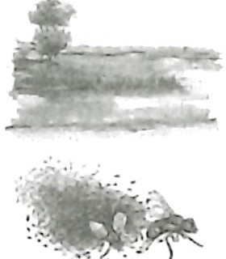

Some commentators sug­ gest that God did not turn the water to blood but that He used other means of turning the water red and making it temporarily undrinkable and unfit for fish. That is unlikely since water that had already been collected from the Nile also turned to blood.

The Nile was also asso­ ciated with the Egyptian gods Isis, Khnum, and Osiris. The river was thought to be Osiris's bloodstream, making the first plague even more offensive to the Egyptians .

**RESOURCE:** Display resource 6 to track the purpose and plagues for each triplet of plagues.

## First triplet of plagues (7:14-8:19)

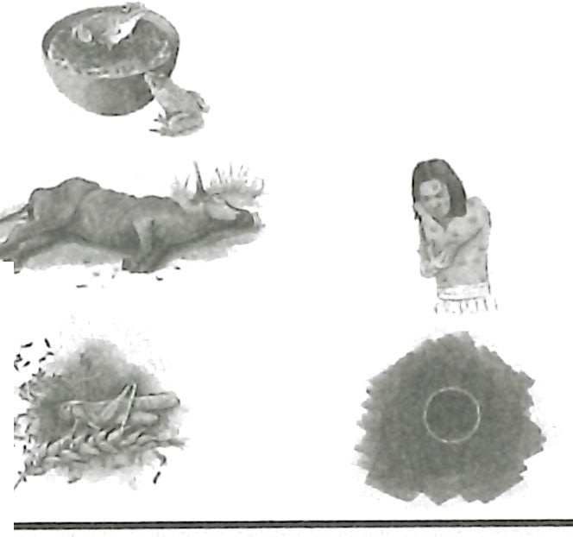

Three Triplets of Plagues

Purpose:

To revea l Yahweh .

Pl•! ij(s ,-1

Purpose:

Purpose:

To revu l God's To revealthe re ls none llke

provld enceo vMth eu rth. Yahwehh1all lheu rth.

Pl1s un - 6

Pl11uu 7- 9

***tP***

*r*

The first triplet of plagues brought disruptive irritations . Normal life was turned upside down.

## The purpose (7:14-17a)

Moses and Aaron met Pharaoh at the Nile, as God had instructed (7:15).

Perhaps Pharaoh was at the river to worship Hapi, the Egyptian god of the Nile. The Nile floodwaters brought fertile soil to the farmland that helped sustain life in Egypt. The Egyptians believed that without Hapi their nation would die. Hapi's responsibility for sustaining life made him one of the most revered gods in Egypt, perhaps even above Ra, their sun god.

In the setting of the Nile and Egypt's highly revered deity, God revealed His purpose for the first triplet of plagues. He told Pharaoh through Moses and Aaron that the plagues would reveal that He is Yahweh (7:17). Pharaoh would begin to learn about God's character and abilities. Remember that Pharaoh had already admitted that he didn't know God and therefore would not obey Him (5:2). But even after God revealed Himself to Pharaoh, he would still re­ fuse to obey God (4:21).

## The plagues (7:17b-8:19)

The first plague was the turning of the Nile and other freshwater sources into blood. Even the water the Egyptians had collected in wood buckets and stone pitchers turned to blood (7:19). As a result of the plague, the fish in the Nile died; their rotting carcasses created a stench in Egypt (7:21).

Hapi, the Egyptian god of the Nile, was also called the *Lord of the Fishes.*

Obviously Pharaoh and the rest of Egypt understood that the plague was an attack on their god. The rotten stench was a testimony to Hapi's weakness. Yet Pharaoh's heart was not moved. His magicians duplicated the plague in some way (7:22, 23), though they could not turn the blood back into water.

**READ:** Exodus 7:24, 25. **ASK:** What did God reveal about His intentions by not changing underground water to blood and by limiting the plague to seven days? (Q4) *That He did not intend for this plague to take life.*

The second plague was the sudden onslaught of frogs. They came from the Nile and filled the land (8:1- 6). As with the Nile, the Egyptians saw frogs as sacred.

**READ:** Exodus 8:3, 4. **ASK:** How would you respond to having frogs inundate your life? (QS)

The frogs were more annoying than they were anything else. Though Pha­ raoh's Egyptians imitated the plague, the constant croaking and the inability to es­ cape the frogs drove Pharaoh to admit the power of Yahweh to take away the frogs (8:7, 8). Moses gave Pharaoh the opportunity to name the time that God would kill the frogs. God responded and killed the frogs the following day as Pharaoh had

prescribed (8:9-12). The result was again a stench of rotting flesh throughout the land . But Pharaoh hardened his heart, as the Lord had said he would, and did not let Israel go (8:13-15).

The third plague was turning dust into lice, which were possibly gnats or even mosquitos. The plague came without Moses appearing before Pharaoh, and it ended with Pharaoh hardening his heart even more .

**READ:** Exodus 8:18, 19. **ASK:** What did the magicians essentially admit about God when they said the plague was His doing? (Q6) *That God exists and that He has power greater than theirs.*

These first three plagues most likely also came on the Israelites, since God does not say He made a distinction between them and Egypt for those plagues. The first three plagues would have helped them understand God's power so they would learn to trust and honor Him.

## Second triplet of plagues (8:20-9:12)

The second and third triplets did not fall on the Israelites. God spared them and thereby showed that His people were different from the Egyptians.

## The purpose (8:22)

The purpose of the second set of plagues was to reveal God's providence over the world (8:22). God was in the midst of the land of Egypt even though it was not His *home turf.* His presence and control would be seen as He distinguished be­ tween the Israelites and the Egyptians in plagues four through nine.

**READ:** Exodus 8:22. **ASK:** When the fourth plague came on only the Egyp­ tians, what explanation for the plagues had to be ruled out? (Q7) *That the plagues were* a *result of* a *natural phenomenon.*

God was with His people. His presence was verified by the absence of the plagues in the land of Goshen, where they lived. The Israelites should have felt privileged as they witnessed the atrocities in the rest of Egypt.

## 2. The plagues (8:20-9:12)

The second triplet of plagues began with Moses again meeting Pharaoh at the Nile. Moses warned Pharaoh that swarms of flies would inundate the land if he did not let God's people go (8:20, 21). Moses gave Pharaoh one day to change his mind. He did not. So God sent the flies. They came as an oppressive swarm and may have been the type of flies that have a painful bite. If so, the fourth plague was the first one that directly caused physical pain. The flies' presence would have been mad­ dening to the Egyptians.

In response, Pharaoh told Moses to sacrifice to God in the land of Egypt. But doing so would have brought the Egyptians' wrath on the Israelites (8:25, 26). So Pharaoh said he would allow the Israelites to go, but not far away. He then added that he wanted Moses to intercede for him (8:27, 28). Moses said he would inter­ cede for Pharaoh but that Pharaoh should not continue to deal deceitfully with him. God answered Moses' prayer. The flies departed, but Pharaoh hardened his heart again and refused to let God's people go (8:29-32).

**The plague against the livestock was a strike against several Egyptian gods including Apis, the**

**bull god.**

The fifth plague was a pestilence on any livestock that remained in the field (9:3). Again God kept the Israelites' livestock safe while also protecting all the live­ stock the Egyptians brought into shelters (9:4). God showed His power by killing every animal left in the field and by sparing every animal in the shelter. The exact nature of the plague could not be explained as a natural phenomenon.

**ASK:** Why would the Egyptians leave their livestock in the field when God gave them an entire day to get the animals to safety? (QB) *Because bringing their livestock to safety meant they believed that God can do what He says He can do.*

The specific nature in which this plague was carried out should have been a clue that the plague was not normal. But Pharaoh wanted to be sure. He sent mes­ sengers to verify that the Israelites didn't lose any livestock at all (9:7).

**READ:** Exodus 9:7. **ASK:** Why would Pharaoh be so interested to know if any of the Israelites' livestock died? (Q9) *Because it would be another indicator that the plague was supernatural and that God must have control over life and death.*

Despite the seriousness of the plague, Pharaoh again hardened his heart.

The final plague in the second triplet was the worst yet for the Egyptians physically. Standing in front of Pharaoh, Moses threw ashes from a furnace into the air to cause boils on all the Egyptians and on their livestock (9:8- 10). The boils were so painful and debilitating that Pharaoh's magicians were physically unable to stand before him.

**ASK:** What did the plague of boils reveal about God's power? (Q1O) *That God has the power to affect* a *person's body and that the effects can be devastating.*

The ashes Moses and Aaron threw into the air most likely came from a fur- nace that the Israelites used to make bricks. Pharaoh would not have missed the connection between the Israelites' suffering as slaves and the physical suffering brought on by the boils. Yet Pharaoh hardened his heart just as God had said he would (9:11, 12).

## Third triplet of plagues (9:13-10:29)

* + 1. **The purpose (9:13-16)**

God's purpose for bringing the third triplet of plagues on Egypt was to demon­ strate that His power is far beyond any other power known to man. God was not more powerful than just the gods of Egypt, He was also more powerful than any other god worshiped by anyone on all the earth (9:13, 14). In sending the full furry of His plagues, God would address Pharaoh at his heart. His rebellious, hardened heart would turn to the point of begging the Israelites to leave his land (cf. 6:1).

As Moses met with Pharaoh to start the third set of plagues, God reminded Pharaoh that He could have wiped the Egyptians off the face of the earth. But God had tempered His plagues in order to use Pharaoh to display God's power and to make 'His reputation and character known worldwide (9:15, 16). Indeed, when the Children of Israel went to enter the Promised Land forty years later, the accounts of the Exodus were still reverberating around the earth (cf. Josh. 2:1- 11).

**READ:** Joshua 2:8-11. **ASK:** How did the account of the Exodus affect the Canaanites? (Ql 1) *Their hearts melted in fear when they heard about how God had delivered Israel from Egypt through the parting of the Red Sea.*

There is a real sense in which the message of God's redemption of His people from Egypt is still echoing today.

**2. The plagues (9:17-10:29)**

Since Pharaoh still exalted himself against God's people, God would bring three more devastating plagues on Egypt before the final plague (9:17).

The seventh plague was large hail, heavy rain, and deadly lightning on all those in Egypt who did not seek shelter. The hail was the most devastating hail Egypt had ever experienced as a nation (9:18,24). Yet God kept it from destroy­ ing the Egyptian houses and shelters. Only those who remained in the field were killed by the storm. And, as in the previous three plagues, God protected the Isra­ elites from the plague (9:26).

**READ:** Exodus 9:20, 21. **ASK:** What motivated the Egyptians who called their servants and livestock in from their fields? (Ql 2) *They feared God and believed that what He said, He would do.*

Pharaoh initially responded by telling Moses that the Israelites could leave. But as in all the previous plagues, he ended up hardening his heart and refusing to let Israel go (9:27- 35).

The eighth plague was locust. They finished off the crops that the hail hadn't destroyed. Pharaoh again waffled in his decision about letting Israel go. He even said he had sinned (10:16, 17). But in the end he again hardened his heart (10:20).

The last plague in the third triplet was oppressive darkness that could be *felt* (10:21). No one in Egypt could see anyone else for three days. The nature of the darkness is unknown, though it must have been supernatural, for God again

spared Goshen from the plague (10:22, 23). Ra, the Egyptian sun god, would have been humiliated by this plague.

Pharaoh tried to negotiate with Moses but to no avail (10:24- 26). Moses would not settle for anything but a complete departure of God's people from the land.

Ironically Pharaoh ordered Moses out of his presence, declaring that Moses was to see his face no more. Moses told Pharaoh he would get his wish (10:27- 29).

So ended the three triplets of plagues. God had revealed Himself as Yahweh/ Jehovah/LORD. His power was evident, as was His mercy. The most severe plagues came with warnings and the means of escaping the consequences of the plagues. A meaningful way of escape came with the tenth plague too.

1. **God Provided Redemption (Exod. 11:1-12:42)**

Having shown His power, God provided the Israelites with redemption.

* 1. **Announcement of the final plague (11:1-10)**

God first announced the tenth plague to Moses, who then proclaimed it to Pharaoh . Every Egyptian firstborn son and firstborn animal would die in the middle of the night as God passed through Egypt (11:4, 5).

The result would be a great cry of grief throughout the land (11:6). But the Isra­ elites would be so peaceful that even dogs wouldn't feel the need to bark. The resultant grief would cause the Egyptians to beg the Israelites to leave their land (11:7, 8) .

While communicating the plague to Pharaoh, Moses grew angry with him. Countless lives would be spared if Pharaoh would simply humble himself before God (11:8). But instead Pharaoh remained as hard hearted as ever (11:9, 10).

* 1. **Institution of the Passover (12:1-20)**

God gave specific instructions for the first Passover. On the tenth day of the month of the Abib (or Nisan, the current month at that time), each family was to take a year-old, unblemished male lamb and keep it until the fourteenth day (12:1- 6). Each family was then supposed to kill their lamb at twilight and to use hyssop (12:22) to apply their lamb's blood to the doorway of their house. The family was to roast the lamb and eat it with unleavened bread and bitter herbs. Each member of the family was to dress as if ready for traveling, even eating with a staff in hand. The uneaten portion of the lamb was to be burned (12:7- 11).

When God moved through the land of Egypt, He would kill all the firstborn of all men and beasts that were not under the blood of a passover lamb. By killing both man and beast, God would demonstrate one final time that He was mightier than any god of Egypt represented by the animals and worshiped by men (12:12). The tenth plague was the last in God's blows against the Egyptian' deities.

**ASK:** Why would it be important for Israel to know that God was far stronger than the gods of the mighty nation of Egypt? (Ql 3) *So the Israelites would not be tempted to worship the Egypti an gods after Israel left Egypt.*

Remember, God protected the Israelites from the effects of plagues four through nine. But with the tenth plague, they needed to carefully follow God's prescribed steps in order to save their firstborn sons alive. The blood applied to their doorways was the sign for God to pass over their household on the night of the plague (12:13). So the lamb took the place of the firstborn son. The lamb was the acceptable substitute for the son.

God did not want Israel to forget their redemption. He instructed them to cel­ ebrate Passover every year, repeating some of the elements from the first Passover (12:14). God also gave specific instruction about the Feast of Unleavened Bread,

a weeklong observance following the annual celebration of Passover (12:15-20). The Feast of Unleavened Bread was to memorialize how hurriedly the Egyptians made Israel leave their land. And God's emphasis on purity throughout the feast (signified by the absence of leaven in the home) showed the feast's seriousness. The feast was to encourage God's people to increase their faith in God and remind them of His redemption of them.

* 1. **The deliverance from Egypt (12:21-42)**

Moses communicated all of God's instructions to Israel (12:21- 27), emphasiz­ ing the importance of remembering what God was about to do for them.

**READ:** Exodus 12:25-27. **ASK:** What would happen as future generations par­ ticipated in the passover celebration? (Q14) *They would ask their parents what the sacrifice symbolized; their parents would tell them about the first Passover in Egypt.*

When the people heard all the instructions and how God would spare their firstborn sons, they bowed their heads and worshiped, the proper response to what God was about to do for them (12:27). The Children oflsrael then proceeded to do exactly what God had commanded them to do (12:28).

God passed through Egypt as He had said He would. Every house in Egypt, in­ cluding Pharaoh's house, experienced a death. The cry that went up in Egypt was great (12:29, 30). Not one Egyptian escaped the pain of loss that night.

Pharaoh called Moses and Aaron and told them to leave to worship their God (12:31, 32). He added that he wanted Moses to bless him. That was not a signal that Pharaoh had any kind of trust in God, for he later regretted letting the Israelites go and led his army to go after them (14:5- 8).

The rest of Egypt was anxious to get Israel out of their land, fearing they might all die if Israel didn't leave right away. The Children of Israel left with the riches of Egypt, as God had said they would (12:33- 36). Apparently some of the Egyptians went with the Israelites, making the group a mixed multitude (12:37, 38). It seems God's revelation of Himself through the plagues was enough to convince some of the Egyptians that Yahweh was greater than their gods.

After 430 years of sojourning, Israel left Egypt on the exact day God had ap­ pointed (12:40, 41).

Psalm 105, most likely written by King David, provides additional insight into the Exodus.

**READ:** Psalm 105:42, 43. **ASK:** What does David reveal about God's heart during the Exodus? (Q15) *God brought His people out of Egypt with joy and gladness.*

The word *gladness* (Ps. 105:43) means *joyful shout.* God was thrilled to be able to redeem His people from slavery in Egypt.

Israel also bowed their heads and worshiped God when Moses first told them about God's coming to them to deliver them

(4:31). However, their wor­ ship of Him after witness­ ing the first nine plagues had to be filled with a much deeper understand­ ing of Who God is.

**MAKING IT PERSONAL**

**Grateful for Redemption**

The blood of the passover lamb is a picture of Christ's shed blood on the cross. Christ purchased our redemption from sin. God was pleased to send His Son to die (Isa. 53:10).

**ASK:** Express your gratitude for Christ's death in your plac e. (Q16)

**ASK:** Who will you tell about the redemption God gladly offers through the blood of Christ? (Q17)

## Living in Light of Redemption

**ASK:** If you were part of Israel at the time of the Exodus, how do you think you would respond to being delivered from Egypt? (Ql 8)

**ASK:** Does your level of obedience to God match the grandness of your redemption? Explain. (Ql 9)

Encourage the learners to live in appreciation of the grand redemption God purchased for them. Deliverance from sin should motivate us to obey God more every day.

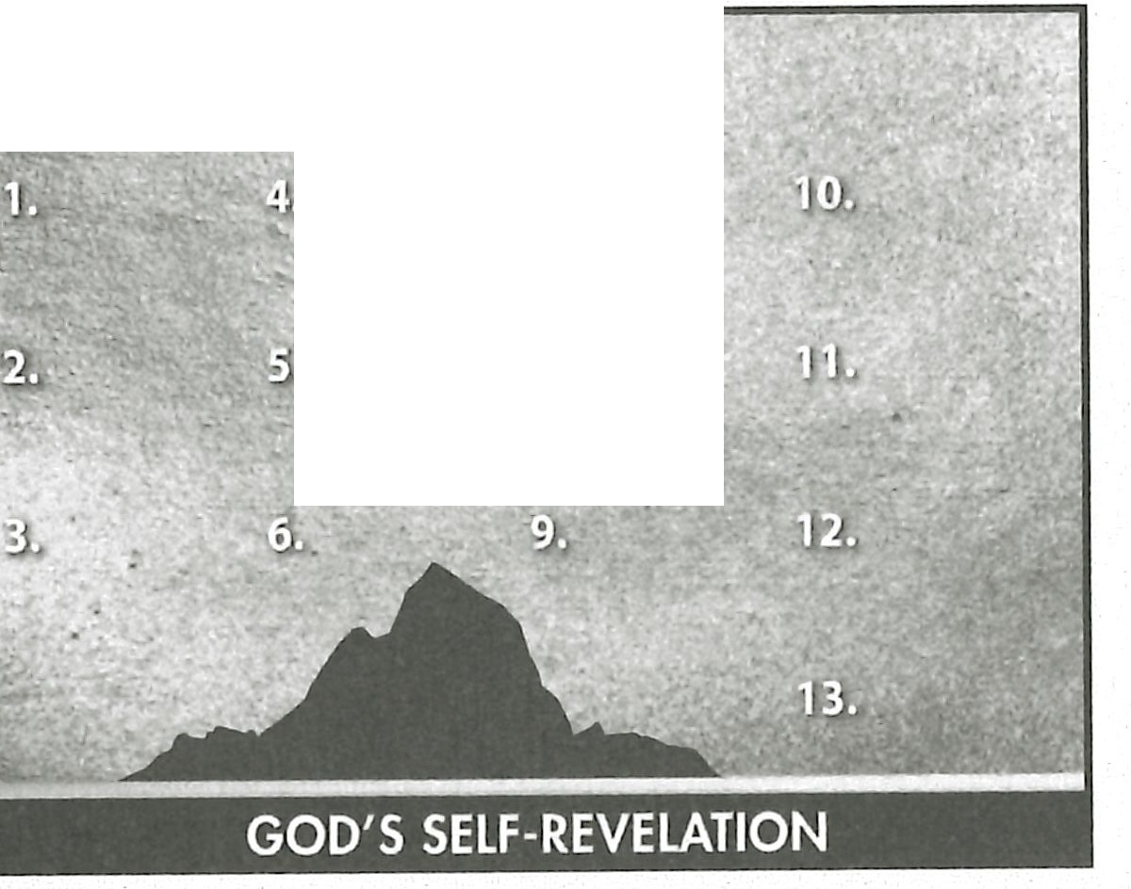

,,

**1AM**

## Summary and Memory Verse

**RESOURCE:** Display resource 1. Add a summary statement about God's introduction of Himself in lesson 4 or use the following: I AM Redeemer.

Encourage learners to memorize Exodus 9:16. Give them an opportunity to say the verse in class next week.