

## Topic

**God's faithfulness to His promises**

## Theme

**God is trustworthy because He is prom­ ise-keeping Yahweh.**

## Desired Learner Response

**The learner will use truths about God to build his trust in God and to motivate his obe­ dience to God.**

##### Materials

* Resources 1 ands
* Notecards

##### 26

**1AM**

Promise Keeper

## Scripture Focus

**Exod. 4:18- 7:13**

## Summary

This lesson covers Moses' transition from Midian to Egypt. God communicated His commitment to His promises to Israel. He then demanded Moses be com­ mitted to Him. Both Moses and the people wavered in their trust in God when Pharaoh made their lives hard. God responded with the important revelation of Himself as Yahweh.

##### Outline

1. **God Stated His Commitment to Israel (Exod. 4:18-31)**
   1. God personalized His commitment to Israel (4:18-23)
   2. God demanded commitment from Moses (4:24-26)
   3. Israel worshiped God for His commitment to them (4:27-31)
2. **God Allowed Hard Circumstances(Exod. 5)**
   1. Pharaoh denied God's request (5:1-18)
   2. The people criticized Moses (5:19-21)
   3. Moses questioned God (5:22, 23)

**Ill. God Remembered His Covenant (Exod. 6:1- 7:2)**

1. God made extraordinary promises (6:1-9)
2. God used ordinary people (6:10-7:2)
3. **God Restated His Command (7:3-13)**
   1. God gave reasons for His command (7:3-5)
   2. Moses obeyed God's command (7:6-13)

##### Memory Verse

*"Wherefore say unto the children of Israel, I am the LORD, and I will bring you out from under the burdens of the Egyptians, and I will rid you out of their bondage, and I will redeem you*

*with a stretched out arm, and with great judgments" (Exodus 6:6).*



# GETTING STARTED

#### You Just Made Things Worse

Read the following scenario and have the learners answer the questions that follow.

A family was made to work as slaves in a mine. They had done nothing to deserve their slavery. Eventually they could bear their incredibly difficult circum­ stances no longer. They secured a spokesperson to plead with their slave owner for their release. But instead of releasing them, the slave owner made their work even harder and longer. They had to mine without shovels and pickaxes. The slave owner even began to beat members of the family for lack of production .

**ASK:** If you were the family in the scenario, how would you respond to your spokesman?

**ASK:** What would you tell him if he said your increased suffering would work out for your good?

A similar scenario to this one is played out in our passage for today. Except there is one more Person involved. He revealed Himself as Yahweh and told the spokesman and the families of Israel they would be okay. We will learn how they responded to Him.

#### Another Side of You

We don't know all there is to know about one another. We all have sides of ourselves that no one else would ever guess. Perhaps you are a neatnik, keeping all your clothes neatly in your dresser drawers. Or maybe you are creative and you enjoy home decorating.

Give each learner a notecard or slip of paper on which to record a sentence that describes *another side of himself.* Collect the notecards and read them one at a time. Have the learners guess who wrote the sentences. If you have a large class, have the learners get into groups of eight to ten to complete the activity.

The more we learn about a person, the better we can relate to him and the closer we feel to him. God continued to reveal Himself to His people and to Moses. The passage for today includes God's revelation of Himself as Yahweh and both Moses' and Israel's responses to His revelation.

# SEARCHING THE SCRIPTURES

#### God's Stated His Commitment to Israel (Exod. 4:18-31)

Perhaps out of courtesy, Moses returned from Sinai to Midian to ask Jethro for his permission to leave for Egypt (Exod. 4:18). Moses wanted to see how his breth­ ren were doing. Jethro told Moses to *go in peace.*

Moses' phrase *see whether they be yet alive* (Exod.

4:18) was a way of saying he wanted to see how his Hebrew kin were doing. See Genesis 45:3 for a similar usage by Joseph in reference to his father Isaac, whom Joseph al­ ready knew was alive.

### God personalized His commitment to Israel (4:18-23)

God came to Moses and directed him to return to Egypt. God's reference to the dead who had sought Moses' life (4:19) reminded Moses that he had tried to take the deliverance of God's people into his own hands. That turned out to be a major blunder. He ended up fleeing Egypt for his life. But here Moses was returning to Egypt according to God's plan and God's timing.

Moses saddled a donkey, put his family on it, and headed with them toward Egypt. His staff, once ordinary, became the *rod of God* in his hand (4:20). The rod was evidence of God's presence with Moses. Moses' family would become the cen­ ter of a crisis as they journeyed. But first God had a message for Moses to help put the coming crisis into focus.

God gave Moses a personalized message to give to Pharaoh. God told Moses to refer to Israel as *my son, even my firstborn* (4:22). The sense of the word *firstborn* is *first in rank.* No people group on earth was more important to God at that time, and Pharaoh was holding them captive. God has a special relationship with Israel even to this day. He chose them to be His people and to make a covenant with them.

**READ:** Exodus 4:23. **ASK:** D escribe the seriousness of God's relationship with Israel. (Q3) *God would take the life of Pharaoh's firstborn son if Pharaoh did not let God's people go. God took the enslavement of His people personally.*

**ASK:** How does considering Israel as God's son help you understand the commitment God had toward Israel? (Q4) *It reveals that God deeply loved Israel and had* a *sense of resp onsibi lity for them.*

God told Moses to tell Pharaoh to let His people go so they might *serve* Him (4:23). God essentially pitted Himself against Pharaoh, the one the Israelites served at that point. This theme of *God versus Pharaoh* is repeated throughout the account of the Exodus. It escalates to *God versus Pharaoh's gods* when God brings the plagues upon Egypt. It culminates when God takes the life of Pharaoh's son just as He said He would.

* + - 1. **God demanded commitment from Moses (4:24-26)**

Following the statement of God's commitment to Israel is a shocking, seem­ ingly out-of-place account of God confronting Mos es. God seemed anything but committed to Israel when He threatened Moses, His chosen deliverer of Israel.

**READ:** Exodus 4:24. **ASK:** What are your thoughts when you read this verse in the context of God's commitm ent to Israel? (QS)

God's anger with Moses must have been related to the rite of circumcision. While God detained Moses, his wife, Zipporah, circumcised Moses' son and cast the foreskin at Moses' feet. Zipporah accused Moses of being a *bloody husband* to her (4:25). Apparently Zipporah didn't think much of the rite of circumcision . She probably conducted the act out of fear for Moses' life. God forced her hand to en­ sure Moses' family performed the rite of the covenant. God let Moses go once the circumcision was complete (4:26).

**READ:** Genesis 17:10-14. **ASK:** What was supposed to be the consequence of not performing the rite of circumcision? (06) *The uncircumcised would be cut off from his people as* a *covenant breaker.*

This account reveals God demanded that Moses be committed to Him. God wanted Moses to honor Him and take the rite of circumcision serious ly. He expect­ ed circumcision to be an outward sign of a heart for Him (cf. Deut. 30:4- 6; Rom. 2:28, 29). How could Moses lead God's covenant people if he didn't practice the rite of circumcision with his own boys?

#### Israel worshiped God for His commitment to them (4:27-31)

God prompted Aaron to meet Moses at Sinai (4:27). There Moses let Aaron know all that God had done and commanded (4:28). Undoubtedly the brothers must have spent time catching up on what had gone on in their lives during the past forty years.

The account then jumps ahead to the meeting between Moses and Aaron and the leaders of Israel in Egypt (4:29 - 31).

**READ:** Exodus 4:29-31. **ASK:** In light of their initial response to God, how would you expect the elders of Israel to respond to God from this point for­ ward? (07) *Perhaps with submission and gratitude .*

God's people were grateful for God's intervention . But this intervention would not lead to a smooth transition out of Egypt. God was going to allow them to expe­ rience some hard circumstances, which would test their trust in Him and try their belief that He is faithful to His promises.

#### God Allowed Hard Circumstances (Exod. 5)

* + - 1. **Pharaoh denied God's request (5:1-18)**

Moses and Aaron went in to Pharaoh to communicate to him the demand of the *LORD God* that he let Israel hold a feast to God *in the wilderness* (5:1).

**READ:** Exodus 5:1, 2. **ASK:** Why would Pharaoh have such a low opinion of Israel's God? Consider Israel's situa tion. (08) *Pharaoh must have thought God was weak, since He had not delivered His people during hundreds of years of slavery.*

Moses and Aaron appealed to Pharaoh, saying that God would bring pesti- lence and sword on Israel if they did not leave to sacrifice to Him. Pharaoh wanted Moses and Aaron to stop encouraging the Israelites to think of such nonsense. He demanded the people get busy building instead (5:4). Furthermor e, he took away the straw, making the laborers search for the necessary ingredient for making bricks (5:7). Pharaoh also demanded that the Israelites keep up their pace for making bricks. He figured if they had time to hear tales about their God, then they must be idle and in need of more work (5:8, 9). Letting them take time off would only encourage the Israelites to grow even greater in number.

The Israelites could not keep up their previous pace for producing bricks. As a result, the taskmasters beat the Hebrew officers (5:14). When those officers went to Pharaoh and blamed the Egyptian taskmasters for taking away the straw, Pharaoh again accused Israel of being idle (5:15- 18).

* + - 1. **The people criticized Moses (5:19-21)**

The people realized their protests were falling on deaf ears. As they left their meeting with Pha raoh , they met Moses and Aaron, who were waiting to hear the outcome (5:19, 20).

**READ:** Exodus 4:31; 5:21. **ASK:** What about God had changed between these two passages? (Q9) *Nothing!*

The God the people of Israel had worshiped earlier was the same God Who allowed them to experience hard labor and beatings.

**ASK:** Do a person's circumstances change Who God is? Explain. (Q1O) *No. God is not defined by what* a *person experiences. God remains perfectly holy even when hardships come.*

* + - 1. **Moses questioned God (5:22, 23)**

Taking his cue from Israel's leaders, Moses went to God to complain. As far as he could see, his appearance before Pharaoh with God's request had triggered disastrous circumstances . Moses asked God why He had brought trouble on the people (5:22). He then went a step further and blamed God for not stepping in to help Israel (5:23). In his estimation, God hadn't done anything at all to deliver His people. Moses basically told God to stop His plan. God was only making things worse.

**ASK:** Have you ever felt as if God was being less than faithful? What ques­ tions did you want to ask Him? (Q11)

**The pronoun** *I* **in Hebrew** is **normally indicated by a sound at the end of the**

**accompanying verb. God's emphasis on Himself would have been readily apparent** to Moses. If you **were to hear the Hebrew read, you would notice** the **repetition** of **a long** *e* **sound at the end of the verbs in particular.**

God was neither absent nor out of control. He went on to communicate to Moses that He would be faithful to His promises.

### God Remembered His Covenant (Exod. 6:1-7:2)

* + - 1. **God made extraordinary promises (6:1-9)**

God's answer to Moses could be summed up in one word: *now* (6:1), Moses would begin to see God's hand at work. God would delay His plan no longer. Whether the strong hand in verse 1 refers to Pharaoh or to God is debatable. But either way, God would move to bring about the deliverance of His people.

**READ:** Exodus 6:2-8. **ASK:** Who is the focus in this passage? How do you know? (Q12) *God is the focus. He speaks from the first person seventeen times, using the pronoun* I *each time.*

God's focus on Himself is further emphasized by the repetition of the phrase

*I am the LORD* (6:2, 6, 7, 8). The name *LORD* is *Yahweh,* or *Jehovah.* God had been called by this name as far back as Genesis 4:26. But there was a sense in which the full mean in g of that name was not revealed until God began to work on behalf of His people in Egypt (6:3). He was primarily known to the patriarchs as *El Shadd­ ai,* meaning *God Almighty.* As Yahweh/Jehovah, God would be *with* Israel. His

*presence* would be particularly evident to them as He brought about their deliver­ ance from Egypt.

God reminded Moses of the covenant He had made with the patriarchs to give them the land in which they sojourned as strangers (6:3, 4). About four hundred years after the patriarchs sojourned in the Promised Land, God heard the groans of His people in Egypt and *remembered* His covenant (6 :5). God was emphasizing His continuous remembrance of His covenant with Israel. He never forgot it. So His message to Moses was that He is near and that He is the Covenant Keeper.

God then went on to detail what His covenant keeping would involve so Moses could communicate the details to the Children oflsrael (6:6- 8). God began this detailing by calling Himself Yahweh again, thus forming the foundation for His ac­ tions. He then gave the threefold promise oflsrael's deliverance from Egypt (6:6):

*I* will *bring, I* will *rid ,* and *I* will *redeem.* He spoke as if the action of these verbs

had already happened by using a tense that normally indicates past action. God's point was to build Israel's confidence in Him as their Redeemer. Referring to His *stretched out arm* added to the personal , close nature of His redemption of Israel. His use of *arm* was a symbol of His power. And the term *great judgments* meant that God would use the coming plagues to free Israel from Egypt.

God went on to assure Moses, and subsequently Israel, that He would adopt Israel as His own (6:7). That is an amazing truth given Israel's situation at that time .

**READ:** Exodus 6:7. **ASK:** What reasons might God have had for choosing an­ other nation to be His people at this point in history? (Ql 3) *Israel was* a *slave nation; Israel was regarded as lowly by the world; the four hundred years of slavery made God look powerless and uncaring to Pharaoh and Egypt.*

What God would dare to associate Himself with a nation of poor, dirty, help­ less slaves? Yahweh would. He chose to be Israel's God so they could know He is Yahweh, *the LORD,* the God Who is with them and Who would redeem them. Furthermore, Yahweh would give Israel the Promised Land as a heritage, just as He had promised He would (6:8).

When Moses told the Children of Israel all that God was going to do for them, they were not excited or even hopeful (6:9).

**READ:** Exodus 6:9. **ASK:** Why didn't Israel trust God? (Ql 4) *They were experi­ encing anguish at the hand of Pharaoh. Their circumstances seemed too difficult for God to overcome.*

Israel found no hope in God's message of deliverance. In their estimation, what they were experiencing was too big for God. The weight of the oppression from the Egyptians was affecting them deeply. The language in the passage con ­ veys that they were short of breath in their inner being. In other words, they felt in their souls that they could not catch their breath from sobbing, and some actual sobbing probably did go along with their inward anguish.

Israel's hearts were laid bare by the oppression they were experiencing. Hard circumstances always reveal what is really in a person's heart.

#### God used ordinary people (6:10-7:2)

God's message to Israel was purposefully strong and encouraging. Moses must have originally gone to the Children of Israel with some excitement. But whatever excitement he had felt was soon turned to gloom and doom by the people's doubt. So after God told Moses to speak to Pharaoh (6:10, 11), Moses questioned God once again (6:12). If his own people didn't believe him, how would Pharaoh believe him?

**READ:** Exodus 6:13. **ASK:** What did God communicate to Moses by ignoring Moses' objection and charging him and Aaron to bring the Children of Israel out of Egypt? (Ql 5) *He communicated that the revelation of Himself as the near and promise-keeping Yahweh was all Moses needed to know to be successful.*

The text then transitions to a genealo gy. Rather than being out of place, the genealogy serves to contrast Moses and Aaron with Yahweh. Moses and Aaron both descended from Levi, the third son of Jacob (6:18-20). Levi, along with his older brothers Reuben and Simeon, was disqualified from the right of the firstborn (cf. Gen. 34:25- 31;35:22). Remember, that right went to Judah (cf. Gen. 49:8- 12).

Furthermore, Moses and Aaron weren't even from Levi's oldest son, and Moses was not even the firstborn in his family, since Aaron had been born before him.

The deliverance of Israel was not in human hands; it was in Yahweh's hands (Exod. 6:28, 29). Moses and Aaron had the privilege of being a part of *Yahweh's* work. God graciously included them as His representatives to Pharaoh and the Children of Israel. Moses had trouble seeing that Who God is as Yahweh made his estimation of his own abilities irrelevant (6:30).

God then had a this-is-t he-way-it-will-go-down moment with Moses. Moses would be *a god to Pharaoh* and Aaron would be as Moses' *prophet* (7:1). In other words, Moses would speak with all the authority of Yahweh, and Aaron would convey the message to Pharaoh (7:2).

#### God Restated His Command (7:3-13)

* + - 1. **God gave reasons for His command (7:3-5)**

God let Moses know up front that he would not be successful in talking to Pha ­ raoh. But Moses' inabilities would not be the reason. God would harden Pharaoh's heart to *multiply* His *signs and ... wonders* in Egypt (7:3).

**READ:** Exodus 7:4, 5. **ASK:** What did God want to teach the Egyptians through the signs and wonders? (Ql 6) *That He is Yahweh, the LORD.*

The showdown in Egypt was more than just between God and Pharaoh; it was also between God and the Egyptian gods. The next lesson will bear that out. There is some evidence that some of the Egyptians did come to a full realization and acceptance of Israel's God as Yahweh. Apparently some of them left Egypt with the Israelites (12:38).

#### Moses obeyed God's command (7:6-13)

Perhaps Moses finally understood that resisting God's plan was futile: God had spoken and He would accomplish His plan. Moses and Aaron went to Pharaoh

as God had commanded (7:10), performed the signs as God had prescribed (7:10- 12), and got the results that God had predicted (7:13). Yahweh was on the move. The Egyptians' world was about to be rocked to its core. And in the end Yahweh's mighty hand would prevail.

**MAKING IT PERSONAL**

### Three Responses

**RESOURCE:** Display resource 5 as a review of how the people, Moses, and God all responded to the difficult circumstances in Egypt.

Once the intense persecution came, the people looked at Pharaoh as being too hard to overcome. And Moses consistently considered his own resources as the basis for determining whether he could do what God was asking Him to do.

**ASK:** Describe a time when you neglected to do God's will based on the difficulty of your circumstances. (Ql 7)

**ASK:** Describe a time when you neglected to do God's will based on your estimation of your abilities. (Ql 8)

### God as Promise Keeper

**ASK:** What is your estimation of God based on the truths He revealed about Himself in the passage for this lesson? (Ql 9)

**ASK:** How will you let what you have learned about God affect your willing­ ness to be obedient to Him? (Q20)

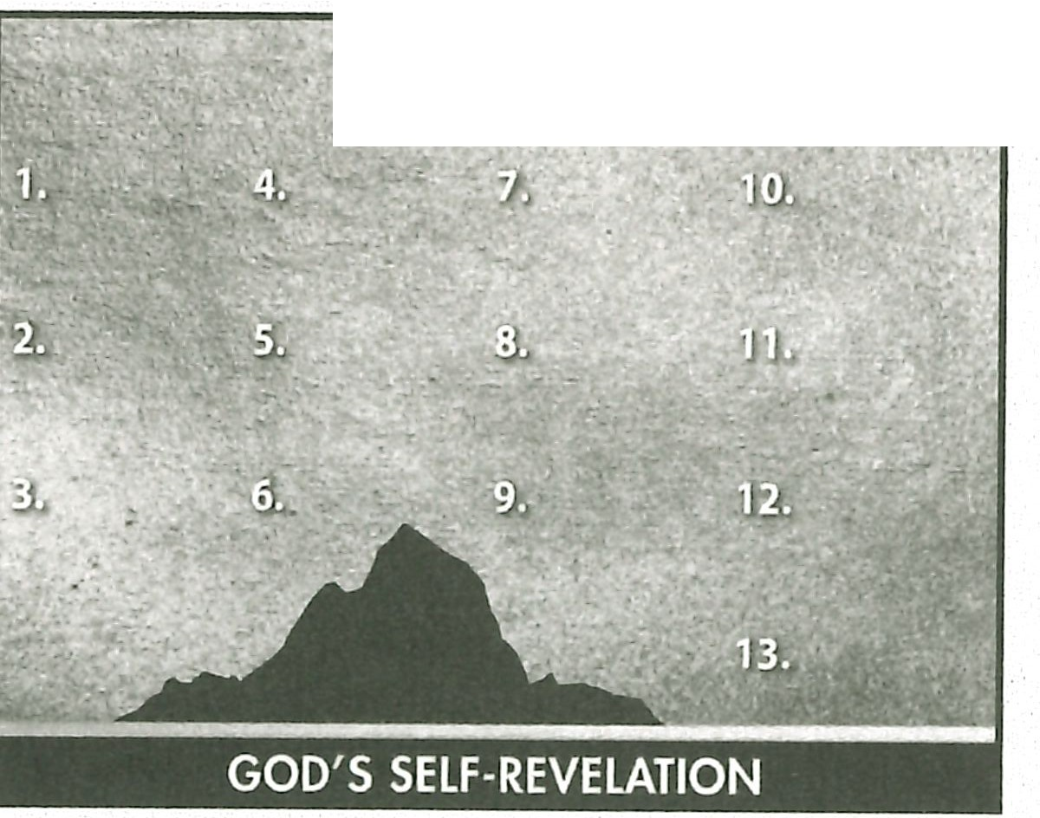

· **1AM**

### Summary and Memory Verse

**RESOURCE:** Display resource 1. Add a summary statement about God's in­ troduction of Himself in lesson 3 or use the following: I AM Promise Keeper.

Encourage learners to memorize Exodus 6:6. Give them an opportunity to say the verse in class next week.

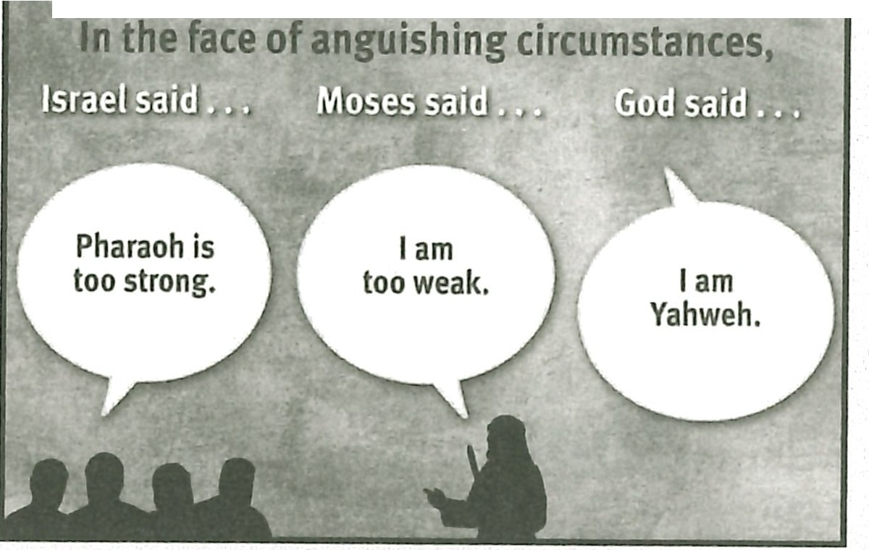IT fBiMIF)rr@filffift l IT'

**I AM Redeemer**



## Topic

**God's redemption**

## Theme

**God is the gracious Redeemer.**

## Desired Learner Response

**The learner will praise God for redemption and will consider how he might live in apprecia­ tion for redemption.**

##### Materials

* Resources 1 and 6
* One-of-a-kind items

## Scripture Focus

**Exod. 7:14-12:42**

## Summary

This lesson covers Go d's revelation both of His power through the first nine plagues and His redemption of Israel through the tenth plague.

##### Outline

1. **God Proved His Power (Exod. 7:14 - 8:19)**
   1. First triplet of plagues (7:14- 8:19)
      1. The purpose (7:14-17a)
      2. The plagues (7:17b- 8:19)
   2. Second triplet of plagues (8:20- 9:12)
      1. The purpose (8:22)

2. The plagues (8:20- 9:12)

* 1. Third triplet of plagues (9:13- 10:29)
     1. The purpose (9:13-16)

2. The plagues (9:17- 10:29)

1. **God Provided Redemption (Exod. 11:1-12:42)**
   1. Announcement of the final plague (11:1-10)
   2. Institution of the Passover (12:1- 20)
   3. The deliverance from Egypt (12:21- 42)

**Memory Verse** *''An d in very deed for this cause have I raised thee up,for to shew in thee my power; and that my name may be declared throughout all the earth" (Exodus 9:16).*