

## Topic

**God's transcendence and eminence**

## Theme

**God is both transcen­ dently above us and eternally with us.**

## Desired Learner Response

**The learner will consider how to reverence our transcendent God and how to let God's pres­ ence affect his life.**

**Materials**

* Resources 1, 3, and 4
* Slips of paper
* Pencils
* Newspaper

**1AM**

Transcendent

Helper

## Scripture Focus

**Exod. 2:23-4:17**

## Summary

This lesson covers God's continuation of His plan for His people, including His call of Moses. The themes of both His transcendence and His eminence run through the account. God wanted Moses to have confidence in Him . Moses grew in His faith but did not reach full surrender to God's will.

**Outline**

1. **God Continued His Plan for Israel (Exod. 2:23-25)**
   1. God on high heard Israel's cry (2:23, 24a)
   2. God on high loved Israel (2:24b, 25)
2. **God Continued His Preparation of Moses (Exod. 3:1-9)**
   1. God came down to Moses (3:1-4)
   2. God commanded separation (3:5-9)

**Ill. God Commissioned Moses (Exod. 3:10-15)**

1. God assured Moses of His presence (3:10-12)
2. God revealed His transcendence (3:13-15)
3. **God Instructed Moses (Exod. 3:16-22)**
   1. God's message to Israel (3:16- 18a)
   2. God's message to Pharaoh (3:18b)
   3. G od's message of deliverance (3:19- 22)
4. **God Answered Moses (Exod. 4:1- 17)**
   1. God's demonstrated His power (4:1-9)
   2. God's promised His presence (4:10- 17)

**Memory Verse** *"And God said unto Moses, I AM THAT I AM: and he said, Thus shalt thou say unto the children of Israel,*

*I AM hath sent me unto you" (Exodus 3:14).*

**18**



**I Am . . .**

# GETTING STARTED

Distribute a slip of paper to each learner. Have the learners write *I am* on their papers three times. Then have them write three facts about themselves that would best tell people about them selves. For example, they might write *I am a good cook* or *I am retired .* Have volunteers share what they wrote.

**ASK:** What were you surprised to learn about someone?

**ASK:** What three facts do you suppose God would write on His slip of paper?

God did record for us important facts about Himself in His Word. This study is about His transcendence and His presence. Both are important revelations for us today.

### Job Match

Collect job listings from a newspaper or from the Internet. Read the job list­ ings, pausing between them to allow the learners to suggest who in the class might be best qualified to do the job.

**ASK:** Why did you associate certain people with certain jobs?

**ASK:** Of the jobs you have held, which one do you think fit you the best? Explain.

God called Moses to a specific job. But it was Moses who seemed to be con­ ducting the interview. He questioned both his qualifications to do the job and God's fitness to be his boss. We will learn about his questions for God as well as God's important self-revelation to Moses.

# SEARCHING THE SCRIPTURES

### God Continued His Plan for Israel (Exod. 2:23-25)

Forty years had passed since Moses' departure from Egypt. God was ready to continue His plan for His people.

### God on high heard Israel's cry (2:23, 24a)

When the account resumes, we learn that the king of Egypt who had chased Moses out of Egypt had died. A new pharaoh was in place, but the conditions in Egypt had not improved.

Israel groaned because the Egyptians worked them hard. Remember that the hard labor was meant to keep the Israelites from multiplying and from being strong enough to rebel. So, as they grew in number, their labor got harder. And the build­ ing projects they worked so hard to complete were making Egypt stronger and less vulnerable to being overthrown. From the Hebrews' perspective, their situation was becoming more and more desperate. Such a thought led to their groaning .

... ... ...

**READ:** Exodus 2:23. **ASK:** Why is it significant that Israel's cry came up unto God? What does that phrase communicate about God? (Q3) *The phrase shows that God is separate from humanity. He is above the earth in that He operates out­ side of the restrictions of time and space. Yet He is aware of the affairs of the world.*

The *aboveness* of God is an important theme in His continuation of His plan for Israel. We call this God's *transcendence.* He is inapproachably far above humanity. No one could possibly reach either His level of character or His ability. But God, though transcendent, still heard Israel's cry. That is a profound truth and one ripe with hope not just for Israel but for all humanity. The *coming down* of our transcen­ dent God will become a repeated theme in the account of God's dealings with Israel.

* 1. **God on high loved Israel (2:24b, 25)**

Though the Hebrew slaves in Egypt didn't yet know it, God had *heard* their groan­ ing, *remembered* that He had made a covenant with them (2:24), *looked upon* them, and *had respect unto them* (2:25). God has never forgotten His covenant with Israel.

He has been and always will be faithful to His promises to them. And His covenant with them is not an albatross around His neck. For God to *look upon* His people was to *consider* their situation. They were important to Him. Though transcendent, He gave His attention to the slave nation in Egypt. And having *respect unto them* meant being *concerned* about them. He had a genuine desire to care for His people. He acted on their behalf out of covenantal love, rather than simply covenantal duty.

**READ:** Jeremiah 31:3. **ASK:** How does God describe His love for Israel? (Q4)

*As an everlasting love.*

God Who sits enthroned far above humanity showed concern for His Chosen People and loved them with a love that will never end.

### God Continued His Preparation of Moses (Exod. 3:1-9)

To rescue Israel, God needed to finish preparing Moses for the task. So He turned His attention to Moses, a shepherd who seemed to have become insignifi­ cant and even forgotten.

### God came down to Moses (3:1-4)

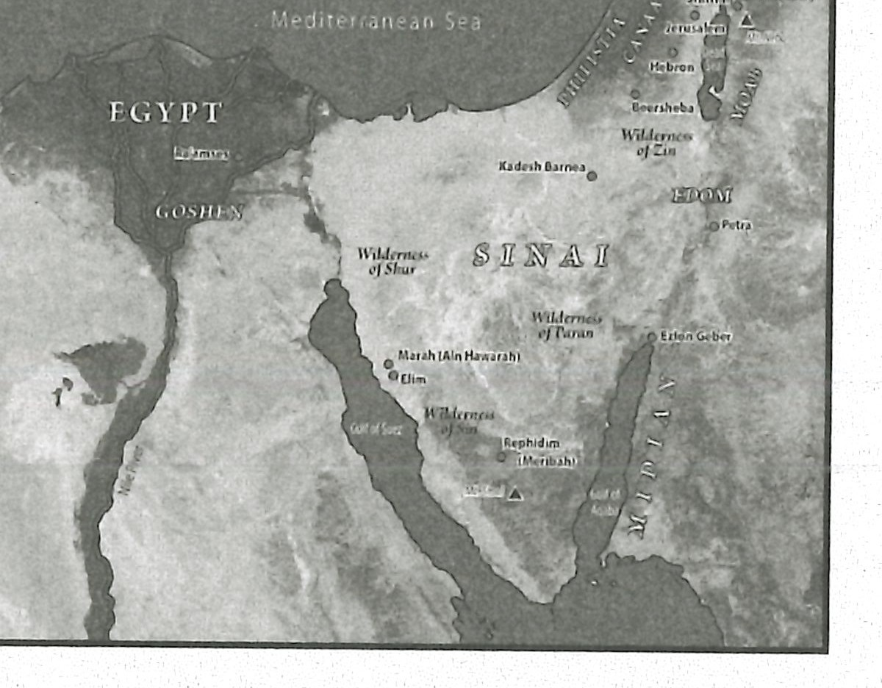Moses led Jethro's flock to the west of Midian and came to what later became known as the *mountain of God* called *Horeb* (Exod. 3:1). Moses included the name of the mountain in retrospect as he wrote Exodus many years after the event. By doing so he acknowledged that God was directing his steps as he carried out the mundane task of looking for food and water for Jethro's flock. Later Moses would end up at the same mountain as the shepherd of God's people (cf. 3:12; 19:1, 2).

**MAP:** Display resource 3 to show the probable location of Mount Horeb (Mount Sinai).

The Angel of the Lord appeared to Moses in a burning bush that was not con­ sumed by the fire. Moses turned aside to see this miracle (3:2, 3). The fact that the bush was not consumed indicated that this was from Go d. And the fire indicated

God's presence, which became apparent to Moses when God called to him (3:4). Moses responded to God by saying, *Here am I.*

**READ:** Exodus 2:23; 3:4. **ASK:** What is the connection between Israel's cry and God's call? (QS) *God came down to call out to Moses because Israel's cry had come up to Him.*

Later in the passage God said He had *come down* to rescue His people (3:8), a result of Israel's cries coming up to Him (2:23; 3:9).

* 1. **God commanded separation (3:5-9)**

God warned Moses not to draw near the bush (3:5). He instructed Moses to take off his shoes, for the ground was holy. This was a physical illustration of the transcendence of God. He had come down, but He was not on man's level. His ho­ liness separated Him from man. God then introduced Himself as *the God of thy fa­ ther, the God of Abraham , the God of Isaac, and the God of Jacob* (3:6). In response Moses hid his face, fearing to look on the manifestation of God before him.

**READ:** Exodus 3:6. **ASK:** What did God's presence help Moses to understand about both himself and God? (Q6) *Moses understood his sinfulness alongside the absolute holiness of God.*

Hiding his face was the appropriate response for Moses in the presence of God.

He understood God's transcendence and sensed his own unworthiness to be in God's presence. He was more than willing to honor God's command to stay back from the burning bush.

God explained that He had come down because Israel's cries had come up to Him. Again, He communicated that He heard the people and knew their sorrows. His plan was to deliver His people and take them to *a land flowing with milk and honey* (3:7- 9).

So the scene included God demanding Moses *stay back* while communicating

to him that He had *come down* because He cared about His people and wanted to deliver them. This dichotomy of both God's transcendence and His eminence continued as God commissioned, instructed, and answered Moses.

1. **God Commissioned Moses (Exod. 3:10-15)**
   1. **God assured Moses of His presence (3:10-12)**

God, having given His initial introduction and His reason for appearing, revealed Moses' involvement in His plan. Imagine Moses still hiding his face from God as he hears God's plan (3:10).

**READ:** Exodus 3:10, 11. **ASK:** Can you identify with Moses' reaction? Explain. (Q7)

Remember that Moses had left Egypt on the run. The pharaoh at that time wanted to kill him, and the Israelites had rejected his leadership, voicing their suspicion of his character (2:14). Those scenes must have come flooding back to Mos es' mind. It is no wonder he resisted God's plan to send him to Pharaoh.

... ... ... .

Asking about God's *name* (Exod. 3:13) is the same as asking about His character and abilities.

**READ:** Exodus 3:12. **ASK:** What should have given Moses confidence as he returned to Egypt? *(QB) God's presence with him.*

Don't miss the contrast between God demanding Moses not come near Him (3:5) and God's assurance that He would go *with* Moses to Pharaoh (3:12). God wanted Moses to understand both His transcendence and His eminence as He commissioned Moses. Moses would learn more about what it meant for God to be with him as God revealed to him more about His transcendent nature.

### God revealed His transcendence (3:13-15)

Moses wanted to know more about God. If God was going to go *with* him, what could he count on God to do *for* him? Moses didn't come right out and ask God what He was like. Instead he suggested that God's people in Egypt would like to know what God is like (3:13). Most likely the people *would* ask Moses about God's identity. Moses would need to know how to identify God. But perhaps Moses was also hiding his lack of confidence in God by removing the question from his lips and putting it on the Israelites' lips. His question was perhaps more to strengthen his confidence in God than it was to have answers for the Israelites. Moses' whole interaction with God is fraught with his personal doubt and fears.

God went along with Moses and answered his question in the context of the people of Israel (3:14). God told Moses that His name is *I AM THAT I AM.* That name means little to us, but in the Hebrew it was clear to Moses. The name *I AM* means God is self-sustaining. He is dependent on no one. He never had a beginning and will never have an end. He is outside time and space and infinitely big and powerful. In other words, He is transcendent. God is indescribably above all humanity.

**READ:** Exodus 3:14. **ASK:** What would have been for Moses some of the implications of God's transcendence? (Q9) *He would have had nothing to fear. He could confidently trust God. He could be assured that God would accomplish His plan just as He had said.*

**READ:** Exodus 3:15. **ASK:** What did God reveal about the longevity of His name? (Ql O) *He will be the* I AM *forever. He never changes.*

God is still the *I AM* today. He is still far above us, yet He promises to be with us ev­ ery moment of every day. What a privilege to personally know our transcendent God.

### God Instructed Moses (Exod. 3:16-22)

God went right from His introduction: of Himself as the I AM to His instructions for Moses, not pausing to give Moses an opportunity to question God's call on his life.

### God's message to Israel (J:16-18a)

Moses was to gather the elders of Israel and tell them that God had appeared to him (3:16). Again God called Himself the *God of your fathers* and specifically *of Abra­ ham, of Isaac, and of Jacob.* It was important for the Hebrews to understand that Moses had talked with the same God Who had made a covenant with Abraham.

Moses was to communicate to the elders that God had visited His people and had seen what they were experiencing. Next Moses was to assure the elders that

God would bring Israel out to the land flowing with milk and honey (3:17). The *withness* of God is emphasized in His message to His people. They needed to hear He had already been in their presence and would be with them to lead them to the Promised Land.

**READ:** Exodus 3:18a. **ASK:** Why would Moses have had reason to doubt that the elders of Israel would heed his voice when he told them God's plan?

(Ql 1) *Forty years earlier they had questioned his right to lead them (2:1 4).*

God put special emphasis on Moses' *voice* (3:18).Israel would heed his voice because God was with him. But even with God's special emphasis, Moses would later question whether the people would indeed listen to his *voice* (cf. 4:1).

### God's message to Pharaoh (3:18b)

God's initial message to Pharaoh was to be brief and limited. Moses was to tell Pharaoh to let God's people go three days' journey into the wilderness so they could worship God (3:18). This would mean that his building projects would remain idle for about a week. Pharaoh would not agree to let the Hebrews take a week's vacation to go into the wilderness to worship.

### God's message of deliverance (3:19-22)

**READ:** Exodus 3:19. **ASK:** What did God say would not compel Pharaoh to let Israel go? (Ql 2) *A mighty hand.*

The *mighty hand* is a reference to God's hand (3:19). Soon God would come down on Egypt with tremendous power and might. With each blow from God's hand, Pharaoh would give in and say he would let God's people go. But in each case Pharaoh would eventually respond by hardening his heart and refusing to let God's people go. In fact, Pharaoh would never make a permanent decision to let God's people go for good (cf. 14:3, 4).

God's blows on Egypt would eventually move Pharaoh enough to let God's people get out of town (3:20). The people of Egypt would be so anxious to see Isra­ el leave that they would give them gold, silver, and clothing (3:21, 22).

**ASK: Why should Moses have had complete confidence in God at that point in his conversation with God? (Ql 3)** *God is the I AM. As the I AM, God said He would lead His people out of Egypt and to the Promised Land. That should have been all Moses needed to know.*

**Eventually Moses would demand that Pharaoh let God's people leave for good (Exod. 6:10, 11).**

### God Answered Moses (Exod. 4:1-17)

Moses had not yet come to the point of completely trusting God as the I AM. He questioned God again.

### God's demonstrated His power (4:1-9)

Remember, God was promising Moses that the people of Israel would listen to Moses' *voice* (3:18). But Moses wanted to play the *what if* game with God. He still thought God's people might not believe that God had actually appeared to him

.., .., ,

Why would God have the staff turn into a *snake?* Perhaps to make a point that He was stronger than Pharaoh. The Egyptian king wore a snake on his headdress. When Aaron turned Moses' staff into a snake later in the account, the term used for *snake*

is *tannin,* possibly the Hebrews' nickname for Pharaoh (Exod. 7:9, 10).

Later on God would turn all of the waters of the Nile into blood as the first of ten plagues against Egypt (Exod. 7:17).

(4:1). Moses was like the boy standing on the edge of the pool doubting whether his father would actually catch him and hold him up when he jumped into the deep water. The perceived risk of drowning nagged at the boy and caused him to doubt. For Moses, the risk of rejection by God's people nagged him. He felt com­ pelled to raise the what-if scenarios as if God had not thought through His plan or was powerless to bring about its outcome.

God patiently provided Moses with signs which would show that God had indeed appeared to him. First, God told Moses to throw his staff on the ground (4:2, 3). When he did, it became a snake. Moses, afraid of getting bit, ran from the snake (4:3). His reaction is normal. Everyone in their right mind recognizes the threat of a snake. But once Moses had a chance to consider what had just happened, he became embold­ ened, grabbing the snake by the tail as God instructed. Such an action almost always results in a snakebite. Instead, God turned the snake back into Moses' staff (4:4).

**READ:** Exodus 4:3-5. **ASK:** How would you describe Moses'faith in God's power at this point in the narrative? (Q14) *Perhaps* growing *or deepening.*

God added two more signs to demonstrate His power. First He made Moses' hand diseased and then healed it (4:6, 7). This sign would be a warning that God has power to inflict harm on the human body. Eventually God did bring harm on the Egyptians' bodies (9:8- 10).

Next, Moses was to scoop water from the Nile as part of the third sign (4:9).

The water would turn to blood as he poured it out. This sign sent a powerful message that was most likely not lost on both God's people and the Egyptians . The Nile was where Egyptians had murdered countless Hebrew boys as part of their plan to keep the Hebrews in Egypt. The blood from those Hebrew baby boys was, there fore, at one point in the Nile. God was well aware of that atrocity. The turning of the water to blood communicated His power over life, which was clearly seen in the death of the Egyptians' firstborn sons during the fast plague (11:4- 6).

God clearly demonstrated His *aboveness* to Moses. He showed He is the tran­

scendent One Who has unlimited power and knowledge and is therefore able to do whatever He desires.

* 1. **God's promised His presence (4:10 - 17)**

Once God demonstrated by deed that He was worthy of Moses' trust, Moses became more direct in addressing his problem with God's plan. He flat out said he didn't think *he* had what it took to talk convincingly to God's people and to talk eloquently with Pharaoh.

**READ:** Exodus 4:10, 11. **ASK:** Why was Moses' excuse an affront to God? (Q15) *God had made Moses' mouth and had designed how it worked He could help Moses speak as needed*

God told Moses not to worry about what to say or how to say it. He had made Moses' mouth exactly as He wanted it. He would be with Moses' mouth and *teach* him what he should say (4:12). God was again focusing on His presence *with* Moses.

**ASK:** What advantage might those with weaknesses or deficiencies have as they seek to serve God? (Ql 6) *They have the advantage of seeing God work through them despite their weaknesses. They get to see more of God's power in their lives.*

Moses, unconvinced of the sufficiency of God's presence, asked God to send someone else to Pharaoh (4:13). Moses didn't understand that God's call didn't have an escape clause . God was going to use Moses no matter what Moses decid­ ed. Moses would simply miss out on seeing the full extent of God's work. Moses would still lead, but Aaron's capable voice would be the main line of communica­ tion between God and His people. God would speak to Moses, who would pass on to Aaron the message to communicate to the people (4:14-17).

**MAKING IT PERSONAL**

### Reverencing Our Transcendent God

God is far above us. He is the I AM, needing no one to make Him complete, and remaining that way for all eternity. It is both God's power and His holiness that make Him far above us. To relate to God properly, we must remember that He is transcendent. We should never treat Him as trivial or as just another person.

**ASK: Do you consider God's transcendence as you relate to Him? Explain.**

**(Ql 7)**

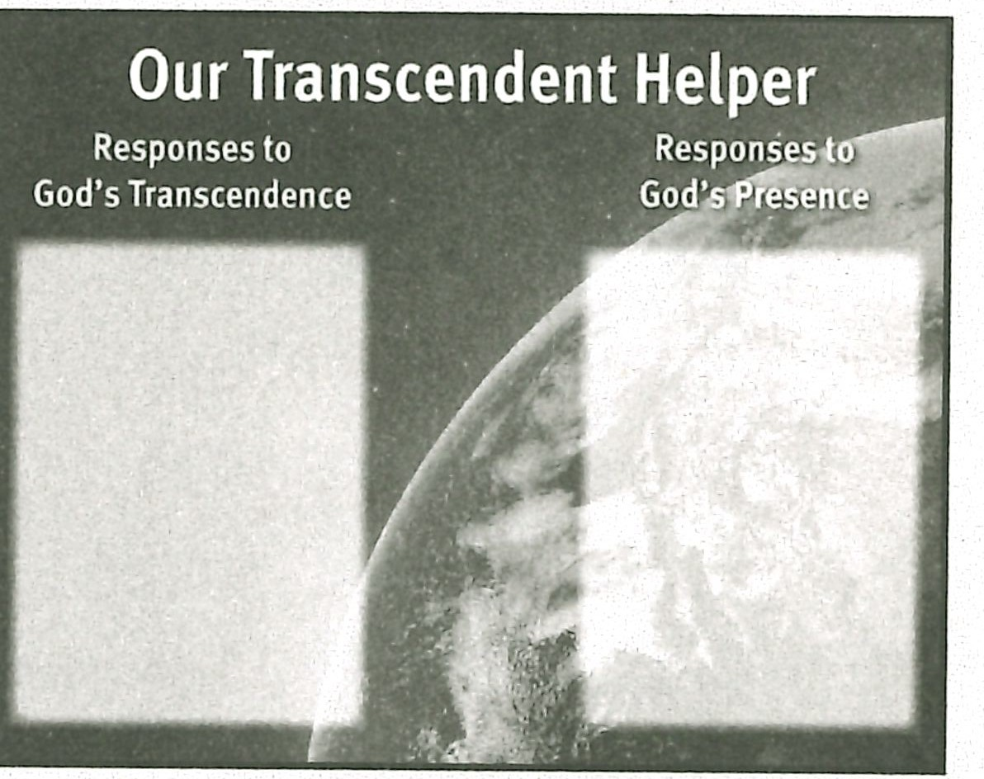**RESOURCE: Display resource 4. ASK: How should we respond to God's tran­ scendence? (Record or reveal answers.) (Ql 8)** *With praise for His perfection; with confidence in His power; with respect for His position; with trust in His abilities; with* a *desire to be holy as He is holy.*

### Relating to Our Eminent God

God also assured Moses that He was *with* him. He *came down* to be *with* Moses and His people. God is not only with us, but He is also *in* us in the Person of the Holy Spirit.

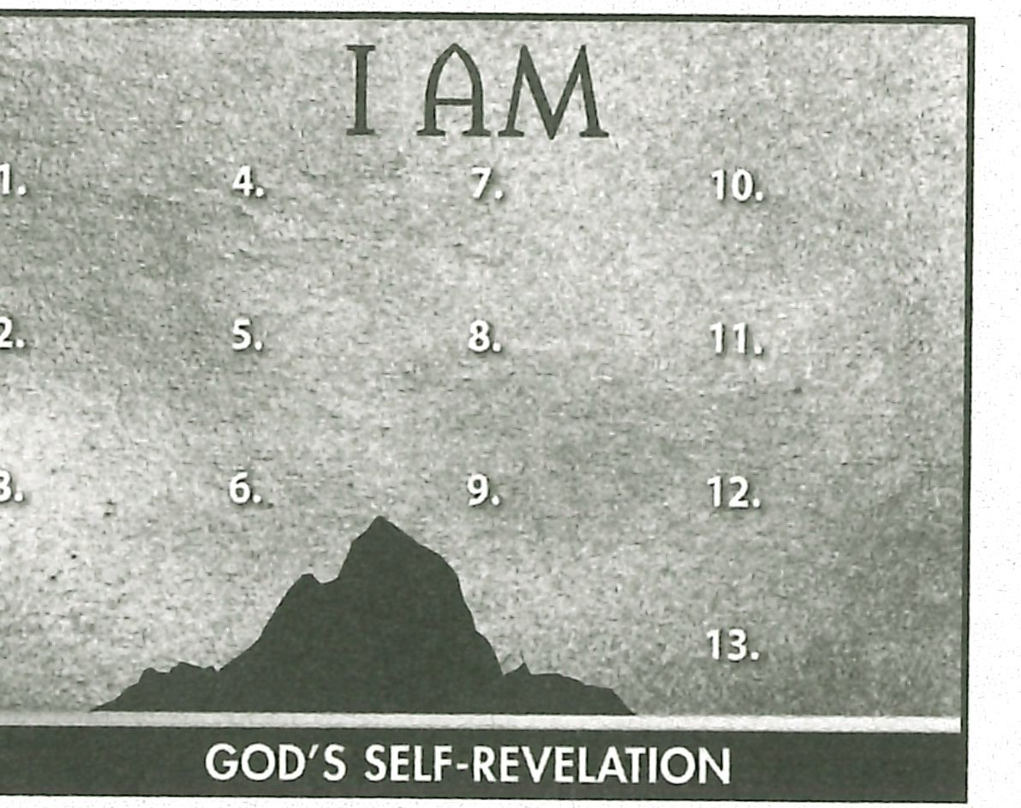**RESOURCE: Display resource 4. ASK: How should we respond to God's pres­ ence with us? (Record or reveal answers.) (Ql 9)** *With awareness that He knows us perfectly; with gratitude that He is near and ready to help us in times of need; with dependence on Him for strength; with dependence on Him for guidance.*

### Summary and Memory Verse

**RESOURCE: Display resource 1. Add a summary statement about God's introduc­ tion of Himself in lesson 2 or use the following:** I **AM Transcendent Helper.**

Encourage learners to **memorize Exodus** 3:14. Give **them** an **opportunity** to say the verse in class next week.

.., .., ..,

**1AM**



## Topic

**Promise Keeper**

## Scripture Focus

**Exod. 4:18- 7:13**

## Summary

This lesson covers Moses' transition from Midian to Egypt. God communicated

His commitment to His promises to lsraeL He then demanded Moses be com­ mitted to Hi,m Both Moses and the people wavered in their trust in God when

**God's faithfulness to His**

**promises**

## Theme

**God is trustworthy because He is prom­ ise-keeping Yahweh.**

## Desired Learner Response

Pharaoh made their lives ha,rd of Himself as Yahweh,

#### Outline

God responded with the important revelation

**The learner will use truths about God to build his trust in God and to motivate his obe­ dience to God.**

#### Materials

* Resources 1 and 5
* Notecards

**26**

1. **God Stated His Commitment to Israel (Exod. 4:18-31)**
   1. God personalized His commitment to Israel (4:18 - 23)

, B God demanded commitment from Moses (4:24- 26)

C. Israel worshiped God for His commitment to them (4:27- 31)

1. **God Allowed Hard Circumstances (Exod. 5)**
   1. Pharaoh denied God's request (5:1- 18)
   2. The people critici zed Moses (5:19- 21)
   3. Moses questioned God (5:22 , 23)

**Ill. God Remembered His Covenant (Exod. 6:1-7:2)**

1. God made extraordinary promises (6:1- 9)
2. God used ordinary people (6:10- 7:2)
3. **God Restated His Command (7:3-13)**
   1. God gave reasons for His command (7:3- 5)
   2. Moses obeyed God's command (7:6-13)

#### Memory Verse

*"Wherefore say unto the children of Israel, I am the LORD, and I will bring you out from under the burdens of the Egyptians, and I will rid you out of their bondage, and I will redeem you*

*with a stretched out arm, and with great ju dgments" (Exodus 6:6).*