LESSON 13

The Triumphant King

Scripture Focus

- RBP transparencies 1 and 16
� Resource 2 from resource

CD
- Lesson 13 case study from resource CD
, Micah 6:8 verse card from resource CD
Micah 4-7
Key Verse
"He hath shewed thee, 0 man, what is good; and what doth the LORD require of thee, but to do justly, and to love mercy, and to walk humbly with thy God?" (Micah 6:8).
Overview
Micah predicted the still future time periods known as the Tribulation and the Kingdom. The Tribulation will be a time of unprecedented war and de-struction, especially for Israel. At the close of the Tribulation, Christ will return to the earth, defeat Israel's enemies, and establish His worldwide Kingdom. God was displeased with the sins of His people, and Micah challenged them to repent and experience God's forgiveness.
Topic
End time events
Theme
After the Tribulation, Jesus Christ will return to establish a worldwide Kingdom.
Desired Learner Response
The learner will rejoice in God's forgiveness of our sins that allows us to take part in Christ's Kingdom.
Outline
- The Coming Kingdom and Its King (Mic. 4:_1-5:15)
  - Characteristics of the kingdom (4:1-5)
  - Triumph of the kingdom (4:6-13)
  - King of the kingdom (5:1-Sa)
  - Conquest of the kingdom (5:Sb-15)
- The Coming Judgment and Its Reason (Mic. 6:1-16)
  - The Lord's controversy (6:1-5)
  - The prophet's response (6:6-8)
  - The nation's sins (6:9-16)
- The Coming Compassion and Its Prerequisites (Mic. 7:1-20)
  - Micah's sorrow over Judah's sins (7:1-7)
  - Judah's recovery from its sins (7:8-13)
  - God's promise to forgive Judah's sins (7:14-20)

102

LESSON 13 'the Triumphant King 103

When It Happens
Mention the following remarks parents may make to their children: "Work hard at your studies so you can get a good job"; "If you don't brush your teeth, they'll fall out." Ask whether your learners have ever said something similar, and if they'll share it with the class.
Discuss: What is the "time" element that is understood in these "predic-tions"? How might you clarify that time element in your comments? In what way did the prophets incorporate time elements in their prophecies? What phrases did they sometimes use to clarify?
Global Peace
Discuss: Why is global peace not an attainable goal for people living in the world today? Discuss: Do you think there would be global peace even if everyone in the world trusted in Christ as his or her Savior? Explain. (Ques-tions 1, 2)
Some people believe that the people of the world can get rid of war. Those people are not being realistic. They also don't understand the reasons we don't have peace. Christ is the only answer to global peace. No amount of human effort will ever solve the problem of conflict.
Micah describes Christ's return and the peace He will bring as He rules on earth in His Kingdom.

- The Coming Kingdom and Its King (4:1�5:15)
Micah predicted that the final fulfillment of his prophecy would take place. "in the last days" (4:1). This phrase denotes the yet future time periods known as the Tribulation and the Millennium or Kingdom.
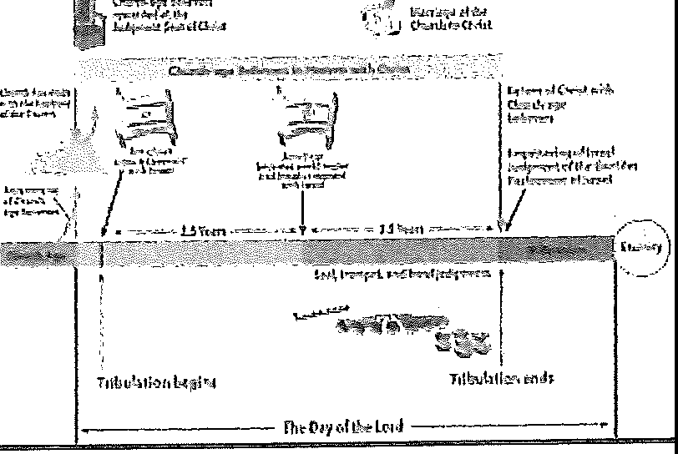
TIMELINE: Display resource 2 as you review the
END-TIME EVENTS
end-time events.

The Tribulation will be a time of unprecedented war and destruction. Christians need not fear this period because prior to it Christ will return in the clouds to take us to Heaven. At the close of the Tribulation, Christ will return to the earth with us, defeat His enemies, and establish His rule (Rev. 19:11-20:6). He will be King of a worldwide Kingdom.

Characteristics of the kingdom (4:1-5)
READ: Micah 4:1-5.

During the Kingdom, Mount Zion and its temple will be restored according to the specifications found in Ezekiel 40-43. Christ will rule from the mount, thus it will be exalted above all other hills (Mic. 4:1; Zech. 8:3). Micah provided an unmistakable contrast with the desolate condition of Jerusalem described in 3:12. People will throng to the mount (4:1) and then enter the temple ("house of the God of Jacob," 4:2) in order to listen to the Lord teach His ways.
The King will judge the nations of the world and rebuke strong nations that are far from Israel (v. 3). Micah predicted the worldwide character of the Kingdom, the unquestioned rule of its King, and the peaceful nature of the Kingdom. The nations will no longer study the art of warfare, and war will give way to an agricultural boom as weapons are recycled into farming implements. The people of Israel will return to the land of their inheritance, and they will recover ownership of their property. Everyone will sit under his own vine and fig tree, and none shall be afraid (v. 4).
ASK: Could anyone truly say that he or she is ever completely safe from being harmed by others? Explain. DISCUSS: When are you most aware that you live in a world of ever-present threats from other people? (Questions 3, 4)

READ: Micah 4:4. ASK: What will make the world a completely safe place? (Question 5)

During the Kingdom, the nations will walk in the Lord's paths (v. 2). There-fore, when Micah explained that the nations follow their own gods (v. 5), he must have been referring to the nations of his day. Micah's point was this: Just as Assyria and Babylonia followed their gods, Israel will finally follow her God during the Kingdom.

Triumph of the kingdom (4:6-13)
When Christ returns in triumph to set up His Kingdom, He will bring deliverance to all those who are lame and take halting steps, to those who are outcasts, and to those who are afflicted (v. 6). During the Tribulation, Jewish people will be persecuted severely and driven out of their land. When Christ returns, He will restore the righteous remnant, including the lame, to its land (v. 7). Israel will become a strong nation under its King, who will reign throughout the Millennium and on into eternity, and Jerusalem will watch over the nations like a tower over a flock (v. 8).
ASK: Why is the exaltation of Israel as the focal nation in the world so hard to imagine? (Question 6)

Before triumph, however, Israel will go through two national hardships without a king. Micah compared these adversities to the pain of a woman in labor (v. 9).


105
LESSON 13

 Micah 4:H), 1 'I. What two national hardships for Israel are mentioned in this passage? (Question 7)

First, Israel would go into exile to Babylonia (4:10). This took place in 586 b.c., when Nebuchadnezzar destroyed Jerusalem and deported many to Babylonia. Eventually the people would return from exile, and this took place during the reign of Cyrus the Persian, who allowed the Jews to return.
Second, at the close of the yet-future Tribulation, the nations of the earth will gather against Jerusalem (4:11; Zech. 14:2, 3). They will t1y to defile the city, but they will not succeed because the Lord will fight against them. The nations will think that it is entirely of their own doing that they have gone against Zion, but in reality it will also be part of God's plan (Mic. 4:12). God will gather the nations as "sheaves into the floor" (4:12), and Israel will thresh them (4:13).

King of the kingdom (5:1-5a)
Micah 5:2 is probably the most well-known verse of the whole book. It is a messianic prophecy concerning the first advent of Christ, and it explains that Christ would come from the otherwise insignificant city of Bethlehem Ephratah. This was the very same city from which David had come (2 Sam. 17:12).
Even though Jesus was born into this world at Bethlehem, His activities, or "goings forth," had "been from of old, from everlasting." In fact, Jesus was present with the Father in eternity past before the creation of the world (John 1:1), and He was active during the creation of the world (Col. 1:16).
Israel will be given over to its enemies until Christ returns as King and sets up His Kingdom (Mic. 5:3). Micah likened defeat to labor pains, as he did in 4:9 and 10, and he repeated the promise of future restoration (2:12, 13; 4:6, 7).
 Micah 5:4, Sa. Why was it important for Israel to see God as their Shepherd? (Question 8)

Micah continued the shepherd theme by predicting that Christ will "feed" His people in His strength and majesty (5:4). The Assyrians of old were able only to approach the gate of Jerusalem (1:9, 12), but during the future Tribulation, nations will attack Jerusalem and will enter the city and will tread through the palaces (5:5). Thankfully, when Christ returns, He "shall be the peace" for Jerusalem by destroying the invaders.

Conquest of the kingdom (5:5b-15)
With the Lord's help, the Jewish people will have more than enough lead-ers to resist the Tribulation invaders (5:5b).
When Christ returns to set up His Kingdom, His brethren, the Jews, will turn the tables on their enemies and will conquer them. Ironically, they will even conquer the land of Nimrod (Gen. 10:8, 9), which is a synonym for the land of Assyria (Mic. 5:6). Israel's influence will extend over many people, since Christ's Kingdom will be worldwide (v. 7). The Jewish people will be like

a refreshing shower or dew that comes according to God’s timing, not man's timing. Israel will dominate the other nations just as a lion dominates all other beasts-especially sheep (v. 8). No nation will be able to resist conquest by Israel, which is led to victory by its King (v. 9).
Israel's tremendous conquest will be unlike so many of the other victories in her past.
READ: Micah s:·I0-15. ASK: What did Israel trust in past battles? DISCUSS: How are these similar to the things we rely on today? DISCUSS: What is God's reaction to misplaced trust, according to these verses? Why? (Question 9-11)

In the past she relied on horses and chariots, but Christ will remove her military power from her (5:10). In the past she relied on her walled cities and her fortresses, but Christ will remove her defenses from her (5:11). In the past she relied on witchcraft and fortune-telling, but she will not do so during the Millennium (5:12). In the past she relied on her false gods (5:13, 14), but in the Millennium Christ will execute judgment against any wayward nation (5:15).

The Coming Judgment and Its Reason (6:1-16)
  - The Lord's controversy (6:1-5)
Micah started his prophecy with a trial scene (1:2), and he returned to this motif again (6:1, 2). This time the mountains were the jurors, and God challenged Israel to stand before them and give her defense against the case ("controversy") that God had presented. The Israelites often complained that God and His ways were wearisome, but God challenged His people to testify against Him (6:3).
READ: Micah 6:4, 5. ASK: In what ways had God been good to Israel? (Question 12)

Far from being a burden, God had in fact demonstrated His goodness and righteousness to His people throughout their history. God delivered the people from Egypt and gave them leaders such as Moses, Aaron, and Miriam (6:4). God reminded the people of the time that Balak king of Moab tried to get Balaam to prophesy against Israel (6:5; Num. 22-24). Instead of uttering curses, Balaam was led of God to pronounce blessings upon Israel.
DISCUSS: Are you ever tempted to think that fol-lowing God is wearisome? Why? DISCUSS: How can remembering God's goodness to you guard against a "poor me" attitude? (Questions 13, 14)

The prophet's response (6:6-8)
After hearing the Lord's case against Israel, Micah asked on behalf of the people what he must do in order to regain the Lord's pleasure. Micah asked if

he should appear before the Lord with sacrifices for the sin (6:6, 7). He even suggested that he bring his firstborn son to God as a sacrifice.
God was not satisfied with sacrifices alone. He was displeased with His people because they thought that they could live in sin and then pay for their sins with sacrifices. They were wrong because God demanded a heart that was right with Him (v. 8).

 Display transparency 16. What "sacrifices" do we bring to God as an attempt to gain His favor? (Record learners, answers on the transparency.) (Question '15)

Micah spoke to each individual in Judah ("Oman") and explained what was good and what the Lord required. First, God demanded justice. He did not want the people to distort justice for financial gain (2:1, 2). Second, they were to love mercy. Mercy, as it appears here, has the idea of loyal love; it speaks of keeping one's commitments. Third, they were to walk humbly with God. This means enjoying obedient fellowship with God without arrogance or ungratefulness.
- WHat tHe Corel Reguires 111c,1i&W


Display transparency 16.
What are some examples of "doing justly"?
What are ways we can 11love mercy”? What are some examples of walking humbly? (Record
!earners' answers on the transparency.) (Questions 16-'18)

.C. The nation's sins (6:9-16)
Micah invited the wise people of Judah to listen to the Lord and to His rod of judgment (6:9). Nevertheless, most of the people did not listen. Wealthy people hoarded treasures acquired wickedly with dishonest scales and false weights (vv. 10, 11), and they were violent and deceitful (v. 12). Because of their sins, God would punish them (v. 13). They would eat but not be satisfied (v. 14a) in fulfillment of Leviticus 26:26. The people would t1y to "deliver" or save some of their harvest, but their enemies would take it by the sword (v. 14b). They would not be able to eat the grain, use the oil, or drink the wine for which they had worked so hard (6:15; Deut. 28:33, 34).
Since the people of Judah followed in the ways of Omri and Ahab, God would turn them into a desolation (6:16; 1 Kings 16:23-34). Ahab had favored the worship of Baal (1 Kings 16:31, 32).

The Coming Compassion and Its Prerequisites (7:1-20)
  - Micah's sorrow over Judah's sins (7:1- 7)
Micah expressed sorrow over Judah's sins. Just like a fruit picker who has gone out to gather fruit but finds none (7:1), Micah could find none who were upright. He found only those who were filled with violence (7:2; 3:10; 6:10, 12) and energetically committed evil "with both hands" (7:3).

The princes, judges, and prominent citizens asked for bribes, and the lead-ers were so wicked that even the best of them was like a sharp brier (vv. 3, 4). Since the land was filled with deceitful businessmen (6:11, 12), bribed judges (7:3, 4), and false prophets (3:5), deceit abounded (7:5). People could no longer trust in a friend, in "a guide" (or companion), or even in their spouses. With deceit everywhere, families began to fall apart (7:6). This was too much for Micah, and in sorrow he cried out to God (v. 7).

Judah's recovery from its sins (7:8-13)
Micah spoke for the nation (he referred to himself fifteen times in 7:8-10). Judah would be defeated, but eventually God would deliver His people (v. 8). Judgment would bring the people back to the light of God's righteousness (v. 9).
When Christ returns to establish His Kingdom (5:4-9), Israel's enemies will be put to shame and will be trampled down like mud in the street (7:10). Israel will rebuild her walls, and her boundaries (or "decree") shall be ex-tended (v. 11).
People from Assyria and from around the world will come to Israel and worship (7:12; 4:2) after Christ judges the nations and makes them desolate (7:13; Isa. 24:1). The fact that Jesus Christ will return to establish a worldwide Kingdom is one of Micah's themes.

God's promise to forgive Judah's sins (7:14-20)
Micah called upon the Lord to feed His people like a shepherd, just as He had promised (7:14; 2:12; 5:4). The Lord responded to Micah's request by promising a future display of divine intervention similar to that which sur-rounded Israel's exodus from Egypt (7:15). When Christ delivers His people at His second coming, the nations will be ashamed of their might, which is nothing compared to that of God's (v. 16). They will be speechless and will not even want to hear about Israel's victories. They will fear the Lord and will lay low like serpents and worms (v. 17).
Micah closed his prophecy by rehearsing the goodness and mercy of God.
READ: Micah 7:18-20. DISCUSS: What comfort do you take in these attributes of God? (Question 19)

God is without equal in His willingness to forgive, and He delights in mercy (7:18; 1 John 1:9). Micah looked forward to the day when God would subdue Israel's enemies and would completely forgive its sins (7:19; Ps. 103:12). Micah was confident that God would once again bless Israel because He is truthful and merciful and keeps His promises (7:20; Gen. 12:2, 3; 15:18-21; 28:13, 14).

Use the case study for lesson 13 as desired.
Prayers of Thanks
Ask: What are you looking forward the most about taking part in the Millenium-

Pray: Ask a few learners to lead in pray praising God for forgiveness of sins and the assurance of spending eternity with Him. (Questions 20, 21)

Ask: What insights have they learned from this series on the first six Minor Prophets? Discuss: What surprised you the most in your study of the prophets? (Questions 22, 23)

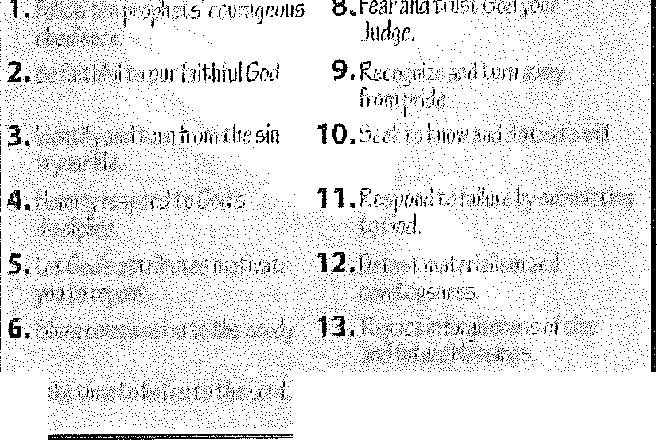
Use transparency 1 to review the response for this lesson: Rejoice in for-giveness of sins and future blessings.
7.

Distribute copies of the Micah 6:8 verse card from the resource CD. En-courage the learners to memorize the verses.
- Responses to toe Godof the Prophets

