LESSON 12


Woe to Rulers, Priests, and Prophets
Sc1·iptu1·e Focus

- RBP transparencies 1, 3,
and 15
e Resource 1 from resource CD
- Lesson 12 case study from resource CD
- Micah 3:'11 verse card from resource CD
Micah 1-3

Key Verse
"The heads thereof judge for reward, and the priests thereof teach for hire, and the prophets thereof divine for money: yet will they lean upon the LORD, and say, is not the LORD among us? none evil can come upon us" (Micah 3:11).
Overview
Micah began his book by depicting a courtroom scene with Judah and Israel as the codefendants. Next, he listed several villages from the area of his hometown and made puns with their names to describe the near destruction of Judah in graphic terms. Israel and Judah would be destroyed because the leading citizens were covetous, because the false prophets promised peace in exchange for their honorariums, and because the mlers perverted justice. Micah did, however, promise blessing for Israel in the still-future millennial Kingdom.
Topic
Covetousness and materialism

Theme
God detests covetousness and materialism.

Desired Learner Response
The learner will evaluate his or her life for signs of the sins of covetous-ness and materialism.
Outline
- Micah's Person and Prophecy (Mic. 1:1)
  - His origin
  - His era
  - His book
- Micah's Lament over Destruction (Mic. 1:2-16)
  - Approaching destruction (1:2-7)
  - Prophetic lament (1:8-16)
- Micah's Warning to the Evildoers (Mic. 2:1-13)
  - Warning to the people (2:1-5)

94

  - Warning to the prophets (2:6-11)
  - Promise of future restoration (2:12, 13)
IV Micah's Message against the Leaders (Mic. 3:1-12)
- Against the rulers (3:1-4)
- Against the prophets (3:5-8)
- Against rulers, priests, and prophets (3:9-12)

Word Play
Write the word "camera" on the whiteboard. Ask learners to think of as many puns relating to "camera" as they can (e.g., We'll see what develops; Picture this; Doesn't this pun make you "shutter"?). See how long learners can keep the puns coming, and enjoy them together.
Ask: What is a pun? Ask: How can this play on words attract a listener's attention? (Questions 1, 2)
Micah used puns in his writing. His puns are inspired by the Holy Spirit, and they emphasize a coming judgment on Israel because of the nation's materialism and covetousness.

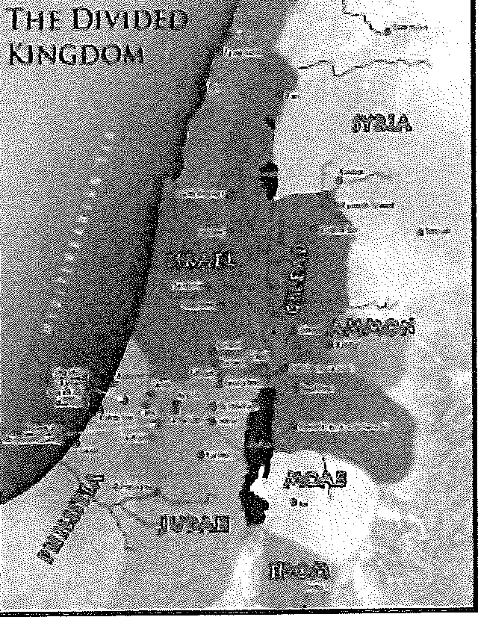
Micah's Person and Prophecy (1:1)
  - His origin
We know very little about Micah the prophet. We do know that he was a Morasthite (1:1). This means that his hometown was Moresheth Gath (see 1:14; and Jeremiah 26:18), a village of Judah near the Philistine city of Gath.
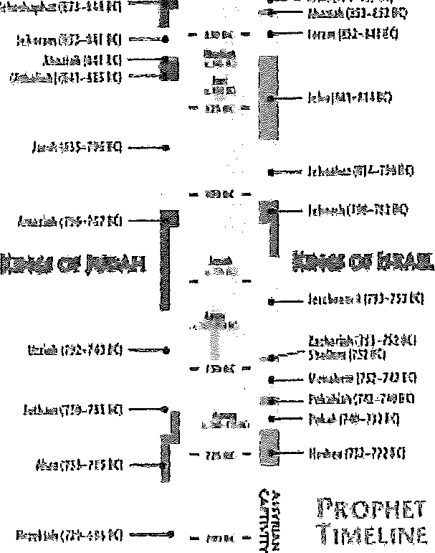
MAP: Display resource 1 from the resource CD to point our Moresheth Gath and other places as they are mentioned in the text or lesson,

His era
TRANSPARENCY: Display transparency 3, and point out Micah's place on the timeline,

Micah ministered sometime about 735 to 700 BC, and Hosea, Amos, Isaiah, and Jonah were his contemporaries. Micah prophesied during the reigns of three of Judah's kings: Jotham, Ahaz, and Hezekiah (1:1). Years later, in the days of Jeremiah, the elders quoting from Micah 3:12 argued that King Heze-kiah had not put Micah to death; therefore, the priests, prophets, and people

should not put Jeremiah to death either (Jer. 26:8, 17-19).

His book
READ: Micah 1:1.
Micah's prophecy concerns both Samaria and Jerusalem (1:1). Samaria was the capital city of the northern kingdom of Israel, and Jerusalem was the capital city of the southern kingdom of Judah. The two capital cities represent their countries as a whole, and Micah demonstrated that the Southern Kingdom was just as sinful as the Northern Kingdom.
The word of the Lord came to Micah in three segments, each beginning with the command to "hear" (1:2-2:13; 3:1-5:15; 6:1-7:20). Micah reminded God's people that sin leads to discipline and that God expected His people "to do justly, and to love mercy, and to walk humbly" with Him (6:8). Judg-ment and future restoration are the book's major themes with the message of hope for a righteous remnant appearing in each segment of the book (2:12; 4:7; 5:7, 8; 7:18).
Micah provided some splendid examples of messianic prophecy. He fore-told the exact birthplace of the Messiah (5:2; cf. Matt. 2:5, 6), and Jesus quoted from Micah to show that His first coming would bring about divisions (7:6; cf. Matt. 10:35, 36). Micah looked beyond the collapse of Israel and Judah to the incarnation of Christ and even further into the future by describing the millennial reign of Christ.

Micah's Lament over Destruction (Mic. 1:2-16)
  - Approaching destruction (1:2-7)
At the start of the first segment of the book, Micah portrayed a court in session.
READ: Micah 1:2-5. ASK: Name the jury, the wit-ness for the prosecution, and the codefendants in this court case. (Question 3)

Micah was confident that the jurors would render a guilty verdict after they had heard the Lord's testimony. He pictured the Lord as entering the courtroom from His holy temple in Heaven. God's presence was so overwhelming that Micah depicted Him as walking from one mountain summit to another-all in a single step (v. 3). As a result, the mountain-tops melted like wax before fire and cascaded like water poured down a slope (v. 4). Here Micah hinted at God's judgment against the pagan altars, or "high places," that stood on many of the hilltops of Israel and Judah (v. 5).
ASK: Picture yourself in a courtroom peering through a window to catch sight of the Lord arriv-ing as Micah described (vv. 3, 4). How do you think the Lord's arrival would affect you? (Question 4)

The Northern Kingdom and its capital of Samaria would experience judg-ment first (vv. 6, 7), and Judah would follow (vv. 8-16). Samaria fell to the Assyrians in 722 BC after an appalling three-year siege (2 Kings 17:1-18), and Micah accurately predicted that the city would be completely demolished even to its foundation (Micah 1:6). The Assyrians would take away the idols of Samaria and beat them into pieces (v. 7).
The worship of Baal, a popular fertility god, sometimes included "sacred" prostitution. "Worshipers" paid a temple official for illicit relations with the temple harlots, and these payments filled the temple treasury. Micah foretold that the Assyrians would burn this ill-gotten gain and then use the currency as payment for their own temple prostitutes (v. 7).

Prophetic lament (1:8-16)
Micah mourned at the prospect of Samaria's certain destruction (v. 8).
READ: Micah 1:8. ASK: How did Micah plan to mourn for Samaria? DISCUSS: Why do you think he mourned so dramatically? (Questions 5, 6)

Micah's mourning was for two reasons (v. 9). First, Samaria's judgment was unavoidable; it was like an incurable wound. Second, judgment would spread to the south so that it would come to the gate of Jerusalem (v. 12). This prophecy was fulfilled in 701 BC when the Assyrians overwhelmed Judah. Jerusalem itself almost capitulated, but for the time being the city survived (2 Kings 19:34-37).
Micah mentioned a number of villages in 1:10-15. It seems he selected these place-names for two reasons. First, they were all located near his hometown of Moresheth-gath. Second, the meanings of the names of the villages allowed Micah to string together creative puns.
The prophet began with the command, "Declare ye it not at Gath" (v. 10). David spoke these same words when he did not want the Philistines of Gath to rejoice over Saul's defeat.
Similarly, Micah did not want the citizens of Gath to revel over Assyria's onslaught against Judah. Another point of interest comes in that "Gath" sounds somewhat similar to the first part of the Hebrew word for "tell."
Micah called on those who lived "in the house Aphrah," or Beth Aphrah, a village belonging to Judah, to roll themselves in the dust (v. 10). "Aphrah" means "dust," and rolling in dust or ashes was a visible gesture of extreme sorrow (Jer. 25:34).
The people of Saphir were to pass by in naked shame (Micah 1:11). Micah drew a contrast because the word "Saphir" means "beautiful," but the village's inhabitants would endure public disgrace.
Those who lived in Zaanan were not to come forth from their city walls because the Assyrians would be encamped against them (v. 11). Micah again developed a contrast since "Zaanan" means "going out."
Micah referred to the mourning of Bethezel (v. 11). "Bethezel" means "house of closeness or nearness." The commanders of Judah's army would

Micah compared his wailing to that of the "dragons,>' which might also be translated "jackals.'1 He compared his mourning to that of the "owls." The jackal is a nocturnal scavenger, and the owl is a nocturnal bird. Both chvell in desolate places. Micah referred to nakedness because it was a sign of intense sorrow (2 Sam. 15:30).

desperately need a place close by to make a defensive stand, but Bethezel would not provide such a place.
In Maroth, the people would wait for good news of Judah's advancing army, but none would come (v. 12). Instead the Assyrians would advance right to the gates of the capital city itself. "Maroth" means "bitterness," and the Marothites would experience the meaning of their town's name since disaster would come down from the Lord.
The city of Lachish was famed for its horses, and Micah called on its citizens to make ready a chariot with swift steeds (1:13). "Lachish" sounds somewhat like the Hebrew word for "team," and it required a team of horses to pull a speeding chariot. Lachish inspired the rest of Judah, referred to here as "the daughter of Zion," to sin.
Judah would give gifts to Moresheth Gath much like an Israelite father gave a betrothal gift to his daughter when he gave her away in marriage (v. 14). "Moresheth Gath" means "possession of Gath," and Judah would give the village to Assyria as a possession.
The houses of Achzib would be a lie to the kings of Israel. "Achzib" means "lie" or "deception," and indeed the residences of that village would become deceitful. The fleeing Israelite kings and their troops would presume to find sanctuary in the village, but the people would refuse them shelter.
Micah promised that God would bring an heir to the town of Mareshah (v. 15). "Mareshah" means "inheritance," and it would be inherited by its new heir-Sennacherib, king of Assyria.
Micah brought poetic closure to the wordplays of the lament by ending as he started. The prophet again alluded to David by referring to Adullam, which means "refuge." Just as David once sought refuge in the cave of Adullam (1 Sam. 22:1), so the "glory of Israel," a reference to the nation's leaders, would seek safety in the village of Adullam.
DISCUSS: Why do you suppose God wanted Micah to use puns to share the prophecy of Assyrian's invasion of Judah? (Question 7)

Micah began the lament (Micah 1:8) by speaking of his own mourning, and he ended it by inviting all the parents of Judah to join him (v. 16).
READ: Micah 1:16. ASK: In what manner did Micah want all the parents of Judah to mourn? ASK: Who was to be the focus of their mourning? (Questions 8, 9)

Micah's Warning to the Evildoers (Mic. 2:1-13)
  - Warning to the people (2:1-5)
READ: Micah 2:1-5.

Micah pronounced a solemn warning of "woe" to the people of Judah for their sins of covetousness and materialism. The fact that God detests covet-ousness and materialism is one of Micah's prominent themes in the first three chapters.
14Qb2'l'-$

TRANSPARENCY: Display transparency 15. ASK: What is covetousness? ASK: What is materialism? DISCUSS: Why are these serious sins? (Questions 10-'! 2)

At night the people of Judah plotted evil, and at the crack of dawn they busily carried out their schemes (2:1). They coveted fields, houses, and de-frauded families by taking their inheritances (v. 2). For those who devised evil work, God had devised His own disaster (v. 3). Judgment was inevitable, and the "family" of Judah would not be able to remove it from their necks.

Warning to the prophets (2:6-11)
False prophets spoke only that which people wanted to hear, and they tried to prohibit true prophets from prophesying (v. 6). Micah responded by reminding the "house of Jacob" that the Spirit of the Lord is not restricted ("straitened") by the optimistic speeches of the false prophets (v. 7). After all, God's words, as spoken by the true prophets, do good to those who walk uprightly.
The prophets' failure to warn the people and to call them to repentance robbed them of their only opportunity to avoid Assyrian oppression. Because of the false prophets, the Assyrians would cast mothers out of their homes and would take away their children (v. 9).
READ: Micah 2:9. ASK: How does this judgment show the seriousness of covetousness and materialism? DISCUSS: What is your reaction to the God's stiff punishment of Judah1s covetous crimes? (Questions 13, 14)

The false prophets preached a message of rest and safety that had made the people more comfortable in their sins and so destined them for utter destruction. Micah sarcastically chided the people for accepting the lying prophets since they envisioned wine and strong drink for their future (vv. 10, 11).

Promise of future restoration (2:12, 13)
The first segment of the book ends with a glimmer of hope.
READ: Micah 2:12, 13.ASK: How are the Lord and His people like a shepherd and sheep? (Question 'I 5)

Micah predicted that God would one day reassemble the believing remnant of Israel on her land and that God would shepherd His people (v. 12).
Just as a shepherd opens a pen's gate so the sheep might go out through it,
- Govetousness anti Materialism


the Lord will remove any barrier to millennial blessings for His people (v. 13). The picture of God's people as sheep is appropriate in a chapter that be-gins with woes against their covetousness and materialism. Sheep are content with they are with their shepherd. One day Israel will be reunited with her
Shepherd and enjoy complete contentedness and trust in God.

Micah's Message against the Leaders (Mic. 3:1-12)
  - Against the rulers (3:1-4)
READ: Micah 3:1-4. ASK: How did the rulers fit into the shepherd and sheep illustration? (Ques-tion 16)

In contrast to Israel's future millennial King, Who will care for His people like a shepherd, the leaders of Israel in Micah's day did not "know judgment" or justice (3:1). Instead, they hated good and loved evil (3:2; cf. Ps. 97:10; Prov. 8:13).
Micah likened their injustices to a ravenous animal's devouring sheep. Because of the maltreatment, God would not deliver the leaders from their deportation (3:4).

Against the prophets (3:5-8)
READ: Micah 3:5. ASK: What was the accusation against the prophets? (Question 17)

Rather than lead the people to safety like caring shepherds, the false proph-ets led the people astray (v. 5). People would come to the false prophets to hear a message from the Lord, and they would pay the false prophets an honorarium of food. While the false prophets ate their food ("bite with their teeth"), they would proclaim a false message of "Peace" for those who fed them.
Judgment would come upon the false prophets, and their prophetic insight would be darkened (v. 6). The seers and diviners would be ashamed and would even cover their "lips" in disgrace (v. 7).
Micah was "full of power by the spirit of the Lord" (v. 8). The princes did not know "judgment" (or justice) (v. 1), the false prophets had no spiritual might (vv. 6, 7), but Micah proclaimed both God's "judgment" and His might.

Against rulers, priests, and prophets (3:9-12)
Empowered by God, Micah directly confronted the rulers of Israel and Judah because they abhorred justice (v. 9). They also "perverted" (twisted) "all equity" (that which was straight). It is true that they had built up Jerusalem, but they had done it by violence (v. 10). The rulers judged for reward, the priests taught for hire, and the prophets divined for money (v. 11).
The Babylonians would ruin Jerusalem, and the city would be plowed as a field (v. 12). The heaps of ruins would remind everyone of Micah's accuracy. Even the "mountain of the house" (the temple mount) would become like any other hilltop in the forest.

identifying Covetousness
Ask: What might be some clues that we are covetous and materialistic? (Question 18)
Our Shepherd Too
In a sense the Lord is our Shepherd too. We as believers today can enjoy freedom from covetousness and materialism as we learn to trust our Shepherd. Discuss: Which of our Shepherd's characteristics should bring us rest and contentment? (Question 19)
When we rejoice in our Shepherd, then we stop focusing our lives on get-ting more money and possessions. We then find contentment and true joy in life as we learn to give and love like our Shepherd.
Review Transparency
Use transparency 1 to review the response for this lesson: Detest material-ism and covetousness.
Memory Verses
Distribute copies of the Micah 3:11 verse card from the resource CD. En-courage the learners to memorize the verses.

Use the case study for lesson 12 as desired.

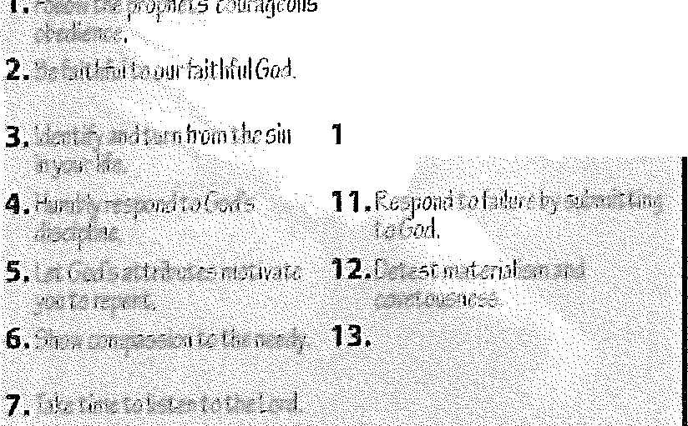
- Responses to tne Goel of the Prophets
8,fearandt1·uct C1 I\,),,r
Judge,
- Ra( uiili::-,; -➔n-i ium-_:,�jj fn_•rt1pr11ie
- St�l.: t',-•�now,1itl

