Scripture Focus
Jonah 3; 4
Key Verse
LESSON 11


God of the Second Opportunity
- RBP transparencies 1/I 2,
and 14

"And the word of the LORD came unto Jonah the second time, saying, arise, go unto Nineveh, that great city, and preach unto it the preaching that I bid thee. So Jonah arose, and went unto Nineveh, according to the word of the LoRD" (Jonah 3:1-3a).
Overview
God gave Jonah a second chance to obey by going to Nineveh. Jonah went and preached. One of the greatest revivals in history broke out. Jonah pouted but finally accepted God's will.
Topic
Failure and God's grace
Theme
God graciously uses believers even after they fail Him.
Desired Learner Response
The learner will realize that failure does not preclude all future blessings and will praise God for His graciousness in his or her life.
Outline
- Jonah Preaches to the People (Jonah 3)
  - Jonah's second call (3:1-3)
  - Jonah's preaching (3:4)
  - The people's repentance (3:5-9)
  - God's mercy (3:10)
- God Teaches His Prophet Jonah 4)
  - Jonah's displeasure (4:1-3)
  - God's question (4:4, 5)
  - God's object lessons (4:6-8)
  - God's application (4:9-11)
One for Two
Ask: Name one saint from the Old Testament and one from the New Tes-
- Lesson 1·1 case study from
resource CD
,. Jonah 3:1�3a verse card from resout'ce CD

87

tament who failed when first called to do a work for God but who was given a second opportunity. (Answers may include Moses and Peter.)
Jonah is another person to whom God gave a second opportunity after failure. This lesson challenges us not to give up, but to praise God for His gracious second opportunities to do His will.
Second Opportunity
Jonah failed miserably when God asked him to do His will.
Ask: When, if ever, have you miserably failed to do God's will? Ask: How did you respond to the failure? (Questions 1, 2)
God's grace makes a way for us to still be useful to God after we fail Him. Jonah is a good example of someone taking advantage of a second opportu-nity to follow God's will.

Jonah Preaches to the People (Jonah 3)
We have seen that Jonah ran from God when God called him to preach to Nineveh. He sailed away across the Mediterranean Sea attempting to flee from the presence of God. God sent a storm; and when Jonah was thrown overboard, God sent a great fish to swallow Jonah. From the belly of the fish Jonah repented and prayed. God responded by directing the fish to deposit Jonah on the shore.

Jonah's second call (3:1-3)
Does God ever give us a second chance if we fail Him the first time He calls us to do a job for Him? The answer is seen in comparing 1:1 with 3:1. They both say that the word of the Lord came to Jonah, but 3:1 adds three significant words: "the second time."
Jonah finally went to Nineveh in obedience to God's call.
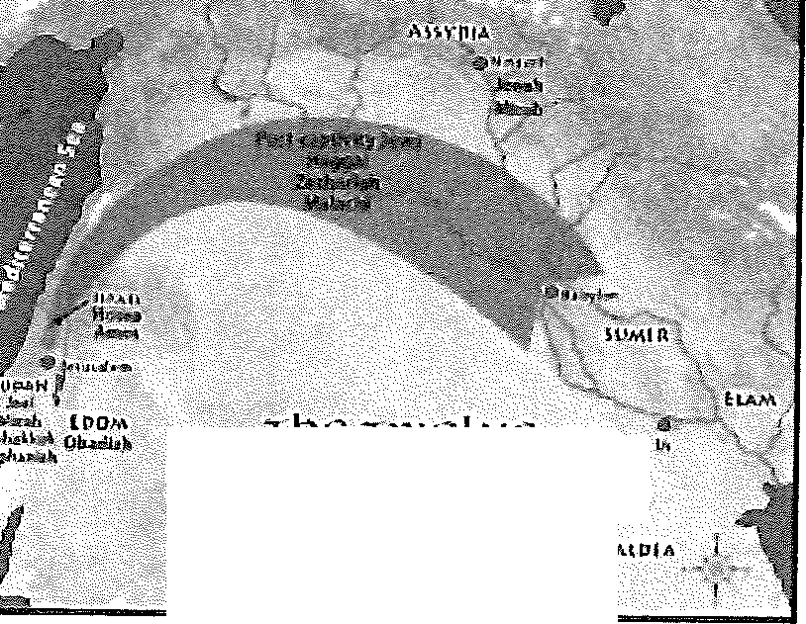
ASK: If you were in charge of evangelizing Nineveh/ would you give Jonah a second chance to do the job? Explain. (Question 3)

lb<: TW0LVG
nm,..JOR PROplJETS

For Jonah to go from Israel to Nineveh would have been about a 600-mile trip. It probably would have taken him three or more months to make the trip.
TRANSPARENCY: Display transparency 2 to show the distance between Israel and Nineveh,

Verse 3 says, "Now Nineveh was an exceeding great city of three days' journey." Archeologists have excavated part of ancient Nineveh and have found that it was indeed a vast city. The circumference of the outer suburbs of Nineveh was about sixty miles. Sixty miles on foot would certainly be a

good three days' journey.
After Jonah arrived at Nineveh, he started walking through the suburbs toward the inner city, which was the hub of the military and the government. There the palace of the king was located.
ASI<: How do you think Jonah, just one man in a very large city, was able to get God's message to everyone? (Question 4)

Jonah's preaching (3:4)
Verse 4 says, "And Jonah began to enter into the city a day's journey." Jonah preached as he walked into town. The source and content of a missionary's message are both impo1tant. Jonah got his message from God. He was told by God to preach only what God told him to preach.
We don't know a lot about Jonah's message. Undoubtedly he told the people about God, for they believed God as a result of his message (v. 5). Jonah may have even shared his personal story of how God kept him alive so he could bring them God's important message.
DISCUSS: Why are believers' stories about second chances sometimes so powerful in convincing
others to follow God? (Question 5)

It seems that Jonah repeated God's message over and over as he walked into town. "Yet forty days and Nineveh shall be overthrown. Yet forty days and Nineveh shall be over thrown. Yet forty days and Nineveh shall be overthrown."

The people's repentance (3:5-9)
The people of Nineveh believed Jonah's message. They wept at his words and believed in God.
READ: Jonah 3:5-10, ASK: What happened as a result of God giving Jonah a second opportunity to obey Him? (Question 6)

As we will learn, Jonah was not happy about Nineveh's repentance. But no doubt he reflected later in his life on the blessing of seeing such a large number of people believe in God. The fact that he wrote the book of Jonah shows that he was eventually glad God had used him in such a tremendous way.
EVALUATE: When we disobey God we are saying no to the blessings of obedience, (Question 7)

The people's faith was placed, not in Jonah, but in Jonah's God. This is the mark of genuine revival and should be the goal of eve1y true witness, missionary, preacher, or Bible teacher.
The people also proclaimed a fast. Not only was their faith immediate,

but so was the outworking of that faith. Their outward actions showed their inward change.
The people then put on sackcloth. Sackcloth was a rough garment that was worn as a sign of sorrow and humility. The people of Nineveh were genuinely sorry for their sinful ways, and they then humbled themselves before God.
This revival touched people in all walks of life. Even the king humbled himself before God (v. 6). In fact, he took the lead. He made an official proc-lamation decreeing a city-wide fast. The decree called on the people to fast, wear sackcloth, cry out to God, and turn from their evil ways (vv. 7-9).
The people acknowledged that their possessions (animals) were at the ser-vice of God. Giving God our hearts affects all areas of our lives. Billy Sunday once said, "When a person is converted, even his cat will know it."

God's mercy (3:10)
Verse 10 is a difficult verse. Immediately three questions come to mind. First, "Does God ever need to repent?" Second, "Can God do any evil?" Third, "Does not God always keep His Word?"
READ: Numbers 23:19. ASK: What does this verse dearly teach about God? (Question 8)

This is a problem, especially in light of Numbers 23:19, which says, "God is not a man, that he should lie; neither the son of man, that he should re-pent: hath he said, and shall he not do it? or hath he spoken, and shall he not make it good?"
First, "Does God ever need to repent?" God took note of the change in
Ninevah, so He brought about a different result. Instead of judgment, He showed mercy. That is what "God repented" means. God acted differently because the people had changed. He did not repent in the sense of being sorry for having done something sinful.
Second, "Can God do any evil?" There are two meanings of "evil" in verse
10. When it talks of the people of Nineveh turning from their evil ways, it is speaking of moral evil, such as murder, bloodshed, adultery.
In the second part of the verse "evil" is referring to calamity. We speak of a thunderstorm as being a "bad" storm. But a storm cannot sin. We simply mean it was a destructive storm. God said He was going to destroy Nineveh. TI1at is the evil the second part of the verse is speaking of. God would have still been perfectly holy even if He had brought calamity on the city.
Third, "Does not God always keep His word?" We must remember that this threatened doom was conditional, not absolute. It was conditioned on the continued wickedness of the people. If they had gone on as they were, judg-ment would have fallen. But since they forsook their evil ways, they were no longer under the threat of judgment. God was consistent. He always judges sin, and He always shows mercy to those who repent.

God Teaches His Prophet (Jonah 4)
      - Jonah's displeasure (4:1-3)

DISCUSS: After seeing God's merciful work in his own life and in the lives of those in Ninevah what attitude would you expect Jonah to have toward God? READ: Jonah 4:·1. ASK: How did Jonah
respond to the Ninevites' repentance? (Questions 9, 10)

Jonah was not just a little annoyed, he was red hot with anger. Why was Jonah exceedingly displeased and very ang1y?
Jonah himself gave the reason in verse 2. He was angry because he did not want Nineveh to share in the mercy of God. He had received pardoning mercy when he repented, but he did not want pagan Nineveh to share in the same.
READ: Jonah 4:2. ASK: What did Jonah believe about God? READ: Jonah 4:3. ASK: What did Jonah desire more than continuing to serve God? (Questions 11, 12)

God's question (4:4, 5)
God did not take Jonah's life; rather He asked Jonah a question. He said, "Doest thou well to be angry?" He said in effect, "Jonah, stop and think for a moment. Is it right for you to be angry? Is this how you should react to Nineveh's repentance?"
Jonah kept up his guard and made no reply. Instead he made a booth so that he could sit out under its shade and wait to see if the city would still be destroyed.
DISCUSS: How would you describe a person who longed to see other people destroyed by God? (Question 13)

God's object lessons (4:6-8)
Jonah did not realize it, but God was preparing three object lessons to teach Jonah another truth. Earlier God had prepared a fish to swallow Jonah and save his life. Now God prepared a plant, a worm, and an east wind.
While Jonah's booth gave him some shade, this plant gave much denser shade. His crude hut may have had a roof only, but no walls for a windbreak. The plant would provide a windbreak as well as denser shade.
We read that Jonah was exceedingly glad for the gourd. This is the only time in the book we read of Jonah's being happy.
READ: Jonah 4:6, DISCUSS: What did Jonah's happiness about the gourd reveal about how he viewed himself? (Question 14)

The next day the Lord proceeded with the second object lesson. God pre-pared a worm, and it ate off the gourd vine, or destroyed its root system. Plants

like squash, gourds, or pumpkins have a watery stem and wither rapidly if cut. Jonah's joy was in a plant. For this reason his joy was short lived (v. 7).
As the day progressed, God brought on the third object lesson. He prepared a sirocco, a blistering desert wind, to make things hot for Jonah. The sun also beat down on Jonah's head. The heat was too much for Jonah. He grew faint and wished he were dead (v. 8).
READ: Jonah 4:8. ASK: What does Jonah's desire for death reveal about his view of God, the creator of the plant, the worm, and the wind? (Question 15)

      - God's application (4:9-11)
The Lord then asked Jonah another question: "Doest thou well to be ang1y for the gourd?" It was the perfect question for the occasion, for Jonah would be proved wrong either way he answered it. If he had said, "No, it is not right for me to be angry because of a plant," he would stand self-condemned.
If he answered yes, as he did, he would be silenced by the obvious appli-
cation God was about to make. Jonah answered in his headstrong, stubborn way that he was right in being angry over the gourd vine (v. 9). The stage was set for the Lord to show Jonah the application of these object lessons.
The Lord pointed out to Jonah that he had pity on the gourd vine, yet he had no vital relationship to it. He did not plant it; he did not water it; he had done nothing to help the plant along. God also pointed out the temporariness of this particular plant. It came up one night and died the next. And yet for all this, Jonah expressed great compassion on this plant (v. 10).
God then asked Jonah one final, ve1y pointed question. "And should I not spare Nineveh, that great city, wherein are more than sixscore thousand persons that cannot discern between their right hand and their left hand?" (v. 11).
ASK: What was the only relationship God had with the people of Nineveh before they believed in Him? DISCUSS: How should that relationship have af-fected Jonah1s view of the people of Nineveh before he even preached to them? (Questions 16, 17)

The hundred and twenty thousand most likely refers to the children. To get His point across, God did not mention the adults. Jonah could argue that they deserved to be destroyed for their wickedness, so God mentioned only the children. God looked down from Heaven and saw 120,000 children in Nineveh in need of His grace, and His great heart yearned with compassion over this lost city.
Then the Lord drew out the application one step further when he added "and much cattle." If Jonah were right in grieving over one dried up gourd vine, surely it would be cmel to destroy Nineveh with all its innocent animals.
Jonah had no answer, and he quietly slips away from our sight. But Jonah finally got it all together, for he later wrote this book under the inspiration of the Holy Spirit. This very fact shows us the graciousness of God. He continues


to work with us even after we fail Him. He is indeed the God of the second chance. For Jonah He was the God of multiple chances.
Use the case study for lesson 11 as desired.
Ill Responses to the God of the Prophets
JOI\Ih!•�
11 Goel of the Seconc:I Chance

lessons from Jonah
Transparency: Display transparency 14. Discuss: Why does God desire to work with us even after we fail Him? Discuss: What can we learn from Jonah about the value of obeying God the first time? (Record learners' answers on the transparency.) (Questions 18, 19)
Fot·feited Blessings
Discuss: Are you resisting God's will for your life? If so, how? Ask: What blessings might you be forfeiting as a result of your disobedience? (Questions 20, 21)
God's desire to use us is great enough that He doesn't give up on us when we resist Him. His desire is great because He loves people and wants us to have the privilege of witnessing and ministering to them. Submit to God today and realize the blessings of obedience!
Praise God!
Lead your class in praising God for His graciousness in giving us second opportunities to obey and serve Him.
Review Transparency
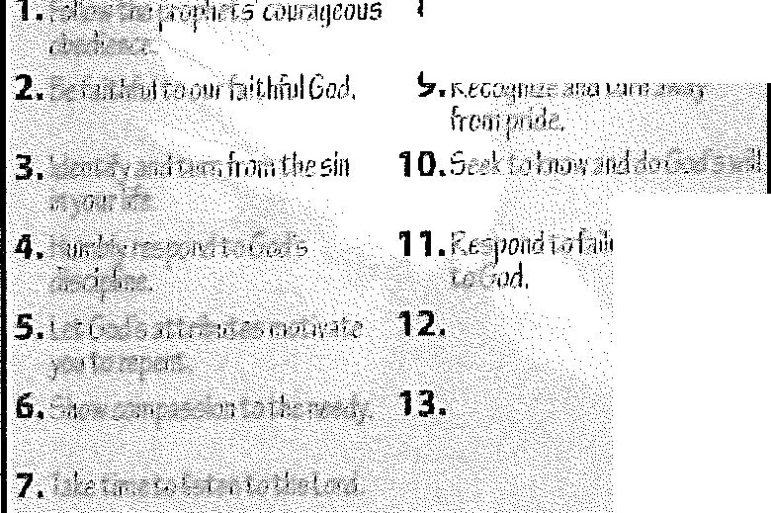
Use transparency 1 to review the response for this lesson: Respond to failure by submitting to God.
8.faal'andt,w:ctGrxl ,,,,,-t
Judge
Memory Verses
Distribute copies of the Jonah 3:1-3a verse card from the resource CD. Encourage the learners to memorize the verses.

