LESSON 10

You Cannot Run from God

Scripture Focus

- RBP transparencies 1, 2, 3,
and 13
- Resource 1 from resource

CD
- Lesson ·1O case study from
resource CD
- Jonah 2:7 verse card from resource CD
11 Children's story book of the
account of Jonah
Jonah 1; 2
Key Verse
"When my soul fainted within me I remembered the LoRD: and my prayer came in unto thee, into thine holy temple" (Jonah 2:7).
Overview
Jonah received a call from God to go to preach in Nineveh, but he ran away from God. He boarded a ship going to far-off Tarshish. God intervened with chastisement, sending a storm. Jonah requested to be thrown overboard and was swallowed by a fish. In the fish he repented, turning to God in prayer.
Topic
God's will
Theme
God expects His people to be available to do His will.
Desired Learner Response
The learner will make him- or herself available to God to use as He wills.
Outline
- God's Call to Jonah (Jonah 1:1-16)
  - The man and his times
  - The call (1:1, 2)
  - Jonah's response (1:3)
  - God's chastisement (1:4-16)
- Jonah's Call to God (Jonah 1:17-2:10)
·A.The time ofJonah's prayer (1:17-2:10)
B. The content of Jonah's prayer (2:2-9)
C. God's response to Jonah's prayer (2:10)

Easy Version
Bring in a good children's book that tells the story of Jonah. Read it aloud to your learners, enjoying it together and showing them the pictures.

80

LESSON 10 You Cannot Run from God 81

Discuss: Though the story of Jonah is easy to read, what aspects of it are sometimes hard to live out?
Jonah found submitting to God's will difficult to do. His failed attempt to run from God serves to remind us of our need to willingly make ourselves available to be used by God.
Wholly Available
Ask: Do you have a secret list of places you hope God never calls you to? Ask: Have you ever tried to resist God's calling on your life? If so, what happened as a result? (Questions 1, 2)
God had big plans for Jonah, but he wasn't interested. He tried to run from God but soon learned the futility of his attempt.

God's Call to Jonah (Jonah 1:1-16)
Jonah 1 contrasts in several ways with Jonah 2. In the first chapter, we have God's call to Jonah; in the second chapter we have Jonah's call to God. In the first chapter we find God's plan for his man; in the second chapter we find a man's prayer to his God. In the first chapter we see Jonah's rebellion; in the second chapter we see Jonah's repentance.
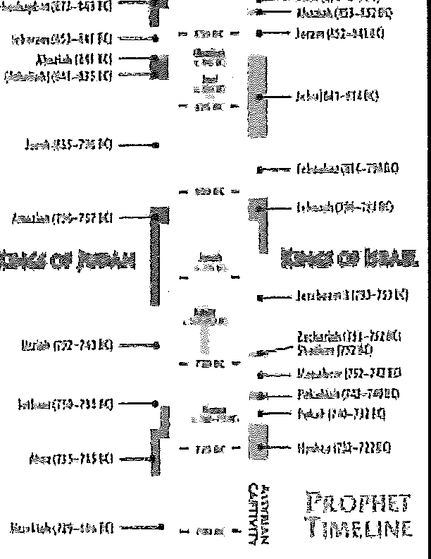
The contrast in Jonah will help us evaluate where we stand in relation to making ourselves available to God.

The man and his times
Jonah is one of the strangest books of the Bible in some ways. Jonah was a prophet, yet there is no prophecy in his book except the one sentence he preached in Nineveh. This short sentence has only eight words (five in the original Hebrew). He was a missionary, but he did not want to go to the mis-sion field. He saw great revival, yet he was very unhappy that the revival came about. Who was this man? When did he live? Was he for real?
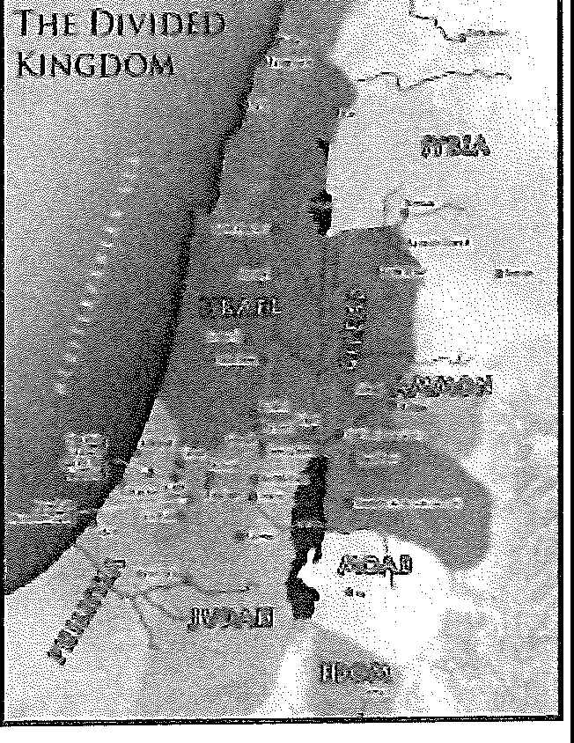
Jonah, whose name means "dove," was the son of Amittai. TI1e book of Jonah gives no other information about him. However, he is mentioned briefly in three other books of the Bible. Second Kings 14:25 is helpful in determining his town, tribe, and date.
TRANSPARENCY: Display transparency 3 to place Jonah in the right tirne frame,

Jonah's home town was Gath Hepher, a city in the tribal lands of Zebulon between the Sea of Galilee and the Mediterranean Sea. Thus he was from the Northern Kingdom (Israel).
MAP: Display resource 1 to show the location of Gath Hepher and other places as they are men-

82 RESPONDING TO GOD'S FAITHFUL INTERVENTION: MINOR PROPHETS PART l

tioned in the text or lesson.

He prophesied in the days of Jeroboam II. This king ruled the northern kingdom of Israel from 793 to 753 BC, so we may place Jonah's date at about 775 BC.
King Jeroboam II had a long and prosperous reign. He is noted as a great military leader who expanded the kingdom of Israel until it once more reached the size it had under David and Solomon. This period is known as the golden age of the Northern Kingdom.
Jonah is also mentioned in Matthew (12:39-41; 16:4) and Luke (11:29-32), where he serves as a type of Christ. The credence Christ gave the account of Jonah shows that Jonah was a real, historic person who was a prophet, a preacher, and a sign to the people of Nineveh.
  - The call (1:1, 2)
READ: Jonah 1:1, 2.

How did the word of the Lord come to Jonah? In his day some of the Bible was already written. God may have spoken to Jonah in part through these early books. But most likely God's Word came through an audible voice or by a vision or a dream, all common ways for God to speak to His prophets.
DISCUSS: How does God speak to us today? (Ques-tion 3)

God's call toJonah was, "Arise, go to Nineveh, that great city, and cry against it" (1:2). Jonah received a threefold command. He was to arise, to go, and to c1y. God was sending Jonah to be a foreign missionary.
God's will for our lives involves action. He wants us to live for Him. He wants us to be active in His work. It is not enough that we simply learn Bible facts and figures. We need to apply Biblical principles to our lives.
God told Jonah to go to Nineveh, a "great city" (v. 2). Nineveh was the capital of the Assyrian Empire, the largest and strongest empire in the Near East in Jonah's day.
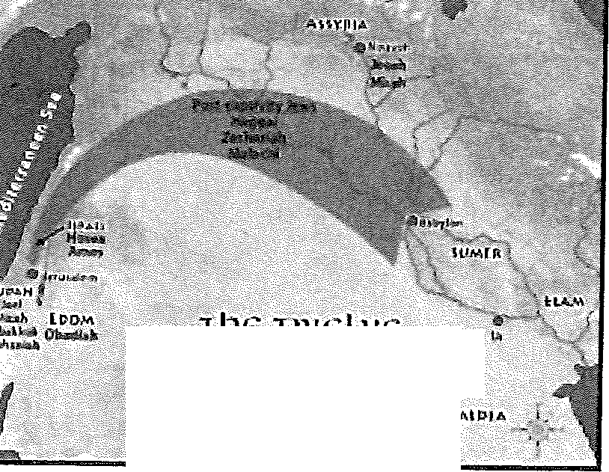
TRANSPARENCY: Display transparency 2, and point out Nineveh's location.
cnn..JOR PROJJIJflS
TIJE TW<.:'LV<:

Nineveh was a massive city located on the east bank of the Tigris River. With its suburbs, it covered an area about 25 by 30 miles. At the center was a core city that measured 1.5 miles. This inner city had great protective walls 100 feet high, 50 feet thick, and 8 miles in circumference. On the top of the walls were towers that reached upward another 100 feet.
Nineveh was a populous city. Estimates of its population run as high as 600,000, including the suburbs. An inscription left by king Ashurnasipal II states that about 70,000 of Nineveh's elite attended a dedication banquet at the king's palace.

LESSON 10 You Cannot Run from God 83

Jonah was to go and preach ("cry") against this great city.
ASK: Why did God want Jonah to preach to Ni-neveh (v. 2)? (Question 4)

Assyria was known as the cruelest of all ancient empires. The word "wick-edness" of verse 2 is the same word that is used of Cain in Genesis 4:10. Cain was the world's first murderer. This word is also used of Sodom in Genesis
18. Sodom was known for its immorality and sexual perversion. Nineveh was also associated with bloodshed and treachery.
Nineveh had the philosophy that "Might makes right." It brutally maimed and mangled the smaller nations around it. Its wickedness had come up before God. Now God called Jonah to go preach judgment on Nineveh.
ASK: How comfortable would you feel going to preach to a city as cruel as Nineveh? ASK: What are sorne modern mission fields that might compare to Nineveh's cruelty? (Questions 5, 6)

Jonah's response (1:3)
Verse 3 gives Jonah's response to God's call. We might wish that it said, "So Jonah rose up to go unto Nineveh." Instead we read, "But Jonah rose up to flee unto Tarshish."
Isn't that strange? Here was a prophet, a man of God, who knew that God was sovereign and who had just received a call from God. Yet he set out to disobey.
ASK: What excuses might Jonah have given con-cerning the practicality of trying to preach to a great city? (Question 7)

We find it easy to be critical of Jonah, but we all have been as blatantly disobedient to God at some point in our lives. Jonah's disobedience just hap-pens to be recorded in the Scripture for us to read and study.
Jonah went to Tarshish, a place archeologists have yet to identify. Some Bible teachers think the city was in southern Spain, near the rock of Gibral-tar. Others feel it was on the western edge of the northern coast of Africa. In either case, Nineveh was east and Tarshish was west. Jonah could not have gone more contrary to the will of God.
DISCUSS: What must Jonah have believed about God's will by so blatantly disregarding it? DiSCUSS: What must Jonah have believed about God by try-ing to run from Him? (Questions 8, 9)

Jonah went to Joppa to catch a ship. Joppa was a seaport town about fifty miles from Jonah's home town of Gath Hepher. It is the modern city of Haifa, today the second largest city of Israel. Even in Jonah's day it was a

84 RESPONDING TO GOD'S FAITHFUL INTERVENTION: MINOR PROPHETS PART 1

busy port.
At Joppa Jonah found a ship going to Tarshish. It might have been easy for Jonah to rationalize and say, "It is all right for me to go to Tarshish because here is a ship going to that very place, and it has room for an extra passenger."
DISCUSS: Do circumstances always indicate God's will? DISCUSS: Do they ever indicate it? Explain. (Questions 10, 11)

For Jonah, circumstances were favorable for him to rnn from going to Ni-neveh. But God had told Jonah that His will for Jonah was to go to Nineveh. If we know from God's Word that He wants us to do something, we should do it regardless of circumstances. Circumstances may be helpful in determin-ing God's will for our lives, but circumstances never indicate His will if they are contrary to His Word.

God's chastisement (1:4-16)
God is sovereign, and Jonah should have known he could not really run from God.
READ: Jonah 1:4.

The original language is very vivid here. God hurled a great wind onto the sea.
The sailors did two things to alleviate the situation. On the one hand they unloaded the cargo to lighten the ship and keep it from sinking (v. 5). They wanted it to ride higher in the water so that the waves would not dump so much water into the ship. This action was expensive. It meant the cargo was irretrievably lost.
The other thing the sailors did was to call upon their gods (v. 5). They were pagans, but they were religious. They cried each man to his god; but it was all to no avail, for their gods were helpless idols.
TI1e captain of the ship finally aroused Jonah and told him to attend the prayer meeting. The captain realized that the gods of the sailors were helpless, and he thought Jonah's god might be able to help.
READ: Jonah 1:6. DISCUSS: Why do you suppose Jonah didn't immediately begin calling out to God? DISCUSS: What does running from God's will do to our personal relationship with God and in turn our spiritual growth? (Questions 12, 13)

When Jonah arrived on deck, the sailors cast lots to determine who the cause of the storm was. Casting lots is ordinarily a thing of chance, but here God intervened and saw to it that the lot fell on Jonah. So suddenly all eyes were fixed on him. The men then asked him to give an account of himself.
Notice the irony of this situation. Jonah was in this position because he refused to preach to pagans. But now, in spite of himself, he was about to do

LESSON 10 You Cannot Run fro:m God 85

precisely that. God was going to show that His purposes will always be ac-complished even, if need be, by one who is obstinately disobedient.
Jonah told them about his nationality and his God. He also told them to throw him into the sea. The sailors tried to go back to shore, but were unable to make it. "So they took up Jonah, and cast him forth into the sea: and the sea ceased from her raging" (1:15).
DISCUSS: What could Jonah have done to stop the storm instead of asking the sailors to throw him overboard? DISCUSS: What did Jonah show about his attitude toward both God and the people of Nineveh by choosing suicide? (Questions 14, 15)

The sailors understood the seriousness of the situation. By offering sacri-fices to God they showed at least a sensitivity toward Him and compassion for people (v. 16).

Jonah's Call to God (Jonah 1:17-2:10)
Though Jonah was rebelling against God, God cared enough about Jonah to prepare a great fish to provide a place for Jonah. God's plan for Jonah was not to perish in the sea, but to preach in the city.
Scoffers have mocked at the idea of Jonah's being swallowed by a fish and surviving the ordeal. It could be pointed out that there are cases where this has happened. However, the answer to objections is that this was a miracle performed by an omnipotent Creator.

The time of Jonah's prayer (1:17-2:10)

READ: Jonah 1:17; 2:1, DISCUSS: Why do you suppose Jonah waite·d three days before praying? (Question '16)

Jonah continued to rebel against God and things went from bad to worse. Finally after three days of misery in the stomach of the fish, wishing for death but not being able to die, Jonah came to the end of himself and turned to God.
The school of affliction often becomes the school of prayer. Things got so bad for Jonah that he finally broke down and prayed.

The content of Jonah's prayer (2:2-9)
READ: Jonah 2:2-9. ASK: List the various aspects of Jonah's prayer, (Question 17)

In his prayer Jonah acknowledged that God had chastised him, that he had not cried out to God for a while, and that God heard him when he did (v. 2). He also expressed hope of looking again toward God's temple (v. 4). He vividly described sinking into the water and having the seaweed wrap itself around his head (v. 5). He remembered a vow he had made, and he

86 RESPONDING TO GOD'S FAITHFUL INTERVENTION: MINOR PROPHETS PART 1

determined to keep it. He closed his prayer with the blessed thought that "salvation is of the Lord" (v. 9).

God's response to Jonah's prayer (2:10)
God answered Jonah's prayer. He directed the fish to bring Jonah to the shore and deposit him there. Jonah would have been too weak to swim back to shore from too far out in the sea (v. 10).
Jonah could have saved himself and others much grief by following God's call in the first place, but finally he was ready to go to Nineveh.

- ALIGNING WITH GOD'S WILlionll,l:l

Use the case study for lesson
10 as desired.


.., Responses to the God of the Prophets
1. �4;,ictll,,/ profht!:o'co;1r.11cou5 8.Fearan,ltn,st Ga,�,•�:,r
.:i�11u.
2.�t�1ttflilt)o11rbllhfo!Guci.
.Ju,l,1c.
⁹•i^{P}i:.1^{u}1:��1::•,1,:·,11'1t.u0,1·''/01\'
1O.S,,k td,;cw 3ndd.iC--,-.f,;;;;,1
11.
S.i�U'<d'utti:tir:l!',""'A'm" 12,
,�;1Ul�.
6.�"'•"�kl I;�r.-r�, 13.
The Meaning and Practice of Alignanen't
Transparency: Display transparency 13. Discuss: What does it mean to "align ourselves with God's will"? Discuss: How do we do that? (Record learners' answers on the transparency. (Questions 18, 19)
Discuss: How does the statement "align with God's will" summarize the theme of Jonah? (Question 20)
Personal Alignment
Testimony: Ask if any learners would like to share a testimony about how God worked in their lives to teach them to align themselves with God's will. (Question 21)
Review Transparency
Use transparency 1 to review the response for this lesson: Seek to know and do God's will.
Memory Verse
Distribute copies of the Jonah 2:7 verse card from the resource CD. Encour-age the learners to memorize the verse.

