LESSON '1


God's Servants '
the Prophets
Scripture Focus

Various passages
KeyVet·se
"Be not afraid of their faces: for I am with thee to deliver thee, saith the LoRD" (Jeremiah 1:8).
Overview
God sent numerous prophets throughout the history of the Old Testament. All true prophets courageously declared God's will. They not only made pre-dictions, but they also condemned sin and confronted kings. This quarter will cover the books Hosea through Micah. As "seers," the prophets saw God's will; as "prophets," they communicated His will. This communication involved ethical preaching and detailed predictions, much of it phrased as poetry.
Topic
Courageous prophetsss
Theme
God sent the prophets to proclaim His Word courageously.
Desired learner Response
The learner will develop prophet-like courage in doing and saying the right things.
Outline
- The Success of Old Testament Prophets
  - Prophets who ministered before Joshua
  - Prophets who ministered during the judges
  - Prophets who ministered during and after David
- The Purpose of Old Testament Prophets
  - As seers
  - As prophets
- The Activities of Old Testament Prophets
  - Ethical preaching
  - Detailed predictions
  - Great poetry
- RBP uansparendes ·1 and 2
,ft Lesson 1 G1se study frcun resource CD
- .Jer,�miah 1:8 ve.-se card
from ��esource CD
0 Microphone (real Oi' prop)

9

10 RESPONDING TO GOD'S FAITHFUL INTERVENTION: MINOR PROPHETS PART 1

Choose one of the following activities to introduce this lesson.

To give your learners the opportunity to feel their fear of making a speech tell them that you will randomly choose one of them each week during the quar-ter to give a ten-minute speech on one of the prophets. Encour-age them to be ready to give a speech next week. Allow them to react or protest before telling them you aren't going to make them give speeches.
Microphone Response
Display a microphone. Ask: What would go through your mind if I handed you this microphone and asked you to give a speech? Ask: How would you respond if I told you your speech must be one of condemnation to a group of ungodly people? (Questions 1, 2)
Nearly 50 percent of people would list giving a speech as their most ter-rifying experience. Have the learners who think giving a speech is terrifying raise their hands. Comment on the percentage of people in the class who fear giving speeches.
God's prophets gave numerous speeches on subject matters that sometimes cost them their lives. Yet they spoke confidently and courageously because they were speaking for the Lord. Their courageous obedience should encour-age us to obey courageously too.
Ambassador Treatment
Ask: What are three ways you would expect a foreign country to treat one of our country's ambassadors? Ask: What would you expect our country to do if one of our ambassadors was attacked or thrown in jail by his host count1y? Ask: Why would you refuse to be the next ambassador to that abu-sive country?
God's prophets were God's ambassadors, but the people to whom they were sent often mistreated them or even took their lives. Being a prophet of God took courage. They serve as our examples of courageous obedience to God.

The Success of Old Testament Prophets
  - Prophets who ministered before Joshua
Prophecy and "prophets" existed from the very beginning. For example, Je-sus identified Adam and Eve's son Abel as the very first prophet (Luke 11:49-51; cf. Gen. 4:1-10). Enoch, described as the seventh from Adam, prophesied (Jude 14; cf. Gen. 5:22-24). Jacob assembled his sons and in his final blessing he foretold to them what would take place in the distant future (Gen. 49:1-28). God designated Aaron as Moses' prophet, or mouthpiece (Exod. 7:1).
READ: Exodus 3:10. ASK: What courageous act did God ask Moses to do for Him? ASK: How much would you have protested God's plan if you were in Moses' place? READ: Exodus 3:13-15. ASK: God's

LESSON 1 God's Se14vants, the Prophets 11

name "I AfW' refers to His eternal and independent existence. How should those qualities have affected Moses as he decided whether to obey God? (Ques-tions 3-5)

Moses functioned as the ideal model for all later prophets (Deut. 18:15-18). Moses interceded between God and the people by approaching God, receiving His word, and reporting back to the people all that God had said.

Prophets who ministered during the judges
Following Moses, God kept His promise to send a succession of prophets who regularly reminded the people of His will (Deut. 18:15, 18). Unfortunately, the Israelites stubbornly rejected the word of the Lord (Jer. 7:25, 26).
READ: Jeremiah 7:25, 26, ASK: How did God describe the people's response to His prophets? (Question 6)

The book of Judges mentions an anonymous prophet who reminded the people of God's past provision and their present disobedience (Judg. 6:8-10). When Samuel was a boy, the voice of prophecy was rarely heard (1 Sam. 3:1); but during his adult ministry, a whole "company of prophets" arose (10:5).
Members of this prophetic band were probably disciples of Samuel. It is possible that several such groups arose with each one located at the various stops on Samuel's judicial circuit (7:15-17). Some Israelites wondered if King Saul were not a member of a company of prophets (10:10-12; 19:18-24).

Prophets who ministered during and after David
A host of prophets ministered during the days of the kings of Israel and Judah. They may be classified into two groups: non-canonical prophets, who did not write books of the Bible, and canonical prophets, who did.
One of the more famous non-canonical prophets was Nathan, who proph-esied during the reigns of David and Solomon (2 Sam. 7:2-17; 1 Kings 1:8-45). On one occasion he confronted King David regarding his sins of adultery and murder (2 Sam. 12:1-15). This shows how the true prophets of God demon-strated great courage while making their pronouncements.
READ: 2 Samuel ·12:7-12, ASK: What phrases from
!\lathan1sspeech show that he approached his role as
a prophet seriously and courageously? (Question 7)

The prophet Gad ministered before and during David's reign (1 Sam. 22:5; 2 Sam. 24:11; 1 Chron. 21:9-19), and Ahijah predicted the division of the
kingdom (1 Kings 11:29-40).
Years later, Micaiah was not afraid to warn King Ahab of his impending death in battle-even though the king's messenger cautioned Micaiah that all four hundred of the king's personal prophets had unanimously foretold suc-cess (1 Kings 22:5-28). Just like Nathan, Micaiah was not afraid to confront a king. Unlike Nathan, Micaiah was imprisoned because of it (22:26-28).

12 RESPONDING TO GOD'S FAITHFUL INTERVENTION: MINOR PROPHETS PART 1

READ: 1 Kings 22:26-28. ASK: Whom did Micaiah fear more-Ahab or God7 DISCUSS: How do you know? (Questions 8, 9)

Probably the two best known non-canonical prophets are Elijah (1 Kings 17-2 Kings 2) and Elisha (2 Kings 2-13). These two prophets announced divine judgment against Israel and performed many miracles. Elijah and Elisha called the people to return to the God of their fathers and to forsake the false gods, especially Baal.
Elijah was fed by ravens at the brook Cherith, and later from the widow's self-replenishing flour bin. He prayed and God sent back the widow's son from the dead, sent fire from heaven upon Mount Carmel, and sent an abundant rain to end the long drought. After the "mountaintop experience" at Carmel, Elijah momentarily lost his courage and fled from Queen Jezebel.
READ: 1 Kings 19:10. ASK: Elijah lost his courage because he felt all alone. What happens to your courage to obey God when you focus on your limited abilities'? (Question 1O)

God reassured Elijah of His presence with him and then revealed to Elijah that there were seven thousand other follows of God in Israel too.
After returning to Israel, Elijah designated Elisha as his successor by casting his mantle on him. In the end, Elijah was carried to Heaven in a whirlwind after being separated from Elisha by a chariot of fire.
Elisha became Elijah's heir to ministry since he had received a double por-tion of his master's spirit (2 Kings 2:9-11; Deut. 21:17). As Elijah's successor, Elisha performed many miracles. Most notably, Elisha instructed Naaman the Syrian to wash in the Jordan so he would be healed of his leprosy, led the blinded Syrian army to Samaria, performed a miracle with the widow's oil, and raised the Shunammite's son from the dead. Elisha predicted the rise of Hazael to the throne of Syria and sent one of the "sons of the prophets" to anoint Jehu to be king over Israel.
Originally, Elisha was one of Elijah's pupils, which explains why Elisha called Elijah, "My father, My father" (2 Kings 2:12). Similarly, the "sons of the prophets" were all followers of a senior prophet (either Elijah or Elisha). This master-student relationship resembles that of the "company of the prophets" who studied under Samuel. •
The sons of the prophets were not wealthy (2 Kings 4:1; 6:5), and so they survived on the alms of the people (2 Kings 5:15; 8:8; 1 Sam. 9:8) and on their own foraging (2 Kings 4:39). Some lived together and shared meals (2 Kings 4:38-41), others were married and lived in their own houses (2 Kings 4:1, 2).
ASK: Why did living on donations and foraging demand that the sons of the prophets show cour-age? (Question 11)


LESSON 1
13

Some of the sons of the prophets acted as messengers for their senior prophet. For example, Elisha called on one of them to anoint Jehu as king over Israel (2 Kings 9:1-10).
In addition to the non-canonical prophets, sixteen canonical prophets wrote seventeen books of the Old Testament. Their writings include the books of Isaiah through Malachi. Jeremiah wrote both the book that bears his name and the book of Lamentations.
The last twelve of these books, Hosea through Malachi, are known as the Minor Prophets. We do not call them "Minor" in the sense that they are of little significance. Certainly they form an integral part of God's Word. Instead we call them "Minor" because of their relative brevity, especially when com-pared with the much longer prophecies of Isaiah, Jeremiah, and Ezekiel. In the Hebrew Bible, the Minor Prophets were all copied onto one scroll and were entitled "The Twelve."
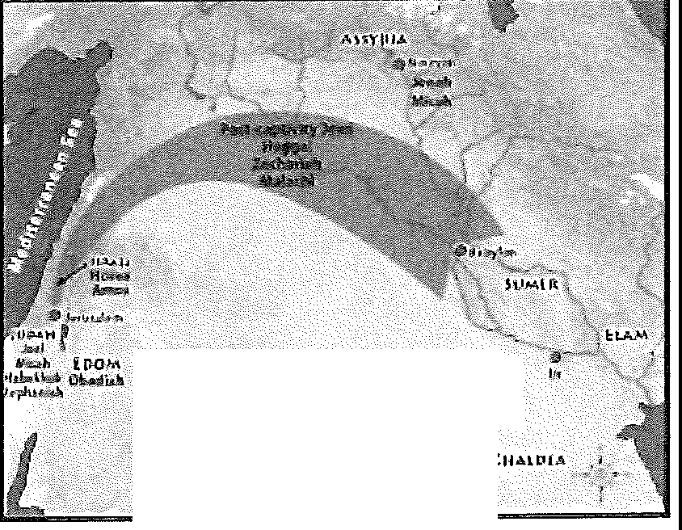
Display transparency 2 as you describe the various areas and times of ministry of the Minor Prophets.

ll)E twcLVE
OJ11'.IOR PROPIJGTS

Most of the Minor Prophets ministered before the Babylonian captivity. Three ministered after the exile. Some prophesied to the northern kingdom of Israel, others to the southern kingdom of Judah, still others to foreign na-tions. During the coming quarter we will study Hosea, Joel, Amos, Obadiah, Jonah, and Micah.

The Purpose of Old Testament Prophets
God sent His servants, the prophets, for a reason. Fundamentally, their function was to convey the word of the Lord. Their messages were of divine origin and were given under divine compulsion.

As seers
The titles used to designate the Old Testament prophets give insight into their God-given purpose. Two primary English terms appear in the Bible: "seer" and "prophet."
The common title for a prophet during the early years of Israel's history was "seer" (1 Sam. 9:9). This title emphasized the prophets' role of receiving the divine message, in that the prophets saw or envisioned the word of the Lord.
The English word "seer" translates two different Hebrew words. The first word means "one who sees," and it occurs, for example, in 1 Samuel 9:9. The second word means "one who envisions," and it occurs, for example, in Amos 7:12. Therefore, the seer was one who perceived (saw) God's will and visual-ized (envisioned) God's future judgments and blessings.

As prophets
The title "prophet" emphasized the prophet's function of speaking God's message. An excellent passage that illustrates this emphasis is Exodus 7:1 and 2 (see also 4:16).

Our survey of the Old Tes-tament prophets would not be complete without referring to the Old Testament prophetesses as well. Both j\!liriam (Exod. 15:20) and Deborah were prophetesses (Juclg. 4:4). Other prophetesses included Isaiah,s wife (Isa. 8:3) and Huldah (2 Kings 22:14).

14 RESPONDING TO GOD'S FAITHFUL INTERVENTION: MINOR PROPHETS PART 1

READ: Exodus 7:1, 2,

Often the prophets spoke of the future while using the Hebrew "perfect tenset which describes completed action. T11ey did this because fulfillment was assured. Translators have used the future tense to accurately convey the meaning.
Aaron functioned as Moses' spokesman, and in like manner the prophets functioned as God's spokesmen, proclaiming the divine message. When God called Jeremiah into prophetic ministry, God made this clear to him. Jeremiah was to speak whatever God commanded him, and he was not to be afraid (Jer. 1:7, 8).
READ: Jeremiah 1:7, 8. ASK: Why was Jeremiah not to be afraid? What was supposed to give him courage? (Question ·12)

Since the word came from the Lord, the desired result would invariably occur. After all, when God speaks, He accomplishes His will. The prophets made many detailed predictions of events that would not transpire for many years. All of their predictions have been or will be completely fulfilled because the same God who revealed them has and will accomplish them. The Lord Himself explained this principle of certain realization.
READ: Ezekiel ·I2:25a, ASK: How do you think the certain realization of God's message affected Eze-kiel as he proclaimed God's words? (Question 13)

The terms "seer" and "prophet" each emphasize a different aspect of the prophetic ministry. As a seer, the man of God received the divine message. As a prophet, he proclaimed that message. The prophets' primary function, then, was to speak the messages that God had revealed to them. Isaiah 30:10 succinctly points to this twofold purpose of seeing and then speaking.
READ: Isaiah 30:10,

The Activities of Old Testament Prophets
  - Ethical preaching
The prophets were divinely appointed moral preachers, and they sounded warnings against the dangers of religious apostasy and formalism. In this ca-pacity they sometimes confronted not only the populous at large but priests and kings in particular.
ASK: On a scale of 1 to 10, with 10 being extremely difficult, where would you rank the task of confront-ing priests and kings about their sin? ASK: Where would you rank the task of confronting a friend about his or her sin? (Questions 14, 15)

Ethical preaching is difficult because no one is perfect but God. Yet God still called His imperfect prophets to this ministry.

LESSON 1 God's Servants, the Prophets 15

READ: Isaiah 6:1-7, ASK: What did Isaiah realize he needed before he could be God1s prophet (v. 5)? (Question 16)

Detailed predictions
Prophets made numerous predictions concerning the future of Israel and the Gentile nations, and they foretold specific details concerning the Person and ministry of the coming Messiah. Their Messianic prophecies took two forms. Some prophecies spoke of a victorious King, while others mentioned a suffering Servant. We know that at His first coming, Jesus Christ fulfilled the promises of a suffering Servant. The prophecies concerning a victorious King await fulfillment at Jesus Christ's second coming.

Great poetry
The prophets were premier orators and great poets. Their messages provide us with the finest literature in the world. To arrest the attention of their audi-ences, the prophets also communicated at times by means of symbolic acts. For example, Jeremiah wore a yoke (Jer. 27; 28), Isaiah walked about naked and barefoot for three years (Isa. 20), Ezekiel enacted the siege and destruc-tion of Jerusalem (Ezek. 4; 5), and Ahijah tore a new garment to represent the division of the kingdom (1 Kings 11:30-39).
READ: Isaiah 20. ASK: What point was Isaiah illus-trating by walking around for three years with no clothes on? ASK: What two words would you use to describe the courage Isaiah would have needed to complete such a task? (Questions 17, 18)

God will never ask us to go three years without wearing clothes, but He does expect us to have the same courageous obedience we see in His proph-ets in the Scriptures.

Great Desire
The prophets' great desire was to communicate God's Word. This means that they did so even when it required courage. Discuss: What desires might be controlling us when we refuse to share God's Word courageously? Ask: What are some situations in your life right now in which you need courage to conununicate of God's Word? (Question 19)
Paralyzing Fears
Discuss: What fears threaten to paralyze our obedience to God? Discuss: How do they compare to the fears that threatened many of God's prophets? Ask: What truths about God should help us overcome our paralyzing fears? (Questions 20-22)

Use the case study for lesson 1 as desired.

16 RESPONDING TO GOD'S FAITHF'UL INTERVENTION: MINOR PROPHETS PART 1

ml Responses to the God of the Prophets
Review Transparency
Use transparency 1 to review the response for this lesson: Follow the prophets' courageous obedience.
1c11f�-:.t�'iti:ll[J'opht1t!.-'a,i11�1qco·us 8 ..
,;tp��1tcCl
2. 9.
3. 10.
4.
s.
6.
11.
12.
13.
7,
Memory Verse
Distribute copies of the Jeremiah 1:8 verse card from the resource CD. Encourage the learners to memorize the verse.

