**1A**, **M**



**Topic**

**God's faithfulness**

**Theme**

**God as the Solid Rock is faithful to His people and His promises and worthy of our trust.**

**Desired Learner Response**

**The learner will put his confidence in God as the faithful, Solid Rock.**

**Materials**

* Resources 1 and 16
* Small stones (optional)
* Permanent markers (option­ al)

the Solid Rock

**Scripture Focus**

**Deut. 7-34**

**Summary**

This lesson covers Moses' song and blessing as well as his death. The focus of his song in particular is.God's faithfulness to Israel despite their unfaithful­ ness to Him . Moses calls God the Rock, a fitting description of His unwavering character throughout Israel's history.

**Outline**

1. **Moses' Song (Deut. 31:28-32:52)**
   1. Moses' call to listen (31:28- 32:2)
   2. Moses' praise of God (32:3, 4)
   3. Israel's response to God's person (32:5, 6)
   4. God's goodness to Israel (32:7-14)
   5. Israel's response to God's goodness (32:15-18)
   6. God's response to Israel 's unfaithfulness (32:19- 35)
   7. God's salvation of Israel (32:36-43)
2. **Moses' Application (32:44-52)**

**Ill. Moses' Blessing (Deut. 33)**

* 1. Introduction of the blessing (33:1-5)
  2. The blessing of the tribes (33:6-25)
  3. Conclusion (33:26-29)

**IV. Moses' Death (Deut. 34)**

**Memory Verses** *"Because I will publish the name of the Lord: ascribe ye greatness unto our God. He is the Rock, his work is perfect: for all his ways are judgment:*

*a God of truth and without iniquity.just and right is he" (Deuteronomy 32:3,4).*

**114**



**Swan Song**

# GETTING STARTED



**ASK:** What is a swan song? *(Someone's last performance or final accomplish­ ment.)*

The phrase *swan song* comes from an ancient legend about a swan. The legend says that the swan's only sound during its entire life is a song it sings right before it dies.

**ASK:** What would you like your swan song to be? (Q1)

**ASK:** How have you been influenced by someone else's swan song? (Q2)

The Bible passage for the final lesson in this course could be called Moses' swan song. In fact, he wrote his final words to Israel as a song. The song provides a good summary of Israel's understanding of the Lord, the I AM. It puts their history and future as well as God's characteristics into focus.

## Meaningful Songs about God

God created music and intended for His people to sing about Him and His works. Songs make remembering those important truths easier.

**ASK:** What songs about God's person and works are particularly meaningful to you?

. **ASK:** When has a song about God helped you in a difficult time in your life?

The Bible passage for the final lesson in this course is Moses' final words to Israel. He wrote the words in the form of a song. The song provides a good summa· ry of Israel's understanding of the Lord, the I AM. It puts their history and future as well as God's characteristics into focus.

# SEARCHING THE SCRIPTURES

Deuteronomy 7- 31repeats a lot of Israel's history and clarifies God's com­ mandments about a variety of topics. The new generations needed to hear God's law from Moses before he died and before they moved into the Promised Land. The overriding theme of the section is the need for Israel to love God for Who He is and What He has done for them. That theme reached its crescendo in Moses' song that ended his instructions to Israel (Deut. 32; 33). Moses sung about God as the Solid Rock and about Israel as the often unfaithful, rebellious nation. The value in the song comes in hearing a review of God's introduction of Himself through His relationship with Israel. All of the major lessons gleamed from God's interaction with Israel are repeated in some form in his last song for Israel.

1. **Moses' Song (Deut. 31:28-32:52)**
   1. **Moses' call to listen (31:28-32:2)**

Moses commanded the leadership of Israel to be assembled before him so he could give his final address (31:28, 29). Moses' song begins with a call for creation to witness the judgment that is going to be revealed. The heavens and earth are fitting *witnesses* since Moses' message was of grand importance.

**READ:** Deuteronomy 32:2. **ASK:** What effect did Moses want his teaching to have on the Israelites? (Q3) *He wanted his teaching to become* a *vital part of the Israelites' lives.*

Rain and dew sustain life for plants and cause growth. Moses wanted his words to be like rain that soaked into the ground and provided moisture for growth.

**ASK:** How might the Israelites soak in Moses' important words about God? (Q4)

*By memorizing them, thinking on them, and actively looking for ways to apply them.*

Perhaps the reference to the *tender herb* was meant to communicate that Israel was vulnerable and had an urgent need for the truth about God. A *tender herb* would quickly dry up and die without water.

* 1. **Moses' praise of God (32:3, 4)**

Moses began the heart of his song by praising God. He said, *I will publish the name of the LORD* (32:3). That didn't mean Moses was going to print God's name in the local newspaper. To *publish the name of the Lord* means to point out God's

qualities. His *name* then reflects His qualities. In anticipation of proclaiming God's name, Moses told the Israelites to *ascribe ye greatness unto our God* (32:3). To *ascribe greatness* means to *credit God with greatness .* Israel had many reasons to ascribe greatness to God. It should have come naturally for them as they reflected on their history. Later in the song Moses listed some of those reasons to ascribe greatness to God (32:7-14).

God deserved to be credited with greatness because He is the *Rock* (32:4). The name the *Rock* sums up how He had treated Israel since their beginning.

**READ:** Deuteronomy 32:4. **ASK:** What are some qualities of God that remind you of a rock? (QS) *God is consistent. He doesn't waver or change in His character. He is faithful and strong. He is always reli able.*

Moses added that God's *work* is *perfect* (32:4), a bold but true statement about God's actions . There was never a moment in Israel's history in which God treated them less than perfectly. Yet there were many times Israel tried to make that case (Exod. 14:11, 12; 15:22-24; 16:2, 3; 17:1- 3; Num. 11:4- 6; 14:1- 4). Israel believed any

time they weren't completely happy with their circumstances that God had some­ how wronged them. But in each instance they were the ones who were wrong.

Moses added the statement that *all His ways are judgment,* meaning *just* or *right* (Deut. 32:4). *Ways* is a reference to God's decisions . The word *all* left no room for arguing that God had ever made a choice that was tainted with *iniquity* or *injus­ tice.* Conversely, He is a *God of truth.* He has no devious or impure motives driving His actions and decisions .

**ASK:** How should Israel have responded to God's record of perfect actions and motives? (Q6) *They should have trusted Him completely, never complaining about their circumstances and doing exactly as He commanded with joyful hearts.*

## Israel's response to God's person (32:5, 6)

Moses' words to describe God give the sense of unwavering straightforward­ ness. His words to describe Israel are the opposite.

Israel rejected God even though He treated them perfectly. Their rejection of Him was a corrupt response (32:5). God most notably called Israel's actions corrupt when they made and worshiped the gold calf (9:12).They gave to their idol the honor that was God's exclusively. That put a *spot* on them that was not the *spot* of God's children . In other words, they acted as if they didn't belong to God. Moses further described them as a *perverse and crooked generation. Perverse* conveys the idea of *warped* or *twisted .* The picture is of Israel wandering off the straight path God laid out for them.

Israel's warped and crooked cond ition prompted Moses to ask two questions . The first question asked them if this was the way they were going to repay *(requite)* the Lord (32:6). Such an action was *foolish* and *unwise.* A *fool* is someone who thinks he knows better than God and that his way is the right way. The Israelites were convinced that they were in the right and God was wrong.

The second question pointed out that God was Israel's Father in the sense that He had formed them as a nation and *established* them . Hence they were responsi­ ble to Him. To take a crooked path away from God made no sense. Moses wanted Israel to understand the folly of living according to their desires.

**ASK:** In what sense does every sin against God not make any sense? (Q7)

*God is good to all men and perfectly just in His dealings with them.*

* 1. **God's goodness to Israel (32:7- 14)**

To make Israel's indictment even more serious, Moses went on to recount God's specific actions toward Israel. He introduced this section by calling on Israel to remember their past and to ask their elders to recount for them what God had done in their lifespans (32:7). This verse was for the current generation but also for the generations to come that would recite the song.

When God divided the nations He did so as the *Most High* (32:8) rather than as Yahweh, the name He used in His covenant relationship with Israel. God set Israel apart as His people and gave them Canaan to be their land. Israel was God's inheritance, the only nation with that special privilege (32:9).

The mention of a desert land in verse 10 is a reference to the early days of Israel's formation as God's chosen people. From that point in Israel's history, God protected them, directed them, and provided for them. To be the *apple* of God's *eye* means to be held as extremely dear by God.

**READ:** Deuteronomy 32:11, 12. **ASK:** How does Moses point out that God deserved all the credit for leading and caring for Israel? (Q8) *He said there was no other god with Israel when the Lord led them.*

Moses looked ahead to the time when Israel would be in the Promised Land and listed some of the sumptuous foods they would enjoy there (32:13, 14). He would give them the best of the best as they lived off the land.

* 1. **Israel's response to God's goodness (32:15-18)**

Moses, still looking to the future, knew what Israel's response would be.

Rather than responding with loyalty to God's generous expressions of love, Israel would reject God, pursue idolatry, and forget the God Who formed them (32:15- 18). *feshurun* (32:15) is a rare name for Israel. It is derived from a verb meaning *up­ right.* This passage's usage of *Jeshurun* creates a tragic irony; Israel is portrayed as anything but upright.Jeshurun is particularly tragic when set next to God's name, the *Rock.* Remember that is God's name that harkens back to His solid faithfulness throughout Israel's history.

**READ:** Deuteronomy 32:17, 18. **ASK:** What descriptions of the Israel's false gods make them sound so insignificant next to God, the Rock? (09) *They are called devils (demons); they were previously unknown by Israel and hence had*

*nothing to do with Israel's formation; they were new arrivals and therefore not* a *part*

*of bringing Israel to such* a *wonderful land.*

## God's response to Israel's unfaithfulness (32:19-35)

God *abhorred,* or *despised,* Israel for their idolatry (32:19). He said He would hide His face from them because of their lack of faith and their perverseness (32:20). When God shined His face on Israel they enjoyed His blessings. When God hid His face from Israel they experienced His chastening . God would work to turn Israel back to Himself by letting them see the inevitable results of their rebe llion.

God is just in this judgment because Israel turned from Him to worship *that which* is *not God* and idols. God's *jealousy* motivated His judgment, meaning He loved Israel too much to let them wander from Him. God would execute His judg­ ment by those *which are not a people* (32:21). This signifies that God would use the nations of the world to discipline His chosen people. Israel would witness terrifying bloodshed and destruction because of their infidelity to the Lord (32:22, 23). They would suffer hunger, attacks by beasts, and devastating attacks by invading armies. The armies would reach even into their homes, providing no safe place or retreat from the killing (32:24, 25). God would stay His hand only so that the invading armies would not credit themselves for the destruction instead of God (32:26, 27).

**READ:** Deuteronomy 32:28, 29. **ASK:** Why would God reveal all this destruc­ tion to Israel right before they were to enter the Promised Land? (01 O) *To deter them from idolatry; to help them understand the seriousness of idolatry; to show them that God loves them far too much to let them turn from Him.*

**READ:** Deuteronomy 32:30. **ASK:** What is the point of the question in this verse? (011) *To communicate that the Rock is faithful and that any destruction of Israel was due to their unfaithfulness.*

Lest Israel's enemies think they are free from responsibility for their actions,

Moses predicted their eventual destruction. Their *rock,* or *god,* is not like God, the *Rock* (32:31). God fights for His people and is mighty in power. Even His enemies at times judged this to be true (Exod. 14:25). God would take vengeance on Israel's enemies for their destructive cruelty (Deut. 32:32- 35).

### God's salvation of Israel (32:36-43)

The description of God's judgment is very severe (32:36). One could conclude that God will completely annihilate Israel in the latter days. But God will never abandon Israel.

**READ:** Deuteronomy 32:36-38. **ASK:** What will Israel learn from God's judgment of their sinful idolatry? (Ql 2) *That their false gods are powerless and ultimately mythical.*

God is the only true God. There are none beside Him at all. He controls the nations and the course of history. The arrows that pierced Israel would eventually pierce their enemies and no one could stop it (32:39- 42). This reversal would be cause for the Gentiles to rejoice with God's people (32:43).

**RESOURCE:** Display resource 16 to review God's faithfulness to Israel.

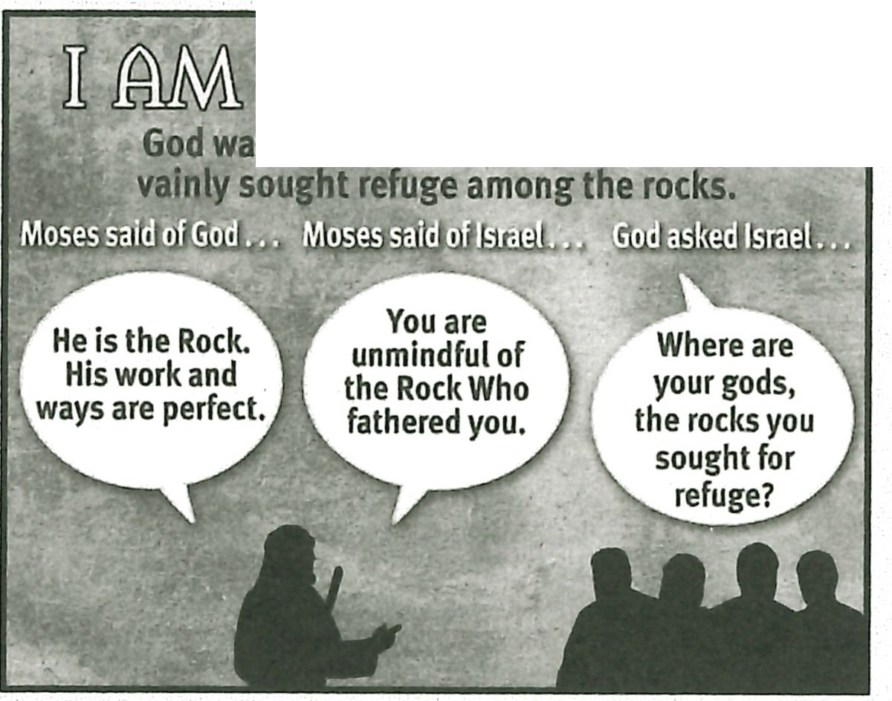

- ffihl @lll(Q) q

**was faithful to Israel though they**

Individual generations may experience God's judgment, but God will ultimate­ ly restore Israel. Moses expanded on this glimmer of hope in Deuteronomy 33.

### Moses' Application (32:44-52)

The bleak picture of coming judgment was intended to motivate faithfulness and obedience in the Israelites' lives.

**READ:** Deuteronomy 32:45-47. **ASK:** Why would it be worth the effort for Israel to strive to obey God? (Ql 3) *Their striving would not be in vain. And their obedience was their life. God would prolong their days in the Promised Land based*

*according to their obedience to Him.*

Prophesies of judgment are to create anticipation in the reader by motivating the individual to avoid judgment.

**READ:** Deuteronomy 32:51, 52. **ASK:** Why did God not allow Moses to enter the Promised Land? (Ql 4) *He failed to honor God*

The text's inclusion of God's instruction for Moses to die on Mount Nebo in this position seems strange at first (32:48- 52). However, it serves as an emotionally charged reminder: no one is beyond receiving God's judgment. Even Moses, the friend of God (Exod. 33:11), could face judgment because of unbelief. He was an immediate example to the rest of the nation.

### Moses' Blessing (Deut. 33)

Whereas Deuteronomy 32 focused on the judgment of Israel in the latter days, Deuteronomy 33 focuses on their eventual blessing. This final poem's form is very similar to Jacob's poetic blessing of Israel, the first major poem of the Pentateuch (Gen. 49). Deuteronomy 33 is filled with links to other passages throughout the

Pentateuch. These connections reinforce the overall message of the Pentateuch: the redeemed lived by faith. A significant portion of the content of Israel's faith was focused on the developing profile of the Messiah.

* 1. **Introduction of the blessing (33:1-5)**

Moses prefaced his blessings on the tribes by recalling when the Lord came down on Mount Sinai and gave Israel His law through Moses (Deut. 33:1- 4) . The Lord was motivated by His love for His people (33:3).

**READ:** Deuteronomy 33:2, 3. **ASK:** What motivated God to leave Heaven to come to Mount Sinai and meet with the sinful Israelites? (Ql 5) *His love for them.*

**ASK:** What motivates God to have a relationship with us today? Are we so special that God can't help meeting with us? (Ql 6) *His love for us. There is nothing in us that makes us desirable or worthy of God's love. He chooses to love us despite our unloveliness.*

The *king* in verse 5 could refer either to God or Moses. Most scholars see God as the King, though the context does allow for interpreting the king as Moses. While never an official king, Moses served as the authoritative, mediating leader of Israel.

The theme of *king* in Deuteronomy 33 :5 perhaps links to the *king* promis- es found in Genesis 49:10 and Numbers 24:7 - 9. If Moses is the king in mind in

Deuteronomy 33:5, then his identification as king in that passage should also be coupled with his role as priest. Moses met repeatedly with God and communicated God's law to the people. As a king, Moses would be similar to Melchizedek, the priest-king in Genesis 14:18 - 20.

* 1. **The blessing of the tribes (33:6-25)**

Moses blessed the tribes of Israel by name in Deuteronomy 33: 7- 25. The struc­ ture of the blessing creates a structural link with Genesis 49 . Both passages have an eschatological focus marked by a reference to the *latter days* in their introduc­ tion. And both passages project Israel's future.

In Genesis 49 the blessing of Judah is rather extended. By contrast Moses' blessing on Judah in Deuteronomy 33 encompasses only verse 7. The Deuteronomy passage assumes knowledge of the Genesis text.

The king theme in Deuteronomy 33 has already been injected with the intro­ duction to the poem. So Moses' blessing of Judah emphasizes Judah's *military*

role. That makes sense since the army of Judah was expected to lead the rest of the tribes into battle (Num. 2:9).

There is a cluster of words appearing in Deuteronomy 33 that are also clus­ tered together in Genesis 15. Genesis 15 recounts God's covenant with Abraham. The common vocabulary of *help* (Deut. 33:7; Gen. 15:2), *covenant* (Deut. 33:9; Gen. 15:18), *righteousness* (Deut. 33:21; Gen. 15:6), *judge* (Deut. 33 :22; Gen. 15:14),

*possess* (Deut. 33:23; Gen. 15: 4) , *land* (Deut. 33:28; Gen. 15:7, 18), and *shield* (Deut. 33:29; Gen. 15:1) create a link between Moses' blessing of Israel and the covenantal promises given to Abraham. These groupings of words seem to point to an inten-

tional connection between the two events. A definite Abrahamic covenant link is highlighted in Moses' view of the *latter days.*

There are several other links between Abraham's blessing and the rest of the Pentateuch . But the links referenced above are sufficient to confirm our understand­ ing that the Pentate uch has a definite messianic orientation. Israel was to live each day by faith, trusting that God would fulfill His promises to provide the Messiah.

### Co nclus ion (33:26- 29)

Moses concluded his blessing of Israel by returning his focus to the nation as a whole (33:26- 29). Like this poem's int roduction , these verses return to the theme of God's favor toward His chosen people. Ultimately God's blessing of Israel is rooted in His character . He loves them , fights for them, protects them, and blesses them because of Who He is.

The promises in Deuteronomy 33:28 and 29 should have given Israel confi­ dence as they approached the Promised Land. God would fight for them, so victory was already assured. The Israelites ' biggest struggle would be within their hearts. Would they tread down the pagan high places of worship , or would they embrace them instead? Ultimately, Israel embraced pagan worship . So God sent them into captivity for their disobedience.

But one day Israel will live in the land and fully realize God's promises to them such as those in Deuteronomy 33:28 and 29. Christ will rule from His throne, and they will be happy in His presence.

### Moses' Death (Deut . 34)

**READ:** Deuteronomy 18:15. **ASK:** What did God promise in this verse? (Ql 7)

*He would raise up* a *prophet like Moses.*

Besides filling in the details of Moses' death, Deuteronomy 34 helps us interpret the previous chapters and the Pentateuch as a whole. Deuteronomy34:10 communi­ cates there had not yet arisen a prophet like Moses in Israel. This statement coupled with Deuteronomy 18:15 means Israel needed to anticipate this future prophet.

We have already learned that Moses was presented as a priest-king; now the role of prophet is added to that profile. The only person that can ultimately fulfill these three roles is the Messiah, Jesus Christ. So Deuteronomy 34:10communi­ cates that Israel should have been anticipating His arrival.

Christ did arrive eventually, but Israel rejected Him. He is coming again, though. And we can look forward to His retu rn.

# MAKING IT PERSONAL

### Still Solid

God is still the Solid Roel<. He is as faithful as ever. He has never veered onto a crooked or perverse path. We can trust Him completely and never question His

actions or His motives. We can look back at not only what He did for Israel but also at what He has done since, including His work in our own lives.

**ASK:** Which act of God on behalf of Israel bolsters your faith in Him? (Ql 8)

**ASK:** What has God done in your life that gives you confidence in Him as the Solid Rock? (Ql 9)

**Course Review**

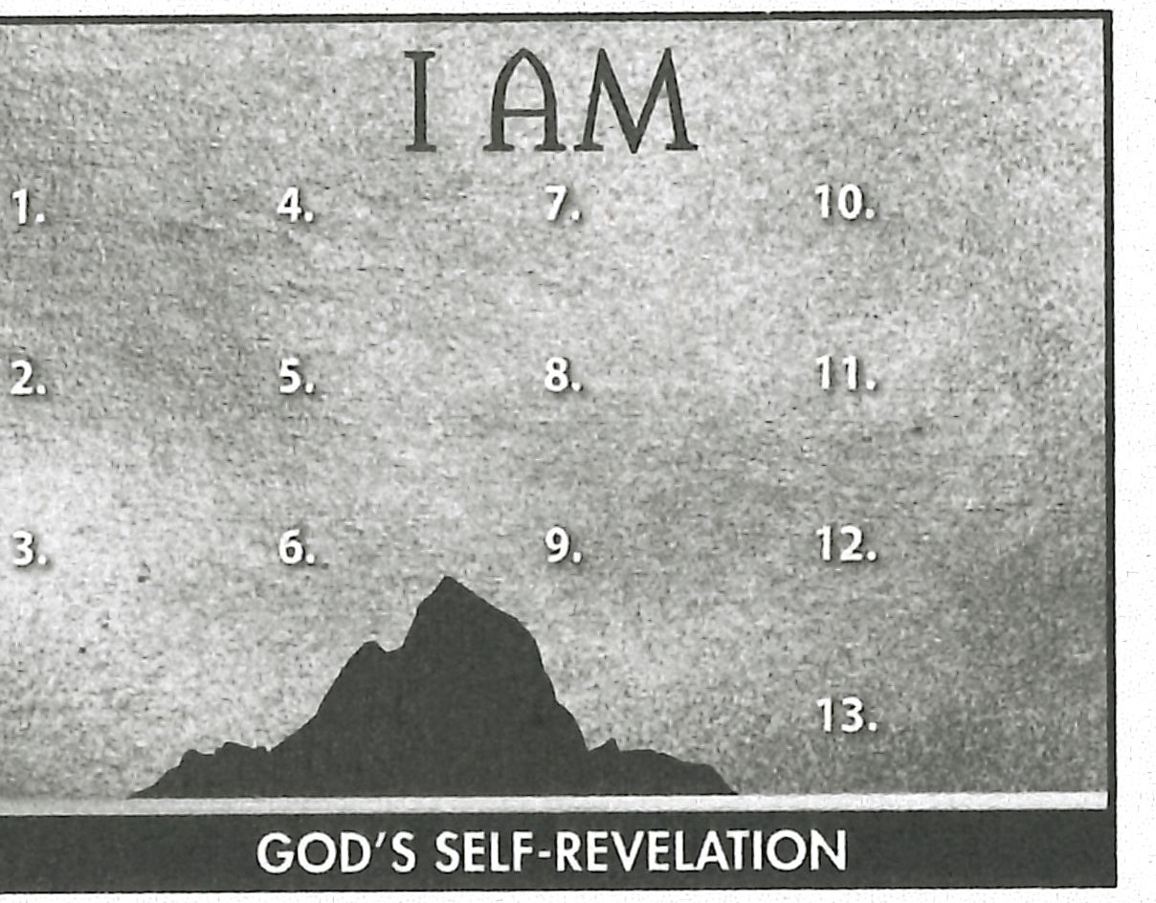**RESOURCE:** Display resource 1 to review God's introduction of Himself to Israel. Add a summary statement about God's introduction of Himself in lesson 12 or use the following: I AM the Solid Rock.

**ASK:** Which of these aspects of God's introduction to His people do you see reflected in Moses' song and blessing? (Q20)

**ASK:** Which one do you need to consider in your relationship with God? (Q21)

Encourage your learners to take their introduction to the I AM as an oppor­ tunity to grow in the Lord. If feasible, give each learner a stone as a reminder of God's solid faithfulness. Using a permanent marker, they could write a Scripture reference or a few words on the stone to remind them to trust the Solid Roel<.

**Memory Verses**

Encourage learners to memorize Deuteronomy 32:3 and 4. Give them an oppor­ tunity to say the verses in class next week.