

### Topic

**God's love**

### Theme

**God loves us and de­ sires us to love Him with all our being.**

### Desired Learner Response

**The learner will strengthen his confi­ dence in God's love for him and will develop his love for God.**

**Materials**

* Resources 1 , 3, and 15

**1 AM**

# Loving Lord

### Scripture Focus

**Deut. 1- 7:11**

### Summary

This lesson introduces Deuteronomy, a book written to the new generation of Israelites who were about to enter the Promised Land. They needed to hear God's laws from Moses so that they might live rightly before Go d.

**Outline**

1. **God ' s Love for Israel (Deut. 1:1- 7:11)**
2. **Israel ' s Love for God (Deu t. 6:4- 25)**
   1. The extent of Israel's love (6:4-9)
   2. Threats to Israel 's love for God (Deut. 6:10-19)
      1. The threat of prosperity (6:10- 12)
      2. The threat of pluralism (6:13-15)
      3. The threat of doubt (6:16-19)
   3. Israel's motivation to love God (Deut. 6 :20- 25)

**Memory Verses** *"And thou shalt love the LORD thy God with all thine heart, and with all thy soul, and with all thy might . And these words, which I command thee this day,*

*shall be in thine heart" (Deuteronomy 6:5, 6).*

**106**



**Forty Years Ago**

## G E T T I N G S T''A R T E D

Do an Internet search to find out what life was like forty years ago, including average household income, average house price, and major world events. Report your findings to your class .

**ASK:** What, if anything, do you remember from forty years ago? (Ql)

**ASK:** How dramatically has your life changed since then? (02)

It had been forty years since Israel left Mount Sinai. The older generation had died off; the new generation needed a renewed message about God and His expec­ tations for them in the Promised Land. Moses' message to them focuses both on God's love for Israel and God's desire for Israel to love Him back.

#### Message to the Next Generation

**ASK:** What would you include in a message to the next generation?

**ASK:What** would you say about your life experiences, particularly over the last forty years?

This lesson picks up the account of Israel's journey to the Promised Land with Moses' message to the new generation in Deuteronomy. The older generation had died off. The new generation needed to a renewed message about God and His expectations for them in the Promised Land. Moses' message to them focuses both on God's love for Israel and God's desire for Israel to love Him back.

## SEARCHING THE SCRIPTURES

The book of Deuteronomy is God's preparation of His people for the Promised Land. The book is far more concerned about Israel's heart in response to God than are the books of Leviticus and Numbers. In fact, the word *love* appears more times in Deuteronomy than it does in all other Bible books except for Psalms, Proverbs, Song of Solomon, John, and 1 John. Obviously *love* was an important theme in God's message to His people. He focused on both His love for them and their love for Him.

Since Deuteronomy is a message to God's people, it doesn't move the story of Israel's journey along . Rather, it contains reflections on the past journey, instruc­ tions for the present in anticipation of possessing the land, and prophecies about the fut ure. The message was given by God through Moses so the present and future generations might learn to love their loving God.

#### God's Love for Israel (Deut. 1:1-6:3; 7:1-11)

Moses began his look at Israel's past by recalling what happened when Israel left Mount Sinai (Horeb) for the Promised La nd. After the spies had returned from

surveying the Promised Land, the people saw the fruit but refused to enter be­ cause of the giants in the land.

**READ:** Deuteronomy 1:25-28. **ASK:** What did those who refused to enter the land conclude about the Lord? (Q3) *That He hated them.*

Moses tried to convince the people to go forward based on God's care for them in the past (1:29- 31).

**READ:** Deuteronomy 1:29-31. **ASK:** What does the picture of God carrying Israel convey about God's relationship with Israel on their way to the Prom­ ised Land? (Q4) *He loved them with* a *familial love. He was with them and ensured that they would arrive safely.*

Yet the people refused to believe God. So God judged them; those twenty years and older died at some point over the next forty years in the wilderness (1:32- 40).

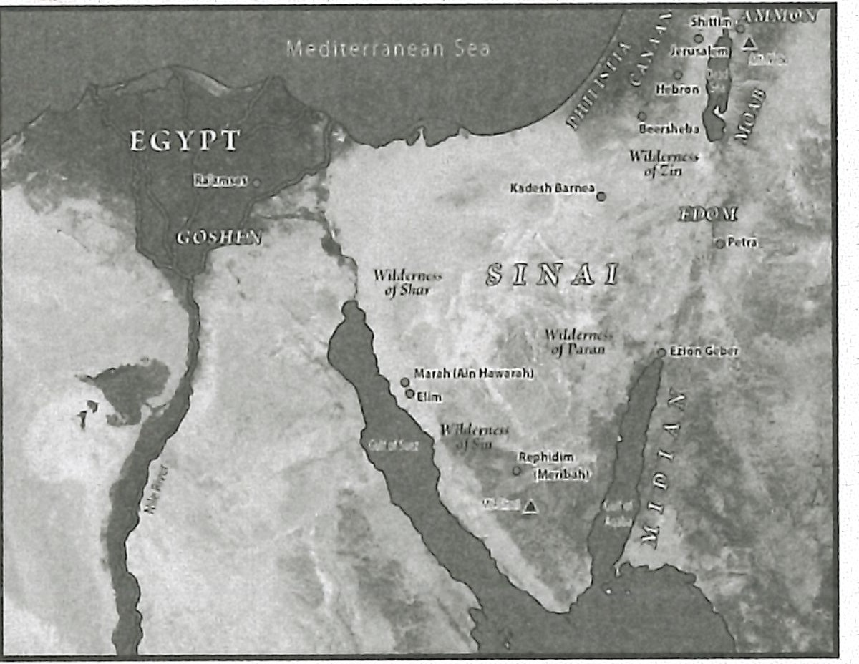**MAP:** Display resource 3 to show the locations mentioned in the lesson.

The next chapter briefly recounts the wilderness years and then presents Israel's second approach to the Promised Land. Interestingly, the main focus in the chapter is on what God did for the Edomites, Moabites, and Ammonites.

The Edomites were descendants of Esau (Jacob's brother), and the Moabites and Ammonites were descendants of Lot (Abraham's nephew). God had given an inheritance to both Esau (Gen. 36:6- 8; Deut. 2:4, s) and Lot (Deut. 2:9, 19), so the Israelites were not to attack Edom and Moab as they passed by them. In fact, the Edomites and Moabites both chased giants from their lands. The giants were

comparable to those giants who occupied the Promised Land and had scared the previous generation of Israelites into refusing to enter the land.

The record of God's care for Edom, Moab, and Ammon in chasing giants from their lands (2:20- 22) had to be both an encouragement for Israel as they looked forward and a disappointment as they considered their past. If God provided land for nations because they were simply descended from relatives of the patriarchs, then how much more would He care for the nation He called His own? The former generation of Israelites thought God hated them. They couldn't have been more wrong, as evidenced by God's work on behalf of Edom, Moab, and Ammon and as evidenced by God's care for them during their forty years of wandering (2:7).

Moses then went on to recount the victories over the Kings Sihon and Og, whose territories were east of the Jordan River (2:26- 3:11).Moses divided their lands as part of Israel's inheritance (3:12- 22). The historical reflection ends with Moses recounting his request to enter the Promised Land. God stood by His deci­ sion and told Moses to stop asking. Joshua would lead the people into the Prom­ ised Land (3:23- 29).

Obeying God's commands and refraining from idolatry would be fundamental to Israel's enjoying their land . God had promised them at Mount Sinai that, if they were obedient and loyal to Him, they would enjoy the land and live long in it (4:9, 10, 23, 40).

**READ:** Deuteronomy 4:23, 24. **ASK:** What caused God to be jealous of Israel's attention? (QS) *His love for Israel. He wanted them to love Him exclusively.*

Israel was more privileged than any other nation (4:32-40). They heard God's voice and received from Him instructions on how to live.

**READ:** Deuteronomy 4:37. **ASK:** Why did God choose Abraham to father His nation? (Q6) *He loved Abraham.*

Deuteronomy 4:37 is the first mention of God's love in the book. The fact that it is connected to Israel's patriarchs is significant. God's relationship with Israel was always based on His love for them. He didn't grow to love them; He loved them with an everlasting love (Jer. 31:3). In the Promised Land He wanted them to love Him back. Loving God made perfect sense for the Israelites after all God had done for them.

Moses reintroduced God's law in the form of the Ten Commandments (Deut. 4:44-6:3). He also included the conversation that had gone on after the giving of the law. God longed for Israel to have hearts that were set on obedience to Him (5:29). The reason for His longing was His love for Israel (7:1-11).

**READ:** Deuteronomy 7:1-11. **ASK:** How did God describe His relationship with Israel? (Q7) *He said they were* a *special treasure above all the people of the earth.*

God chose to love Israel. They had nothing that made them better than anyone else (7:7, 8). What a privilege for Israel to know God as their loving Lord!

#### Israel's Love for God (Deut. 6:4-25)

After encouraging the people again to be faithful to God, Moses talked about the greatest commandment.

#### The extent of Israel's love (6:4-9)

**READ:** Deuteronomy 6:4. **ASK:** How does this verse describe God? (Q8) *The LORD our God is one LORD.*

**ASK:** Why would it be important for the Israelites to understand this descrip­ tion as they approached the Promised Land? (Q9) *They would face extreme temptation to worship other gods, especially the gods of the people living in the Promised Land*

If the content of the law could be summarized in one succinct confessional statement, Deuteronomy 6:4 would likely be that statement. This verse, which later became known to Jews as the *Shema,* communicates several critical concepts. The Hebrew construction of the verse contains no verb after the command to hear. This unusual construction allows four Hebrew words to teach several truths simultane­ ously. The first truth taught is that God is the LORD. We have learned that LORD is God's covenantal name, a name that focuses on God's faithfulness to His promises. This is the God of the universe. God is not some whimsical, flawed god found in so many ancient religious texts. The true God is faithful; He keeps His word.

Second, this verse teaches the LORD is *our God.* Israel enjoyed a unique and special relationship with God. God was their LORD. His relationship with them was

not to the exclusion of outsiders but in order to communicate His character to the outsiders. Israel was God's chosen people; God was uniquely their God.

Third, God is Israel's only God. They were to have no other gods. This truth is why some scholars prefer this phrase to be translated, *The LORD* is *our God, the LORD alone.* Both the immediate context of chapter 6 and the extended context of Deuteronomy 4:32-40 and 5:7 and 8 shows that this third truth is emphasized in this verse.

**READ:** Deuteronomy 6:5. **ASK:** What was Israel commanded to do in re­ sponse to this brief content summary of Israel's faith? (Q1O) *Love God with all their heart, soul, and might.*

Jesus described the commandment of Deuteronomy 6:5 as the greatest com­ mandment (Matt. 22:37, 38). The natural response to the truth that there is only one God is that His followers should love Him with all their being. Loyalty to God should not be divided. The terms *heart, soul,* and *might* in this verse are not precise terms referring to definite aspects of a person's being. In Scripture, the *heart* often refers to the seat of emotion and will, *soul* refers to one's being, and *might* encompasses physical abilities. But the use of these three terms together is a descriptive way

saying to love God with all you are. This explanation may illumine the differences in wording found in Jesus' references to this verse in the gospel. The main point is that the people of Israel were to love God with every aspect of their lives.

**READ:** Deuteronomy 6:6-9. **ASK:** Where and when were parents to teach their children? (Q11) *Everywhere and at all times as different situations arose.*

**TESTIMONY:** Share a specific example from your life when you taught chil­ dren about faith in God using a real life teachable moment? (Q12)

The command to teach children uses a series of merisms to reinforce the holis­ tic strategy in view. A merism is a rhetorical device that uses a pair of opposites to signify a whole (e.g., *from A to Z* or *from high to low).*

Whether the Israelites were out and about or enjoying the comforts of home, they were to teach the next generation. They were to talk about the commands at bedtime, in the morning, and every time in between. As a family and as a commu­ nity they were to consider the law.

Some Jews take the instructions of Deuteronomy 6:8 and 9 literally. They make or buy phylacteries to keep the law with them at all times. A phylactery is a small box containing a fragment of the law. Jews tie them to their foreheads and hands by a series of straps. They also buy or make mezuzahs to affix the law to the doorframes of their homes. A mezuzah is a wooden or metallic case or tube with

a small parchment in it. The parchment has the words of Deuteronomy 6:4- 9 and

11:13- 21 written on it in Hebrew .

**ASK:** What tangible reminders of the Christian faith do you have in your home? (Q13)

**ASK:** How do you help others, especially children, appreciate the signifi­ cance of those reminders? (Q14)

#### Threats to Israel's love for God (Deut. 6:10-19)

Unfortunately, there are no guarantees that the redeemed will seek to perpet 0 uate their faith. In fact there are many threats to the faithful transmission of faith . God warned Israel of three threats to passing their faith on to their children .

#### The threat of prosperity (6:10-12)

**READ:** Deuteronomy 6:10-12. **ASK:** How would prosperity threaten the transmission of faith once the Israelites entered the rich Promised Land?

(015) *They would become so enamored by the luxuries and wealth that they would ignore God, the One Who gave them the blessings.*

Moses challenged the people of Israel before they entered the Promised Land. He warned them about the cities, homes, farms, wells, and material wealth God would give to them as they conquered the land. The nomadic lifestyle they had been living for the past forty years was going to change . God knew this change would tempt Israel to abandon their faith. The new wealth would tempt them to forget that God had delivered them from Egypt. They would be tempted to think they were self-sufficient and that they didn't need God.

**ASK:** What are some threats money and possessions pose to today's Chris­ tian family? (016) *Wealth and possessions threaten to create in the Christian family* a *sense of independence from God They also threaten to capture the family's desires; they think money will bring satisfaction.*

#### The threat of pluralism (6:13-15)

**READ:** Deuteronomy 6:13-15. **ASK:** What gods threatened the perpetuation of Israel's faith? (017) *The gods of the people in and around the Promised Land, many of which were credited for the land's abundance.*

God knew the false religions of the people living in the Promised Land would be a temptation for Israel. Unfortunately, much of Israel's history is marked by falling into idolatry.

Jealousy is a sin when manifested in humanity. God, however, is righteously jealous (6:15). He shares His glory with no one and nothing. He alone deserves to be worshiped . As mentioned in the section on God's love for Israel, God's jealou­ sy is rooted in His love for Israel. God's relationship with Israel was like that of a husband and wife. Israel, as His bride, needed to remain faithful to Hirn.

Pluralism is a view that puts forth that multiple beliefs can coexist within the same person or group of people. Israel became pluralistic when they added local deities to their worship of the Lord. Obviously this practice was intolerable to God.

Pluralism is prevalent in our culture too. People blend Christianity with all sorts of unbiblical beliefs . Pluralism is a serious threat to perpetuating one's faith to the next generation .

**ASK:** What are some examples of pluralistic influences on Christianity? (018)

*Tolerance is presented as the moral and right approach to those who disagree with*

*you religiously. There is an emphasis on cooperation between religious groups in or­ der to fix social ills. There is* a *growing intolerance of those who separate from others for doctrinal reasons.*

**ASK:** Where might people get exposed to these pluralistic forms of Christianity? (Ql 9) *Religious universities that emphasize tolerance; religious pop culture that cele­ brates cooperation; national religious leaders who downplay doctrinal differences.*

* + 1. **The threat of doubt (6:16-19)**

Shortly after Israel experienced a spectacular deliverance from Egypt, they sinned against God by doubting He was still with them (Exod. 17:7). They had no water and concluded God must not be watching over them. This incident became a reference point for Israel's repeated episodes of doubt throughout the wilderness wanderings.

Moses challenged Israel not to test God as they had at Massah (Deut. 6:16). As Israel conquered the Promised Land, temptations to doubt God's presence with them would arise. Doubting God's presence would obviously be a serious threat to establishing their children in their faith in God. Instead of doubting God's presence, the Israelites needed to diligently keep God's commandments (6:17). They needed to be so sure that He was with them that obeying Him became their way of life.

Eventually Israel's doubts about God led to their disobedience and hardship in the land . They never fully realized the blessings God promised them if they would do what was right in His eyes (6:18), and they were never able to completely con­ quer the Promised Land (6:19). Consequently, future generations were not firmly established in their faith. Faithlessness grew with each passing generation. Doubt of God's presence created an atmosphere where perpetuating one's faith seemed to be the exception rather than the norm.

**ASK:** How might doubt manifest itself in a family today? Consider espe­ cially subtle evidences of doubt such as prayerlessness. (Q20) *Prayerlessness, complaining about problems, excusing oneself from serving in the church, sporadic church attendance, stingy giving, lack of concern for the lost, ignoring God's Word.*

#### Israel's motivation to love God (Deut. 6:20-25)

**READ:** Deuteronomy 6:20-25. **ASK:** What question did Moses anticipate the Israelite children would ask in the future? (Q21) *What do these testimonies, statutes, and judgments mean?*

Moses imagined children would ask about the requirements God gave to Israel. Most likely Moses had in mind sincere rather than skeptical questions. Most children go through a stage in which their favorite question is *why.* Moses viewed their questions as legitimate. He wanted to equip the current generation of par­ ents to provide answers that perpetuated their faith in their children's lives. The children needed to learn to love God too.

Moses instructed the adults to answer by recounting their merciful redemption from Egypt. Israel's deliverance from Egypt was their fundamental motivation for loving God and living as consecrated to Him. Similarly, the redemption provided

in Jesus Christ should motivate believers to love God and live for Him. When peo­ ple ask why we believe and act the way we do, our·answer should point them to Christ's redempt ion work on the cross .

Moses' use of the word *righteousness* in Deuteronomy 6:25 should not be under­ stood as referring to imputed righteousness. Israelites at that time could no more earn a righteous standing before God than people today could. This *righteousness* refers to everything being right in the family. God's blessing would be on the fami­ ly. The children would learn to love and honor God with their lives. They would be secure in their understanding of God and would want to know and serve Him.

**RESOURCE:** Display resource 15 as a review of Israel's estimation of God and God's expectation of Israel.

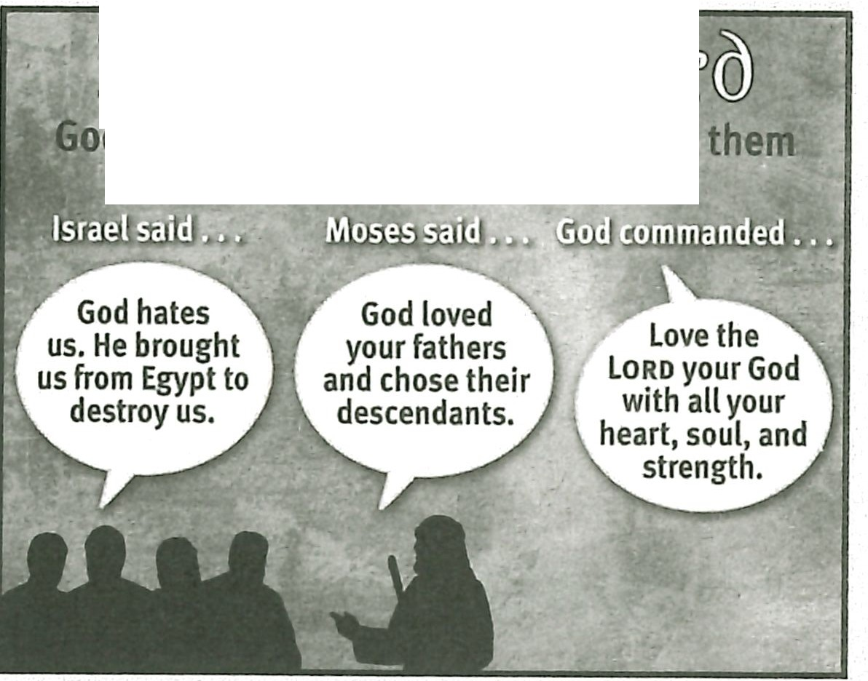

Il •

**d loved Israel always. He expected them to love Him exclusively.**

WWillThcgJ IL@lf1

**MAKING IT PERSONAL**

#### Love from God

**ASK:** Have you ever felt as if God hated you? What were the circumstances? (022)

**ASK:** Why are circumstances not a good gauge of God's love for you? (023) *God allows us to experience difficult and unpleasant circumstances in order to accomplish His will in and through us. Those circumstances may make it seem as if He is against us.*

**ASK:** When you begin to doubt God's love for you, what steps will you take to counteract that doubt? (024) *Meditate on Scripture that speaks of God's love; ask God for wisdom in handling the circumstances causing the doubt; rely on the Spirit to give you faith.*

#### Love for God

**ASK:** What might loving God with your whole being look like? (025) *Seeking to know God better every day; using your mind and body to serve God faithfully; reaching out to others to share God's love with them.*

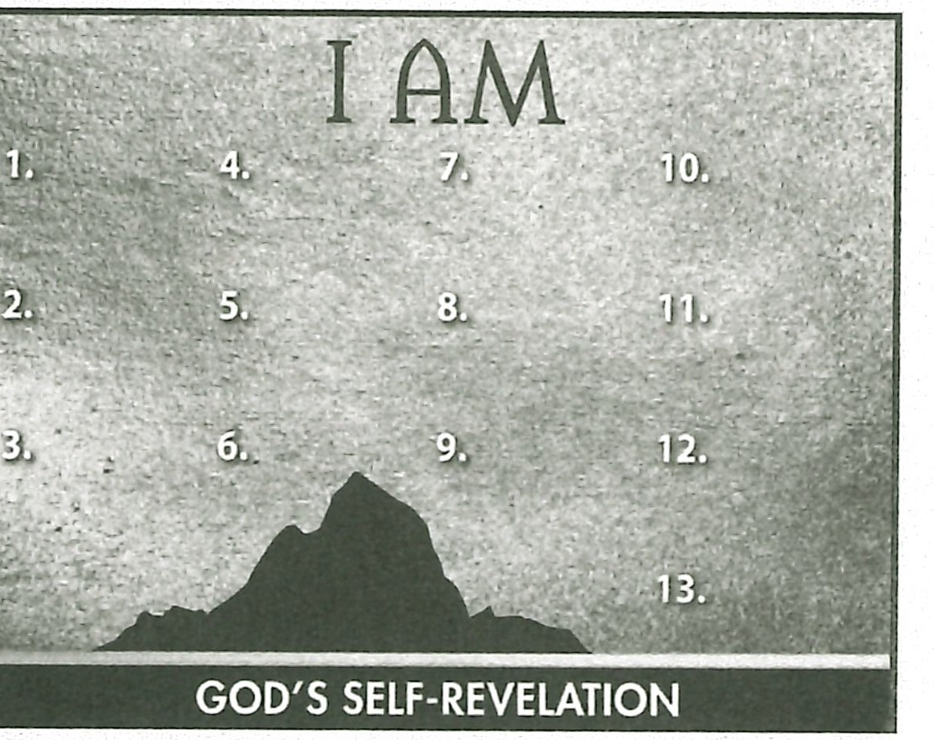**ASK:** How might you grow your love for God this week? (026)

#### Summary and Memory Verses

**RESOURCE:** Display resource 1. Add a summary statement about God's introduction of Himself in lesson 12 or use the following: I AM Loving Lord.

Encourage learners to memorize Deuteronomy 6:5 and 6. Give them an oppor- tunity to say the verses in class next week.



### Topic

**God's faithfulness**

### Theme

**God as the Solid Rock is faithful to His people and His promises and worthy of our trust.**

### Desired Learner Response

**The learner will put his confidence in God as the faithful, Solid Rock.**

##### Materials

* Resources 1 and 16
* Small stones (optional)
* Permanent markers (option­ al)

**1AM**

# the Solid Rock

/

**Scripture Focus Deut. 7-34 Summary**

This lesson covers Moses' song and blessing as well as his death . The focus

of his song in particular is God's faithfulness to Israel despite their unfaithful­ ness to Him . Moses calls God the Rock, a fitting description of His unwavering character throughout Israel 's history.

##### Outline

1. **Moses' Song (Deu t. 31:28-32:52)**
   1. Moses' call to listen (31:28- 32:2)
   2. Moses' praise of God (32:3, 4)
   3. Israel 's response to God's person (32:5, 6)
   4. Go d's goodness to Israel (32:7-14)
   5. Israel 's response to Go d's goodness (32:15- 18)
   6. God's response to Israel's unfaithfulness (32:19- 35)
   7. God's salvation of Israel (32:36- 43)
2. **Moses' Application (32:44- 52 ) Ill. Moses' Blessing (Deut. 33)**
   1. Introduction of the blessing (33:1- 5)
   2. The blessing of the tribes (33:6- 25)
   3. Conclusion (33:26- 29)

**IV. Moses' Death (Deut. 34)**

**Memory Verses** *"Because I will publish the name of the Lord: ascribe ye greatness unto our God. He is the Rock, his work is perfect: for all his ways are judgment:*

*a God of truth and without iniquity.just and right is he" (Deuteronomy 32 :3, 4).*

**114**