j

**a** •

## Topic

**God's power**

## Theme

**God's power could never be overcome by another.**

## Desired Learner Response

**The learner will submit to God's power and God's desire to use his life to do His will.**

#### Materials

* Resources 1 , 3, and 14

**1AM**

**Powerful Proclaimer**

## Scripture Focus

**Num. 14:39-24:25**

## Summary

This lesson covers Israel 's rebellion in not entering the land and Moses' rebel­ lion in striking the rock . It also covers the account of Balaam , a notable ancient diviner, and Balak , the king of Moab who feared Israel. Balak summoned Balaam to curse Israel, but God intervened and caused Balaam to bless Israel instead of cursing them. Through all three accounts God sho wed that He can­ not be overpowered or outwitted.

#### Outline

1. **Israel' s Rebellions (Num. 14:39- 17:13)**
   1. Attempting to enter the Promised Land (14:39- 15:31)
   2. Breaking the Sabbath (15:32-41)
   3. Rebelling against Moses and Aaron (16; 17)
2. **Mose s' Rebellion (Nu m. 2 0 )**

**Ill. Bala am' s Fut ility (Num. 22:1- - 24:2 5)**

* 1. Balak 's summons (22:1- 22)
  2. Salaam's arrival (22:23-40)
  3. Salaa m's oracles (Num . 22:41-24:25)
     1. Salaam 's first oracle (22:41- 23:12)
     2. Salaam 's second oracle (23:13- 26)
     3. Salaam 's third oracle (23:27- 24:25)

**Memory Verse** *"God is not a man, that he should lie; neither the son of man, that he should repent: hath he said, and shall he not do it?*

*or hath he spoken, and shall he not make it good ?" (Numbers 23 :19 ).*

**97**

**Pet Messages**

# GETTING STARTED

**ASK:** If your pet could talk, what do you think it would want to say to you? (01)

**ASK:** How do you think you would react if your pet talked to you? (02)

This lesson introduces the character of Balaam, an ancient diviner. God used Balaam's donkey to get Balaam's attention. Balaam learned that God could never be overpowered or outsmarted.

**Common Symbols**

**ASK:** What do the Jewish flag and an ambulance have in common? *Both borrow symbols from the book of Numbers.*

The blue stripes on the Jewish flag are reminders to obey the Lord (Num.

15:38- 41). The serpent on the pole on the side of an ambulance is a reminder of the salvation God provided for His people after they sinned (21:8 , 9). Both the passages from which those symbols are drawn are part of the lesson for today. The focus of the lesson is on God's power. Both Israel and Israel's enemies learned that God cannot be overpowered or outsmarted .

# SEARCHING THE SCRIPTURES

* + - 1. **Israel's Rebellions (Num . 14:39- 17:13)**
         1. **Attempting to enter the Promised Land (14:39- 15:31)**

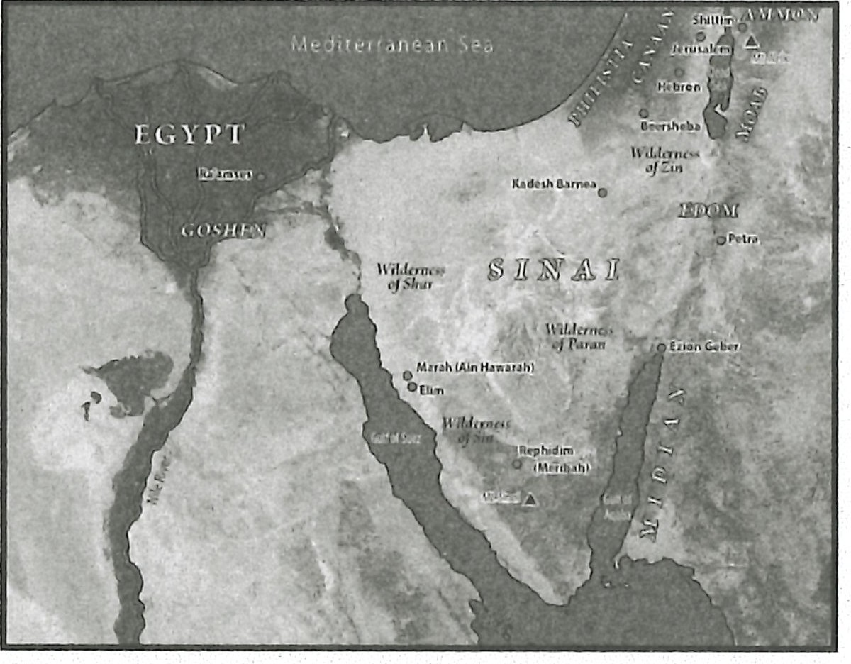**MAP:** Display resource 3 to show the major places mentioned in the lesson.

God condemned Israel to spend forty years in the wilderness when they chose to reject Him and His gracious gift of the Promised Lan d. So every Israelite twen­ ty years old and older would die during the forty years of wilderness wandering (Num. 14:33,34). The people tried to change God's decision by invading the Prom­ ised Land after He handed down His death sentence (14:39- 45).

**READ:** Numbers 14:39-45. **ASK:** What did the people learn about their ability to overcome God's will? (03) *They learned that they had no power to overcome God's will. What God says comes true.*

God's ban on the Promised Land would not be forever. And when it came time for the Israelites to enter the land, no one would be able to keep them out. That

is why God continued to give Moses instructions about Israel's worship of Him in the land that He was giving to them (15:1- 21). God also gave them additional laws concerning unintentional sins and presumptuous sins.

* + - * 1. **Breaking the Sabbath (15:32-41)**

He then instructed them on the punishment for breaking the Sabbath. Some in the congregation found a man collecting sticks on the Sabbath. The people stoned the man according to God's command (15:32- 36). Obviously the Israelites were to take God's commands seriously. So God gave them a way to remember their need to obey Hirn.

**READ:** Numbers 15:37 - 41. **ASK:** Why did the Israelites need a reminder to obey God? (Q4) *Their hearts and eyes were inclined to commit spiritual harlotry by going after other gods.*

### Rebelling against Moses and Aaron (16; 17)

The events recorded after God's instructions concerning the tassels proved why Israel needed them . Korah, a Levite, led a rebellion of Reubenites and oth- er men of reputation, accusing Moses and Aaron of exalting themselves above the rest of the people and criticizing Moses specifically for acting like a prince over them (16:3, 13). No doubt Korah's ambition was to garner enough support to

overthrow both Moses and Aaron. Since his generation was already condemned to die in the wilderness, perhaps he and his fellow rebels thought they could change the curse if they got rid of their leaders. They blamed Moses, both for taking them from Egypt, a land they considered flowing with milk and honey, and for failing to bring them into the Promised Land (16:12- 14).

God judged Korah and his two fellow rebels by opening the earth to swallow them up (16:31-33). The rest of the *respectable* men that questioned Moses were struck by God's fire (16:34, 35). The judgment was a sign to the rest oflsrael that Moses was a leader by the will of God; he was not a self-appointed leader (16:28). This crisis proved again that God's will cannot be thwarted.

The people, however, failed to learn the lesson. They blamed Moses and Aaron for killing the people of the Lord (16:41). God plagued them until Aaron mercifully intervened (16:42- 50). God then proved that Aaron was His choice to be priest. His rod produced blossoms and brought forth almonds, while the rods of all the other tribes remained dead (17:1- 11). God's will could not be overcome.

### Moses' Rebellion (Num. 20)

The record of Israel's time in the wilderness is sparse. But what is recorded is important, and no event is greater than Moses' rebellion at Kadesh. The nation was most likely nearing the end of their wilderness time when they complained yet again about not having water. Once again God told Moses the water would

come from a rock. Moses was to speak to it, but he hit it twice with his rod instead

(20:8-11). The water came forth, but God was not happy with Moses and Aaron. Because they had not hallowed God before the congregation , God would not allow Moses and Aaron to enter the Promised Land (20:12).

Moses failed to believe God in some mann er. Calling the people *rebels* and asking them about needing to *fetch* water from the rock are perhaps clues that Moses was frustrated that God was going to provide water for the people without disciplining them in some way. Whatever the reason, hitting the rock in anger

instead of speaking to it was a rebellious act against God.

**READ:** Numbers 20:12. **ASK:** What message did Moses send to the people about submitting to God's will? (QS) *That it was not particularly import ant.*

After the nation journeyed from Kadesh to Mount Hor (20:22), it was time for Aaron to die. He ascended Mount Hor with his son Eleazar and Moses. There Mo­ ses stripped Aaron of his priestly garments and passed them on to Eleazar. Aaron died shortly thereafter (20:23- 29).

Israel then defeated the Canaanites at Hormah before the journey got long and laborious (21:1- 4). They complained about what God had been giving th em- man ­ na- and about what He hadn't given them- water. This time God did judge them.

He sent deadly snakes into the camp (21:5, 6). Moses erected a bronze serpent to which those who were bitten could look for salvation (21:7- 9). Perhaps the judgment and the salvation were a lesson for Moses as he neared his death: he

could trust God to be just, merciful, and gracious - all part of God's glory God had revealed to Moses on Mount Sinai (cf. Exod. 33:17- 19).

* + - 1. **Balaam's Futility (Num. 22:1--40)**

While Israel continued on, a new character entered the narrative. Balaam was a notable diviner familiar to multiple ancient people groups. His notoriety spilled into the New Testament, where 2 Peter 2:15 and Jude 11 present him as a negative example of profiting from evil. Multiple other passages condemn Balaam. This lesson's Scripture focus presents Balaam as a foreigner who knew God by His covenantal name, blessed Israel, and gave Messianic prophecies . Yet God directly chastised Balaam for pursuing gain from Balak.

Balaam is a complicated character, but God's message through the account of Balaam is clear: no one can ever overpower or outsmart God.

* + - * 1. **Balak's summons (22:1-22)**

**READ:** Numbers 22:1- 4. **ASK:** What was Balak's disposition toward Israel?

(Q6) *He feared Israel greatly because of their large population.*

**READ:** Deuteronomy 2:8, 9. **ASK:** Did Balak need to fear Israel? (Q7) *No. God had instructed Israel not to fight Moab.*

Balak, the king of Moab, feared that Israel would overcome his lands and his people. Balak was aware that Israel had defeated Sihon and Og, king of Bashan (Num . 21).

In reality Balak had nothing to fear because God had told Israel not to battle Moab. The Moabites were descendants of Lot (Deut. 2:8, 9). God had promised that land to the Moabites. The Moabites' land was not part of the Promised Land.

But in desperation Balak summoned Balaam, an internationally known divin­ er, who used animal entrails and nature to determine a god's will. He also cursed and blessed people to try to influence the gods.

**READ:** Numbers 22:5, 6. **ASK:** How confident was Balak in Balaam's ability to

influence the course of history? (Q8) *He firmly believed that Balaam's blessings and curses were always effective. Yet he was not completely sure that even Balaam's sure curse on Israel would guarantee him victory in battle.*

Balak believed that if Israel was cursed, then Moab and Midian would have a chance to defeat Israel despite the apparent odds. Balak's words about Balaam's blessings and curses are similar to God's words to Abram in Genesis 12:3.

**READ:** Genesis 12:3. **ASK:** What did God say would happen to those who cursed Abram? (Q9) *They would be cursed themselves.*

God's message was that all those who bless Abram will be blessed and all those who curse him will be cursed. So Balaam was in a no-win situation. Even if he did manage to curse Israel, he would in essence be cursing himself.

Balak sent two entourages to Balaam, attempting to convince him to accept the job of cursing Israel. But God met with Balaam before he responded to each request. God instructed Balaam to deny the first request. However, God allowed Balaam to accept the second request with the caveat to do only what God said (Num. 22:20). Many commentators view Balaam's words during these negotiations as ploys for a larger payment.

Nevertheless, Balaam rose early and went with the princes of Moab (22:21). God's response to Balaam's actions is surprising (22:22). The best explanation is to allow other passages to aid our understanding. Both 2 Peter 2:15 and Jude 11 criticize Balaam for gaining from wrongdoing. Evidently Balaam was motivated more by a desire for the riches promised by Balak than by a desire to do what God wanted. Although Balaam had met with God in some fashion, he apparently believed he could override God's will and gain financially.

* + - * 1. **Balaam's arrival (22:23-40)**

The account of Balaam and his donkey is one of the most comical pictures in the Bible. Three times the Angel of the Lord stood in front of the donkey, causing it to pause (22:23-26). The third time Balaam hit the donkey. Surprisingly it respond­ ed to let Balaam know it wasn't trying to be rebellious against him. Then the Lord opened Balaam's eyes so he, too, could see the Angel of the Lord (22:27-31). The Angel of the Lord said he had come to stop Balaam because his way was perverse before God. Balaam confessed his sin and offered to turn back (22:32-34).

**READ:** Numbers 22:35. **ASK:** What did the Angel of the Lord tell Balaam? (Ql 0)

*Balaam could speak only the words that the Angel of the Lord told him to speak.*

Balaam was a learned, proud man. God used the speech of a donkey to teach Balaam just how insignificant he was. The humor we appreciate in this story is representative of the ridiculousness of someone believing he can override or con­ trol God.

* + - * 1. **Balaam's oracles (Num. 22:41-24:25)**

When the diviner met the king, Balak asked Balaam to curse Israel; however, Balaam, constrained by God, blessed Israel. This cycle repeated three times. Prior

**Groupt**

Compare Numbers 23:1- 12

to Genesis 12:1- 3; 26 :1- 5;

and 35:9- 15.

**Group2**

Compare Numbers 23:13-

26 to Genesis 12:1- 3; 49:8,

9; and Exodus 1:15-20.

**Group3**

Compare Numbers 24:3 - 9,

15- 19 to Genesis 49:8 - 10.

to the first two oracles of blessing, Balaam performed an elaborate sacrificial ritual. The contrast between Balaam's sacrifice and God's instructions for sacrifice (see Numbers 15) highlight Balaam's actions as pagan. God still used Balaam in a signif­ icant way. Balaam's oracles blessed Israel and prophesied of the Messiah. The third oracle is expanded to include the third major poem of the Pentateuch.

**BIBLE STUDY:** Organize your learners into three groups (larger classes may double the number of groups). Instruct each group to read their assigned passages and look for parallels and connections, paying particular attention to the pronouns. Each group will select one person to share their discover­ ies. See the margin for passages by group.

1. **Balaam's first oracle (22:41-23:12)**

Balaam's first oracle (Num. 23:7- 10) highlights his inability to fulfill the assign­ ment of cursing Israel. Balaam instead blessed Israel. Balaam's words of blessing were from God, not random encouragements of his own creation.

**READ:** Numbers 23:7- 1 0. **DISCUSS:** Group 1, what connections did you find in your assigned texts? (See commentary.)

The first blessing is connected with God's covenantal promises made to the patriarchs (Gen. 12:1- 3; 26:1- 5; 35:9 - 15). Balaam's blessing recognized that God was blessing Israel. Even if Balaam were to utter words of cursing, he could not change God's favorable disposition toward Israel. The blessing was especially concerned with the promises that Israel would be a great nation.

Balaam's rhetorical question regarding Israel's population (Num. 23:10) paral­ lels God's promise to make Israel as numerous as the stars in the sky and the sand on the seashore. Balaam even added that he wished he could be part of Israel and take part in their blessing.

**READ:** Numbers 23:11, 12. **ASK:** How did Balaam respond to Balak's ques­ tioning? (Ql 1) *He told Balak that he had to speak what the Lord had put in his mouth.*

Balaam stated his need to align himself with God's view of Israel (23:12). He could speak only what God told him. Balaam's actions throughout this extended text do not indicate that he became a genuine believer. But for moments at least, Balaam understood that God could not be overpowered or outsmarted.

1. **Balaam's second oracle (23:13-26)**

**READ:** Numbers 23:18- 24. **ASK:** Group 2, what connections did you find in your assigned texts? See commentary.

Balaam began his second oracle focusing Balak's attention on God's immu­ tability (23:18, 19). God does not change . God promised Abraham and his descen­ dants a land, seed, and blessing, and God could never renege on those promises. He could never replace His blessings with a curse. God is always faithful.

Again, God gave Balaam the words of this oracle. The repeated emphasis on blessing throughout this passage reminds us of God's promises to Abraham, Isaac,

and Jacob and Is rael's dual role as blessed of God and *blesser* of others (Gen. 12:3).

This oracle focused on Israel's great strength in contrast to the first oracle, which focused on Israel's large population. Numbers 23:22 compares Israel to a *unicorn,* or strong wild ox.

The emphasis on Israel's strength creates another connection with Israel's Egyptian experience. The Egyptian midwives told Pharaoh that the Israelite moth­ ers were vigorous and could deliver their babies quickly. Moses expanded this idea of strength in his next statement and applied it to all of Israel (Exod. 1:19, 20).

**ASK:** What did the ora le say about the power of sorcery and divination in relation to Israel (Num. 23:23)? (Ql 2) *No sorcery or divination would work against Israel.*

God had already blessed Is rael. No sorc ery or divination would ever overpower God's blessing. And Balaam's oracles were proving that! There are no loopholes through which God could be overpowered or outsmarted.

**READ:** Numbers 23:24. **ASK:** How do you think Balak reacted to the last description of Israel? (Ql 3)

The last part of the second oracle compares Israel to a hunting, conquering lion that won't lie down until it drinks the blood of the slain. That description had to send chills through Balak!

Balak's initial response to Balaam's second oracle was to silence Balaam (23:25). Balak thought that if Balaam could not say anything advantageous for Moab, then he should not say anything at all. Balaam showed the fault in that strategy by saying he must speak the words God had given to him (23:26). He could not overpower God.

1. **Balaam's third oracle (23:27- 24:25)**

**READ:** Numbers 24:3- 9. **ASK:** Group 3, what connections did you find in your assigned texts? (See commentary.)

At first glance the third oracle appears similar to the second. Many of the same observations made in reference to the second oracle can be applied to the third oracle. A significant difference between the two oracles is found in the pronouns. Balaam's second oracle spoke of "them" in reference to Israel; Ba laam's third ora­ cle spoke of "him." This change in pronouns is significant.

The mysterious references to *him* in 24:3- 9 refers to the future Messiah. This understanding is suppo rted by the expansion of the third oracle in 24:15-24. Those verses are about the *latter days* (24:14).

Balak was livid with Balaam (24:10- 13). He slapped his hands together for ef­ fect and told Balaam to go home without payment. Balaam reiterated that he had to speak what God said even if it meant he would be working for free.

As Balaam departed, he gave a final addendum to the cycle of three oracles. This final poem is the third major poem of the Pentateuch (Gen. 49; Exod. 15) and the second introduced with a focus on the *last days* (cf. Gen. 49:1).

**READ:** Numbers 24:15-24. **ASK:** What descriptors are used for the central

Be aware of the transla­ tions your learners are using. Some modern translations harmonize the two oracles by phras­ ing Numbers 24:3- 9 with plural pronouns .

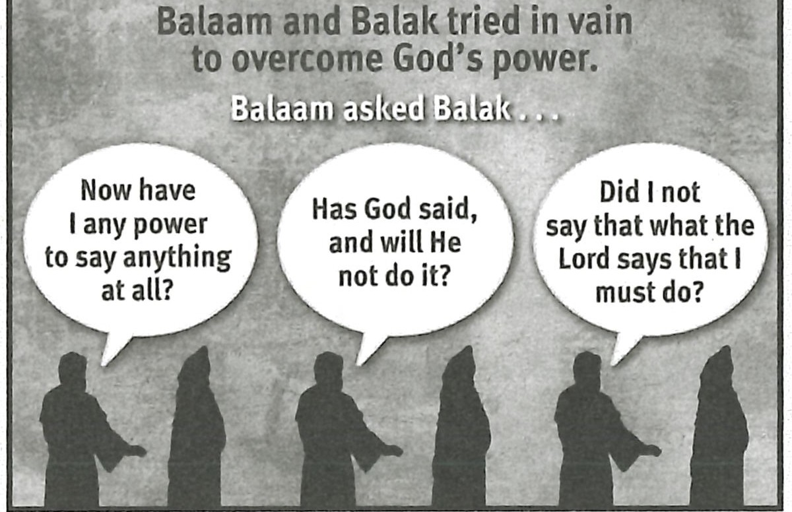Il ®M !pl@w:QJ@rlliiWil ft

person of this oracle? (Q14) *A star out oflacob, a scepter, one who will have dominion, one who will dispossess and destroy His enemies.*

This poem resumes the eschatological focus found earlier in Genesis 49. The events described should generate in the reader a longing for the fulfillment of these prophetic utterances.

Balaam's description of an individual Who was coming but not yet near points to the Messiah (Num. 24:17). The further description of Him as a scepter rising out of Israel echoes Genesis 49:10. That verse says the scepter would not depart from Judah, one of the twelve tribes of Israel. The two poems are obviously referring to the same individual, the promised Messiah.

The reference to the individual as a victorious warrior leader (Num. 24:17- 19) closely parallels Genesis 49. Some of the military victories prophesied in this pas­ sage happened partly in Old Testament history. Edom, for example, was defeated according to 2 Samuel 8:14; 2 Kings 8:20 - 22; and Isaiah 63:1- 6. However the best explanation for the passage as a whole is to see a future fulfillment of these victo­ ries. The names "Edom" and "Seir'' could stand for general enemies of God rather than those specific nations.

**ASK:** How does comparing Numbers 23:19 to 24:17 affect your faith in God's power? (Q15)

**READ:** Numbers 24:25. **ASK:** What do you think Balak concluded about God after listening to Salaam's oracles? (Q16) *That trying to overpower God was hopeless and that any further attempts would just make his situation worse.*

God's words through Balaam should strengthen our faith in God. He clearly demonstrated that He cannot be overpowered or outsmarted. He communicated that He cannot lie and cannot go back on His word (Num. 23:19). That means a lot to us when we consider the prophetic tone of Balaam's last oracle. The Messiah did come, and He is coming again to set up His ldngdom on earth. That is settled. No one or noth­ ing can change God's words. We can put our faith in Him with complete confidence.

**RESOURCE:** Display resource 14 to review the futility of Balaam and Balak to overcome God's power and plan.

**MAKING IT PERSONAL**

**Do God's Will**

Multiple characters in the passages for this lesson had a run-in with God's powerful will. Each time God proved that His will cannot be overcome and that He must be trusted.

**ASK:** When have you acted as if you didn't need to listen to God? (Q17)

**ASK:** What must we believe about God when we attempt to resist or ignore His will? (Q18) *That God is less powerful than He says He is.*

Encourage your learners to respect God's power and to seek to *do* rather than

*escape* His will.

### Scripture's Authority

Balaam received direct communication from God. Today we have the Bible as His communication to us. We should value the Bible as authoritative in all areas of our lives. The Bible is sufficient instruction for living a godly life.

**ASK:** What behaviors evidence that someone values the Bible as authorita­ tive in his life? (Ql 9)

**ASK:** What will you do this week to increase your respect for God's authorita­ tive Word? (Q20)

### Summary and Memory Verse

**RESOURCE:** Display resource 1. Add a summary statement about God's introduction of Himself in lesson 11 or use the following: I AM Powerful Proclaimer.

Encourage learners to memorize Numbers 23:19. Give them an opportunity to say the verse in class next week.

, .

•

·,, ,

## Topic

**God's love**

## Theme

**God loves us and de­ sires us to love Him with all our being.**

## Desired Learner Response

**The learner will strengthen his confi­ dence in God's love for him and will develop his love for God.**

#### Materials

* Resources 1 , 3, and 15

**1AM**

**Loving Lord**

## Scripture Focus

**Deut. 1-7:11**

## Summary

This lesson introduces Deute ronomy, a book written to the new generation of Israelites who were about to enter the Promised Land . They needed to hear

God's laws from Moses so that they might live rightly before Go d.

#### Outline

1. **God's Love for Israe l (Deut. 1:1- 7:11)**
2. **Israe l's Love for God (Deut. 6:4- 25)**
   1. The extent of Israel 's love (6=4-9)
   2. Threats to Israel 's love for God (Deut. 6:10- 19)
      1. The threat of prosperity (6:10- 12)
      2. The threat of pluralism (6:13- 15)
      3. The threat of doubt (6:16- 19)
   3. Israel 's motivation to love God (Deut. 6:20- 25)

**Memory Verses** *''And thou shalt love the LORD thy God with all thine heart , and with all thy soul, and with all thy might. And these words, which I command thee this day,*

*shall be in thine heart" (Deuteronomy 6:5,6).*

**106**