

**Topic**

**God's gracious giving**

**Theme**

**God is a gracious giver of blessings, and He is for believers.**

**Desired Learner Response**

**The learner will recog­ nize that God is for him and will be content with his lot in life.**

**Materials**

* Resources 1, 3, and 13

**1AM**

Gracious Giver

**Scripture Focus**

**Num.1-14**

**Summary**

This lesson will track Israel 's movements from Sinai to the edge of the Prom­ ised Land . Israel's discontentment with God leads to their eventual rejection of Him and the Promised Land. They failed to see that God was for them as a gracious giver of good blessings.

**Ou tline**

1. **God Provided for Israel (Num. 1-11)**
   1. God's blessing on Israel (1:1- 6:21 ; 7-11)
   2. God's prayer for Israel (6:22-27)
2. **Israel Complained (Num. 11:1-3)**

**Ill. Israel Craved Meat (Num . 11:4-35)**

* 1. Israel's dissatisfaction (11:4-9)
  2. Moses' complaint (11:10-15)
  3. God's response and judgment (11:16- 35)

1. **Miriam and Aaron Criticized Moses (Num. 12)**
2. **Israel Rejected God (Num. 13; 14)**
   1. Spying out the land (13:1-24)
   2. Refusing the land (13:25-14:38)

**Memory Verse** *"What shall we then say to these things? If God be for us, who can be against us? He that spared not his own Son, but delivered him up for us all,*

*how shall he not with him also freely give us all things?" (Romans 8 :31, 32) .*

**88**



**Rejected Grace**

# GETTING STARTED

**ASK:** How would you feel if you gave someone a mansion on a luscious property, only to have them criticize you and speak evil of you?

**ASK:** Why does it hurt so much to have someone reject or criticize your gift to them?

God gave and gave to the Israelites, and they rarely said thank you. They most­ ly complained and wanted something else, denying His goodness in the process. This lesson will present God as the gracious giver. It should help us see God's gracious heart and learn to identify and embrace His grace in our lives.

### The Journey Part of Vacation

Have the learners get into small groups of four or five. Have them share with each other bad experiences they have had while traveling to a vacation destina­ tion. Ask for a few volunteers to share their experiences with the entire class.

**ASK:** How did the people on the trip respond to the bad circumstances? (Ql)

**ASK:** How did the anticipation of the destination help alleviate some of the anxiety caused by the bad circumstances? (Q2)

The Israelites expected the journey to the Promised Land to be as good as the destination. They complained when it wasn't. God's response to them helps us see Him as the gracious giver.

# SEARCHING THE SCRIPTURES

### God Provided for Israel (Num. 1-11)

* 1. **God's blessing on Israel (t:1-6:21; 7-11)**

This lesson picks up Israel's journey to the Promised Land at their departure from Mount Sinai. The nation gave offerings to the Lord to support the worship of God (7). They had a priesthood in place (8:5- 26) and a brand new tabernacle as God's dwelling place. They celebrated their second Passover as a freed nation (9:1-14) and enjoyed God's presence, signified by His guiding cloud and pillar of fire (9:15- 23). God even instituted a communication system using two silver trumpets (10:1- 10). The various signals would tell each tribe when it was time for them to move out so the nation's departures were orderly. Moses also used the trumpets to assemble Israel.

**READ:** Numbers 10:9. **ASK:** What purpose would the trumpets serve in the Promised Land? (Q3) *Israel would blow them to activate God's involvement in their battles. God would come to rescue them.*

Chronologically the next chapter in Israel's history is Numbers 7. The census of Numbers 1- 6 hap­ pened after the events of chapters 7:1- 10:10.

**READ:** Numbers 10:10. **ASK:** What do God's instructions in this verse assume about Israel's future? (04) *That they would worship the Lord with gladness in the Promised Land*

The emphasis of the benediction in Numbers 6:22-27 is on the nation of Israel, but the Hebrew

pronouns for *you* are

singular, emphasizing the personal nature of the

prayer.

God gave Israel the two silver trumpets to embolden Israel in battle and to wor­ shipfully respond to God's presence with them in the Promised Land. The trumpets should have reassured Israel of God's desire to give them His gracious blessings.

Before moving out, God had Moses complete a census of the people (1). The emphasis was on numbering the men who could go to war (1:46). God then provid­ ed instructions on how the tribes were to be arranged around the tabernacle (2).

God's dwelling place was the hub of the camp, with the priests from the tribe of Levi dwelling between the people and the tabernacle. Moses numbered the Levites and detailed the responsibilities for each major division of Levites (3; 4). Moses ended Israel's stay at Sinai with additional instructions (5:1- 6:21).

* 1. **God's prayer for Israel (6:22-27)**

The benediction God gave to Moses to give to Aaron and the Levites is rich with meaning and emotion (6:22- 27). That it is written as poetry means it was to illicit a deep response from Israel. The prayer serves to reveal God's desire to bless Israel (6:27). His intentions for Israel were always for their good, beginning with His promises to the patriarchs. The words *and keep thee* point to God's desire to preserve Israel so that they might enjoy His blessings into the future, particularly in the Promised Land.

The Lord's face shining on the Israelites is a reference to the Lord's presence with Israel (6:28). Moses' face shone after he was in God's presence (Exod. 34:29 - 35). God's presence would bring Israel grace, favors they wouldn't deserve but that God delighted in providing for them.

The last section of the prayer is climatic (Num . 6:26). It called for the Lord to tum His face toward Israel and to give them peace. *Peace* communicates more than just absence of wars. The meaning is very personal, including a sense of completeness and wellness of soul. This peace would come as a result of God's attention. *Lift up his countenance upon thee* is the equivalent of God smiling at Israel. God delighted in giving Israel His gracious gifts. As the priests prayed this benediction that the Lord prescribed, the Lord would identify Himself with His people and bless them (6:27).

**READ:** Numbers 6:22-27. **ASK:** What three words would you use to describe God's intentions for Israel? (OS) *Perhaps blessing, peace, and grace.*

God provided for Israel's needs as He promised He would. And He promised His blessing on them going forward. But it was what God chose to provide for Is ra­ el that had them eventually complaining. God's desire for Israel was to recognize Him as their giver of blessings. He desired for them to be *content* and *rejoicing,* especially as they looked ahead to the wonderful blessings of the Promised Land. Israel disappointed almost immediately.

1. **Israel Complained (Num. 11:1-3)**

Reading Numbers chronologically helps show the stark contrast between

the Lord's desires to bless Israel in the priestly benediction (6:22- 27) and Israel's immediate rebellion against Him as they left Sinai (11:1- 3).

The people complained on just the third day of their journey from Sinai (11:1). Why Israel complained is not as important as knowing it displeased the Lord. Remember that complaining is tantamount to expressing one's dissatisfaction with God.

In His displeasure, God sent a fire to the outskirts of Israel's camp to burn up some of the Israelites. The people cried out to Moses who then prayed to God (11:2). God quenched the fire and spared Israel any more harm. The place was called *Taberah,* meaning *burning* (11:3).

While we don't know why Israel complained at Taberah, we can surmise that they were dissatisfied with their circumstances . No doubt they could imagine being in better circumstances or in a better place. In other words, God had chosen not to provide them with the very best circumstances they could imagine .

**ASK:** Why do you suppose God didn't provide the very best for Israel while they were in the wilderness? (Q6) *Perhaps He wanted their focus to be on the blessings of the Promised Land He wanted them to continue to look forward to His ultimate blessings for them.*

The wilderness was not Israel's final destination . God didn't promise them a *wilderness* flowing with milk and honey. That blessing was for the Promised Land that awaited them at the end of their journey.

### Israel Craved Meat (Num. 11:4-35)

* 1. **Israel's dissatisfaction (11:4-9)**

As was often the case with Israel, they had a short memory when it came to God's discipline of them . Their next round of complaining was apparently led by foreigners, possibly Egyptians, who had left Egypt with them (11:4). The mixed multitude among the Israelites craved meat. So they voiced their complaint, draw­ ing Israel to join them even though the embers from the last incident probably hadn't been cool for long. Israel questioned, *Who shall give us flesh to eat?* They then romanticized what life was like for them in Egypt: eating fish *freely* (11:5). The Egyptians probably did allow Israel to eat the fish readily found in the rivers and

waterways of Egypt. But the Egyptians didn't make for good masters otherwise. How offensive to God for Israel to think that Egypt was a better place to be than in the wilderness with Him.

**ASK:** Who was ultimately responsible for providing Israel with fish and vegetables to eat in Egypt? (Q7) *God, not the Egyptians or anyone else, including themselves.*

When remembering their past, Israel should have praised God for the provi­ sion of food in the midst of such terrible circumstances in Egypt. It was one of the few blessings they en joyed.

Israel overstated their current situation, saying their whole being was *dried*

*away* because they had nothing but *manna* before their eyes (11:6). The manna pro­ vided for their nutrition and kept them alive in an otherwise unforgiving wilderness.

The description of the manna (11:7- 9) would benefit future generations. But the current generation couldn't have been more familiar with it. They loathed it.

* 1. **Moses' complaint (11:10-15)**

Moses quickly grew weary of the people's complaining. He took his weariness to God and asked why he was responsible for a people he had not conceived (11:11, 12). In other words, he told God that he was tired of taking care of someone else's kids! He asked God where he could possibly find meat for all the people (11:13), suggesting he believed it was an impossible obstacle to overcome. Overwhelmed by the task of caring for two million people, Moses asked God to just take his life if that was the way God was going to treat him (11:14, 15).

Obviously Moses had a troubled heart. The task *was* too much for him to bear.

* 1. **God's response and judgment (11:16-35)**

God responded to both Moses and the people. For Moses he appointed seventy men on whom He would bring His Spirit so that they could help Moses (11:16, 17). Perhaps the unspoken rebuke for Moses was that he could have had help had he simply asked. God was ready with a plan to ease His burden.

God's response to Israel was one of judgment. He would give Israel meat to eat, but He would use it to judge them (11:18).

**READ:** Numbers 11:19, 20. **ASK:** Why was Israel's complaining so serious? (QB) *They despised God, wishing He was not with them and that He had left them alone in Egypt.*

Israel would eat so much meat that it would start coming out of their nostrils. The picture is of them gorging themselves on the meat, trying to find satisfaction from it.

**ASK:** Why would Israel not find satisfaction in eating the meat? (Q9) *True sat­ isfaction and peace come only as we are rightly related to God and trusting in Him no matter our circumstances.*

Israel already had all they needed to find peace and satisfaction in their present situation. Manna was God's gracious provision for their needs. But they looked at what manna was not and concluded that God was not the giver of good blessings. Instead they believed He was responsible for keeping them from their ultimate fulfillment. They concluded that God was holding out on them and there ­ fore wasn't worth having around. They despised God's presence and longed to be out from under His leadership.

Moses interrupted God's judgment with some doubts of his own (11:21, 22). He questioned where God was going to come up with such a tremendous amount of meat to feed around two million people. From a human perspective he made a valid point. But God is not a finite human. He asked Moses, *Is the*

*Lord's hand waxed short?* (11:23). His question is obviously rhetorical. God said

Moses would witness His ability to do as He desires, thereby rebuking Moses' lack of faith.

Moses left to tell the people God's word. As God promised, His Spirit came on the elders who had gathered around the tabernacle as well as two men who didn't

come to the assembly (11:24- 30). No doubt the men were a tremendous help to Moses both administratively and spiritua lly.

Also as God had said, He sent quail around Israel's camp in each direction.

The people, believing the meat would bring them contentment stayed up all night collecting the birds (11:31, 32). But before they even had a chance to chew their first bite, God struck them with a plague, killing some while the meat was still in their mouths (11:33). Hence the place was called Kibroth Hattaavah, meaning *graves of craving* (11:34).

**READ:** 1 Timothy 6:6. **ASK:** What would Israel have gained by being content with manna? (Q10) *Their lives, fellowship with God, peace,joy.*

Israel moved on from Kibroth Hattaavah to Hazeroth. No doubt they wanted to leave the *graves of craving* behind. But Hazeroth would bring its own problems .

### Miriam and Aaron Criticized Moses (Num. 12)

The next crisis was one of jealousy. Miriam and Aaron criticized Moses' se­ lection of a wife (12:1). They spoke against him because he had married an Ethio­ pian (Cushite). But their problem with Moses actually had nothing to do with his marriage . Their real problem was with his special relationship with the Lord (12:2). God dealt with the real issue. He called Moses, Miriam, and Aaron to appear before Hirn at the tabernacle (12:4).

**ASK:** What did Miriam and Aaron conclude about God by criticizing His choice of Moses as the leader of His people? (Q11) *That God was somehow incompetent.*

It would be appropriate to point out that Aaron had failed miserably when God left him in charge of the people when Moses was on Mount Sinai (Exod. 32).

**ASK:** How do you think Aaron would have done at leading God's people based on his failed attempt? (Q12) *His utilitarianism and dishonesty would have brought disaster on the people of Israel.*

God described His special relationship with Moses. He spoke face-to-face with Moses, revealing some of His glory and allowing Moses to see His *similitude* (12:6- 8). So God asked Miriam and Aaron why they would dare to speak against Moses. Having His anger aroused , God departed. But when His cloud departed from above the tabernacle, Miriam became lep rous. Aaron pleaded with Moses

and Moses prayed for Miriam. God would heal her, but only after she spent a week as a leper outside the camp. The rest of the congregation waited for Miriam to be restored before moving on.

Again, discontentment with God was the root of this problem . Miriam in particular was not content with how God had used her. She had been instrumen­ tal in preserving Moses' life and had taken part in the song written to praise God for deliverance from Egypt. Yet much like the Israelites who desired meat, she believed God was not a giver of good blessings but rather a robber of her ultimate fulfillment. She wanted to be more than God had called her to be.

### Israel Rejected God (Num. 13; 14)

* 1. **Spying out the land (13:1-24)**

The belief that God was not a giver of good blessings spread to nearly the entire nation after they arrived at the doorstep of the Promised Land in Kadesh Barnea. Moses commanded the people to go up and possess the land (cf. Deut. 1:21). The people asked him to send spies in the land first (1:22). Moses agreed with their request, and God graciously allowed it (Num. 13:1, 2). Moses appointed a man from each tribe, including Joshua and Caleb, to be the spies (13:3- 16). The spies were to report on both the land and the people (13:17- 20).

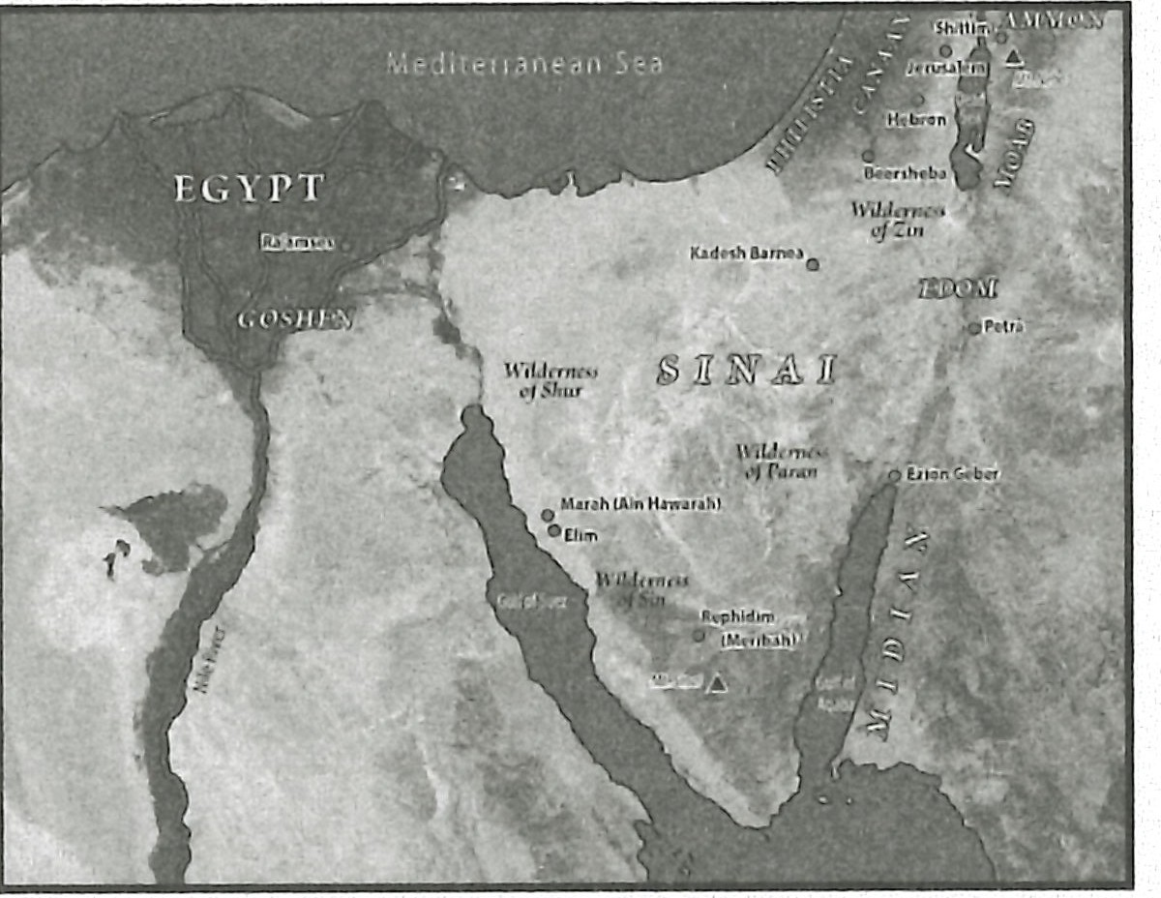**MAP:** Display resource 3 to show the locations of Kadesh Barnea and He­ bron.

The spies' first stop in the Promised Land was Hebron (13:21, 22). They noticed that the descendants of Anak lived there and that the city was built before Zoan in Egypt, probably a reference to how surprised they were at how large Hebron was. The descendants of Anak were giants according to the spies ' report (13:22).

**READ:** Numbers 13:22; Genesis 23:1, 2; 25:7-1O; 35:27-29; 50:13, 14. **ASK:**

What should the spies have noted about the city of Hebron? (Ql 3) *It was the burial place of all the patriarchs to whom God had given the promise of possession of the Promised Land.*

Hebron should have bolstered the spies' faith ; instead it made them afraid .

They focused on the obstacles, not on God's promises .

The only other place the spies noted in particular was the valley of Eshcol, named for its enormous clusters of grapes. The spies took a cluster and carried it on a pole between two men because it was so big (13:23, 24).

### Refusing the land (13:25- 14:38)

After forty days in the land, the spies returned with their report. They con­ firmed that the land indeed flowed with milk and honey, meaning it was a boun­ tiful land that brought forth much fruit. They showed the giant grapes they had carried back, along with pomegranates and figs (13:25- 27).

**ASK:** How should the people have reacted to the report of the bountiful land? (Ql 4) *They should have praised God for His provision and for graciously giving them such* a *bountiful land.*

The big grapes should have excited the Isr aelites. They would soon own those vineyards and have plenty of fruits and meat to eat. All they hated about the wil­ derness God wanted to give them in the Promised La nd.

But the report went on. The spies also talked about the big cities and the big people that stood in the way of those big grapes (13:28, 29). Ten of the spies con ­ cluded they were not able to overcome such big obstacles. Their report must have caused a discouraging response, for Caleb had to quiet the people. He said they would be able to overcome the people. He encouraged them to go forward (13:30).

But the other spies insisted *they are stronger than we* (13:31). They gave a bad re­ port, emphasizing the size and strength of the people and their cities (13:32, 33).

The Promised Land was incredibly bountiful and luscious. It was God's gracious gift to Israel. Instead of recognizing God's graciousness, the people rejected God.

**READ:** Numbers 14:1-4. **ASK:** What did the Israelites conclude about God? (Ql 5) *That He was either incompetent or an enemy; that dying was* a *better lot than life with God as their leader.*

The people were easily swayed. There was no way they were going to enter the land and face the giants . They complained about the gracious gift God had

promised to them and then offered them. They decided to go back to Egypt instead of into the Promised Land.

**READ:** Numbers 14:5-9. **ASK:** What did Joshua and Caleb believe about God? (Ql 6) *That God delighted in Israel and that He was with them to bless them with an incredible gift.*

God presented Israel with the very best He had ever offered them. They flat out rejected His blessing and Him in the process. They never really believed God was for them (14:10). They never trusted His goodness. They were certain that God's idea to bring them out of Egypt would turn out bad in the end. And so in the end it did for the naysayers and complainers. They never entered the Promised Land but died in the barren wilderness (14:29), a sad testimony of missed blessings because of mistrust in God (14:11). The children they claimed to protect would inherit the land without them forty years later (14:31).

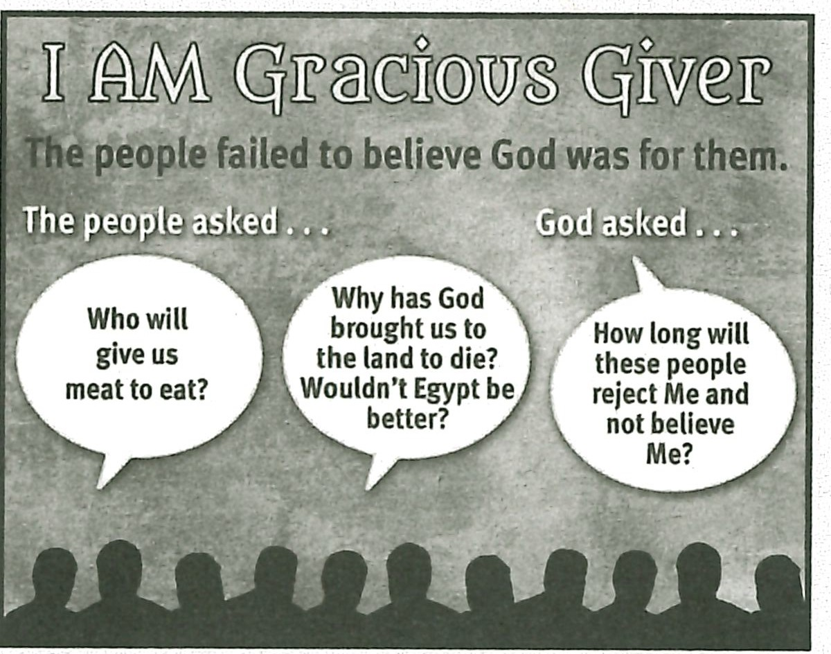**RESOURCE:** Display resource 13 to summarize the people's failure to see God was for them.

# MAKING IT PERSONAL

## God Is for You!

Some believers are convinced that God is against them and that eventually He will pull the rug out from under their lives and finally knock them down. That is a horrible way to live. God is not against us.

**ASK:** How do we know God is not against us? (See Romans 8:31- 39.) (Ql 7) *He has already provided us with the greatest gift of all: salvation through His Son's death on the cross. Nothing can separate us from His love.*

## Count Your Blessings

**ASK:** Have you been content with your lot in life? Explain. (Ql 8)

Having a tough lot in life or a lot we don't like does not indicate that God hates you or is against you. Count your blessings instead of your disappointments.

**ASK:** What reasons do we have to rejoice in the Lord with thanksgiving? (Ql 9)

*Salvation, life, opportunity to serve Him, access to His throne, friendships, the Holy Spirit, His Word, multiple assurances of His love.*

Encourage your learners to rejoice in the Lord and to look forward to the boun­ tiful blessings of eternity with enthusiastic service for the Lord. God is the gracious giver. We should be overjoyed to know Him and serve Him .

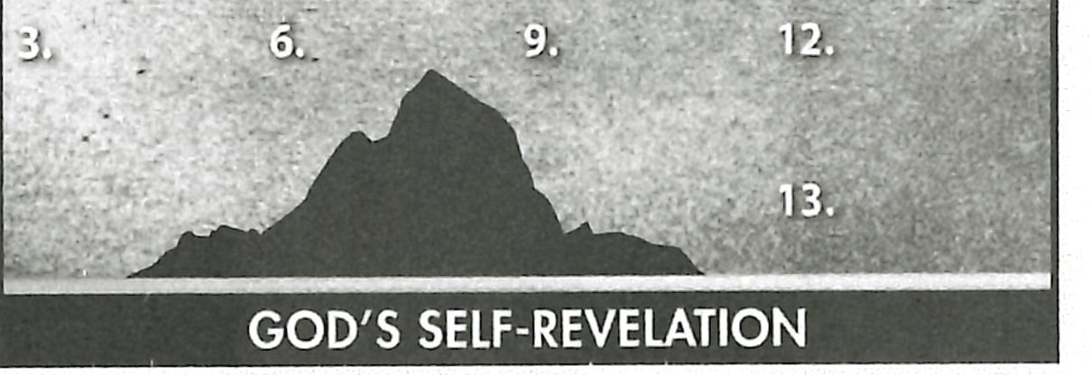

**I.AM**

1J[

### Summary and Memory Verses

 **RESOURCE:** Display resource 1. Add a summary statement about God's in­ troduction of Himself in lesson 10 or use the following: I AM Gracious Giver.

Encourage learners to memorize Romans 8:31 and 32. Give them an opportuni- ty to say the verses in class next week.