**l 1AM**



### Topic

**God's providence**

### Theme

**God sovereignly exe­ cutes His plan despite both human attempts to deny it and human blunders that threaten to derail it.**

### Desired Learner Response

**Learners will declare their trust in God to carry out His will despite obstacles or blunders.**

###### Materials

* Resources 1-3
* Handout 1 from resource CD
* Cup and tape
* Golf putter
* Golf ball
* Objects to use as obstacles on the putting green

# Sovereign

### Scripture Focus

**Gen. 12:1-3; 49:8-12; Exod. 1; 2:1-22; Gal. 3:8, 13-16**

### Summary

This lesson introduces God as the sovereign over all. He works throughout his­ tory to execute His plan. Pharaoh tried to crush Go d's plan by putting impos­ sible demands on the Israelites and by having their baby boys killed. Moses then seemed to derail God's plan by murdering an Egyp tian. Yet God remained sovereign ; His plan could neither be denied nor derailed .

###### Outline

1. **God Declared His Plan for Israel and Humanity (Gen. 12:1-3; 49:8-12)**
   1. God's covenant promises to Abraham (12:1- 3)
   2. J acob 's blessing of Judah (49:8-12)
2. **God Worked His Plan (Exod. 1)**
   1. God grew His nation (1:1-7)
   2. God thwarted Pharaoh's plans (1:8- 22)
      1. Pharaoh 's plan A (1:8- 12)
      2. Pharaoh 's plan B (1:13, 14)
      3. Pharaoh 's plan C (1:15-21)
      4. Pharaoh 's plan D (1:22)

**Ill. God Prepared His Leader (Exod. 2:1- 22)**

1. God's protective hand (2:1-4)
2. God's providential hand (2:5- 22)

1 . Moses' training in his parents' house (2:5- 9)

1. Moses' training in Pharaoh's house (2:10)
2. Moses' training in the wilderness (2:11- 22)

**Memory Verse** *"And the scrip ture,fore seeing that God would justify the heathen through faith, preached before the gospel unto Abraham,saying,In thee shall all nations be blessed"*

*(Galat ians 3:8).*

**9**

#### Flicker Golf

Distribute a copy of handout 1 to each pair of learners. Have them follow the instructions on the page for playing Flicker Golf.

**ASK:** What added strokes to your score? *They were unable to completely control the ball and keep it from going into hazards.*

The lesson for today will show that God sovereignly executes His plan despite both human attempts to deny it, represented by the obstacles on the golf course, and human blunders that threaten to derail it, represented by the golfers' bad strokes.

#### Impossible Shot

Lay a cup on its side and tape it to the floor as a hole for a makeshift putting green. Have a few learners attempt to successfully putt a golf ball into the hole from about ten feet away. Then have learners set up obstacles in front of the hole to make the shot difficult to make. Have a few more learners take turns trying to make the shot. Lastly, add more obstacles in front of the hole to make the shot nearly impossible to make. Have a couple more learners try the impossible shot.

**ASK:** Why did you fail to make your shot? *Either they hit the ball off target, or it was stopped by one of the obstacles.*

The lesson for today will show that God sovereignly executes His plan despite both human attempts to deny it, represented by the obstacles on the golf course, and human blunders that threaten to derail it, represented by the golfers' bad strokes.

## SEARCHING THE SCRIPTURES

* 1. **God Declared His Plan for Israel and Humanity (Gen. 12:1-3; 49:8-12)**
     1. **God's covenant promises to Abraham (12:1- 3)**

Israel's history began with God's call of Abram, later renamed Abraham. God called Abraham to leave his homeland for a land He would show him. Along with that call God made a covenant, or solemn promise, to Abraham.

**READ:** Genesis 12:1-3.

God promised Abraham that he would become a great nation and that his de­ scendants would live in a specific land. And out of that great nation would come a blessing to all the nations of the eart h.

Genesis 12 - 50 record the history of Abraham and his descendants. God passed His covenant with Abraham down to Abraham's descendants. Abraham's son Isaac had a son named Jacob. Jacob, later called Israel, had twelve sons by his

wives Rachel and Leah and by his wives' two maidservants (35:22- 26). Jacob loved Rachel more than Leah and consequently favored her older son, Joseph (37:3).

Joseph was the second youngest among his twelve brothers . The ten older broth­ ers hated Joseph because of Jacob's favoritism and because of Joseph's dreams of greatness (37:1- 11). They seized on the opportunity to get rid of him by selling him into Egypt as a slave (37:12- 36). In Egypt, Joseph rose to second in command when God allowed him to interpret Pha raoh's dream about seven years of bumper crops followed by seven years of severe famine (41).

Jacob and Joseph's brothers eventually moved to Egypt to escape the famine

(46). Instead of se eking vengeance , Joseph proclaimed to his brothers, *Now there­ fore be not grieved , nor angry with yourselves , that ye sold me hither: for God did send me before you to preserve life* (45:5). Eventually all of Joseph's family, includ­ ing his brothers and their families and his father, came to live in prominence in Egypt (47 :1- 12).

##### Ja cob ' s b l ess i ng of Judah (49:8- 12)

Jacob lived in Egypt unt il his death . Before he died, he blessed each of his sons (49:1- 28). The blessing he gave to Judah , his fourth oldest son, is of particular importance . It helps us understand what God meant when He promised that Abra­ ham's seed would be a blessing to all nations (12:3).

**READ:** Genesis 49:8, 10. **ASK:** What does this blessing reveal about a future descendant of Judah? (Q3) *Israel will bow down to Him and people (nations) will obey Him.*

The blessing states of Judah , *Thy father's children shall bow down before thee* (49:8). Obviously Judah was to rule his brothers in some way. That did not happen in Judah's lifetime. So the statement must refer to a yet-future fulfillment. Judah's rule is further explained in verse 10 : *The sceptre shall not depart from Judah, nor a lawgiver from between his feet, until Shiloh come; and unto him shall the gathering of the people be.* This blessing develops the profile of a victorious warrior king.

*Sceptre* refers to the wand of ldngship that extends to between the ldng's *feet. Shiloh* is a reference to the Messiah. The word *Shiloh* can mean *to whom it belongs,* indicating that the scepter belongs to Christ. The scepter, then, will remain with Judah until Christ comes to establish His rule over Israel and the *people,* a plural noun that refers to multiple people groups or nations. Christ's rule will be established on earth during His future millennial Kingdom . The concept of Christ ruling nations is an important theme in the Bible (Ps. 2:8; Dan. 7:13, 14; Rev. 5:5, 9). And it partially reveals how the *seed* (Gal. 3:16) of Abraham will be a blessing to all peoples (Gen. 12:3).

**READ:** Galatians 3:8, 13-16. **ASK:** What is the primary way in which Christ is a blessing to the nations? (Q4) *Christ's death on the cross and the provision of salvation is the ultimate blessing realized by the nations.*

Genesis 49:11 and 12 describe Christ's future rule as a time of great prosperity.

Grapevines will be strong enough to tie donkeys to without worry of the donkey break­ ing free and escaping. And juice from the grapes of those vines will be so plentiful that people could use it to wash their clothes without causing a shortage of juice.

**Judah's three older broth­ ers, Reuben, Simeon, and Levi, disqualified them­ selves from being the heir of the covenantal prom­ ises due to egregious sin (Gen. 34:22- 30; 35:22).**

**ASK:** Assume you don't know the rest of the story of Jacob's descendants. Based on the Genesis 49 blessing, what would you expect to happen next in the narrative surrounding this large family? (QS) *Perhaps the departure of Israel from Egypt, establishment in the Promised Land, and the birth of the One to rule the nations.*

All seemed well when the book of Genesis closed. God's people were living in peace and in favor with Pharaoh in Egypt. God's plan seemed to be perfectly

acceptable as Abraham's descendants grew into a nation. But Exodus begins with a turnabout; life was no longer easy.

**READ:** Genesis 15:13, 14. **ASK:** Why should the Israelites have known that life was not going to continue to be easy for them as a nation? (Q6) *God told Abraham that his descendants would be afflicted in* a *strange land for four hundred years.*

#### God Worked His Plan (Exod. 1)

* + 1. **God grew His nation (1:1-7)**

Jacob moved to Egypt with seventy people. By the time Exodus opens, his descendants had grown exceedingly; the land of Egypt was filled with Israelites (Exod. 1:1-7). God had been faithful to His promise to make of Abraham a great nation. Because the nation had grown, one might expect Israel to peacefully move out of Egypt and on to the Promised Land to claim what was theirs. But God had

a much different plan in mind. He had much more to accomplish than simply getting His people to the Promised Land.

* + 1. **God thwarted Pharaoh's plans (1:8-22)**
       1. **Pharaoh's plan A (1:8-12)**

**RESOURCE:** Display resource 2 to track Pharaoh's plans and God's responses.

|  |  |  |  |
| --- | --- | --- | --- |
| jp)- @I& Wo ®lI» | | | |
| **:Afflict the**  **kebrews to**  **llmll their** | **HeMbraekwes**t**s**h**e**eI**rve**  **with rigor to**  **limit their** | **Co'!'m nd** I**the m1dw1ves to**  **kill the baby** | **th**C**e**o**E**m**g**m**yp**an**ti**d**an**  **peojlle to**  **throw the baby** |
| **number** | **..»lk!r** | **boys** | **boys In the**  **Nile** |
|  |  | **Midwives I** | **God spared Moses and** |
|  | |
|  |  |
| **and spared the** | **his training** |
| **baby boys** | **In Pharaoh's house** |

A pharaoh arose who knew nothing of Joseph's contribution to Egypt (1:8). To

him the exploding nation oflsrael was a power threat (1:9, 10). He was concerned that the Hebrews might rebel if Egypt were attacked. Yet he needed the Hebrews

to provide labor for his ambitious projects. So he came up with a plan for lowering

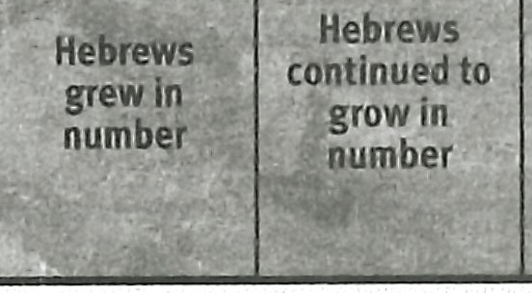1 the risk of a Hebrew rebellion.

i **READ:** Exodus 1:8-11. **ASK:** What was Pharaoh's plan A for lowering the risk of a Hebrew rebellion? (Q7) *He told his people to deal wisely with the Israelites, afflicting them as they worked to keep them from multiplying so quickly.*

Pharaoh's ultimate goal was to prevent Israel from leaving the land. Eventual­ ly that goal would be shared by another pharaoh nearly a century later when Mo­ ses arrived back in Egypt as Israel's deliverer (cf. 5:1, 2). The first fourteen chapters of Exodus build to a climax as both God and the pharaohs seek to carry out their plans for Israel.

The pharaoh in charge when the book of Exodus opens liked having the Hebrews as slaves. Astutely he had them build him two cities that housed supplies and most likely armaments that would help Egypt defeat any invading army. Notice that Pharaoh accounted for *human* enemies that might help the Hebrews but gave no thought about the Hebrews' God being a source of help. That the Hebrews were slaves in his land probably contributed to his low estima­ tion of the Hebrews' God.

**ASK:** How do you think the Israelites felt about building cities that would solidify their state as slaves in Egypt? (Q8) *Their doubts about being delivered must have deepened as they realized Pharaoh was taking defmite measures to ensure they could not leave Egypt.*

**READ:** Exodus 1:12. **ASK:** What became of Pharaoh's efforts to slow down Israel's growth as a nation? (Q9) *Pharaoh's plan didn't work. The Israelites grew more in number instead of less.*

The more Israel grew as a nation, the more worried Egypt became. The Egyp­ tians began to become anxious about Israel's presence in their land.

* + - 1. **Pharaoh's plan B (1:13, 14)**

Pharaoh responded to Israel's increase in strength and number by making the people work even harder. He made Israel work with *rigour,* meaning that the Egyp­ tians treated the Hebrews harshly and drove them to work beyond reason (1:13, 14). Pharaoh's plan was to wear them out so that their desire to survive distracted them from the normal life of marrying and having children. Apparently Pharaoh's plan B didn't work. The Israelites continued to grow. Hard work was not going to break them of their love for family.

There is a sense in which the harder Pharaoh made the men of Israel work, the more they relished having a family to love and support them during the hours they were not being oppressed. Pharaoh's plan was in essence counterintuitive. Of course God's hand was also behind the scenes thwarting Pharaoh's plan B to keep the Israelites from growing as a nation.

**ASK:** When has a difficult circumstance helped you appreciate and grow closer to your family? (Ql O)

* + - 1. **Pharaoh's plan C (1:15-21)**

Still not seeing the results he wanted, Pharaoh tried plan C to deal with the population explosion at its source. He commanded the midwives to kill the He­ brew male babies as soon as they were born. Pharaoh wanted to destroy the future Hebrew soldiers before they grew up and fought against him. Perhaps he thought that at some point in the future he would let some Hebrew boys live to replenish his slaves that aged and were no longer able to work. For an ongoing policy of killing Hebrew boys would have eventually devastated Egypt's workforce.

**READ:** Exodus 1:15-17. **ASK:** What kept the midwives from killing the He­ brew children? (Ql 1) *Their respect for God.*

Whether the midwives Shiphrah and Puah were Hebrew or Egyptian is unclear (Exod. 1:15).

The midwives revered life because they revered God. If the midwives were Hebrews rather than Egyptian, their actions were motivated by their faith.

Pharaoh soon realized that his plan C was not working. He called the mid­ wives and asked them why they weren't obeying him. The midwives made up the excuse that the Hebrew women gave birth so quickly that they weren't even pres­ ent to kill the baby boys. The midwives lied to Pharaoh and hid their reverence for God. Though God never condoned their lie, He did bless them because of their respect for Him in the matter of sparing the Hebrew boys.

* + - 1. **Pharaoh's plan D (1:22)**

Pharaoh became increasingly frustrated and desperate. So he enlisted all of the Egyptians to help him carry out his most cruel plan. He empowered

every Egyptian to act as an executioner on his behalf. When the Egyptians saw a Hebrew baby boy, they were to execute the boy by throwing him into the Nile to drown.

**READ:** Exodus 1:22. **ASK:** Describe what life would have been like for He­ brew families with Pharaoh's executioners lurking all around? (Ql 2) *It would have been terrifying for expectant families. Trying to save their boys would have been nearly impossible. Losing them so cruelly would have been unbearable.*

Chapter 1 ends with these awful circumstances in place. They became the new normal. It appears that Pharaoh had finally come up with a plan to keep Israel

in Egypt. And we can safely assume that many of the Hebrews' boys were indeed drowned in the Nile.

**ASK:** What questions might you have been tempted to ask God if you had been living as a Hebrew slave in Egypt at that point in history? (Ql 3)

What God did next to continue to carry out His plan for His people shows just how powerless Pharaoh was to keep God's people in Egypt.

##### God Prepared His Leader (Exod. 2:1-22)

* + 1. **God's protective hand (2:1-4)**

Perhaps Pharaoh thought that a death sentence for all Hebrew baby boys would deter the Hebrews from having any children at all. But that was not the case. A couple from the tribe of Levi married and had children. The couple is later identified as Amram and Jochebed. Their firstborn boy was Aaron (see 6:20). Their second boy was later named Moses. Fearing Pharaoh's execution­ ers, Moses' parents hid him for three months until it became impossible to do so safely (2:1, 2).

**ASK:** Was keeping Moses safe for the first three months of his life up to just Amram and Jochebed? Explain. (Ql 4) *No. God obviously was working through their efforts to protect Moses.*

Jochebed made a watertight ark of bulrushes, put Moses in it, and nestled it in the reeds by the bank of the Nile. Moses' sister Miriam stood afar off to see what would become of her brother (2:3, 4).

One could argue that Jochebed was acting out of disbelief by taking Moses out of hiding. But she was doing what God wanted. Her plan, whether or not she realized it, was exactly what God wanted. God protected Moses through his mother's efforts.

* + 1. **God's providential hand (2:5-22)**

#### Moses' training in his parents' house (2:5-9)

**READ:** Exodus 2:5-9. **ASK:** What is your reaction when you read that God used Pharaoh's daughter to protect Moses? (Ql 5)

Pharaoh's efforts to keep the Israelites in Egypt were all part of God's plan. God used the circumstances to allow Moses to safely return home. There he most certainly received instructions about God and the importance of his national identity as a Hebrew. The word used for *grew* indicates Moses was at least well into boyhood when he left to live with Pharaoh's daughter. Later he identified himself

as a Hebrew rather than an Egyptian, even after spending most of his life in Pha ­ raoh's house (cf. Acts 7:23- 25). That national connection would be crucial for his leadership of Israel decades later.

#### Moses' training in Pharaoh's house (2:10)

What Moses did while he was in Pharaoh's household and under the care of Pharaoh's daughter is not well documented. But there are some clues and some conclusions we could draw.

**READ:** Acts 7:21, 22. **ASK:** What did Moses learn while he was in Pharaoh's house? (Ql 6) *He learned the wisdom of the Egyptians and became mighty in words and deeds.*

Moses received leadership training while in Egypt. Later on he would balk at God's call to lead the Israelites out of Egypt, claiming he could not speak elo­ quently (Exod. 4:10). One could conclude that the leadership training he received in Egypt did him no good. But imagine how ill prepared he would have felt with­ out his time in the Egyptian schools. Moses was *mighty in words,* meaning he com­ manded the language well and knew what to say on just about any subject. Being *mighty in* ... *deeds* meant he had a good grasp of business and perhaps even war.

* + - 1. **Moses' training in the wilderness (2:11-22)**

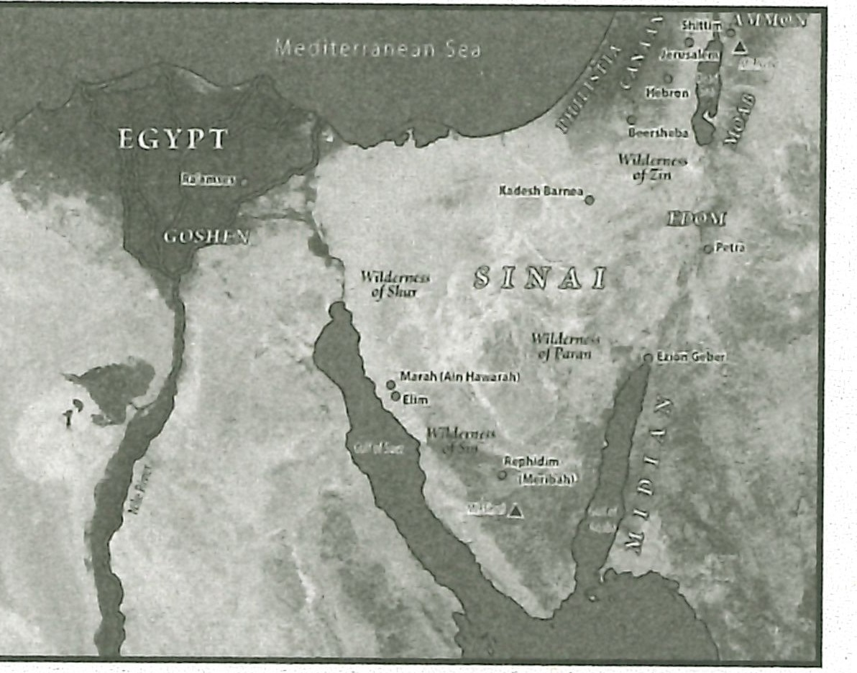**MAP:** Display resource 3 to show the location of Midian in relation to Egypt.

When Moses was forty, he went to visit his people and noticed an Egyptian beating a Hebrew (Exod. 2:11). Moses made sure no one was looking and then killed the Egyptian, burying his body in the sand (2:12). When Moses went out a second day to see the burdens of his people, he intervened in a dispute between two Hebrews. They questioned whether he would kill one of them as he had killed the Egyptian (2:13, 14). Moses realized that his murder of the Egyptian must have been made known. Moses fled Egypt as the report came to Pharaoh (2:15). Pharaoh was probably not as concerned about the murder as he was about Moses siding with the Hebrew slaves.

**ASK:** On the surface, what did Moses' blunder in killing the Egyptian seem to do to his opportunity to lead the Hebrews out of Egypt? (Ql 7) *It seemed like his opportunity was ruined. The Egyptians were hunting for him, and his fellow Hebrews were suspicious of him.*

Moses ended up in Midian on the eastern shore of the Gulf of Aqaba. There he sat down by a well (2:15). Before long Moses was again intervening to stop an injustice. This time is was on the behalf of seven daughters of a Midianite priest named Reuel. Moses kept shepherds from chasing the daughters from the well (2:15- 17). As a result, Reuel gave Moses his daughter Zipporah as his wife (2:18 - 22).

Moses remained in Midian for forty years (Acts 7:30). His life as a shepherd was far different than his life in Egypt.

**ASK:** What lessons would Moses learn from caring for sheep in the wilder­ ness? (Ql 8) *He would learn to adapt to the rigors of the wilderness; he would learn to deal with those who are prone to wander and go their own way; he would learn something about God's care for His wandering people.*

God providentially directed Moses' life to prepare Moses to lead the Hebrew slaves out of Egypt. God had already proved that He sovereignly executes His plan despite both human attempts to deny it and human blunders that threaten to de­ rail it. Next He would introduce Himself to Moses as I AM, the transcendent helper.

## MAKING IT PERSONAL

##### Overcoming Obstacles

The midwives respected God rather than Pharaoh, knowing that God is able to accomplish His will despite seemingly impossible obstacles.

**ASK:** What obstacles to God's will for your life have you considered too big to overcome? (Q19)

**ASK:** How should God's introduction of Himself as the Sovereign affect how you view those obstacles? Consider what God was able to do despite Pha­ raoh's attempts to deny His will. (Q20)

##### Getting Back on Track

Moses seemed to have destroyed God's plan to deliver His people. But God used Moses' blunder to further prepare Moses to lead.

**ASK:** Have you concluded that God could not use you because you've com­ mitted a blunder that seemed to derail His will for you? (Q21)

Deal with those blunders, confessing any outstanding sins and renewing your relationship with God. Pray that God would use you to accomplish His will for your life. (Q22)

##### Summary and Memory Verse

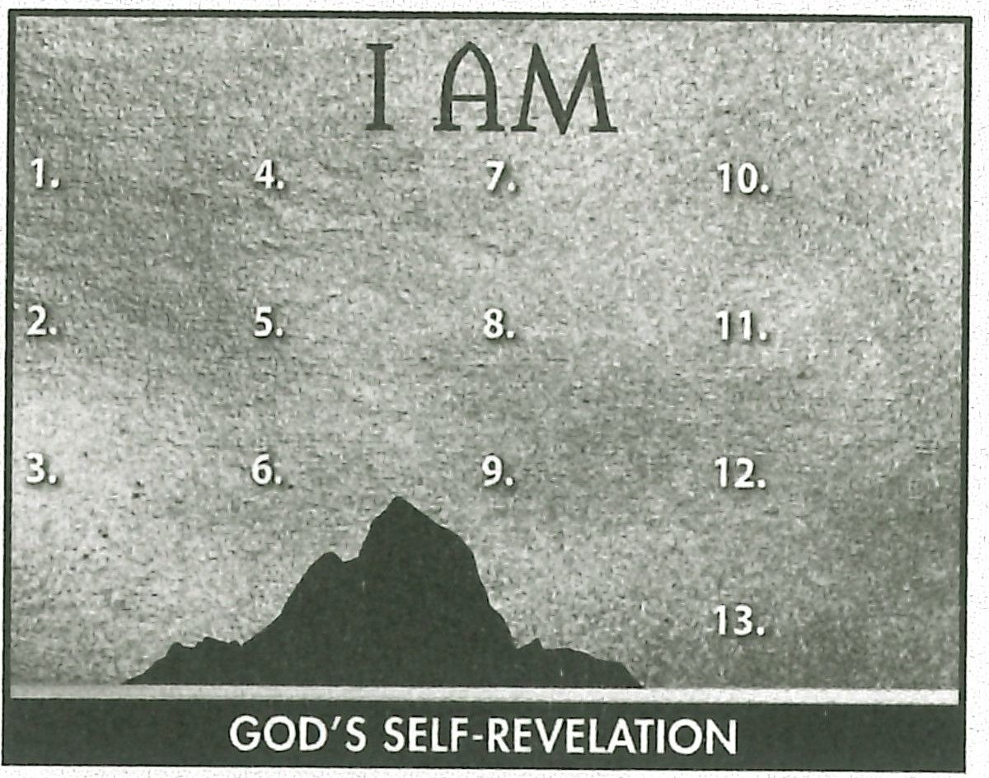**RESOURCE:** Display resource 1. Add a summary statement about God's introduction of Himself in lesson 1 or use the following: I AM Sovereign.

Encourage learners to memorize Galatians 3:8. Give them an opportunity to say the verse in class next week.



### Topic

**God's transcendence and eminence**

### Theme

**God is both transcen­ dently above us and eternally with us.**

### Desired Learner Response

**The learner will consider how to reverence our transcendent God and how to let God's pres­ ence affect his life.**

###### Materials

* Resources 1 , 3, and 4
* Slips of paper
* Pencils
* Newspaper

**1AM**

# Transcendent

**Helper**

### Scripture Focus

**Exod. 2:23-4:17**

### Summary

This lesson covers Go d's continuation of His plan for His people, including His call of Moses. The themes of both His transcendence and His eminence run through the account. God wanted Moses to have confidence in Him . Moses grew in His faith but did not reach full surrender to God's will.

###### Outline

1. **God Continued His Plan for Israel (Exod. 2:23 - 25)**
   1. God on high heard Israel 's cry (2:23, 24a)
   2. God on high loved Israel (2:24b , 25)
2. **God Con tinued His Prep ara tion of Moses (Exod. 3:1- 9)**
   1. God came down to Moses (3:1- 4)
   2. God commanded separation (3:5- 9)

**Ill. God Commissioned Moses (Exod . 3:10- 15)**

1. God assured Moses of His presence (3:10- 12)
2. God revealed His transcendence (3:13- 15)
3. **God Instructed Moses (Exod. 3:16-22)**
   1. Go d's message to Israel (3:16-18a)
   2. Go d's message to Pharaoh (3:18b)
   3. Go d's message of deliverance (3:19- 22)
4. **God Answered Moses (Exod. 4:1- 17)**
   1. Go d's demonstrated His power (4:1- 9)
   2. Go d's promised His presence (4:10- 17)

**Memory Verse** *''An d God said unto Moses, I AM THAT I AM: and he said, Thu s shalt thou say unto the children of Israel,*

*I AM hath sent me unto you" (Exodus 3:14) .*

**18**