St. Paul Memory Garden
St. Paul Lutheran Church
730 County Hwy. PPP
Sheboygan Falls, WI 53085
(920) 467-6449

Date
Subscriber (Applicant) Information:
Name (Last, First, MI)
Name (Last, First, MI)
Please indicate your eligibility status below
1. Current member or Minister | 2. Family of Current Member of Minister | 3. Former Member or Minister | 4. Family of Former Member of Minister | 5. Other
If you checked No. 2 or No. 4, enter the name of the family member who is/was a St. Paul member or minister:

If you checked No. 5, please explain your connection to St. Paul Lutheran Church:

Address
City State Zip Code
Please circle preferred phone number:
Home Phone Work Phone Cell Phone
Email
Niche Information

Cost $2,200 Each niche will accommodate two urns with dimensions of 5 ½” x 5 ½” by 11” to hold the cremains of two persons.
Purchase of contiguous niches: Yes No If yes, how many
A separate application is required for each contiguous niche.
Name of designee #1
Name of designee #2
Niche assignment: Niche location will be assigned in order of purchase. Multiple niches purchased at the same time will be contiguous if space permits. A certificate of Ownership and Inurnment Rights will be issued upon application approval and full payment.
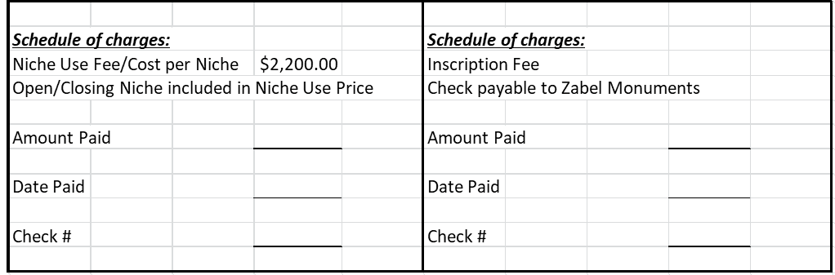
Terms and Conditions
I understand that use of the St. Paul Lutheran Church Memory Garden Columbarium shall be subject to the “Policies and Procedures which was provided to me and I agree to be bound by it. I understand that my application must be approved by the St. Paul Lutheran Church Columbarium Committee. Upon approval of my application, and after payment in full, I understand that I will be assigned a niche location and will receive a signed copy of my Certificate of Inurnment Rights and this application. My application includes a Certificate of Inurnment Rights which I have signed.

Date
Subscriber (Applicant) Signature

Date
Subscriber (Applicant) Signature

Date
St. Paul Lutheran Church Columbarium Committee Chairperson (or designee) Signature

On the next page, please provide a minimum of two (2) additional contacts. It is the sole responsibility of the Applicant, their next of kin or contacts to notify the Church of any change of contact information.
For Office Use Only:
Eligibility Verified by:

Staff Member Signature

Contact 1 (REQUIRED)
Name (Last, First, MI)
Address
City State Zip Code
Relationship
Please circle preferred phone number:
Home Phone: Work Phone: Cell Phone:
Email:

Contact 2 (REQUIRED)
Name (Last, First, MI)
Address
City State Zip Code
Relationship
Please circle preferred phone number:
Home Phone: Work Phone: Cell Phone:
Email:

Contact 3 (OPTIONAL)
Name (Last, First, MI)
Address
City State Zip Code
Relationship
Please circle preferred phone number:
Home Phone: Work Phone: Cell Phone:
Email:

