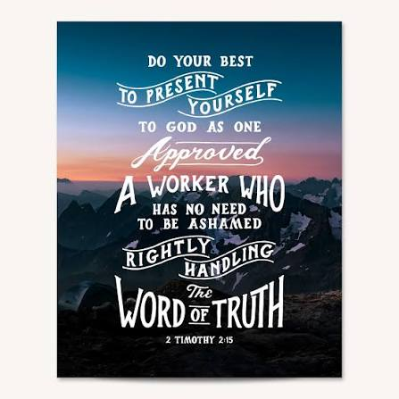
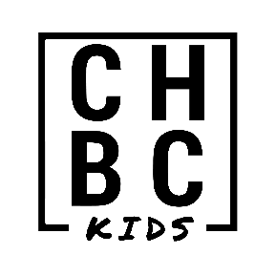
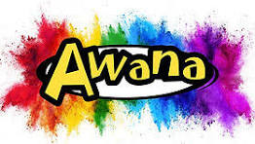

Capitol Hill Baptist Church
chbchurch.org facebook.com/chbcokckids
The purpose of AWANA is to teach children to know, love and serve God. It is our prayer that each child will become a follower of Christ. AWANA has found that when churches and parents work together, they see children that become steadfast in biblical faith and character as young adults. That is what we desire to see in the children that attend. AWANA is also a great discipleship tool for you to share with your children. It provides a wonderful Biblical foundation and opens up opportunities for gospel conversation.
Your child will bring home an entrance booklet, which is the first step in AWANA. We hope you will help your child complete this booklet. After completing the entrance booklet, your child will work through their handbook. They will earn awards as they complete sections in their books. These awards will be given at Award Nights. For more information about AWANA, visit awana.org for tips on how to get the most out of your child’s experience. Also visit awanaplus.com for digital lessons.
If you do not have a church home, we would like to invite you to visit our church. We have Sunday School classes for all ages at 9:00 am. Worship Service begins at 10:15 am, and again at 5:00 pm. There is also a Pastor’s Bible Study that meets on Wednesday night at 6:00 pm while your child is in AWANA. If you have any questions, please don’t hesitate to contact us. We are grateful for the opportunity to teach your children in AWANA.
In His love,
Tom Hollis – CHBC Children’s Minister Fran Klepfer - AWANA Commander
Nightly Schedule
5:45 Checkin for all kids and leaders in the foyer * Sparks and T&T in Worship Center for opening
Cubbies check in from Preschool area
6:00 T&T Girls Game Time: Activity Center T&T Boys Hand book Time: Room 200/202
Sparks Hand Book Time: Room 305 (girls) Room 307 (boys)
6:30 T&T Boys Game Time: Activity Center T&T Girls Handbook Time: Rooms 200/202
Sparks Group Time: Room 307
7:00 T&T Group Time: Room 200/202 Sparks Game Time: Activity Center
7:30 Cubbies dismiss from Preschool area Sparks dismiss to parent Sparks dismissal rooms
T&T dismiss from rooms 200/202


Puggles – 1 or 2 years old; children of AWANA vounteers
5 items for AWANA
Each of these earn “AWANA Bucks” for the store
- Attendance
- Bible
- Handbook
- Uniform
- Offering

Cubbie – 3 and 4 year olds

Sparks – Kindergarten through 2nd grade

T&T – 3rd through 6th grade

Handbook information
- All children will start in their clubs’ entrance flyer. Once that is complete, they can begin their handbook. If your child is still working through a handbook from last year, they will continue in the same book unless they are moving to a new club.
- Cubbies will be in the “Honeycomb” handbook, which they work through together as a group.
- All new Sparks children start in HangGlider. They then complete the books in order: HangGlider, WingRunner, SkyStormer.
- T&T may complete books in any order. All new T&T children will start in “Agents of Grace” this year.
- Kids may not skip around in their handbooks, and they should come prepared to say at least one section each week. Please write your child’s name in multiple places in their handbook.

AWANA Calendar 2026 – 2027
Aug 5: AWANA Leader Training Jan 6: Regular Club – Welcome Back
Aug 12: AWANA Kickoff Jan 13: Fictional Character Night
Aug 19: Regular Club (1st Club night) Jan 20: Twinkie Night/Bring a Friend
Aug 26: Twinkie Night/Bring a Friend Jan 27: Regular Club
Sept 2: Regular Club Feb 3: Regular Club – Cars on Sale
Sept 9: Regular Club Feb 10: Regular Club – Work on cars
Sept 16: Western Night Feb 17: Regular Club – Work on cars
Sept 23: Regular Club Feb 24: Deadline for cars to be done & checked in
Sept 30: Regular Club Mar 3: Grand Prix
Oct 7: Regular Club Mar 10: Regular Club
Oct 14: Fall Break, no AWANA Mar 17: Spring Break, no AWANA
Oct 21: Thunder Up! Mar 24: Regular Club
Oct 28: Glow Night Mar 31: School Spirit
Nov 4: Regular Club Apr 7: Leader Appreciation
Nov 11: Pizza/Pop night Apr 14: Regular Club
Nov 18: Regular Club Apr 21: Regular Club
Nov 25: Thanksgiving Break, no AWANA Apr 28: Regular Club
Dec 2: Christmas Gear May 5: VBS Preview – Paper airplane contest
Dec 9: Store Night/Christmas practice May 12: Store Night/Awards practice
Dec 16: AWANA Christmas Party May 19: Final Awards Night

