
Anchor of the Soul – Hebrews 6:10-20
At the end of Ch. 5 and beginning of Ch. 6 Paul is being pretty rough saying you should mature and move on from milk and onto the meat. Goes on to state a hypothetical situation in which if you could lose your salvation, then you couldn’t get saved again – because Christ died once. The point is if you truly get saved, you can never lose it, but that doesn’t mean you should sit around and live however you want. No! You should mature, grow in your faith, and things should accompany your salvation. So Ch. 6 closes out with Paul now trying to encourage them a little bit.

- _____________________________________________________________________________________

  - God hasn’t ____________________________________________________________
    - Vs. 10 – “For God is not unrighteous to forget your work and labour of love.…”

  - Who are you ___________________________________________________
    - Vs. 12 – “That ye be not slothful, but followers of them…...”
    - 1 Cor. 11:1 – “Be ye followers of me, even as I also am of Christ.”

  - Be someone ____________________________________________________________________
    - Vs. 11 – “And we desire that every one of you do shew the same diligence…”

- __________________________________________________________________________________

  - We’re reminded of _____________________________________________________________
    - Vs. 13 – “For when God made promise to Abraham…..”
    - Gen. 22:16-17 – “And said, By myself have I sworn, saith the LORD, for because thou hast done this thing, and hast not withheld thy son, thine only son: That in blessing I will bless thee, and in multiplying I will multiply thy seed as the stars of the heaven, and as the sand which is upon the sea shore; and thy seed shall possess the gate of his enemies;”

  - The Reliability of ______________________________________________________________
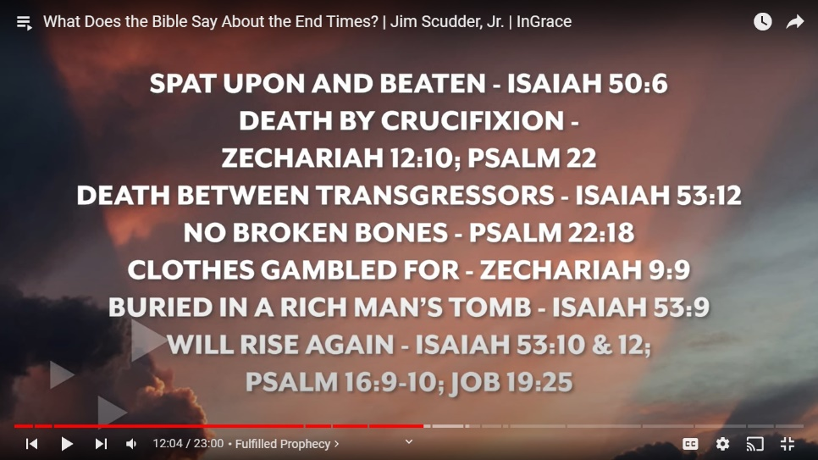
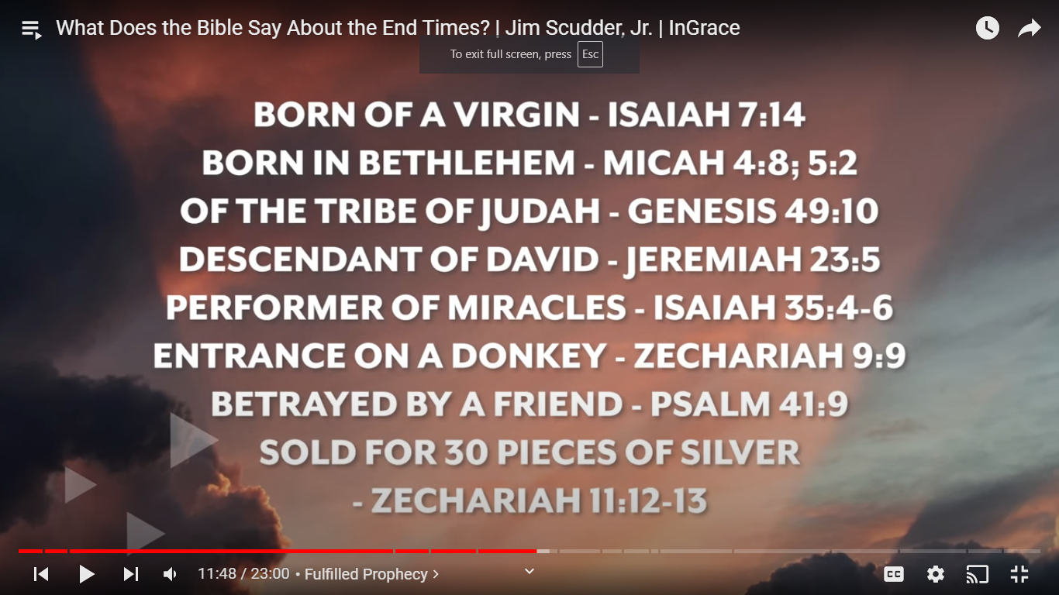

  - We can trust ____________________________________________________________________
    - The Rapture and His 2nd Coming.
      - 1 Thess. 4:16-17 – “For the Lord himself shall descend from heaven with a shout, with the voice of the archangel, and with the trump of God: and the dead in Christ shall rise first:”
      - John 14:2-3 – “In my Father's house are many mansions: if it were not so, I would have told you. I go to prepare a place for you. And if I go and prepare a place for you, I will come again, and receive you unto myself; that where I am, there ye may be also.”

- ___________________________________________________________________________________

  - We need to know we ______________________________________________________
    - Vs. 19 – “Which hope we have……”
    - 2 Cor. 4:4 – “In whom the god of this world hath blinded the minds of them which believe not, lest the light of the glorious gospel of Christ, who is the image of God, should shine unto them.
    - Rom. 10:14 – “How then shall they call on him in whom they have not believed? and how shall they believe in him of whom they have not heard? and how shall they hear without a preacher?”
    - Acts 2:37 – “Now when they heard this, they were pricked in their heart, and said unto Peter and to the rest of the apostles, Men and brethren, what shall we do?”

  - Our hope is ________________________________________________________
    - Vs. 19 – “Which hope we have as an anchor of the soul, both sure and stedfast….”

  - Not just salvation but for __________________________________________________
    - Vs. 18 – “….we might have a strong consolation, who have fled for refuge…”

If you’ve never accepted Christ for salvation, let me share with you the simple ABC’s of Salvation
A – Admit you’re a sinner undeserving of going to Heaven (Rom. 3:23, 6:23)
B – Believe Jesus died for your sins and rose again, proving that He was God (Rom. 5:8, 1 Cor. 15:3-4)
C – Confess Him as your Saviour, trusting Him as your way to Heaven (Rom. 10:9-10, Acts 16:31)
If you have any questions about salvation please call Pastor Kurt @ 513-377-8645

