Praise Band Land of My Father
Is He Worthy

Welcome Pastor Jo Ann

Ringing the Bells Roger and our kids

Centering Thought

“Never confuse a single defeat with a final defeat.”
F. Scott Fitzgerald

*Opening Song Grace Alone
TFWS 2162
Prayers of the People

The Lord’s Prayer
Our Father who art in heaven, hallowed be thy name. Thy kingdom come, thy will be done on earth as it is in heaven. Give us this day our daily bread and forgive us our trespasses as we forgive those who trespass against us. Lead us not into temptation but deliver us from evil. For thine is the kingdom and the power and the glory forever. Amen.

Response: All I Need is You

Children’s Time:
Children may leave with their teachers for the classroom, or return to their families in the sanctuary.

Perspective from the “Pews” Sindy Vasquez

Ministry News Jan Southard
Offering
*Doxology

Choir Anthem What Wondrous Love is This?

Scripture: Luke 13: 6-9 Debbie Chawner

Then he told this parable: “A man had a fig tree planted in his vineyard, and he came looking for fruit on it and found none. So he said to the man working the vineyard, ‘See here! For three years I have come looking for fruit on this fig tree, and still I find none. Cut it down! Why should it be wasting the soil?’ He replied, ‘Sir, let it alone for one more year, until I dig around it and put manure on it. If it bears fruit next year, well and good, but if not, you can cut it down.’ ”

The Word of God for the People of God
Thanks Be to God

*Song of Preparation God of Grace and God of Glory
UMH 577

Message: Second Chances Pastor Jo Ann

*Closing Song Trading My Sorrows

*Benediction

*Please stand as you are able

Margie Stoner’s Feed My Sheep Backpack Ministries Updates
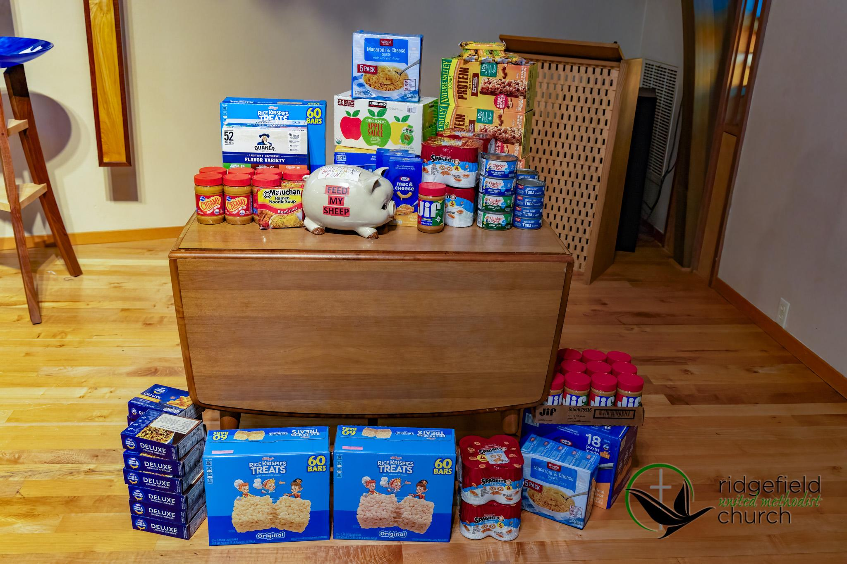
On Sunday, March 16th, we raised $1,577.48 to purchase food for the children in the backpack program. The breakdown is as follows:
$573 cash
$887.50 checks and online giving
$116.98 coins
THANK YOU!

With the amount of food donations, plus the money raised, we are able to purchase food not only for the spring break bags, but we are also thinking ahead and planning to stock the cabinets for the summer! Currently, we are considering what a summer program would look like, and we are working with the Family Resource Center to support children during the summer break!

Spring break food bag menu:
1 bag of chips, 2 Kellog’s Rice Krispy Treat bars, 1 protein bar, 1granola bar, 1 Fruit by the Foot, 2 applesauce pouches, 1 fruit cup, 2 bags of ramen, 2 Pop-Tarts, 1 bag of Knorr Rice Sides, 2 packets of oatmeal, 1 box of macaroni and cheese, 1 container of peanut butter, 1 bag of mini bagels, 3 meat sticks- times 92 bags!!!

Thank you Roger, for delivering the bags each week! Thank you Tony and Kim Novak for doing the shopping! Thank you Sophie, for keeping us so organized on packing days! Thank you Mark and Patty Novak for the beautiful, fresh fruit! Thank you to everyone who has volunteered to pack, and to all of you for your generous donations!

Ministry News

Tuesday
Congregational Care meets at 10:00 a.m.

Wednesday
Women’s Fellowship meets at 11:00 a.m.
Disciple Bible at 6:30 p.m.

Thursday
Quilters, downstairs at 1:00 p.m.
Praise and Choir Practice from 6:00 to 7:30 p.m.

Next Sunday, Phil Hodapp will share a message on the Prodigal Son. Pastor will be in Seattle for the weekend only.

Saturday, April 12
- Annual Clean-Up Day from 9 a.m. to noon. Trustees will identify projects that can happen that day or week. All help is appreciated.
- Passover Seder - Phil Hodapp will take a few hours in the evening to teach us the symbolism of Jesus’ last meal with his disciples. Tickets will be sold to help with planning and preparation.

Monthly income needed (Sunday offering): $25,157.50
March to date: $19,374.30



Musicians: Jennifer Bohn-Hodapp, Bob Southard,
Mike Loring, Jon Detchman, and Tina Moditz
Children’s Ministry: Carly Spears, Saryn Nash, Dale Castle
Nursery: Alvis Asiimwe & Evelyn Varley
AV: Billy Yaddof, Meghan Green
Acolytes: Susan Yaddof
Kitchen Hospitality: Marria Snell
Flower Team: Jan Southard, Carolyn Almond,
Mieko Heriford, Barb Pfeifer, Patti Novak, Cora Brown
Photography: Alan Moditz
Prayers: Meghan Green

Church Staff

Pastor: Rev. Dr. Jo Ann Schaadt
pastorjoann2017@gmail.com
509-770-3760

Children’s Carly Spears (Sunday)
Ministries: ridgefieldumckids@gmail.com

Office Carly Spears (Mon.-Thurs. 8:00-1:00)
Manager: ridgefieldmethodist@gmail.com

Finance Sandi Winn (Tues.)
Secretary: swinndaisy@gmail.com

Choir Director: Dr. Jennifer Bohn-Hodapp
jennifer.bohn@washougalsd.org

Office hours: Monday-Thursday 8 a.m. to 2 p.m.
Email: ridgefieldmethodist@gmail.com
Phone: 360-887-8312
Website: ridgefieldumc.com
P Prayer Chain: ridgefieldmethodistprayers@gmail.com



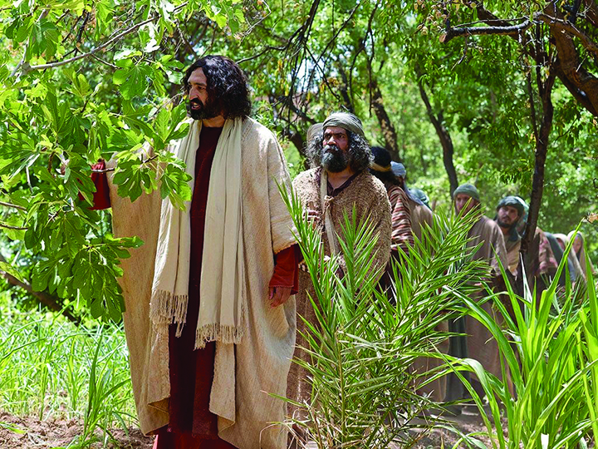

March 23, 2025
10:00 a.m.

