What The Bible Says About Being . . .
Transgender
Selected Scripture
Part 1

Is my gender/sexual identity determined by God and known at birth by the anatomy that I am born with . . .

Or is it determined by my own desires or preferences that I may have at a given time or that I figure out over time?

A Biblical response . . .

God in His goodness and purposefulness assigns gender (male or female) at conception that is revealed at birth through the anatomy that is present. (Genesis 1-2, Psalm 139)

A transgender response . . .

My gender/sexual identity is not determined by anatomy or theology . . . but by my own individuality, my own personal preference, my own changing feelings and or emotions.

In my mind, I determine what gender I will identify with – and this may change over time.

“Gender identity is the personal sense of one's gender. Gender identity can correlate with a person's assigned sex at birth or can differ from it.”

“Gender is a socially and culturally constructed phenomenon that is not linked to any particular sexual characteristics.”

Gender dysphoria is the feeling that one’s emotional and psychological identity doesn’t match the biological sex someone was born with.

‘feeling trapped in the wrong body.’

107 different gender identities

“Gender is a spectrum, and there is no finite number of gender identities.”

The ideology of transgenderism is an ideology of confusion.

“For God is not the author of confusion, but of peace.”
1 Corinthians 14:33

“Now the serpent was more crafty than any of the wild animals the Lord God had made. He said to the woman, ‘Did God really say . . .”
Genesis 3:1

The ideology of transgenderism is a Satanic delusion.

Our children are on the front line of the lies of Satan.

Transgenderism seeks to undermine with confusion the fixed and beautiful sexual nature of God’s highest creation.

“I want to raise a generation of young people devoid of conscience.”
Adolf Hitler



“This is the story of two children who are taking their first joyful steps toward living as their true selves.”

“Only you know whether you are a boy or a girl. No one can tell you.”

“Some children will realize their true identity is not the gender they were assigned at birth, and will choose to make a social transition to live as their true gender.”
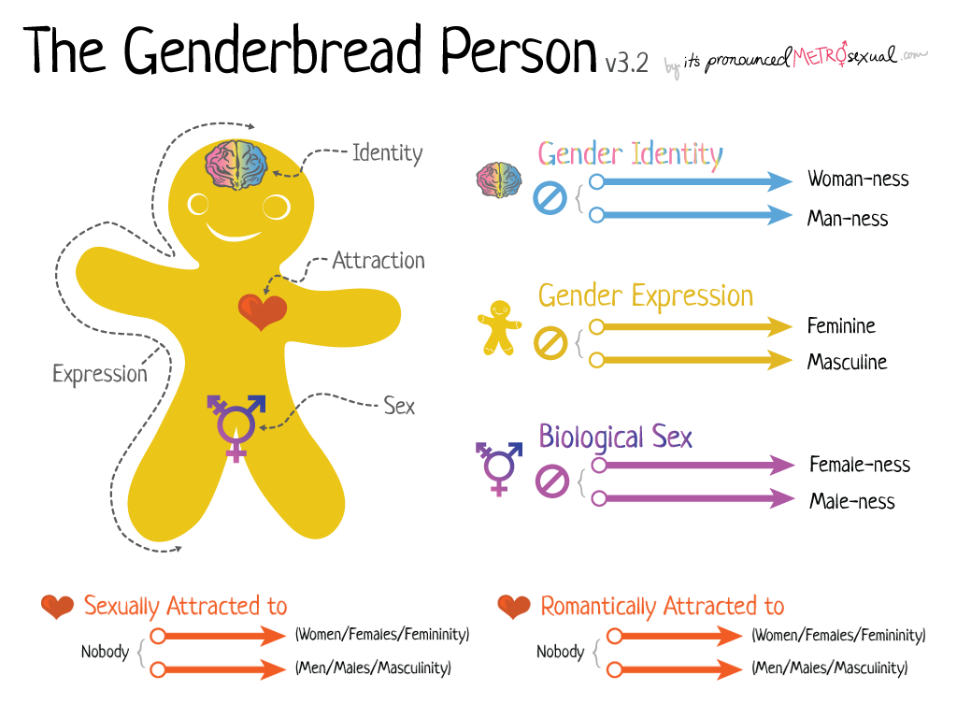

“Gender is one of those things everyone thinks they understand but they don’t. Gender isn’t binary. It’s not either/or. In many cases, it’s both/and. A bit of this, a dash of that. This tasty little guide is meant to be an appetizer for gender understanding. It’s okay if you’re hungry for more after reading it. In fact, that’s the idea.”

“Gender Identity - kids are taught how, in their head, to define their gender”.

“Sex - this is your physical sex, your biological sex. These are the characteristics you are born with – genitalia, voice, body shape, hormones, and chromosomes – but they do not define who you are.”

“And we also thank God continually because, when you received the word of God, which you heard from us, you accepted (welcomed) it not as a human word, but as it actually is, the word of God, which is indeed at work in you who believe.
14 For you, brothers and sisters, became imitators of God’s churches in Judea, which are in Christ Jesus: You suffered from your own people the same things those churches suffered from the Jews
15 who killed the Lord Jesus and the prophets and also drove us out. They displease God and are hostile to everyone
16 in their effort to keep us from speaking to the Gentiles so that they may be saved. In this way they always heap up their sins to the limit. The wrath of God has come upon them at last.”
1 Thessalonians 2:13-16

As followers of Christ . . .

- Our ultimate authority for all of life, sexual ethics, cultural issues and belief is the Bible.

- Believing the Bible means accepting its authority in every area of life – 2:13

To accept transgenderism is to change, misinterpret
or reject the Word of God.

We are not to conform God’s Word to our opinions or feelings but we instead we are to conform our opinions and feelings to God’s Word.

“When God commands, we are to obey. When He asserts, we are to believe Him. When He promises, we are to embrace and trust those promises. Thus, we respond to the sheer authority of God’s word.”
John Frame in Systematic Theology

- Believing the Bible means accepting the opposition it brings – 2:14

“When the whole world is running towards a cliff, he who is running in the opposite direction appears to have lost his mind.”
C.S. Lewis

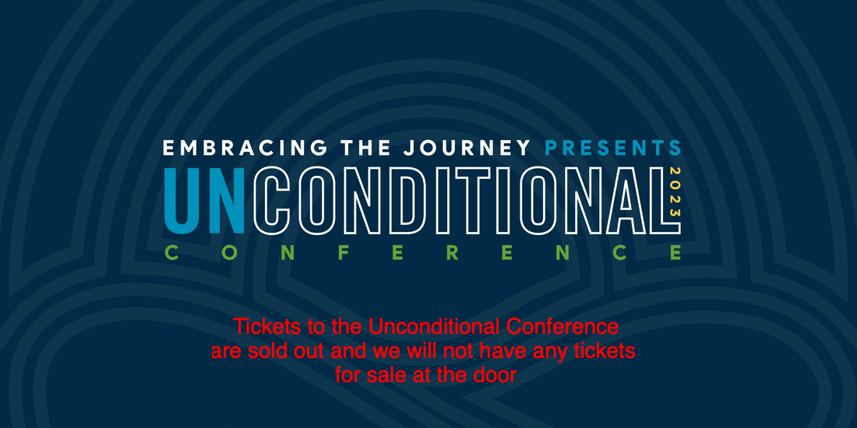

This two-day premier event is for parents of LGBTQ+ children and for ministry leaders looking to discover ways to support parents and LGBTQ+ children in their churches. You will be equipped, refreshed, and inspired as you hear from leading communicators on topics that speak to your heart, soul, and mind. We deeply desire this time will bring about healing and restoration. No matter what theological stance you hold, we invite you to listen, reflect, and learn as we approach this topic from the quieter middle space.

Welcome to Apostles Lutheran Church
Our Mission is to be a Caring Inclusive Christian Community


We, the people of Apostles Lutheran Church, follow Paul’s message to the Galatians (3:28): “There is no longer Jew or Greek, there is no longer slave or free, there is no longer male and female; for all of you are one in Christ Jesus.”

Believing that because we are all one in Christ, and created in God’s image, all are welcome as beloved children of God. We welcome into the full life of the church all those whom God sends us. Rejoicing in God’s amazing diversity, we welcome people of all ages, races, gender identities, sexual orientations, and physical and mental abilities. Centered in Christ, we commit ourselves to breaking down dividing walls and building a community where all are beloved.

- Believing the Bible means accepting its judgment on society – 2:15-16

“in their effort to keep us from speaking to the Gentiles so that they may be saved.”
1 Thessalonians 2:16

“In this way they always heap up their sins to the limit. The wrath of God has come upon them at last.”
2 Thessalonians 2:16

Although our God is patient, His patience has limits.

One of the most unloving things you can do as a follower of Christ
is to affirm someone in their sinfulness.

- We will approach this issue with conviction without compromise but also with compassion.

- Every one of us is born with disordered desires (a predisposition to sin) because of the fall of man.

Gender confusion is a sin issue – it is a misdirected love and disordered desire.

Authentic desires do not excuse a sinful action.

“But God demonstrates His own love toward us, in that while we were still sinners, Christ died for us.”
Romans 5:8

“If anyone is in Christ, the new creation has come: The old has gone, the new is here!”
2 Corinthians 5:17

- We must make a distinction between transgender activists and transgender victims.

“The church should be a place of refuge for the casualties of the sexual revolution. We must point others to the redemption and healing found in the gospel.”
Dr. Albert Mohler

- You will never be able to help a transgendered person if you are only outraged by this issue.

“Be merciful to those who doubt; save others by snatching them from the fire; to others show mercy, mixed with fear—hating even the clothing stained by corrupted flesh.”
Jude 22-23

Our lack of compassion has led to our lack of gospel interaction.

- You will never be able to help a transgender person if you only affirm them and not address the sin issue.

- “trans” kids are prescribed more anti-psychotic drugs after beginning gender transition than before.

- Anywhere from 8-13 percent of those who are transitioning are detransitioning.

