NOTES

Scan our QR Code for upcoming events,
online giving, and more, or visit
benttree.org/tree




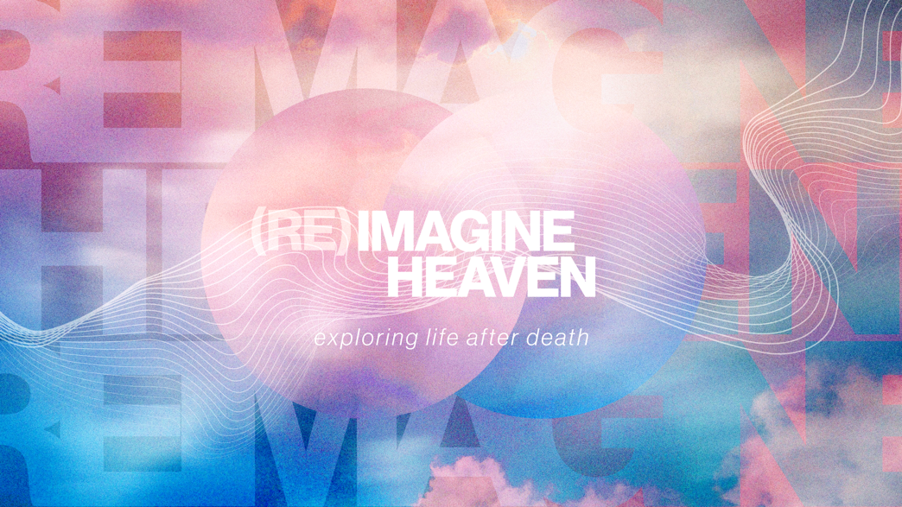

RULING WITH CHRIST
May 10, 2026
Libin Abraham

God did not save us merely to escape Earth.
He saved us to reign with Christ in a redeemed creation forever.

1. WE WERE CREATED TO ___________ UNDER GOD

Genesis 1:26–28
- Adam and Eve were not created for passive existence. They were created to rule under God’s authority.
- Sin corrupted humanity’s rule and fractured creation so instead of ruling creation under God, humanity began ruling selfishly against God.
- God did not abandon his original, plan, he chose to redeem it.

2. JESUS CAME TO RULE THE EARTH ALONG WITH HIS _______

Zechariah 9:9–10

Daniel 2:44

Daniel 7:13–14, 18, 27

Revelation 2:26, 5:9–10, 22:5
- Jesus is the true and eternal King
- Earthly kingdoms rise and fall, but Christ’s Kingdom endures forever
- The saints will reign with Christ on the New Earth
- Heaven is not eternal boredom, but eternal purpose
- The New Earth is the restoration of responsibility without sin.

3. RULING ON THE EARTH LOOKS LIKE _________ LIKE JESUS

Luke 22:25–27

Matthew 5:3, 5, 10
- In God’s Kingdom, greatness looks like servanthood
- Reigning is serving
- Leadership is stewardship
- The meek will inherit the earth

4. OUR LIFE NOW IS _________ FOR THE ETERNAL KINGDOM

Luke 19:11–19

1 Corinthians 6:2–3

2 Timothy 2:12

Romans 8:17–18

Ephesians 6:12
- Faithfulness now shapes responsibility later
- Earthly stewardship is preparing us for eternal stewardship
- Suffering, perseverance, humility, and endurance lead to glory
- We are living in a contested kingdom and spiritual war
“Christ is not simply preparing a place for us; he is preparing us for that place.” Randy Alcorn, Heaven
Luke 12:32 “Don’t be afraid, little flock, because your Father __________to give you the kingdom.”

