THE CORNERSTONE OF THE KINGDOM (MATT 21:42)

- The cross is not a detour in the kingdom. It is the design of the kingdom.
- God’s kingdom is built not through our strength, but through our surrender.
- Philippians 3:10-11 My goal is to know him and the power of his resurrection and the fellowship of his sufferings, being conformed to his death, ¹¹ assuming that I will somehow reach the resurrection from among the dead.
- The kingdom of God is built on a rejected King. His kingdom continues through us as our lives take the shape of the cross by the power of the resurrection.

Scan our QR Code for upcoming events,
online giving, and more or visit
benttree.org/tree




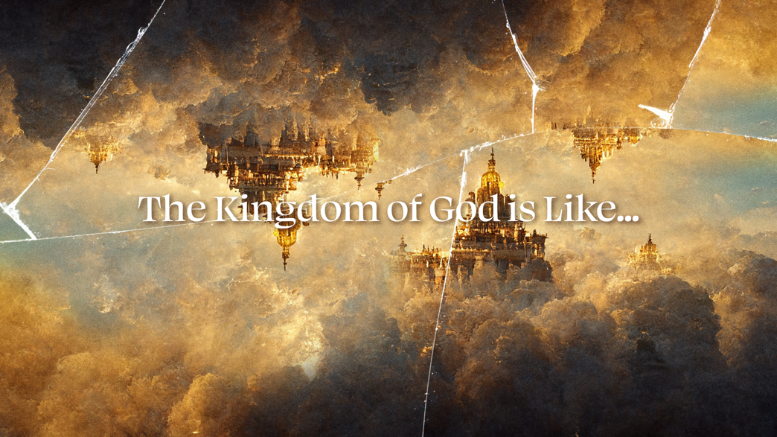

THE CORNERSTONE OF THE KINGDOM
March 29, 2026
Libin Abraham
Matthew 21:33-46

THE STORY THEY HEARD (MATT 21:33-41)
- Isaiah 5:1-2 I will sing about the one I love, a song about my loved one’s vineyard: The one I love had a vineyard on a very fertile hill. ² He broke up the soil, cleared it of stones, and planted it with the finest vines. He built a tower in the middle of it and even dug out a winepress there. He expected it to yield good grapes, but it yielded worthless grapes.
- Isaiah 5:7 He expected justice but saw injustice; he expected righteousness but heard cries of despair.
- Mark 12:6 He still had one to send, a beloved son.

THE STORY THEY MISSED
- The story was their history.
- The Son in the story is the one telling the story.

THE STORY THEY WERE IN (MATT 21:45-46)
- Jesus was rejected not because they lacked evidence, but because they were afraid to lose control and power.
- John 11:47-48 So the chief priests and the Pharisees convened the Sanhedrin and were saying, “What are we going to do since this man is doing many signs? ⁴⁸ If we let him go on like this, everyone will believe in him, and the Romans will come and take away both our place and our nation.”

THE STORY WE ARE IN
- “This is oldest story in human history, as old as Adam and Eve hiding from God in the first garden, and it is the newest story, the latest breaking news, as new as the flattened secularity of the west and the dreamy and empty, bourgeois spirituality of middle America, the endless quest to banish God, the living God, the demanding God, from the vineyard.” – Thomas G. Long
- Romans 5:8 But God proves his own love for us in that while we were still sinners, Christ died for us.
- Ephesians 2:3-5 We too all previously lived among them in our fleshly desires, carrying out the inclinations of our flesh and thoughts, and we were by nature children under wrath, as the others were also. ⁴ But God, who is rich in mercy, because of his great love that he had for us, ⁵ made us alive with Christ even though we were dead in trespasses. You are saved by grace!
- “I think God is very improbable, and I live my life on the assumption that he is not there… There is something infantile in the presumption that somebody else has a responsibility to give your life meaning and point.” - Richard Dawkins, The God Delusion
- “God is the power that allows us to be ourselves, as the love of our parents allows us to be ourselves.” - Thomas Aquinas

