The Nature of the Kingdom
- Luke 13:18-21 He said, therefore, “What is the kingdom of God like, and what can I compare it to? ¹⁹ It’s like a mustard seed that a man took and sowed in his garden. It grew and became a tree, and the birds of the sky nested in its branches.” ²⁰ Again he said, “What can I compare the kingdom of God to? ²¹ It’s like leaven that a woman took and mixed into fifty pounds of flour until all of it was leavened.”
- Luke 17:20-21 When he was asked by the Pharisees when the kingdom of God would come, he answered them, “The kingdom of God is not coming with something observable; ²¹ no one will say, ‘See here!’ or ‘There!’ For you see, the kingdom of God is in your midst.”
- Mark 6:56 Wherever he went, into villages, towns, or the country, they laid the sick in the marketplaces and begged him that they might touch just the end of his robe. And everyone who touched it was healed.
- “Holy people must stop going into ‘church work’ as their natural course of action and take up holy orders in farming, industry, law, education, banking, and journalism with the same zeal previously given to evangelism or to pastoral and missionary work.” - Dallas Willard

Scan our QR Code for upcoming events,
online giving, and more or visit
benttree.org/tree




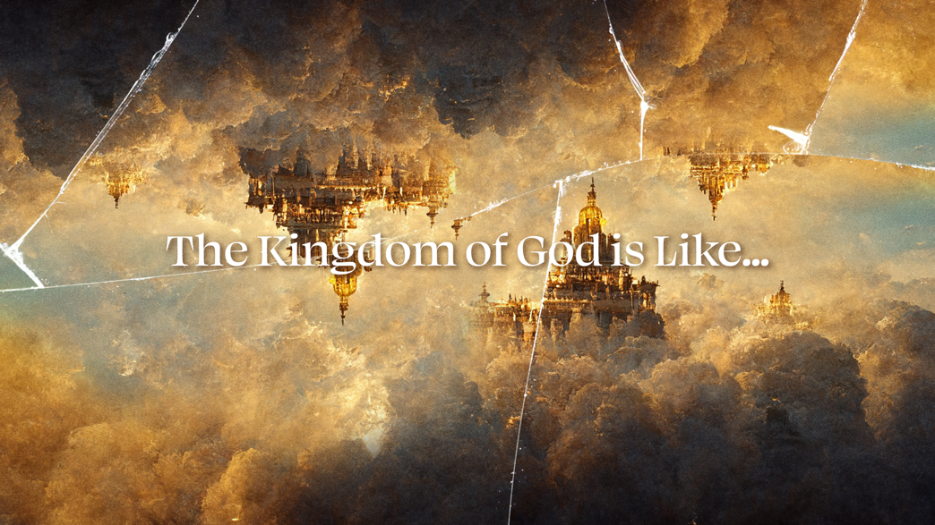

THE KINGS PLACE
March 8, 2026
Libin Abraham

The Kingdom of God is: The King’s reign, through the King’s people, over the King’s place.

The Story of God and His People
- Creation
- Fall
- Redemption
- Renewal
- Consummation

The First Commission Given
- Genesis 1:26-28 Then God said, “Let us make man in our image, according to our likeness. They will rule the fish of the sea, the birds of the sky, the livestock, the whole earth, and the creatures that crawl on the earth.” ²⁷ So God created man in his own image; he created him in the image of God; he created them male and female. ²⁸ God blessed them, and God said to them, “Be fruitful, multiply, fill the earth, and subdue it. Rule the fish of the sea, the birds of the sky, and every creature that crawls on the earth.”

The First Commission Edited
- Genesis 9:1 God blessed Noah and his sons and said to them, “Be fruitful and multiply and fill the earth.”

The First Commission Restored
- Matthew 28:18 Jesus came near and said to them, “All authority has been given to me in heaven and on earth. ¹⁹ Go, therefore, and make disciples of all nations, baptizing them in the name of the Father and of the Son and of the Holy Spirit, ²⁰ teaching them to observe everything I have commanded you. And remember, I am with you always, to the end of the age.”
- Acts 1:7-8 He said to them, “It is not for you to know times or periods that the Father has set by his own authority. ⁸ But you will receive power when the Holy Spirit has come on you, and you will be my witnesses in Jerusalem, in all Judea and Samaria, and to the ends of the earth.”
- John 20:15-16 “Woman,” Jesus said to her, “why are you crying? Who is it that you’re seeking?” Supposing he was the gardner, she replied, “Sir, if you’ve carried him away, tell me where you’ve put him, and I will take him away.” ¹⁶ Jesus said to her, “Mary.” Turning around, she said to him in Aramaic, “Rabboni!”—which means “Teacher.”
Kingdom Renewal
- Jordan Raynor, The Sacredness of Secular Work
  - Abridged Gospel: The gospel is good news that Jesus came to save people from their sins.
  - Unabridged Gospel: God created a perfect world and invited his children to rule over it with him and for him. We sinned, ushering in the curse that broke every part of that perfection creation, ensuring our need for a Savior. Jesus’s resurrection proved emphatically that he is that Savior who saves us by grace through faith. And while we’re not saved by our works, we have been saved for the good works he prepared for us to do all along: partnering with him to cultivate heaven on earth until he returns to finish the job. Then the triune God will finally dwell with us again on a New Earth, where we will rule with him for ever and ever.
- “The kingdom of God does not mean merely the salvation of certain individuals; it means nothing less that the complete renewal of the entire cosmos.” - Anthony Hoekema

