NOTES

Scan our QR Code for upcoming events,
online giving, and more or visit
benttree.org/tree




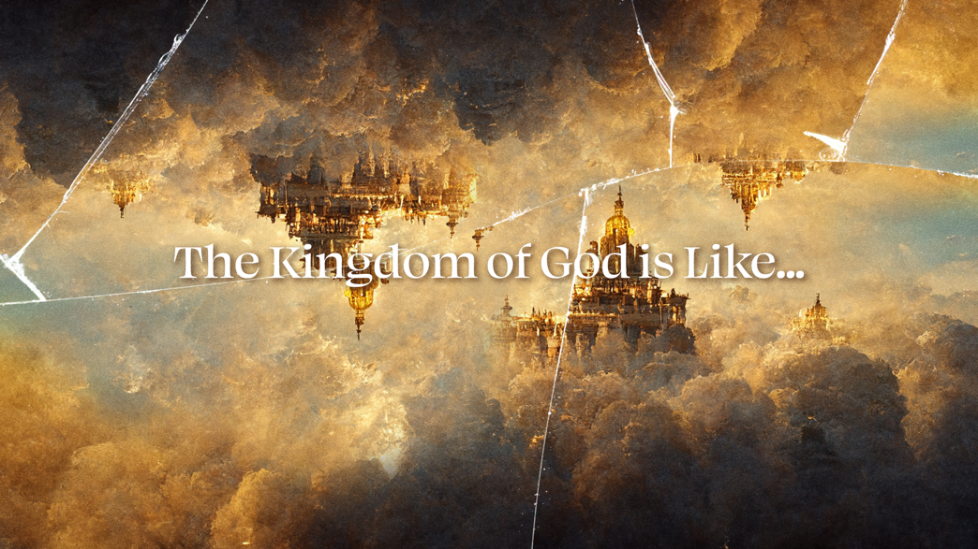

THE KING
February 22, 2026
Steve Frissell

Mark 1:15
“The time is fulfilled, and the kingdom of God has come near. Repent and believe the good news!”

The Kingdom of God is:
The King’s reign, through the King’s people, over the King’s place.

Psalm 8
³ When I observe your heavens, the work of your fingers, the moon and the stars, which you set in place, ⁴ what is a human being that you remember him, a son of man that you look after him? ⁵ You made him little less than God and crowned him with glory and honor.
⁶ You made him ruler over the works of your hands; you put everything under his feet:
Exodus 15:1
I will sing to the Lord, for he is highly exalted; he has thrown the horse and its rider into the sea.
15:18 The Lord will reign forever and ever!

King’s Instructions from Deuteronomy 17
- “He must not acquire many horses”
- “He must not acquire many wives”
- “He must not acquire large amounts of silver and gold”
- “He must write a copy of this instruction”
- “He is to read from it all the days of his life”

Isaiah 52:7 (CSB)
“How beautiful… are the feet of the herald… who says to Zion, ‘Your God reigns!’”

Mark 1:15 (CSB)
“The time is fulfilled, and the kingdom of God has come near. Repent and believe the good news!”

Zechariah 9:9
“Look, your King is coming to you;
he is righteous and victorious,
humble and riding on a donkey…”

Mark 15
¹⁷ They dressed him in a purple robe, twisted together a crown of thorns, and put it on him. ¹⁸ And they began to salute him, “Hail, king of the Jews!”
¹⁹ They were hitting him on the head with a stick and spitting on him. Getting down on their knees, they were paying him homage. ²⁰ After they had mocked him, they stripped him of the purple robe and put his clothes on him.

Bottom Line:
This Kingdom is different than every other kingdom because the King is different than every other king.

