Prayer for the Week:
May the God who raises the dead
give me breakthrough faith—
faith that faces reality
yet refuses to declare it final.
When hope has been wounded,
may I run toward God and not away.
When the silence lingers,
may I press in and not give up.
Let my trust be anchored
not in what I see,
but in the risen Christ,
who makes way for a resurrection, not a burial.
I live with resurrection hope,
that because Jesus is alive, revival is on the way.

Scan our QR Code for upcoming events,
online giving, and more or visit
benttree.org/tree






BREAKTHROUGH FAITH PART 2
February 8, 2026
Libin Abraham
2 Kings 4:8-37, 2 Kings 8:1-6

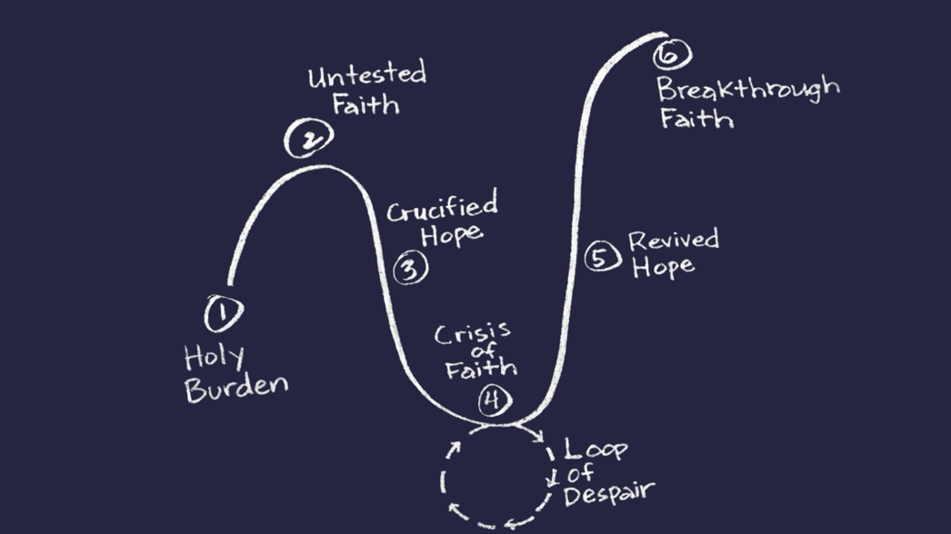

“Expectations demand a certain result; expectancy trusts and hopes. Expectations create anger and disillusionment in our faith when they aren’t met; expectancy is an openness to any outcome God desires. Expectations force God into a box to act as we want; expectancy allows God to be God in our lives, acting on his own will. Broken expectations, on their own, lead us to despair; expectancy takes our broken expectations back to God to rebuild our faith.” Longing for Revival, Choung and Pfieffer
- Breakthrough faith does not deny reality; it refuses to finalize it. (2 Kings 4:18-21)
  - The Shunamite woman plans for a resurrection instead of a burial.
  - “Hope is faith applied to the future.” Longing for Revival
  - Hebrews 11:35 (By Faith) Women received their dead, raised to life again.

- Breakthrough faith runs toward God when hope is disappointed. (2 Kings 4:22-30)
  - Disappointment is a crossroads for faith.
  - We can choose pursuit or retreat.
  - The Shunamite woman carries grief without surrendering hope.

- Breakthrough faith is persistent when results are delayed. (2 Kings 4:30-35)
  - Reviving faith cannot be outsourced or delegated.
  - Delayed results do not mean divine absence.
  - Breakthrough faith presses in even when obedience seems ineffective.

- Breakthrough faith is abiding trust in our resurrected Savior. (2 Kings 4:32-37)
  - Elisha stretched himself over one dead child; Jesus stretched himself on the cross to give life to the world.
  - Elisha’s miracle was temporary; Jesus entered death to defeat it eternally.
  - Elisha prayed for resurrection; Jesus is resurrection.
  - Elisha proves what God can do; Jesus proves who God is.
  - Elisha restored a dead son to his mother; Jesus restores lost sons and daughters to the Father.
  - Elisha gives us a glimpse of the resurrection; Jesus guarantees it.

- Breakthrough faith becomes a public witness to awaken trust in others. (2 Kings 8:1-6)
  - What God revives in private, he often uses in public.
  - God times our testimony for maximum impact.
  - Revival spreads when resurrection stories are told.

