

*



7-26-26: 9:00 Sheila Clayton, Jan Mitchell
10:00 Sheila Clayton, Jan Mitchell
8-2-26: 9:00 Tonya Peterson and Girls
10:00 Tonya Peterson and Girls
No Children’s Church For Summer Services
Nursery will accommodate children
from birth to age 3.

OPERATION CHRISTMAS CHJILD SHOPPING LISTS
Leah Clayton has worked hard coming up with some gift registries for the OCC shoeboxes. It is so much information that it is too big to fit on the bulletin. There are flyers in all couples/ladies Sunday School classes giving you QR code options and gift ideas. With this, you can make sure you are getting the most for your money. There will also be some flyers at the Welcome Center and at the front entrance of the church.

Received Sunday, 7-19-26
Regular Offering $ 15,022.50
Memory of Danny Wrenn $ 20.00


Theresa
Baptist Church
“Theresa Baptist Church exists
to Glorify God through
Growing Disciples who Go
with the Gospel of Jesus Christ.”


Theresa Baptist Church
3919 Chub Lake Road
Roxboro, NC 27574
Theresabaptist3919@gmail.com
www.theresabaptist.org
Church Phone
(336) 599-0635
Pastor Garrett Pope
Cell: (704) 961-6890

July 26, 2026

Prelude
Hymn: Praise! On Screen w/Youth
Welcome and Scripture
Hymn: He’s Got the Whole World in His Hands Screen
Scripture Reading
Hymn: Indescribable # 50
Pastoral Prayer
Special Praise Group w/Congregation
How Majestic Is Your Name (# 52)
Message: “The Lord of Majesty” Pastor Garrett
Main Idea: Behold, be humbled, Psalm 8
and bow before the Lord of Majesty!
Closing Hymn
Hymn: How Great Thou Art # 6

Sunday, July 26th
9:00am Sunday School
10:00am Worship Service
Monday, July 27th
6:30pm Women’s “Romans” Bible Study
Wednesday, July 29th NO REGULAR WEDNESDAY EVENING SERVICES
6:00-8:00pm “Emerald Crossing” Vacation Bible School
Thursday, July 30th
6:00-8:00pm “Emerald Crossing” Vacation Bible School
Friday, July 31st
6:00-8:00pm “Emerald Crossing” Vacation Bible School
7:00pm Theresa vs. Mt. Harmony (Field 2)
8:00pm Theresa vs. Antioch (Field 1)

Visit our Welcome Center!
We welcome our Visitors, New Members, or Long-Time Members to our WELCOME CENTER and MEDIA CENTER located down the hall from the Sanctuary. You’ll find prayer lists, hand-outs, news, devotionals and books to check out.

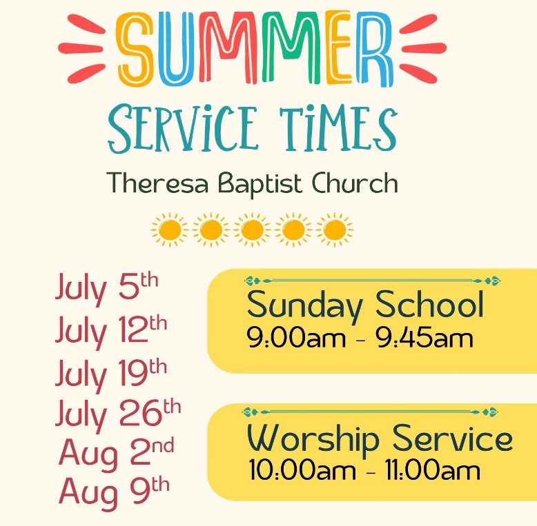

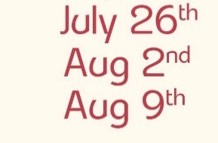

The Lord of Majesty
Psalm 8 Pew Bible Pg. 450
July 26, 2026

Main Idea: Behold, be humbled, and bow before

- Behold the Lord of Majesty (vs. 1-3, 9)

- Be humbled by the Lord of Majesty (vs. 3-8)

- Bow before the Lord of Majesty (vs. 1, 9)

