

Roseau Evangelical Covenant Church

2024 Annual Report

Annual Business Meeting of the Congregation

Sunday, January 19, 2025

Our mission as a church is
to share the love and hope of Jesus in today’s world

Exalt Expand Equip Express

ACTS 1:8

“But you will receive power when the Holy Spirit comes upon you. And you will be my witnesses, telling people about me everywhere – in Jerusalem, throughout Judea, in Samaria, and to the ends of the earth.”
(New Living Translation)

Roseau Evangelical Covenant Church
January 19, 2025 Annual Meeting

Table of Contents

- Table of Contents…………………………………………………………………………………………………………………………………………………………………………….3
- The Evangelical Covenant Church – Tammy Swanson-Draheim, President….………….…………………………..……..…….4
- Northwest Conference – Kara Stromberg, Superintendent…………………………………………………………….…………….…………...5
- Agenda…………………………………………………………………………………………………….…………..……………………………………………………………………………….6
- Secretary Report Annual Congregation Meeting Minutes 2023.………………………………………………………..……….…………….7
- Treasurer’s Annual Report 2024 – Todd Peterson ……………………..……………..…………………….…………………….…………………….10
- Leadership Council Chair Annual Report 2024 – Tony Fichter……………..…………………….…………………….…………………….11
- Senior Pastor’s Annual Report 2024 – Pastor Nate Johnson………………………………………….…………..…………………………….12
- Special Events In the Life of the Church – Pastor Nate Johnson……………….…………………………………………..………….…..13
- Director of Youth Ministry Annual Report 2024 – Chris Shortreed…………………………………………………..…………………….14
- Administrative Assistant Annual Report 2024 – Samantha Grey….…………………………………………………………………………16
- Bluewater Committee Annual Report 2024 – Traci Fichter…………………………………………………………...….…………………..…17
- Christian Formation Board Annual Report 2024 – Kelsey Didrikson.......................................................................18
- Deacon Board Annual Report 2024 – Darrin Smedsmo……………………………………………………………………………………...…..….20
- Missions & Outreach Board Annual Report 2024 – Colleen Klamar ……..……………………………….……………………………..21
- Worship & Music Committee Annual Report 2024 – Milly Prachar …………………………………………………………………..….23
- Pastoral Relations Committee Annual Report 2024 – Dave Anderson….……………………………….…………………………...24
- Annual Statistical Report 2024 ………………………………………………………………………………………………………………………….…………...……..25
- Trustee Board Annual Report 2024 – Kelly Christianson ………….………………..…………..……………….……………………….….…..26
- 2025 Proposed Budget and Capital Projects ………………….……………………………………………………………….………….……………..…..27
- 2025 Elected Positions………………………………….…………………………………………………………………………………………………………………………….30
- Mission, Values and Vision of RECC ……………………………………………………………………………………………………………………………………..32
- Behavioral Covenant……………………………………………………………………………………………………………….………………………………………………..…33
- 2025 Leadership Council and Quarterly Meeting Schedule……………………………………………………………………………………..34

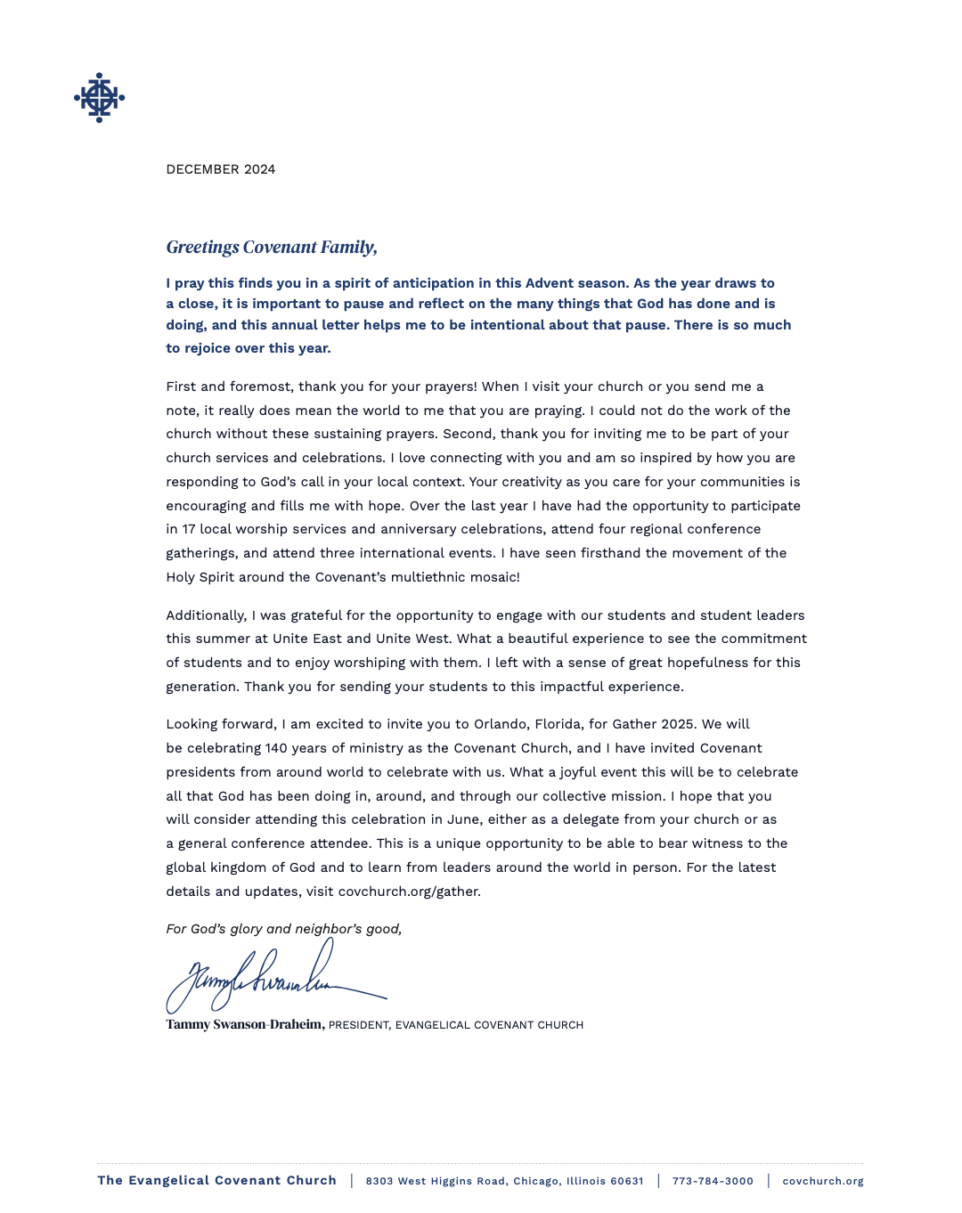
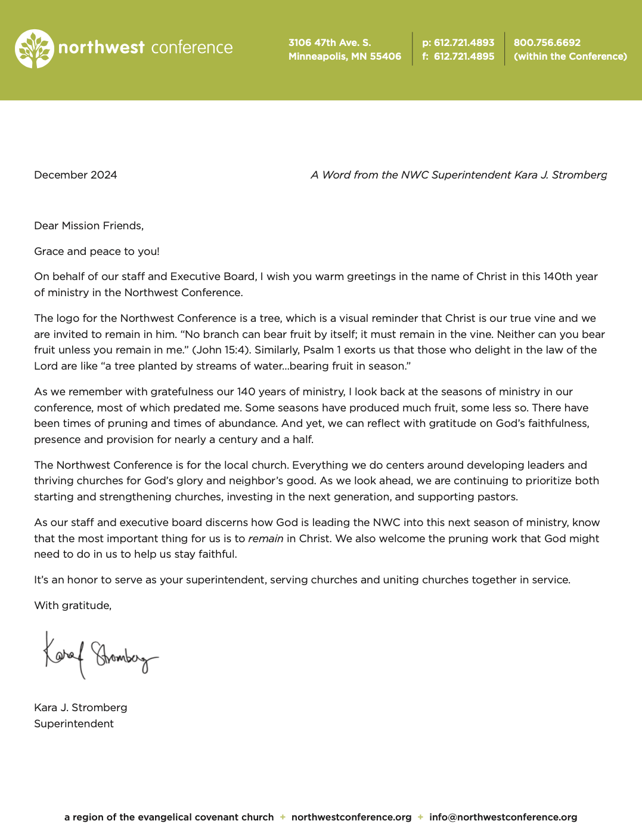
Annual Meeting Agenda
Roseau Evangelical Covenant Church
Sunday, January 19, 2025 @ Noon

- Call to Order: Tony Fichter

- Opening Prayer: Pastor Nate

- Presentation & Approval of Agenda: Tony Fichter

- 2024 Annual Meeting Minutes: Tony Fichter

- New Member Candidates: Darrin Smedsmo

- RECC Ministry Report: Pastor Nate

- RECC Youth Ministry Report: Chris Shortreed

- 2024 Financial & Audit Report: Todd Peterson

- 2025 Budget Presentation & Vote: Kelly Christianson

- Trustee Board Report: Kelly Christianson

- Deacon Board Report: Darrin Smedsmo

- Christian Formation Board Report: Kelsey Didrickson

- Missions & Outreach Board Report: Colleen Klamar

- Bluewater Bible Camp Annual Meeting: 3 Delegates
  - Sunday, February 2 (3:00 pm - 5:00 pm)
  - International Falls Covenant Church

- Northwest Conference Annual Meeting: 3 Delegates
  - May 2 & 3
  - Roseville Covenant Church - Roseville, MN

- RECC Bluewater Board Representative:

- Election of Leadership Council & Board Members:

- Closing Prayer & Motion to Adjourn:

Roseau Evangelical Covenant Church
2023 Annual Congregational Meeting
28 January 2024

Call to Order & Declaration of Quorum: Tony Fichter- Leadership Council Chair
Devotional & Prayer: Pastor Nate Johnson
Presentation & Approval of Agenda: Tony Fichter

Kelly Christianson made a motion to approve the agenda
Chris Shortreed seconded the motion
Motion passed

2023 Annual Meeting Minutes: Sarah Johnson- Leadership Council Secretary

Janell Kofstad made a motion to approve the agenda
Richard Mattson seconded the motion
Motion passed

RECC Ministry Report: Pastor Nate Johnson
- This year has been a year of growth! This is due to the blessing of God and all of our amazing people that volunteer and always go the extra mile. Thank you!
RECC Youth Ministry Report: Chris Shortreed- Youth Ministry Director
- Chris graduated this spring with his masters degree. The youth ministry has continued to grow! There's been 15-20 kids attending just in our 6-8th grade group. The 9th-12th grade group is 4-6 students per week. We are working with the other churches to host released time this year, and have about 20 students going to that each week. Sunday School has been going great this year! Thank you to all of the leaders involved throughout all our youth programs. We have been busy fundraising for our UNITE trip coming up this summer.
2023 Financial & Audit Report: Todd Peterson- Treasurer
- The church books were audited by the trustees. We surpassed our expectation of offerings collected for the year. Our expenses also exceeded our budget, but we were still in the black for the year by a little over $9,000.
Trustee Board Report: Kelly Christianson- Trustee Board Chair
- We re-did the sidewalk this past summer, and that project came in under budget. We did have it in our budget to replace the lights in the sanctuary, but we put that project on hold. Thank you so much to all of our trustees who’ve been working so hard! The kitchen project is underway in the planning and ordering phase. Steve Nelson construction will be handling the project for us. We will plan to do the remodel in May.
2024 Budget Presentation & Vote: Kelly Christianson- Trustee Board Chair
- Kelly presented the budget. This was also presented at our last congregational meeting back in November. Insurance went way up this past year, and there are a few other increases in cost. Therefore, we are looking at a shortfall of $26,000 for 2024. However, we do still have an emergency fund, and money in our “Church Mission Reserve” fund. We are also erring on the conservative side for our offering side of the budget.
- We had a lot of conversation regarding supporting the North Region Pregnancy Center as a $6,000 line item in our budget, as it states in the budget proposal. Multiple people would like to see the $6,000 support being moved from its own line item, to being under the “Missions” fund. This change would mean that the Missions & Outreach board would be in charge of allocating that out, and it would increase their budget from $10,000 to $16,000.
- Rachel Krahn brought up that she would like to see the playground equipment renovation project be added to the “Capital Improvements” budget. Kelly mentioned that we would then need someone with a passion for that project to take on the planning of, so they have a budget for it to present to the trustees.

Traci Fichter made a motion to remove line 27 of the budget, which is the $6,000 line item for the North Region Pregnancy Center
Jan Carr-Herseth seconded the motion
A secret ballot vote was held: 40 Yes 16 No
Motion passed

Cindy made a motion to add $5,000 to the “Missions” fund, which would increase
the budget from $10,000 to $15,000.
Todd Peterson seconded the motion
By a show of hands 25 Yes 18 No
Motion passed

Todd Peterson made a motion to increase the Bluewater budget from $5,000 to
$6,000
Jan Carr-Herseth seconded the motion
Motion passed

Rachel Krahn made a motion to approve the $10,000 for “New Playground
Equipment” capital project with the CF Board in charge of planning.
Kathy Brandt seconded the motion
Motion passed

Tony Fichter made a motion to put together a “Building Committee” as a standing
committee of the church, which would look into the church building as a whole for future needs/projects.
Sonya Peterson seconded the motion
Motion passed

- Tony Fichter has volunteered to lead the newly formed committee to start until someone
else would like to take over.

Todd Peterson made a motion to approve the 2024 budget as amended
Marisa Shortreed seconded the motion
Motion passed

Deacon Board Report: Darrin Smedsmo- Deacon Board Chair
- There is a new hospitality group that has formed, which is going great!
Christian Formation Board Report: Kelsey Didrikson- Christian Formation Board Chair
- Kelsey couldn’t be here today, but everyone looked at the report she provided. Marissa Clevin added that we are postponing the nursery expansion project so we can look at the church building as a whole to fit this project in where it makes sense.
Missions & Outreach Board Report: Colleen Klamar- Missions & Outreach Board Chair
- Each month throughout the year we will be highlighting different missions and/or missionaries that we support. We want everyone to be aware of who we support, how we support them, and what their needs are.
Bluewater Bible Camp Annual Meeting: 3 Delegates
- The meeting is Sunday, March 10th in Lancaster at the Covenant church. Traci Fichter, Dave Brinkman, and Sheila Brinkman have volunteered to be the delegates. We voted in favor of these three representing our church.
Northwest Conference Annual Meeting: 3 Delegates
- The meeting is April 26th-27th, and you can attend online. Tony Fichter, Nate Johnson, and Traci Fichter volunteered to be the delegates. We voted in favor of these three representing our church.

Election of Board Members & Leadership Council:
- Jan Carr-Herseth, representing the nominating committee, handed out the ballots, as Dave Anderson, chair of the committee, was unable to attend. All leadership council members have decided to stay in their positions.

Randy Pracher made a motion to accept the ballot as proposed
Sanford Klamar seconded the motion
Motion passed
All members on the ballot were voted in unanimously

Marisa Shortreed- administration update:
- Please make sure you schedule times you’d like to meet at the church with groups so we can make sure we have room for you. The church website is being used, and it looks great! Please use the planning center app if you’d like to get contact information for anyone at church.

Motion to Adjourn by Chris Shortreed
Gayle King seconded the motion
Motion passed

Closing Prayer
Leadership Council Annual Report 2024

Dear RECC Family,

2024 was another year of growth at RECC. Growth, not just in terms of attendance but significant spiritual growth as well. The challenges we face are indeed opportunities to continue that trend so that we may “Share the Love and Hope of Jesus Christ in Today’s World”.

The RECC staff has been “putting the puck in the net” this year! A big thank you to Marisa Shortreed as she passed the puck to Sam Grey as our new Administrative Assistant. Please express your appreciation and support to Pastor Nate, Chris and Sam for their willingness to serve and shepherd this flock.

The Leadership Council are a very committed group of people who love our Lord and are dedicated to serving Him by serving all of you. The Leadership Council for 2024 was…

- Nate Johnson – Senior Pastor
- Tony Fichter – Chair
- Dave Anderson – Vice Chair
- Sarah Johnson – Secretary
- Todd Peterson – Treasurer
- Darrin Smedsmo – Deacon Board Chair
- Kelsey Didrikson – Christian Formation Board Chair
- Kelly Christianson – Trustee Board Chair
- Colleen Klamar – Missions & Outreach Board Chair

Sarah, Kelsey, Darrin and Colleen are rotating off the LC. Please join me in thanking them for their service and for a job well done. Kelly will be serving one more year. A huge shout-out to Kelly as he has been instrumental in seeing our kitchen project come through to completion. What a beautiful asset this is to our church.

If re-elected to serve as your Chair, it will be my 9th year. I indicated to the Nominating Committee that, God willing, I would be willing to serve one more year after this one. I feel that 10 years is long enough and the church will be ready for some “new blood” by then. Thank you for your support, it has been my honor and privilege to serve this congregation.

As I think of this church, what strikes me is that we are an “ambitious little church”. It takes an army of people to willingly volunteer their time, talents and treasure. A huge thank you to all of you who have served whether it’s from the pulpit or behind the scenes.

“Therefore, as we have opportunity, let us do good to all people, especially to those who belong to the family of believers.” – Galatians 6:10 (NIV)
Gratefully submitted,
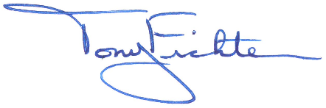
Tony Fichter
RECC Leadership Council Chair

Senior Pastor’s Annual Report 2024
Rev. Nathanael R. (Nate) Johnson

Dear Roseau Evangelical Covenant Church,

It has been another year of steady growth, but we have also mourned the loss of several who were dear to us. We welcomed six new members, baptized or dedicated two children, and rejoiced in the baptism of nine teens and adults at Bluewater and Roseau. Our nursery, children and youth ministries continue to grow, and our adult small groups continue to move forward. A new women’s ministry has been launched, and we have seen men involved in our breakfast group, Monday night Bible study, and Bluewater Men’s and Boys’ Retreat. There are challenges when we have more and more children and young people involved, but with prayer and humility, let us continue to seek God for his empowering to love, pastor, nurture and disciple those whom God has entrusted to us.

This year, several members or their loved ones were taken from us in an untimely manner, and we have mourned our losses. Our hearts have been heavy for those who have been hurting, but we have also rejoiced in the comfort and hope Christ offers to us. He will never leave us nor forsake us, and He will one day bring us home forever if we will give ourselves to Him.
It would be remiss not to recognize Donny Kofstad who passed in October. Donny chaired the church for 29 years, and he (and Elna) were instrumental in the purchase of the land where the church now sits, the construction and renovation of our current building, as well as many other projects. When we lose members like Donny, it is a reminder that our current blessings in the community are a direct result of the faithful generosity and service of those who came before us. May we be faithful in our generation to give and serve generously with our time, talent and treasure. We long that all may enjoy the eternal love, life and joy God has given to us. May Christ fill us with His love, energy, vision, passion and peace in the coming year!

I am so thankful for each one of you. It is a privilege to pastor this community. I pray that we may grow closer to Jesus and to each other in the coming year. There is so much more that God has for us if we will allow Him to work in us.

Seeking Him with You,
Pastor Nate

Significant Events in the Life of Roseau Covenant Church - 2024

Baptisms & Dedications
- May 24th
  - Lindy Hulst (baptism)
- September 1st
  - Taliah Rene Enright (dedication)
- June 29th (adult believer baptism)
  - CJ Otto
  - Brennan Lang
- November 24th (adult believer baptism)
  - Gavin Smith
  - Alex Quinones
  - Greyson Lundbohm
  - Zaden Lundbohm
  - Gianna Grey
  - Chancy Otto
  - Bella Anderson

Funerals
- April 13th Jeff Hanson
- August 3rd Marlene Rudolph
- August 14th Cole Jenkins
- August 30th Gayle King
- October 11th Donnie Kofstad

Director of Youth Ministry Annual Report 2024

From January to December 2024, there has been a lot going on in the youth ministry. We continued to see great numbers from both groups through the rest of the ‘23-24 school year and into the ‘24-25 school year. We brought our biggest group of students to the Bluewater Winter Retreat in the spring, though several students had to back out at the last minute as the girl’s hockey team made it to state.
We went on a Ski Trip with multiple churches from our area in March of ’24. We held our annual End of School Year Party at the city park with outstanding numbers and participation with other churches in May. We also continued our annual trip to the Country Corn Maze in the Fall of ’24 with the other churches in Roseau. This year, we filled the bus with 40+ students for that event alone, and many more drove.

In the summer of ‘24, we sent two students to Adventures in Leadership (AIL). There, they faced challenges unlike anything that past students experienced. Torrential downpour and tornado warnings are just a small portion of their AIL experience. They lead devotionals, navigated the boundary waters, and were pushed to their limits. In the end, both students came out on top and learned how they can be better leaders. One student has even takin the opportunity to help lead the younger group (Thrive).

Bluewater Covenant Bible Camp is the highlight of the summer for many who attend. Though we saw a small number of students attend from our church, God has continued to work in the ministry there. I had the opportunity to be at several of the camps throughout the summer months, including Trailblazers A, Navigators A, Highlanders, and the Men’s Retreat. I was able to connect with many students, counselors, staff, and speakers. Though I didn’t speak this summer, I was able to get an idea of their overall theme, MADE NEW, and to hear the different speakers understanding of the theme.

UNITE 2024, was the biggest event of the year. For us, UNITE 2024 would be held in Bowling Green Ohio. We were given less than a year to put together funding, travel plans, and lodging if needed. Initial costs we were looking at was around $1000 per student. We planned to travel via airplane from Minneapolis to Detroit and then have a bus ride from Detroit to Bowling Green. We left Sunday after a church service and arrived at a local church in the cities. There we found out that our flight had been canceled due to mechanical issues with the plane. The next flight by that airline would not be until Thursday.
After a night of calls to Pastor Nate, Tony, Traci, the airline, Ginny Olson (the Director of Youth Ministry for the Northwest Conference), other youth directors having the same issues, talking with Katelyn Kofstad (my female leader for this trip), and lots of prayer, we made the decision to drive. We informed the families that evening, and set out for a 10 hour drive to Bowling Green in the early AM. I made sure to let Pastor Nate and the families know where we were throughout the trip, and we made it to Bowling Green toward the end of the check-in time window.
UNITE was an amazing experience for the students. 7 out of our 9 students received Christ for the first time or rededicated their lives to Him.
On the way back, we learned that the Microsoft Crowdstrike shutdown many things including airlines and gas stations. It was pointed out to me by a student that God’s plan and protection for us could be seen as we were just not meant to fly. I was even told that some other youth groups had to wait until late Monday evening for return flights (the last day of UNITE was a Friday). We returned safely Saturday evening splitting the trip in 2 legs.

MUUUCE was an adventure, having been my first time attending. It was a whirlwind of 48+ hours, and I’m thankful that I did not have to drive (shoutout to Sheldon Espe). From arrival to departure, the students were having a blast. Valley Fair was a big highlight. What makes it extra special for me was that my students got to meet my youth pastor, Heather Flies, as she was one of the speakers. We also had a little issue with housing, but it was sorted almost immediately.

The ’24-25 Youth Group kicked off in September. Thrive and Impact both meet regularly on Wednesdays here at the church. Thrive has been going through the Gospel of Mark, highlighting specific passages as we read. The older group, Impact, we started with some apologetics. We answered specific questions like: “what is apologetics?,” “why does God allow suffering?,” and “is Jesus the only way?” We also held a session where students could ask questions about their faith, and possibly get answers. And since the end of November, Impact has been studying Hebrews.

We brought our largest group of students to the Bluewater Fall Retreat with 11 students attending this year. We were joined by many other churches and had a great time listening to Micah and Penny as our guest speakers.

We are not doing Release Time in the school year of 2024-25. Instead, we have decided to run small events 3 or 4 time a year were students grades 3-5 can get together, have fun, and learn a little about Jesus. Our first event was in November, and we went bowling. We had at least 30 students attend.

Christopher Shortreed, M.Div.
Youth Ministry Director

Breakdown of 2024 Youth Ministry Budget
Update Rooms: | $1,062.42
Personal Growth: | $19.76
Curriculum: (Did not buy this year) | $0.00
Bluewater Retreats: | $572.73
Release Time / Sunday School | $564.56
Youth School Events: (Out of Pocket) | $0.00*
Youth 1 on 1's | $30.35**
YG Games/Events/Food | $2715.06***
Total | $4964.88***
Under | $35.12
*$80.00+ for athletic pass, concerts, and more
**$70.00+ from out of pocket as cards not being accepted, or used personal card
*** Total may be off due to missing receipt on my end not the treasurer's

Administrative Assistant Annual Report 2024

I joined RECC as the Administrative Assistant on August 5, 2024, and I am grateful for the opportunity to serve this devoted congregation. My role is to support the church’s administrative needs, ensuring smooth daily operations and providing assistance to the Senior Pastor, Youth Ministry Director, the church boards and congregation.

The transition from Marisa Shortreed, the former Administrative Assistant and Building Custodian, to my role as the new Administrative Assistant was as seamless as possible. I am grateful for the foundational work and dedication of my predecessor, which provided a strong framework for me to step into. The handover process included training sessions as well as a detailed Admin Handbook covering all the areas of the position. This handbook allowed me to familiarize myself with the church’s operations, systems, and church culture beyond the one-on-one training sessions. Marisa really exceeded my expectations and set me up for success with her forethought of putting together this handbook! While every transition comes with challenges, the support from Marisa, Pastor Nate, Chris and the congregation has made for a very easy adjustment and I am so grateful!

Some changes that have occurred during the transition include, most significantly, the shift from having a full-time administrative assistant to part-time. My regular office hours are Monday thru Thursday, 9:30am-2:30pm. My schedule is somewhat flexible to accommodate for meetings or events that I am required to attend. So far, these hours seem to work well.

Though new to the role, I have focused on learning the systems, building relationships and contributing to the church’s operations. One important ministry of the church that I have become a part of is the AV/Sound ministry. I am currently working with CJ Fichter to improve some systems, operations, and training. Our current plan includes adding in new volunteers in the near future! Relationship building is a gradual but fruitful process that I so enjoy! My first big “event” in this role was Christmas, or better described as the month of December, and it was a success. Preparations, scheduling and logistics were managed effectively to ensure a smooth month long celebration. I learned a lot about how RECC functions as the Body of Christ over the month of December. A tremendous amount of time, talent, and effort went into the celebration, from the planning that began in October, to the music rehearsals, scheduling, and attention to tiny details – even down to shoveling the sidewalks. Each contribution, whether small or large, was equally important in making the month a success. We had many things on the calendar, there were a lot of moving parts and so many volunteers that contributed to what was an extraordinary celebration of our Lord and Savior! I am in awe of this church family.

In the coming year, my primary goals include enhancing efficiency, communication, and volunteer engagement within the church. I plan to help organize and participate in training sessions to ensure volunteers are equipped with the tools and knowledge they need to succeed in the AV/Sound ministry. A key focus will be building and strengthening the volunteer base for the AV/Sound ministry to support the church’s worship events. Additionally, I will dedicate time to learning and applying the features of Church Center for the app, enabling more effective communication and helping the congregation stay informed about various church activities.

I am deeply thankful to the leadership team and congregation of RECC for their warm welcome and unwavering support as I transitioned into this role. It has been a true joy to contribute to the church’s mission, and I look forward to continuing to serve, grow, and support the community in the years to come.

With gratitude,

Samantha Grey
Administrative Assistant

Bluewater Bible Camp Committee Annual Report 2024
Theme- Made New
Bluewater Covenant Bible Camp is a Christ-Loving Bible camps near Grand Rapids MN.
Their mission is to provide both a spiritually and physically enthusiastic environment that brings people into a loving relationship with God and others through Jesus Christ through youth camps, men’s & women’s retreats, family camps and more!
Roseau Covenant Church (RECC) is one of the 12 churches that own this amazing camp.
Our committee promotes youth, men’s, women’s & family camps.
These camps are open to anyone regardless of church affiliation (or no affiliation) or where you live.

Youth Camps- We provided transportation (bus &/or van) to 109 kids from Roseau, Warroad, Baudette, Karlstad, Thief River Falls and beyond in 2024 to Bluewater’s 9 youth camps. (June-August)
Transportation is crucial! Many of these kids would not be able to attend camp without a ride to
and from camp. (The cost remains $30 each)
Early registration incentives for youth camps- In an attempt to get more kids registered for camp early due to camps filling up earlier and earlier each year (with many having a waiting list) we decided to offer early registration incentives- $75 off if registered by March 31 & $50 off if registered by April 30.
91 of the 109 registered kids we helped transport to camp took advantage of this offer.
Scholarships- We blessed 5 youth (& their families) with full registration fee scholarships totaling -$1,200.00. Full & partial scholarships are available for all camps including Fall youth camp. The RECC scholarship funds exist for those who may not be able to attend camp due to financial barriers.
Donations are always welcomed!

Men & Boys Retreat- a group of men/boys attended Men’s retreat June 23-25.
Women’s Retreat- we helped promote and coordinate transportation for both June and Sept. retreats.
Family Camp- registrations handled directly through Bluewater. (bluewatercamp.com)

Thank you to our bus drivers- Sheldon Espe, Bob Ruud & Darrin Smedsmo!! (We need more!) Dave Anderson, Rachel Krahn, Katelyn Kofstad, Marisa & Chris Shortreed, and Traci Fichter shared in driving the van with the smaller groups. Marisa Shortreed managed registrations, bus requests and
communicating camp transportation details with camp, with the families, and navigating the incentives.
A BIG thank you to Marisa, Chris, Pastor Nate Johnson, and others who helped with the many ministry opportunities including bus loading, unloading, and connecting with campers and their families.
We love being the face of Bluewater Bible Camp to our community.

2024 Committee members -Rob Stroot (RECC Bluewater Board rep.), Kecia Stroot (Ministerial rep. to the Bluewater board & RECC Mission/Outreach board rep.), Kelsey Didrikson (CF rep.), Traci Fichter-
(coordinator/member at large & Deacon rep.), Sonya Peterson (member at large), Sheldon Espe (Trustee rep.) Chris Shortreed- RECC Youth Ministry Director, Marisa Shortreed- RECC Administrative Assistant, Paul Krahn- RECC representatives to Bluewater board.

Youth numbers from previous years:
2024 – 109 2021 - 187 2018- 167 2015 - 173
2023 - 132 2020 - 79* 2017 - 177 2014 - 170
2022 - 167 2019 - 156 2016 – 164 2013 - 168
(*2020-only half the camps with half capacity were held due to MN COVID19 restrictions.)

Respectfully Submitted, Traci Fichter – RECC Bluewater Committee Chair

Christian Formation Board 2023 Annual Report

December 28, 2024

Re: RECC Christian Formation Board 2024 Annual Report

RECC Church Family,

Much of the work of the Christian Formation Board continued as normal - Sunday School, VBS, Teacher Appreciation Sunday, Senior Sunday, presenting 2nd graders with Bibles, supporting Pastor Nate as he resumed confirmation classes, providing activity bags, organizing nursery workers, and running Children’s Church. This work is ongoing, year-round, and for most of the year, weekly. It’s good work, it’s important work, and it’s the result of a small army of faithful volunteers and committed CF Board members. To those people, a heartfelt thank you!

Outside of the “normal” scope of CF responsibilities, this year multiple board members worked tirelessly to oversee the purchase and building of our new playground. Special thanks to Allie Cummings, Tiffany Otto, and Rob Stroot for all the behind the scenes legwork to make the purchase happen, and then to Rob, his family, and others Rob recruited to help for their countless hours assembling. The playground upgrade is a blessing in more ways than one - providing a safe place to play, an option to entertain kids during Bible studies, VBS, Children’s Church, etc, and just peek out there more Sundays than not spring to fall after church and you’ll see it full of our kids. Thank you to the congregation for financially supporting this project.

As our church continues to grow, so does our need for volunteers. This would be a particular and ongoing challenge the CF Board has faced this year. We are grateful for every infant to middle schooler who joins us Sunday mornings for nursery, Sunday School, and Children’s Church, but that also means we need to provide adults every Sunday to invest in these kids. Please continue to be mindful of this need and pray that God would lay it on people’s hearts to serve in children’s ministry.

A note on the CF budget, as you can see in the included overview of 2024 expenses, we exceeded our $7,500 budget slightly. As our congregation grows, so does our children’s ministry, including the accompanying expenses of running our children’s programming. It’s important to me that our volunteers don’t feel burdened by the need to provide their own supplies, and moving forward I think it’s important to be mindful of not passing expenses to volunteers so that our children’s ministry programs and volunteer base are sustainable for all involved.

Finally, as she steps away, a special thanks to Liz Lund for her time and work serving on the CF Board. Likewise, it has been my privilege to serve on the Christian Formation Board and as my term as chair wraps up, I will do my best to help transition the team into a new year and under the guidance of a new board chair.

Yours in faith,
Kelsey Didrikson

2024 Christian Formation Board Budget/Expenses Overview
Adventures In Leadership = 842.20
Bibles = 200.00
Children’s Church = 719.93
Christmas Program = 26.90
Confirmation Expenses = 115.14
Graduation Expenses = 278.05
Leader/Teacher Expenses = 1,045.66
Nursery Expenses = 35.45
Release Time Expenses = 34.04
SS Curriculum = 929.56
Sunday School Kickoff Event = 856.90
Sunday School Supplies = 1,327.38
VBS = 1,209.26

TOTAL = $7,620.47

Deacon Board Annual Report 2024

The Deacon Board and Its members are here to serve our church, in specific, and others in general. Much of what we do Is bring the Church's prayer needs before God. There Is also plenty we do behind the scenes to look out for the Spiritual health of our Church and Its members. Led mostly by Pastoral staff, we also meet the needs of some people that are in need of a gas card or something similar.

We intercess behalf of our Church, our Pastor, our church's leadership, our community, the prayer needs that had expressed In Church on Sunday. Historically this has been done on Wednesday nights, but we have also tried Sunday mornings.. It Is a very meaningful time. Everyone is invited and encouraged to attend.

I can not express how Important a prayer meeting Is to a Church. A church can have the best laid plans, but If they are not of God or blessed by God, they will accomplish nothing. God calls his Church to gather together to pray, and It Is an awesome responsibility, one we shouldn’t take lightly. Please consider serving with us as we commune with God and pray for our congregation.

Deacons prepare and serve communion typically on the first Sunday of the month. We went away from the Mazzo and are now using gluten free bread.

We have finally transitioned from ourselves providing and serving the treats after the church service, allowing others to participate in serving this “ministry” time. We are thankful for the help and love that others are able to minister in this way. We love fostering the fellowship the treat time affords,

One thing we have talked about, and have brought it up the congregational meeting is the thought about having the possibility of more members on the Deacon Board. We found that it is not a constitutional hurdle, but it would have to alter the bylaws. We will continue to pray about and present this idea to the congregation again in the future.

We are excited about what God has in store for us as a Church. Pastor Nate has summed it up well, he wants us all to worship (together), fellowship (together), and serve (together). Church is not a spectator “sport.” Pray how you can be part of the Body of Christ here at RECC

In and for Him,

Darrin Smedsmo
Missions and Outreach Board Chair

Deacon Annual Budget $2,500
Bible Study Supplies and Women’s Ministry $1,159.46
Communion Supplies $116.95
Crisis Fund $668.07
Flower Ministry $1,430.01
Total $3,374.49

Roseau Evangelical Covenant Church Mission and Outreach Board
Summary Report for 2024
In 2024 we made intentional efforts to share information with the congregation on the variety of missionaries and ministries that we support. Each month, we highlighted a different missionary/ministry during one Sunday morning service. We were able to connect with them by video, newsletters, photos, or sometimes in person. We feel that God has placed these people on our hearts at this time for His purpose and glory. With your prayerful and financial support, we have been able to connect with people all over the world.
Our budget was increased in 2024 in order to support the North Region Pregnancy Care Center financially. This ministry is a local pregnancy resource center that has faced financial hardship in the past. But with the generosity of people in our communities, their work can continue, and will continue as the Lord desires. One dresser from our congregation was donated to a local mother in need.
Some of this year’s highlights include:
April: We sent 15 people to put together meals at the Feed My Starving Children event in Grand Forks. Our spaghetti feed raised over $200 to send to the event.
July: We hosted the annual Carnival Workers’ potluck at the Roseau County Fair. This year we served about 150 people from our congregation and the fair. This event provides the opportunity for us to connect with others through sharing a meal together. We were able to provide 20 Action Bibles for the fairworkers, who were excited to share them with their families.
October: Our Fall Festival raised money for the Bluewater Scholarship Fund and the Kitchen/Playground Projects. Chad Persons from Bluewater Covenant Bible Camp was our guest speaker. We had a Praise Choir sing during the service. The Mission Board served a turkey meal for the congregation to enjoy.
November/December: We sent about 108 Shoeboxes full of gifts to the Operation Christmas Child this year. We participated in the local toy drive through Northwest Community Action.
Missionaries: group prayer for all of our missionaries at the end of each meeting
- James Tang (Covenant global personnel serving in Germany)
- Randy Bevis (Covenant global personnel serving in several countries working with fish hatcheries through In-Seine)
- Benjamin and Amy Guibal (Black Forest Academy in Kandern, Germany, through TeachBeyond)
- Jason Stromstad (Pastor at Scammon Bay Covenant Church in Scammon Bay, Alaska)
- Kurt and Nanette Olsen (Serving in Lincoln, Nebraska through iFace.org)
- Ken Danielson (All Nations New Life Center, Warroad)
- Chad and Penny Persons (Bluewater Covenant Bible Camp)
- Micah and Cassie Rude (Bluewater Covenant Bible Camp)
- John and Darlene LeTexier retired from missionary work at the end of April 2024, having served more than 20 years

Missions:
- Faith and Action, Haiti
Mission and Outreach Board Members: Colleen Klamar (Chair), Kecia Stroot, Gary Markstrom, Marisa Shortreed, Sonya Peterson, Karlene Mattson, and Cindy Tangen

- Feed My Starving Children
- Operation Christmas Child shoebox gifts
- Roseau Food Shelf
- North Region Pregnancy Care Center
- Nora’s Quilts and Nora’s Dressers ministry

According to our Constitution and Bylaws, the Board of Missions and Outreach “shall be responsible for meeting the spiritual and humanitarian needs on a global and local basis, beyond our congregation.”
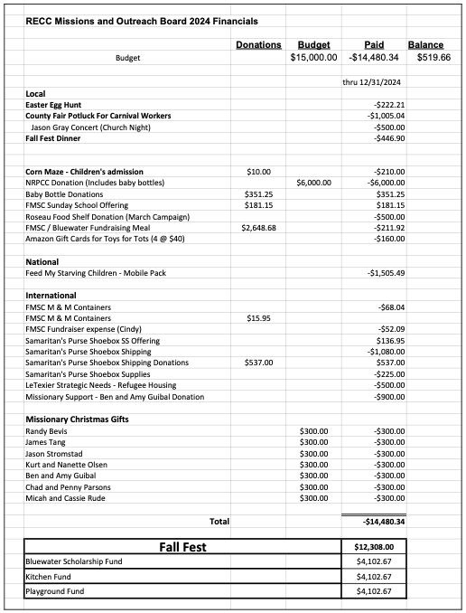

2024 Worship & Music Committee Report

“Be filled with the Holy Spirit, singing psalms and hymns and spiritual songs among yourselves, and making music to the Lord in your hearts. And give thanks for everything to God the Father in the name of our Lord Jesus Christ.” Ephesians 5: 18b-20

In 2024, the Worship Committee met regularly and planned Sunday morning services, as well as special events. Val Johnson, Juli Smedsmo, Trina Billingsley, Pastor Nate and Milly Prachar served as worship leaders in 2024. Val Espe coordinated and played for the Christmas Eve service as well as the Sunday School Christmas program and other special music. Trina Billingsley led instrumental ensembles for both the Easter and Christmas services. Kay Prothero coordinated special music throughout the year. Special “family” services were planned for Easter and Christmas with great attendance and participation, including praise choirs and storytelling by Gregg Iverson. Our pool of musicians (singers and instrumentalists) became deeper in 2024. We are so thankful for the gifts and talents of God’s people that are shared within our church family!

The Hymns and Pie event continued on a quarterly basis this year with a special “Hymns of the Cross” service during Holy Week. Hymns and Pie has now been embraced by the Baptist and Community churches, who will host these events along with RECC. The First Baptist Church hosted the Carols and Cookies service in December.

On August 18, the Community Church, Baptist Church and RECC combined efforts and worshipped together at a community service in Roseau City Park. It was a wonderful event with great attendance and messages from all three pastors.

Thank you to our audiovisual crew, who have done amazing work with all the details of sound, video, streaming, etc. New people joined the AV crew during 2024 – thankful for their help; it’s a busy role! There are many folks who watch our on-line services weekly; and the AV crew makes that happen!

Respectfully submitted,
Milly Prachar

2024 Pastoral Relations Committee Report

The Pastoral Relations Committee (PRC) is a standing committee of the RECC. The PRC is chaired by Dave Anderson and the vice chair is Tony Fichter. The PRC also includes a member of each of our boards; Rob Stroot, Christian Formation, Karlene Mattson, Missions and Outreach, Randy Prachar, Deacons, and Kelly Christianson, Trustees. In addition, Karen Granitz and Jan Carr-Herseth are serving as our two “at large” members. The PRC meets quarterly with our pastor and our youth director.

The primary purpose of the Pastoral Relations Committee is to insure healthy and mutually beneficial relations between the congregation and the pastoral staff. The PRC also assures that the needs of our pastoral staff and their families can be brought forward for conversation and prayer. Our aim is to be there for encouragement and affirmation. If any concern or grievance should arise during the year, the PRC is the official committee to address those concerns with restoration and reconciliation as the goal. Most importantly, we have the privilege and responsibility to uphold our pastoral staff and their families in prayer.

The PRC has enjoyed our time with our church staff. It’s wonderful having Pastor Nate and Chris with us. Both of them are doing an excellent job serving our church. We have seen continued growth in church attendance and membership. We have also enjoyed substantial growth in our youth group. We are lucky to have these men of God serving our church family. Let's remember to continually pray for Nate and Chris and for our church.

Submitted by,

Dave Anderson
PRC Chair

Statistical Report: 1984-2024
Year | Total Attendance  Sunday Morning | # Of Sundays In Year | Average Sunday Attendance | % Change  from previous year | $/Attendee/Sunday
1984 | 4,819 | 52 | 93 | 17.1% | $8.20
1985 | 5,163 | 52 | 99 | 6.45% | $7.37
1986 | 4,982 | 52 | 96 | -3.03% | $11.17
1987 | 4,846 | 52 | 93 | -3.13% | $10.82
1988 | 4,984 | 52 | 96 | 3.23% | $10.49
1989 | 5,401 | 52 | 102 | 6.25% | $9.96
1990 | 5,487 | 52 | 106 | 3.92% | $10.20
1991 | 5,895 | 52 | 113 | 6.60% | $10.18
1991 | 6,567 | 52 | 126 | 11.50% | $9.38
1993 | 7,204 | 52 | 139 | 10.32% | $8.93
1994 | 7,555 | 52 | 145 | 4.32% | $10.90
1995 | 8,263 | 53 | 156 | 7.59% | $11.37
1996 | 8,683 | 51 | 170 | 8.97% | $11.64
1997 | 9,227 | 52 | 177 | 4.12% | $14.17
1998 | 9,176 | 52 | 176 | -0.56% | $15.95
1999 | 9,479 | 52 | 182 | 3.41% | $17.13
2000 | 9,939 | 52 | 191 | 4.95% | $18.81
2001 | 10,478 | 51 | 205 | 7.33% | $17.00
2002 | 10,940 | 52 | 210 | 2.44% | $18.02
2003 | 11,319 | 52 | 218 | 3.81% | $18.14
2004 | 11,531 | 52 | 222 | 1.83% | $19.08
2005 | 10,057 | 52 | 193 | -13.06% | $20.93
2006 | 10,123 | 53 | 191 | -1.04% | $22.57
2007 | 8,845 | 51 | 173 | -9.42% | $24.39
2008 | 8,763 | 52 | 169 | -2.31% | $24.71
2009 | 8,087 | 52 | 156 | -7.69% | $25.83
2010 | 8,095 | 52 | 156 | 0.00% | $26.54
2011 | 7,419 | 52 | 143 | -8.33% | $27.56
2012 | 7,679 | 53 | 154 | 7.69% | $29.36
2013 | 7,129 | 52 | 137 | -11.04% | $32.56
2014 | 6,733 | 52 | 129 | -5.84% | $35.89
2015 | 7,279 | 52 | 143 | 10.85% | $33.57
2016 | 7,264 | 52 | 145 | 1.40% | $36.90
2017 | 7,298 | 53 | 143 | -1.38% | $40.06
2018 | 6,485 | 52 | 138 | -3.50% | $44.69
2019 | 7,400 | 52 | 145 | 5.07% | $41.15
2020 | 7,060 | 52 | 144 | -0.69% | $37.97
2021 | 5,364 | 52 | 103 | -28.47% | $50.40
2022 | 6,131 | 52 | 118 | 14.56% | $44.93
2023 | 8,250 | 53 | 156 | 32.20% | $35.81
2024 | 8366 | 52 | 161 | 3.21% | $37.42
• Total Income 2024 = $313,257.45 /52 (Sundays in 2024) = $6,024.18 (Average weekly giving 2024) /161 (Average weekly attendance 2024) = $37.42 average per attendee per week.
Trustee Board Annual Report 2024

This past year the congregation approved the spending to remodel our kitchen, which started in April and finished in September. This was a large project that took many of our church members many hours to help plan, design and implement the process. The total project cost came in right around $170,000, with roughly $90,000 being donated for this project throughout the year. The church utilized reserved funds along with taking out a $50,000 loan from Citizens State Bank to finance the project. The new kitchen looks great and is a lot more functional than what we had before.

The other main project the congregation approved was upgrading our playground equipment. This project started a little later in the summer and was completed around the end of September. The total cost of this project was roughly $15,000 with roughly $5,500 in donations and Fall Fest money. I believe we will need to purchase another load of pea rock next summer to fill the enclosed area. The new playground set is very sturdy and looks awesome and should last a very long time.

Our Church Insurance has gone up significantly over the last several years and this past year it took another very large increase. This led us to start looking for other alternatives. We settled on switching our insurance over to Church Mutual, which specializes in churches and has been around for 125 years. We ended up getting better coverage and reducing our total premiums down to roughly ½ of what our old insurance company wanted to charge us.

You will notice in the year-end financials that our expenses for our Van and Bus were way up this past year. Please keep in mind that we are dealing with fairly old vehicles that at times will require some unexpected breakdown expenses. Part of these expenses include the cost of having and operating a DOT licensed vehicle along with the regulation costs and reporting costs of our DOT drivers.

Our church continues to be in a good financial position, but our building maintenance and updates remains to be a constant that takes money. Our goal as Trustees is to manage these maintenance and update items so there are no big surprises in one year that would have a negative effect on our churches financial position.

In closing I would like to share my appreciation for the members of your Trustee Board, they do a wonderful job keeping our building and grounds in great shape. I would also like to thank our decorating committee that keeps our church fresh and looking awesome along with our custodian Anika that keeps our church clean.

Respectfully submitted,

Kelly Christianson
Trustee Board Chairperson

Trustee Board:
Sheldon Espe Dave Brinkman Chris Olson Scott Kofstad Shannon Grove
Gregg Iverson Scott Billingsley Todd Peterson (Treasurer)

Roseau Evangelical Covenant Church
Elected Positions 2025
Leadership Council (9 Members) | Tony Fichter | Chair / PRC Vice-Chair | 2025
Leadership Council (9 Members) | Dave Anderson | Vice-Chair / PRC Chair | 2025
Leadership Council (9 Members) | Steve Huglen | Secretary | 2025
Leadership Council (9 Members) | Todd Peterson | Treasurer | 2025
Leadership Council (9 Members) | Kelly Christianson | Trustee Board Chair | 2025
Leadership Council (9 Members) | Randy Prachar | Deacon Board Chair | 2025
Leadership Council (9 Members) | Rachel Krahn | Christian Formation Board Chair | 2025
Leadership Council (9 Members) | Sonya Peterson | Missions & Outreach Board Chair | 2025
Leadership Council (9 Members) | Nate Johnson | Senior Pastor | Ex Officio
Trustee Board (3-9 Members) | Kelly Christianson |  | 2025
Trustee Board (3-9 Members) | Sheldon Espe |  | 2025
Trustee Board (3-9 Members) | Chris Olson |  | 2025
Trustee Board (3-9 Members) | Todd Peterson |  | 2025
Trustee Board (3-9 Members) | David Brinkman |  | 2026
Trustee Board (3-9 Members) | Shannon Grove |  | 2026
Trustee Board (3-9 Members) | Scott Billingsley |  | 2026
Trustee Board (3-9 Members) | Gregg Iverson |  | 2026
Trustee Board (3-9 Members) | John Dennis |  | 2027
Deacon Board (3M + 3F Members) | Todd Lund |  | 2025
Deacon Board (3M + 3F Members) | Randy Prachar |  | 2026
Deacon Board (3M + 3F Members) | Milly Prachar |  | 2026
Deacon Board (3M + 3F Members) | Darrin Smedsmo |  | 2027
Deacon Board (3M + 3F Members) | Jan Herseth |  | 2027
Deacon Board (3M + 3F Members) | Trina Billingsley |  | 2027
Christian Formation Board (6-8 Members) | Rachel Krahn |  | 2025
Christian Formation Board (6-8 Members) | Marisa Cleven |  | 2025
Christian Formation Board (6-8 Members) | Juli Smedsmo |  | 2026
Christian Formation Board (6-8 Members) | Tiffany Otto |  | 2026
Christian Formation Board (6-8 Members) | Sam Grey |  | 2027
Christian Formation Board (6-8 Members) | Auna Brandt |  | 2027
Christian Formation Board (6-8 Members) | Brian Brandt |  | 2027
Christian Formation Board (6-8 Members) | Chris Shortreed | Youth Ministry Director | Ex Officio
Missions & Outreach Board (Minimum of 5 Members) | Cindy Tangen |  | 2025
Missions & Outreach Board (Minimum of 5 Members) | Heather Enright |  | 2025
Missions & Outreach Board (Minimum of 5 Members) | Val Espe |  | 2025
Missions & Outreach Board (Minimum of 5 Members) | Bryan Lundbohm |  | 2026
Missions & Outreach Board (Minimum of 5 Members) | Joel Maxwell |  | 2026
Missions & Outreach Board (Minimum of 5 Members) | Sara Arhus |  | 2026
Missions & Outreach Board (Minimum of 5 Members) | Kecia Stroot |  | 2027
Missions & Outreach Board (Minimum of 5 Members) | Sonya Peterson |  | 2027
Missions & Outreach Board (Minimum of 5 Members) | Kathy Brandt |  | 2027
Nominating Committee (4 Members) | Karen Granitz |  | 2025
Nominating Committee (4 Members) | Thor Didrickson |  | 2026
Nominating Committee (4 Members) | Sarah Johnson |  | 2026
Nominating Committee (4 Members) | Tom Enright |  | 2026

Elected Positions Guidelines:
1) All terms end in the year indicated. Elections are held during the Annual Meeting in January.
2) Leadership Council and Board Chair positions are all elected for 1-year terms.
3) All Board member positions are elected for 3-year terms.
4) All Nominating Committee at-large members are elected for 2 year terms.
5) Each Board appoints one person to each of the Nominating, Bluewater and Pastoral Relations Committees.
6) The Senior Pastor and Leadership Council Chair are ex-officio members of all boards and committees of the church.

Behavioral Covenant

- Be Affirming To Others
- Invest In Others
- Be Respectful Of Others
- Honor Leadership
- Seek First To Understand
- Be Honest and Truthful
- Be Loving, Caring & Sensitive To Others
- Seek That Which Benefits The Whole
- Accept Conflict & Resolve Together

Based on the following Scripture
Colossians 3: 12-17 (J.B Phillips)

As, therefore, God’s picked representatives of the new humanity, (The Church), purified and beloved of God himself, be merciful in action, kindly in heart, humble in mind. Accept life, and be most patient and tolerant with one another, always ready to forgive if you have a difference with anyone. Forgive as freely as the Lord has forgiven you. And above everything else, be truly loving, for love is the golden chain of all the virtues. Let the peace of Christ rule in your hearts, remembering that as members of the one body you are called to live in your hearts, remembering that as members of the one body you are called to live in harmony, and never forget to be thankful for what God has done for you.

Let Christ’s teaching live in your hearts, making you rich in the true wisdom. Teach and help one another along the right road with your psalms and hymns and Christian songs singing God’s praises with joyful hearts. And whatever work you may have to do, do everything in the name of the Lord Jesus, thanking God the Father through him.

2025 Leadership Council & Congregational Meeting Schedule
“To Share the Love and Hope of Jesus in Today’s World”
Exalt God, Expand God’s Kingdom, Equip God’s People & Express God’s Compassion

Sunday, January 19, 2025 Annual Congregational Meeting (Noon)

Tuesday, February 25, 2025 Leadership Council Meeting

Tuesday, March 25, 2025 Leadership Council Meeting

Tuesday, April 29, 2025 Quarterly Congregational Meeting

Tuesday, May 27, 2025 Leadership Council Meeting

Tuesday, June 24, 2025 Leadership Council Meeting

Tuesday, July 29, 2025 Leadership Council Meeting

Tuesday, August 26, 2025 Quarterly Congregational Meeting

Tuesday, September 30, 2025 Leadership Council Meeting

Tuesday, October 28, 2025 Leadership Council Meeting

Tuesday, November 25, 2025 Quarterly Congregational Meeting

Tuesday, December 30, 2024 No Meeting Unless Necessary

Sunday, January 25, 2026 Annual Congregational Meeting (Noon)

Note: Leadership Council meetings begin at 6:00 p.m. at RECC. Congregational meetings begin at 7:00 p.m. unless otherwise noted.



