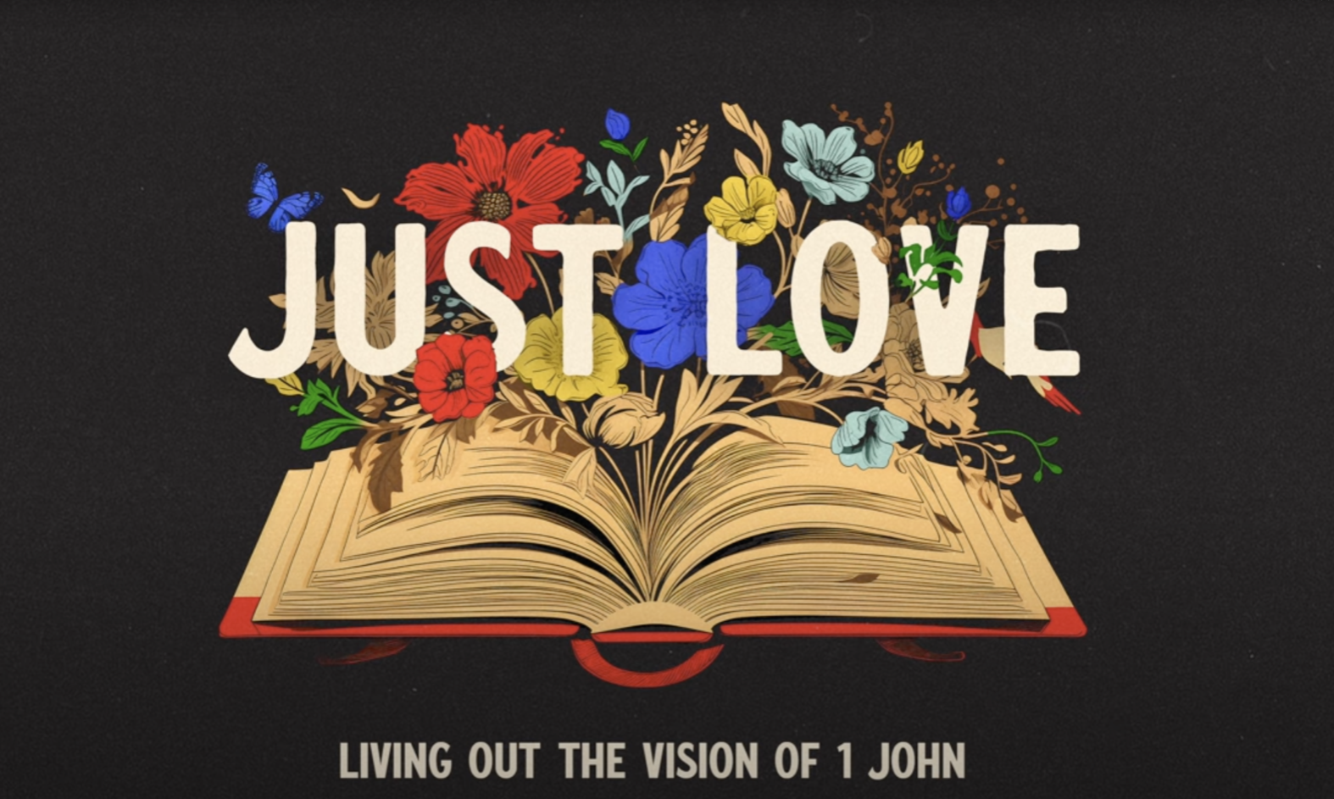

Love Loud | 1 John 5:1-21

June 15, 2025

By Pastor Tim Ghali

**Group Leader Notes**

Welcome to the final sermon in our series, *Just Love: Living Out the Vision of 1 John.* The theme of love is repeated 46 times throughout this letter. John calls us to be the light of Christ, warns us against false teachings, disunity and division. And he asks us to lean into the power of the Holy Spirit to obey the teachings of Jesus and to live more like him. Today we are going to discuss chapter 5 and what it means to *love loud.*

|  |  |
| --- | --- |
| **Questions:** What is *loud love?* | **Bottom Line:** A type of love that is enduring, a love that forgives, a love that sacrifices, a love that is generous. |

**Take Home Message**: Watch out for false teachings, avoid the idols, love God and love others. Just love.

**Main Scripture Reading:** 1 John 5:1-21

Everyone who believes that Jesus is the Christ is born of God, and everyone who loves the father loves his child as well. **2**This is how we know that we love the children of God: by loving God and carrying out his commands. **3**In fact, this is love for God: to keep his commands. And his commands are not burdensome, **4**for everyone born of God overcomes the world. This is the victory that has overcome the world, even our faith. **5**Who is it that overcomes the world? Only the one who believes that Jesus is the Son of God.

**6**This is the one who came by water and blood—Jesus Christ. He did not come by water only, but by water and blood. And it is the Spirit who testifies, because the Spirit is the truth. **7**For there are three that testify: **8**the[[a](https://www.biblegateway.com/passage/?search=1%20john%205&version=NIV#fen-NIV-30633a)] Spirit, the water and the blood; and the three are in agreement. **9**We accept human testimony, but God’s testimony is greater because it is the testimony of God, which he has given about his Son. **10**Whoever believes in the Son of God accepts this testimony. Whoever does not believe God has made him out to be a liar, because they have not believed the testimony God has given about his Son. **11**And this is the testimony: God has given us eternal life, and this life is in his Son. **12**Whoever has the Son has life; whoever does not have the Son of God does not have life.

**13**I write these things to you who believe in the name of the Son of God so that you may know that you have eternal life. **14**This is the confidence we have in approaching God: that if we ask anything according to his will, he hears us. **15**And if we know that he hears us—whatever we ask—we know that we have what we asked of him.

**16**If you see any brother or sister commit a sin that does not lead to death, you should pray and God will give them life. I refer to those whose sin does not lead to death. There is a sin that leads to death. I am not saying that you should pray about that. **17**All wrongdoing is sin, and there is sin that does not lead to death.

**18**We know that anyone born of God does not continue to sin; the One who was born of God keeps them safe, and the evil one cannot harm them. **19**We know that we are children of God, and that the whole world is under the control of the evil one. **20**We know also that the Son of God has come and has given us understanding, so that we may know him who is true. And we are in him who is true by being in his Son Jesus Christ. He is the true God and eternal life.

**21**Dear children, keep yourselves from idols.

**Group Discussion**

Begin in prayer before reading and discussing the text.

1. Pastor Tim began with the lyrics from “*Sometimes You Can’t Make it on Your Own”,* Bono’s song about his complicated relationship with his father, filled with love and unmet expectations. Whether it be reflective of your relationships or what you have seen in others, what does this bring to mind for you?
2. Read verse 1.

* Do you have nieces or nephews, or close friends with children? How do you treat them?

1. Read verses 14-15.

* How does God answer your prayers?
* How do you explain unanswered prayers?

1. Pastor Tim said he is praying for an engaged congregation and that God would meet us in this moment of transition. Ask your group how they are staying engaged and what they are praying for in this season.
2. Read verse 21.

In ancient times, idols were wooden statues that were worshiped for protection, fertility, and flourishing. What are our idols today?

* Who or what makes you feel safe, secure, and successful?
* Think about how many hours a day you spend on devices. How does this compare to the time you spend in relationships, prayer and reading Scripture?

1. Pastor Tim shared a personal story of how his father survived a massive heart attack. Reflecting on the impact of this experience, his father said, “There is an urgency that takes over when you move to the other side of something like this. There’s never been time to waste, there’s even less now and I’m living as surrendered to Jesus as I can.”

* Have you experienced a traumatic or life-changing experience that changed the way you think, the way you live, and the way you act?
* What was the event and how have you changed?
* How has this change affected your relationships with others?

1. Who in your life needs to experience the love of Jesus? Ask volunteers to share. Consider not only those who are close to you (family, friends), but people you pass by every day, strangers. In what ways could you show them the love of Jesus?

***Let’s Pray***

Heavenly Father, thank you for speaking to us through your Word. You remind us to spend time with you through daily prayer and Scripture reading, and to follow the way of Jesus. Guide us to the people around us who need to know they are loved. Through the power of your Holy Spirit, help us to just love the person in front of us. In Jesus name, Amen.