

Thanks for checking out our sermon-based Study Guides!
If you’ve never used our Study Guides before, you’ll find some basic instructions towards the end of the document.

- These study guides will be written by thoughtful and experienced Life Group Leaders.
- Use these guides as a head-start in your own preparation as the needs and culture is different from each group.

NEW THIS YEAR:
As we enter this new season at Grace Chapel in search for the next Senior Pastor, we invite you to consider the significance of this moment and to incorporate a time of prayer for the search.

Outline
- Introduction and Main Scripture Readings
- Group Discussion Questions
- Prayer for Senior Pastor Search
- The Journey Resources
- Support for the Leader

How to Use These Study Guides:
- Before the meeting: Consider sending out the Scripture passage to your group members ahead of time.
- Check In: Begin each meeting with a short time checking in with one another.
- Read Scripture: You may want to begin the discussion by reading the Scripture passage together out loud, or by summarizing the passage if everyone has read it ahead of time.
- Ask Questions: Don’t feel like you need to discuss every question included in the Study Guide. Pick one or two to start with and see how the conversation flows.
- End with Prayer: Be sure to set aside time for sharing prayer requests and praying together.

If your group meets over Zoom:
- Expect to do more overt facilitating over Zoom than you would in person. Feel free to call on people to invite them to share.
- Be sensitive to attention spans over zoom. Keep meetings shorter than they would be in person.

Group Leader Support:
- Please reach out to your Campus Pastor if you have any questions about leading your group or concerns about your group dynamic.
- If you have questions about or feedback on the Study Guides, please reach out to Pastor Tim Ghali or Grace Lee from the Group Life team.

Life Group Study Guide

for Sunday Sermon given on October 1, 2023
by Pastor Bryan Wilkerson

THE BEGINNING OF SIN, DEATH, AND GRACE – Genesis 3/ Romans 5

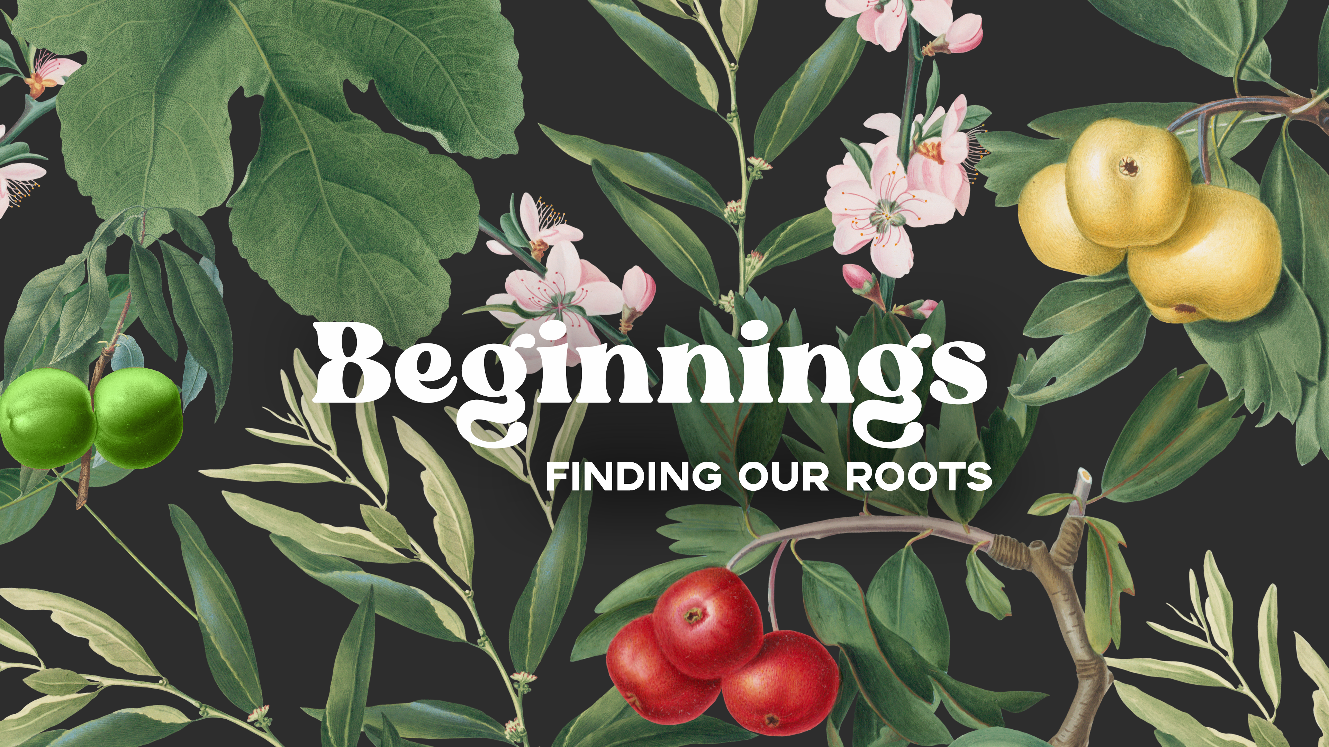

- Introduction

This fall we’re exploring our roots as human beings and people of faith by revisiting the early chapters of Genesis, the book of beginnings. We’re hoping to find wisdom for the future by looking to the past. So far we’ve considered The Beginning of Everything and learned that when God does a new thig, it’s always purposeful, personal, and progressive. Last week we looked at The Beginning of Humankind and learned that we will never know who we truly are until we know the One who made us, loves, us, and calls us his child. Unfortunately, today we’re going to learn that our ancestors made some terrible decisions; decisions that not only affected their lives and the world in terrible ways, but continue to cause problems and pain in our lives and world.

Questions: What is evil, sin, and death? What do these have to do with the choices we make every day and our relationship with God?

Bottom Line: In every new beginning, we have the opportunity to choose life instead of death, good instead of evil, and trust instead of fear.

Let’s begin in prayer before we begin reading and discussing our text.
Main Scripture Readings: Genesis 3/ Romans 5

Genesis 2:8-9
⁸ Now the Lord God had planted a garden in the east, in Eden; and there he put the man he had formed. ⁹ The Lord God made all kinds of trees grow out of the ground—trees that were pleasing to the eye and good for food. In the middle of the garden were the tree of life and the tree of the knowledge of good and evil.

Genesis 2:15-17
¹⁵ The Lord God took the man and put him in the Garden of Eden to work it and take care of it. ¹⁶ And the Lord God commanded the man, “You are free to eat from any tree in the garden; ¹⁷ but you must not eat from the tree of the knowledge of good and evil, for when you eat from it you will certainly die.”

Genesis 3:1-7
3 Now the serpent was more crafty than any of the wild animals the Lord God had made. He said to the woman, “Did God really say, ‘You must not eat from any tree in the garden’?”
² The woman said to the serpent, “We may eat fruit from the trees in the garden, ³ but God did say, ‘You must not eat fruit from the tree that is in the middle of the garden, and you must not touch it, or you will die.’”
⁴ “You will not certainly die,” the serpent said to the woman. ⁵ “For God knows that when you eat from it your eyes will be opened, and you will be like God, knowing good and evil.”
⁶ When the woman saw that the fruit of the tree was good for food and pleasing to the eye, and also desirable for gaining wisdom, she took some and ate it. She also gave some to her husband, who was with her, and he ate it. ⁷ Then the eyes of both of them were opened, and they realized they were naked; so they sewed fig leaves together and made coverings for themselves.
Genesis 3:15
¹⁵ And I will put enmity
between you and the woman,
and between your offspring and hers;
he will crush your head,
and you will strike his heel.”

Genesis 3:23-24
²³ So the Lord God banished him from the Garden of Eden to work the ground from which he had been taken. ²⁴ After he drove the man out, he placed on the east side of the Garden of Eden cherubim and a flaming sword flashing back and forth to guard the way to the tree of life.

Romans 5:12
¹² Therefore, just as sin entered the world through one man, and death through sin, and in this way death came to all people, because all sinned—
Romans 5:17
¹⁷ For if, by the trespass of the one man, death reigned through that one man, how much more will those who receive God’s abundant provision of grace and of the gift of righteousness reign in life through the one man, Jesus Christ!

2 Corinthians 5:17
¹⁷ Therefore, if anyone is in Christ, the new creation has come: The old has gone, the new is here!

Group Discussion Questions:

- Pastor Bryan started the message with a story about a well-known Hollywood actor who tried to force producers of the PBS Series, Finding Your Roots, to edit out a part of his family history that he was ashamed of. We all may have something troubling or embarrassing in our family or personal history that we would prefer to forget or erase.

- Can you relate in wanting to expunge something off our record?
- How has this sermon series helped you process your personal roots, especially the shameful parts of our past?

- In Pastor Bryan’s words, Genesis 3 is a sad story about disobedience, evil, sin, and death.

Pastor Bryan defines evil as “rejection of God and His love; the negation of all that is good and true and beautiful.” Sin is defined as “breaking relationship… breaking trust with the God who made us, and loves us, and wants the best for us.” Death is not “the punishment for breaking the rules but as a consequence of breaking the relationship.”

- As familiar as Genesis 3 may be to you, did any phrase or detail stick out to you while reading/hearing the story this time? Any lingering questions?

- Pastor Bryan referred to a story about a dog named Gypsy, from Sheldon Vanauken’s book, “A Severe Mercy”. After Gypsy realized that she didn’t have to obey her master, “that knowledge was a thrill in her heart, and a salt taste in her mouth.”

- How do you explain that inherent desire that we all have to choose evil over good?

- C.S. Lewis once said, “There is not one square inch of planet earth that is neutral. We are always and everywhere choosing life or death.” In this new beginning, what new choices you want to make to choose life with God?

  - How will you spend your time or money?
  - How will you work and play?
  - How will you treat people around you?
  - How will you handle temptations that come your way?

Take Home Message:
In this new season of our lives and church, in your new season of school or work or family, you have opportunities to choose life instead of death, good instead of evil, and trust instead of fear. Every day, in a thousand ways, we have the opportunity to choose life with God, or without God. Every one of those choices matters.

Let’s Pray

- Prayer for Senior Pastor Search

During this next ministry year as we navigate transitions, we invite you to secure time during your life group to pray over the search process. Click here to access the full resource of the prayer guide.

Prayers for Preparation of the heart
- Pray for God to reveal to you the condition of your soul or the work of God’s Spirit within you, as you consider your feelings about the Senior Pastor search process.
- Prayer is not just an opportunity to make requests from God, but to listen to what God might want for us during this season of transition. Pause and listen for any invitation from God that he is asking you to enter into.

Prayers for the Purposes of God
- Pray that God will use the people of Grace Chapel in the fulfilling of his mission to further the Gospel message and for us to be people of peace and healing in a broken world.

Prayers for the People of Grace
- Pray that Grace Chapel will to seek the Lord as we continue our vision to be a vibrant, growing, multicultural community of seekers and believers, discovering life with God for the good of the world. Pray that we will continue with our mission to make and mobilize more disciples for Jesus Christ in Greater Boston and beyond.

Prayers for the Person God’s calling
- Pray that they will have a passion to continue the work the Lord is doing at Grace Chapel and that they will be excited about the opportunities here.
- Pray that the new pastor will have a clear vision for how to minister to the people of Grace Chapel and the surrounding community.

Prayers for Discernment
- Pray for God’s clear direction in how resumes are examined and interviews conducted.
- Ask God to bring the right person to the attention of the committee.
- Pray for the Search Committee to have God’s wisdom in all the questions and information they share with the prospective pastor.

- The Journey


We’re all on a journey. Where is yours taking you?

The beauty of the way of Jesus is that it’s not just good for us, it is good for the world around us. But that kind of beautiful life doesn’t come from just hearing the words of Jesus. It comes from putting them into practice.

Three kinds of practice, actually:

- The with-God life of our personal habits and routines;
- The with-others life of our genuine and life-changing relationships; and
- The for-the-world life that makes an impact beyond our immediate homes and families, into our communities and beyond.

Growing as disciples of Jesus will make a Kingdom difference in our world and a transformative difference in our lives as believers and as a group. And these resources are helpful in identifying the next steps for our journeys.

Launching by the end of September: The newly, revised Discipleship Planning Tool
We invite your group to take the assessment and to spend a session to share about the practice and perspective you chose to focus on for the next three months.

- Support for the Leader

These Teaching Points are provided to help the group leader make connections from the message to their group with both insights from the Biblical text and opportunities in the life of our church.

Teaching Points:
- Adam and Eve enjoyed a perfect relationship with each other, and with God. They were fully and freely themselves with each other, and with God.

- God granted Adam and Eve FREEDOM, every day, to choose life with Him or without Him. He gave them free will so that they could CHOOSE to love and trust Him.

- EVIL is simply the rejection of God and His love; the negation of all that is good and true and beautiful. Evil is what we are left with when we declare our independence from God, and choose to go our own way, without Him.

- SIN is a person’s decision to think, speak, and act apart from God. Sin isn’t really about breaking rules, it is about breaking RELATIONSHIP. It’s about breaking trust with the God who made us, and loves us, and wants the best for us.

- DEATH is not a punishment for breaking rules, but a consequence of breaking our relationship with God.

- When Adam and Eve acquired the KNOWLEDGE of evil and the propensity to CHOOSE it, and we have all inherited that propensity to choose evil rather than good.

- Signs of God’s GRACE, his surprising kindness and undeserved favor:
  - Adam and Eve don’t die
  - God goes with them
  - God promises a rescue
- Our past sins and failures cannot be undone, but they can be forgiven and redeemed. We can be a new and better person if we choose Christ.

