

Thanks for checking out our sermon-based Study Guides!
If you’ve never used our Study Guides before, you’ll find some basic instructions towards the end of the document.

- These study guides will be written by thoughtful and experienced Life Group Leaders.
- Use these guides as a head-start in your own preparation as the needs and culture is different from each group.

NEW THIS YEAR:
As we enter this new season at Grace Chapel in search for the next Senior Pastor, we invite you to consider the significance of this moment and to incorporate a time of prayer for the search.

Outline
- Introduction and Main Scripture Readings
- Group Discussion Questions
- Prayer for Senior Pastor Search
- The Journey Resources
- Support for the Leader

How to Use These Study Guides:
- Before the meeting: Consider sending out the Scripture passage to your group members ahead of time.
- Check In: Begin each meeting with a short time checking in with one another.
- Read Scripture: You may want to begin the discussion by reading the Scripture passage together out loud, or by summarizing the passage if everyone has read it ahead of time.
- Ask Questions: Don’t feel like you need to discuss every question included in the Study Guide. Pick one or two to start with and see how the conversation flows.
- End with Prayer: Be sure to set aside time for sharing prayer requests and praying together.

If your group meets over Zoom:
- Expect to do more overt facilitating over Zoom than you would in person. Feel free to call on people to invite them to share.
- Be sensitive to attention spans over zoom. Keep meetings shorter than they would be in person.

Group Leader Support:
- Please reach out to your Campus Pastor if you have any questions about leading your group or concerns about your group dynamic.
- If you have questions about or feedback on the Study Guides, please reach out to Pastor Tim Ghali or Grace Lee from the Group Life team.

Life Group Study Guide

for Sunday Sermon given on Sept 24, 2023
by Pastor Bryan Wilkerson

THE BEGINNING OF HUMANKIND – Genesis 1:26-31
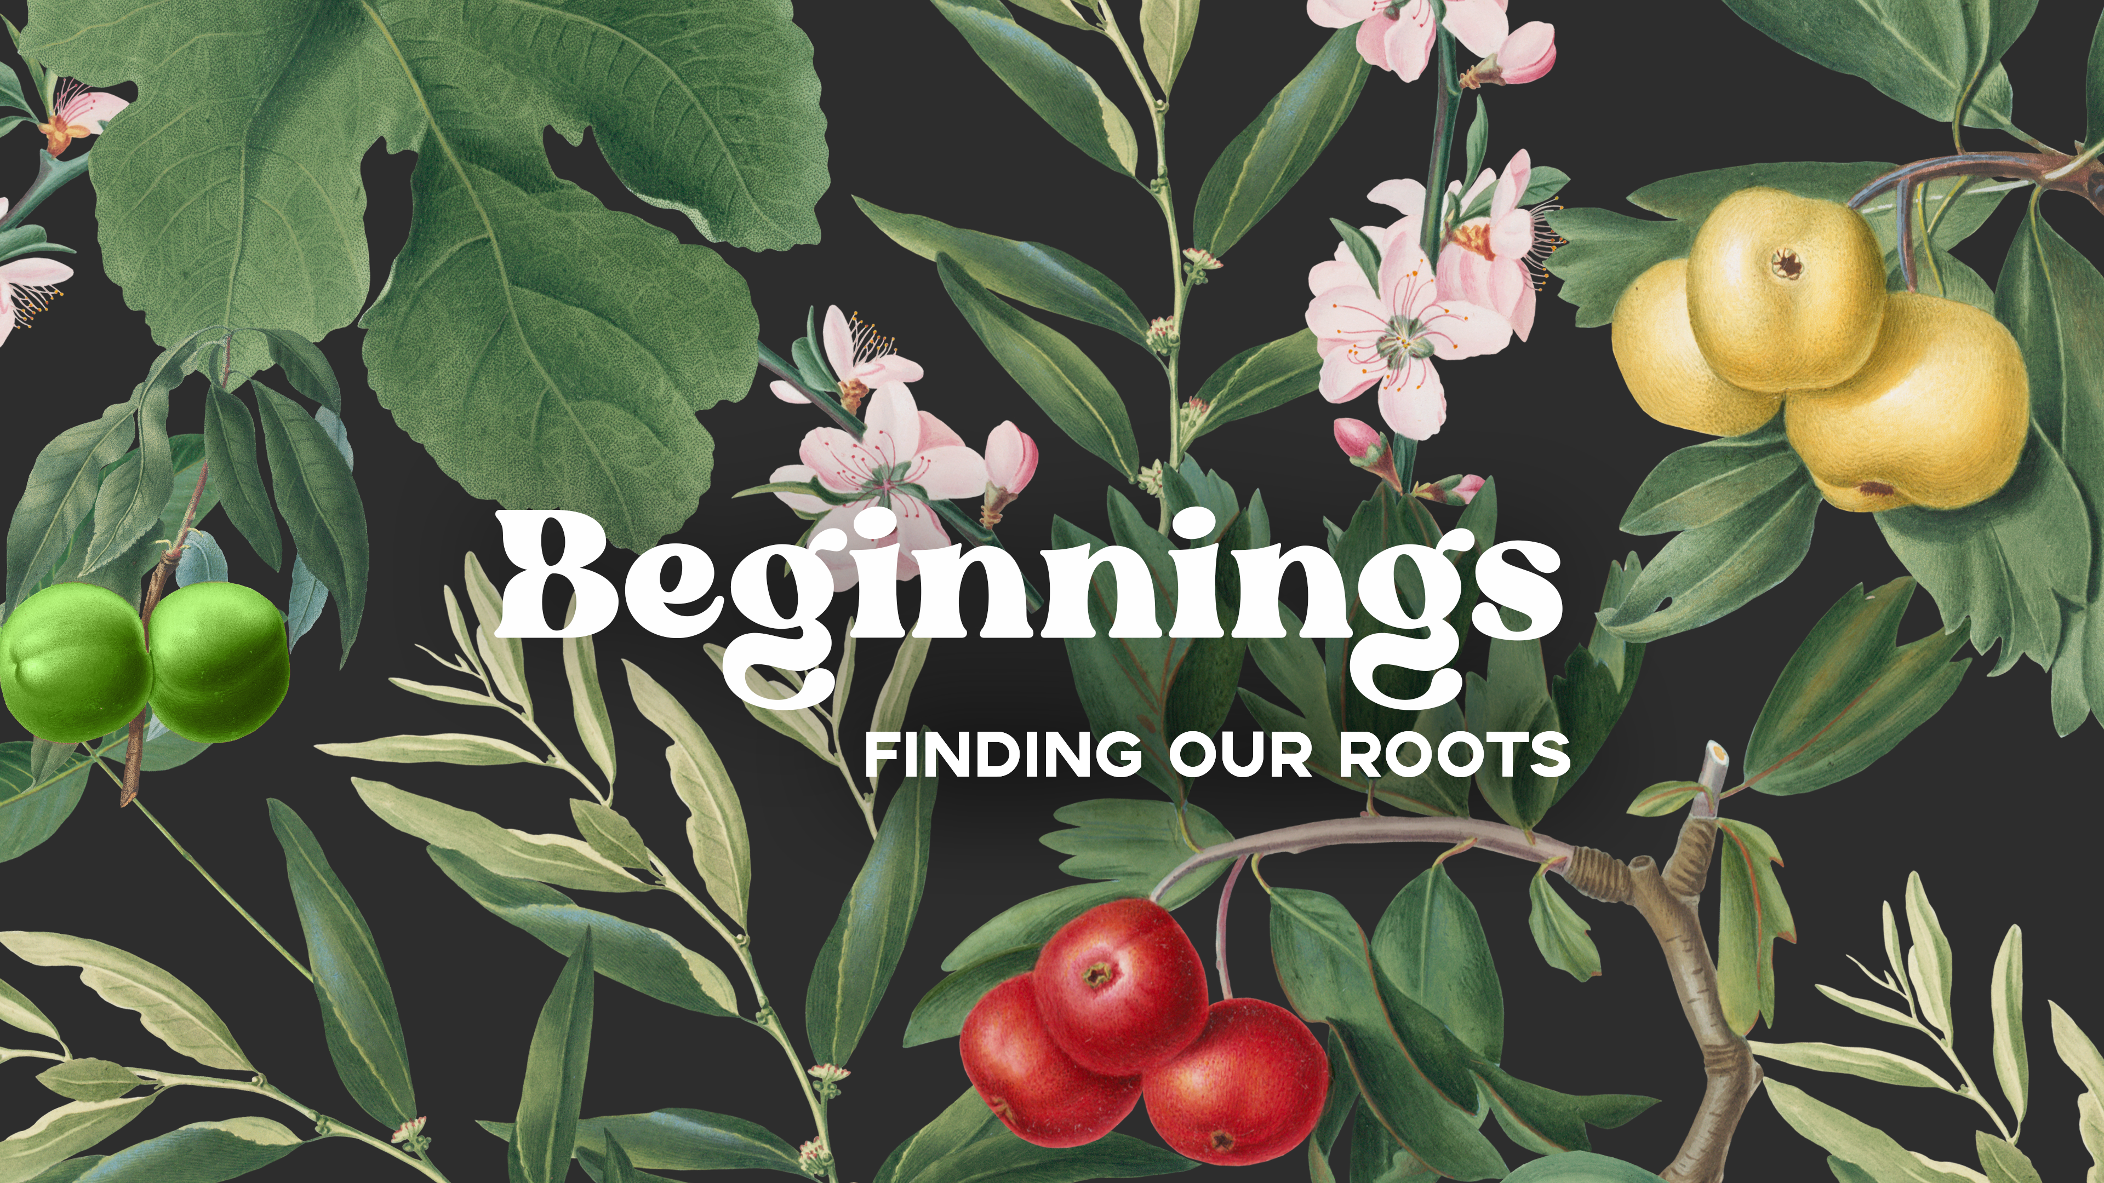

- Introduction
Last week we looked at the The Beginning of Everything, and learned that When God does a new thing, it is always purposeful, personal and progressive. We challenged ourselves to lean into the new things God is doing in our lives and in our church.

Today we are going to focus on identity, purpose and belonging -- to remember where we came from, and who we came from and what we were meant to be. As we think about who we want to be in the future, it seems wise to revisit our past. So in this year of new beginnings, as individuals and a church, we decided to explore our roots, as human beings and people of faith, by returning to the biblical book of Genesis.

Questions: Who am I? Why am I here? Where do I belong?
Bottom Line: You will never know who you are until you know the One who made you, loves, you and calls you His child.

Let’s begin in prayer before we begin reading and discussing our text.
Main Scripture Readings:

Genesis 1:26-31
²⁶ Then God said, “Let us make mankind in our image, in our likeness, so that they may rule over the fish in the sea and the birds in the sky, over the livestock and all the wild animals, and over all the creatures that move along the ground.”
²⁷ So God created mankind in his own image,
in the image of God he created them;
male and female he created them.
²⁸ God blessed them and said to them, “Be fruitful and increase in number; fill the earth and subdue it. Rule over the fish in the sea and the birds in the sky and over every living creature that moves on the ground.”
²⁹ Then God said, “I give you every seed-bearing plant on the face of the whole earth and every tree that has fruit with seed in it. They will be yours for food. ³⁰ And to all the beasts of the earth and all the birds in the sky and all the creatures that move along the ground—everything that has the breath of life in it—I give every green plant for food.” And it was so.
³¹ God saw all that he had made, and it was very good. And there was evening, and there was morning—the sixth day.
John 1:1-3
1 In the beginning was the Word, and the Word was with God, and the Word was God. ² He was with God in the beginning. ³ Through him all things were made; without him nothing was made that has been made.

John 1:14
¹⁴ The Word became flesh and made his dwelling among us. We have seen his glory, the glory of the one and only Son, who came from the Father, full of grace and truth.

Hebrews 2:14-16
¹⁴ Since the children have flesh and blood, he too shared in their humanity so that by his death he might break the power of him who holds the power of death—that is, the devil— ¹⁵ and free those who all their lives were held in slavery by their fear of death. ¹⁶ For surely it is not angels he helps, but Abraham’s descendants.

Ephesians 1:4-6
⁴ For he chose us in him before the creation of the world to be holy and blameless in his sight. In love ⁵ he predestined us for adoption to sonship through Jesus Christ, in accordance with his pleasure and will— ⁶ to the praise of his glorious grace, which he has freely given us in the One he loves.

- Group Discussion Questions:

- Pastor Bryan started the message saying that Americans, as individuals, are having an identity crisis. People are struggling to figure out who they are, why they’re here and where they belong.

- Can you relate to this statement? Have you experienced moments of identity crisis? Do you know someone who is experiencing this?
- If a someone asked, “Who are you? Why are you here? Where do you belong?” what would you say? How will you answer those questions?

- Pastor Bryan suggests that as we think about who we want to be in the FUTURE, it seems wise to revisit our past, which involves remembering where we came from, WHO we came from, and WHAT we were meant to be.

- Take a moment to read Genesis 1:26-28 – either individually or as a group.
- As you read, choose one of the three questions to focus on and share about.
  - Who are you?
  - Why are you here?
  - Where do you belong?
- Share with your group which question you chose to focus on and why. How does the first chapters of Genesis (or other Scripture passages) answer your question?

- Who are you? --- According to the book of Genesis, we find that humans are not mere animals or accidents, but rather are image-bearers of the Most-High God, uniquely designed and formed to express God’s character and nature.
- Discuss with the group what it means to be “image-bearers” of God. How do you best understand this? How do you best describe this?

- Why are you here? ---- Humans have been given authority and responsibility to become co-creators with God, also defined as “promoting human life and flourishing in all its forms across all the earth.”
- In what way are you currently exercising the authority and responsibility to co-create with God?
- Is God inviting you to be his co-creator in a new way for this new season?

- Where do you belong? --- Pastor Bryan reminds us of that God’s intention from the beginning was that we would become sons and daughters (Ephesians 1:4-6). You’ll never know who you really are till you know the One who made you, loves you, and calls you His child.
- None of us are immune from experiencing doubts, discouragements. How can we as a life group affirm and encourage one another that all of us belong to the family of God?

- Pastor Bryan concludes that our identity begins in relationship with God who made you on a purpose, for a purpose. How does knowing that you are a child of God change the way that you see yourself? See others? Change the way you live?

Take Home Message:
God’s intention and purpose in making us was that we might be his children and enjoy life in His universe, with Him and each other. God is so committed to accomplishing that purpose that he sent His Son to suffer and die for all of our sins, so that we might be forgiven and free to become the image-bearers, co-creators, and sons and daughters we were meant to be.

Let’s Pray

- Prayer for Senior Pastor Search

During this next ministry year as we navigate transitions, we invite you to secure time during your life group to pray over the search process. Click here to access the full resource of the prayer guide.

Prayers for Preparation of the heart
- Pray for God to reveal to you the condition of your soul or the work of God’s Spirit within you, as you consider your feelings about the Senior Pastor search process.
- Prayer is not just an opportunity to make requests from God, but to listen to what God might want for us during this season of transition. Pause and listen for any invitation from God that he is asking you to enter into.

Prayers for the Purposes of God
- Pray that God will use the people of Grace Chapel in the fulfilling of his mission to further the Gospel message and for us to be people of peace and healing in a broken world.

Prayers for the People of Grace
- Pray that Grace Chapel will to seek the Lord as we continue our vision to be a vibrant, growing, multicultural community of seekers and believers, discovering life with God for the good of the world. Pray that we will continue with our mission to make and mobilize more disciples for Jesus Christ in Greater Boston and beyond.

Prayers for the Person God’s calling
- Pray that they will have a passion to continue the work the Lord is doing at Grace Chapel and that they will be excited about the opportunities here.
- Pray that the new pastor will have a clear vision for how to minister to the people of Grace Chapel and the surrounding community.

Prayers for Discernment
- Pray for God’s clear direction in how resumes are examined and interviews conducted.
- Ask God to bring the right person to the attention of the committee.
- Pray for the Search Committee to have God’s wisdom in all the questions and information they share with the prospective pastor.

- The Journey


We’re all on a journey. Where is yours taking you?

The beauty of the way of Jesus is that it’s not just good for us, it is good for the world around us. But that kind of beautiful life doesn’t come from just hearing the words of Jesus. It comes from putting them into practice.

Three kinds of practice, actually:

- The with-God life of our personal habits and routines;
- The with-others life of our genuine and life-changing relationships; and
- The for-the-world life that makes an impact beyond our immediate homes and families, into our communities and beyond.

Growing as disciples of Jesus will make a Kingdom difference in our world and a transformative difference in our lives as believers and as a group. And these resources are helpful in identifying the next steps for our journeys.

Launching by the end of September: The newly, revised Discipleship Planning Tool
We invite your group to take the assessment and to spend a session to share about the practice and perspective you chose to focus on for the next three months.

- Support for the Leader

These Teaching Points are provided to help the group leader make connections from the message to their group with both insights from the Biblical text and opportunities in the life of our church.

Teaching Points:
- Identity crisis = a phase many people go through when they question and reassess who they are. This is common during the teenage years, but people may also reassess their lives after a major life event, such as retirement.

- Creation is not an extension of God as if God is IN everything, as some religious systems suggest. But Creation is an expression of God – it reflects God’s nature – His personal and relational and spiritual capacities.

- We are not only image bearers of the Most High God, we are co-creators with the Maker of heaven and earth.

- We were made to fulfill the purpose of God – to fill the earth with goodness, beauty and life.

- The most important part of being human is being loved; being sought out, and looked after; being fought over, to the bitter end. This is what God in Christ has done for every human being who has ever walked the earth, from the beginning right up until today, including you and me.

