

Thanks for checking out our sermon-based Study Guides! If you’ve never used our Study Guides before, you’ll find some basic instructions beginning at the bottom of page 2.

NEW this year: These study guides will be written by thoughtful and experienced Life Group Leaders. As always, use these guides as a head-start in your own preparation as the needs and culture is different from each group. And of course, please continue to give us feedback.

Life Group Study Guide
for the Sermon given on May 14, 2023
by Pastor Bryan Wilkerson
WORSHIP FOR THE WORLD - Revelation 4:1-11; 5:11-12; 7:9-17

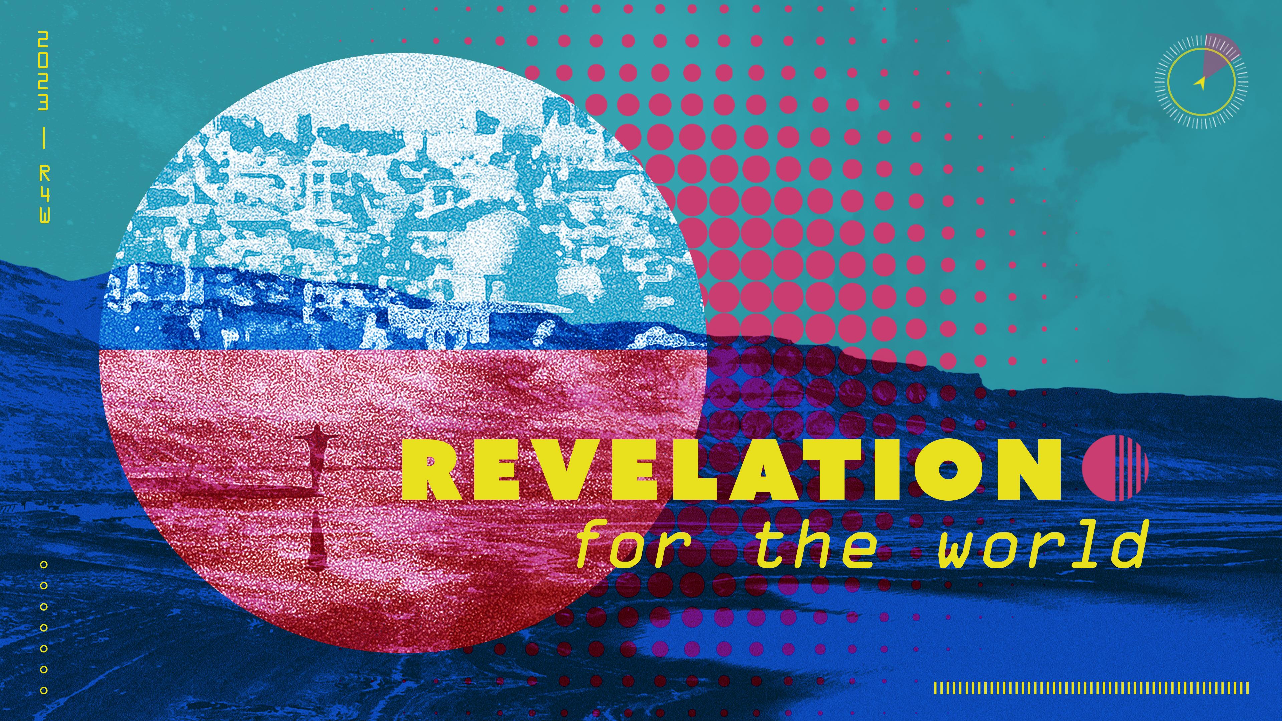

Question: What exactly is worship and why does it matter?

Bottom Line: Worship centers us on God and sends us out to live and love like Jesus.

Welcome to week 3 of our sermon series: Revelation – for the World. So far, we’ve learned that the book of Revelation is less about what’s going to happen and more about what is happening. It offers us a vision of the future, but it does so to help us live in the present as disciples of Jesus. Last week Pastor Tim showed us that Revelation is less about doomsday scenarios and more about the restoration of all things. It exposes the realities of evil and suffering in the world, but it promises ultimate victory over that evil and suffering through Christ. Worship is a major theme in the book of Revelation and that’s what we will focus on today.

Let’s begin in prayer before we begin reading and discussing our text.

Main Scripture Reading:

Revelation 4:1-11
4 After this I looked, and there before me was a door standing open in heaven. And the voice I had first heard speaking to me like a trumpet said, “Come up here, and I will show you what must take place after this.” ² At once I was in the Spirit, and there before me was a throne in heaven with someone sitting on it. ³ And the one who sat there had the appearance of jasper and ruby. A rainbow that shone like an emerald encircled the throne. ⁴ Surrounding the throne were twenty-four other thrones, and seated on them were twenty-four elders. They were dressed in white and had crowns of gold on their heads. ⁵ From the throne came flashes of lightning, rumblings and peals of thunder. In front of the throne, seven lamps were blazing. These are the seven spirits^{[a]} of God. ⁶ Also in front of the throne there was what looked like a sea of glass, clear as crystal.
In the center, around the throne, were four living creatures, and they were covered with eyes, in front and in back. ⁷ The first living creature was like a lion, the second was like an ox, the third had a face like a man, the fourth was like a flying eagle. ⁸ Each of the four living creatures had six wings and was covered with eyes all around, even under its wings. Day and night they never stop saying:
“‘Holy, holy, holy
is the Lord God Almighty,’
who was, and is, and is to come.”
⁹ Whenever the living creatures give glory, honor and thanks to him who sits on the throne and who lives for ever and ever, ¹⁰ the twenty-four elders fall down before him who sits on the throne and worship him who lives for ever and ever. They lay their crowns before the throne and say:
¹¹ “You are worthy, our Lord and God,
to receive glory and honor and power,
for you created all things,
and by your will they were created
and have their being.”

Revelation 5:11-12
¹¹ Then I looked and heard the voice of many angels, numbering thousands upon thousands, and ten thousand times ten thousand. They encircled the throne and the living creatures and the elders. ¹² In a loud voice they were saying:
“Worthy is the Lamb, who was slain,
to receive power and wealth and wisdom and strength
and honor and glory and praise!”

Revelation 7:9-17
⁹ After this I looked, and there before me was a great multitude that no one could count, from every nation, tribe, people and language, standing before the throne and before the Lamb. They were wearing white robes and were holding palm branches in their hands. ¹⁰ And they cried out in a loud voice:
“Salvation belongs to our God,
who sits on the throne,
and to the Lamb.”
¹¹ All the angels were standing around the throne and around the elders and the four living creatures. They fell down on their faces before the throne and worshiped God, ¹² saying:
“Amen!
Praise and glory
and wisdom and thanks and honor
and power and strength
be to our God for ever and ever.
Amen!”
¹³ Then one of the elders asked me, “These in white robes—who are they, and where did they come from?”
¹⁴ I answered, “Sir, you know.”
And he said, “These are they who have come out of the great tribulation; they have washed their robes and made them white in the blood of the Lamb. ¹⁵ Therefore,
“they are before the throne of God
and serve him day and night in his temple;
and he who sits on the throne
will shelter them with his presence.
¹⁶ ‘Never again will they hunger;
never again will they thirst.
The sun will not beat down on them,’
nor any scorching heat.
¹⁷ For the Lamb at the center of the throne
will be their shepherd;
‘he will lead them to springs of living water.’
‘And God will wipe away every tear from their eyes.’”

Group Discussion Questions:

- Pastor Bryan points out that worship is a feature in most religious traditions, taken especially seriously in the Christian tradition. There are things we Christians do and do not do which comprise what we call “worship.”

- If someone asks you, “What is worship?” how would you answer? What actions especially come to mind?

- Have you taken a moment to consider why worship matters?
- Why do Christians take worship seriously? Why should we take it seriously?
- What about us? How serious is our church community, our small group, about worship?

- Is there a point during the church worship service that particularly touches you the most? Examples may include but are not limited to the singing, the prayer, the giving, the message, the testimonies, or communion time.

- Feel free to take turns and share a memory where a specific part of the worship service deeply moved you.

- Read Revelation 4:1. Pastor Bryan notes that the first thing John sees in his vision is an open door. This points to the symbolic reminder that worship begins with an invitation. Pastor Bryan asserts, “God WANTS to be known. The door of worship is open to us, whether we’re walking into a sanctuary, or sitting alone at home or outdoors.”

- God wants to be known. What actions can we take to know God more? What has helped you know God better?

- While God’s door is always open, what are the challenges that prevent people from entering the open door?

- In your personal life, do you easily and readily enter through the open door?

- From Revelation chapters 4, 5 and 7, John uses earthly words and images to describe realities that are beyond human language or visualization.

- While apocalyptic literature may be difficult to read due to its symbolic nature, how can engaging with symbolic language and literature help us grow closer to God?

- Is there any part of the Scripture reading that sparks curiosity or confusion? Awe or fear? Imagination or realism?

- What are you noticing for the first time?

- For the first century disciples, John’s readers were facing persecution and dealing with distraction. From day to day, we too are presented with fears and distractions that take our focus away from God: demanding jobs, bad news, difficult people, health issues, financial setbacks, worry about our loved ones.

- What issues distract your focus away from God?
- How can you find ways to center yourself on God each week (in person or online)?

- Pastor Bryan concludes the message by saying worship sends us out into the world to live and love like Jesus.

- In light of this Sunday’s sermon, what is Jesus sending you out to do? Who is Jesus putting in your heart to love this week?
- After sharing, take time to pray for one another for the strength to center on Christ again and to live like Him.

Take Home Message:

Worship is meant to remind us of who God is, our mission to love one another and to spread the Good News, and what we can look forward to in the life to come. Worship provides a respite from the difficulties and challenges of everyday life, and it sends us back into the world to live boldly and faithfully for Christ.

Homework Until Next Time:

Ask the members of your LG to complete the Discipleship Planning Tool and the GPS Assessment Tool before your next meeting. Here is some fresh language:

We’re all on a journey; where is yours taking you?

The beauty of the way of Jesus is that it’s not just good for us, it’s good for the world around us. But that kind of beautiful life doesn’t come from just hearing the words of Jesus; it comes from putting them into practice. Three kinds of practice, actually:
- The with-God life of our personal habits and routines;
- The with-others life of our genuine and life-changing relationships; and
- The for-the-world life that makes an impact beyond our immediate homes and families, into our communities and beyond.

Growing as disciples of Jesus will make a Kingdom difference in our world and a transformative difference in our lives as believers and as a group. And these resources are helpful in identifying the next steps for our journeys.

Support for the Leader:
These Teaching Points are provided to help the group leader make connections from the message to their group with both insights from the Biblical text and also opportunities in the life of our church.

Teaching Points:

- Worship includes singing, praying, and giving.

- Worship begins with an invitation. The door of worship is always open to us, whether we are at church or sitting alone at home or outdoors. God wants to be in relationship with us.

- We can enter God’s presence just as we are, wherever we are. Enter into the experience with your full mind, body and spirit.

- Parents, one of the most important gifts you can give to your children is a CENTER: a sense of identity and belonging and purpose that transcends every other power, pursuit and pleasure. Worship matters because it centers us on God.

- The essence of worship is declaring in word and deed that God is worthy.

- “Humanity will never discover fruitful life and true joy through technology, wealth, science, sports, celebrity, power or politics. It comes only by engaging in loving service and worship of God and the Lamb, as part of a faithful community of worship. That reality shapes our mission in the world.” – Dean Flemming

- Revelation is less about escape and more about engagement.

How to Use These Study Guides:

- Consider sending out the Scripture passage to your group members ahead of time.
- Begin each meeting with a short time of checking in with one another.
- You may want to begin the discussion by reading the Scripture passage together out loud, or by summarizing the passage if everyone has read it ahead of time.
- Don’t feel like you need to discuss every question included in the Study Guide. Pick one or two to start with, and see how the conversation flows.
- If your group meets over Zoom:
  - You may need to do more overt facilitating over Zoom than you would in person. Feel free to call on people to invite them to share.
  - Try to be sensitive to attention spans over Zoom—keep the meetings shorter than they would be in person.
- Be sure to set aside time for sharing prayer requests and praying together.

Group Leader Support:

Please reach out to your Campus Pastor or your Coach if you have any questions about leading your group or concerns about your group dynamic. If you have questions about or feedback on the Study Guides, please reach out to Pastor Tim or Grace Lee from the Group Life team.

