

Thanks for checking out our sermon-based Study Guides! If you’ve never used our Study Guides before, you’ll find some basic instructions beginning at the bottom of page 2.

NEW this year: These study guides will be written by thoughtful and experienced Life Group Leaders. As always, use these guides as a head-start in your own preparation as the needs and culture is different from each group. And of course, please continue to give us feedback.

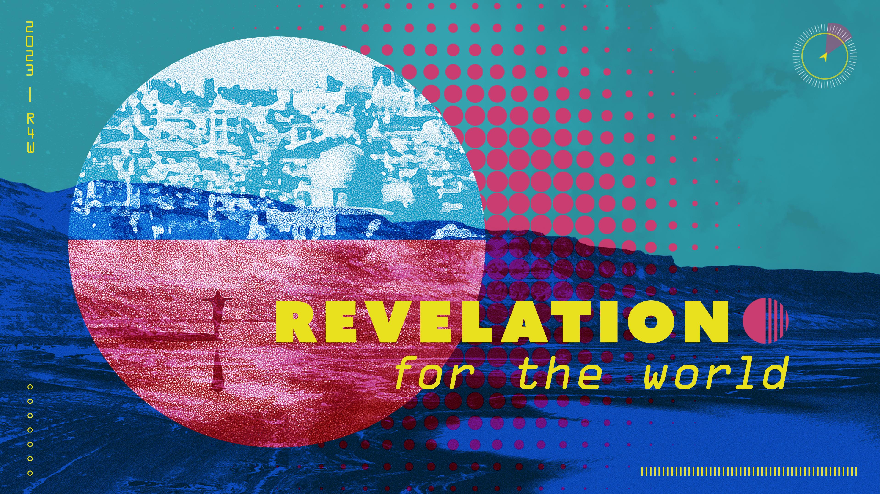

Life Group Study Guide
for the Sermon given on April 30, 2023
by Pastor Bryan Wilkerson
THE STORY OF EVERYTHING - Revelation 1:1-20; 21:1-5

Question: What is the book of Revelation all about?

Bottom Line: Revelation tells the story of God’s victory over evil through Christ, and invites us to play our part in that story.

Our theme for this ministry year is DISCIPLEMAKING: With God, With Others, For the World. In the fall we went to the book of Exodus and learned from Moses how to live a With-God life. In the winter we turned to the One-Anothers of the New Testament and learned how to live a With-Others life. During Lent we focused on the I Am statements of Jesus and learned how to live a With-Jesus life. This spring we are going to take a deep dive into the book of Revelation to discover what a For-the-World life looks like. Two weeks ago, Pastors Jon and Leah introduced us to the book of Revelation where Jesus says, “I am the Alpha and the Omega”, the God of the beginning and the end. Today we are going to begin in Revelation chapter 1.

Let’s begin in prayer before we begin reading and discussing our text.

Main Scripture Reading:

REVELATION 1:1-20
1 The revelation from Jesus Christ, which God gave him to show his servants what must soon take place. He made it known by sending his angel to his servant John, ² who testifies to everything he saw—that is, the word of God and the testimony of Jesus Christ. ³ Blessed is the one who reads aloud the words of this prophecy, and blessed are those who hear it and take to heart what is written in it, because the time is near.

Greetings and Doxology
⁴ John,
To the seven churches in the province of Asia:
Grace and peace to you from him who is, and who was, and who is to come, and from the seven spirits^{[a]} before his throne, ⁵ and from Jesus Christ, who is the faithful witness, the firstborn from the dead, and the ruler of the kings of the earth.
To him who loves us and has freed us from our sins by his blood, ⁶ and has made us to be a kingdom and priests to serve his God and Father—to him be glory and power for ever and ever! Amen.
⁷ “Look, he is coming with the clouds,”^{[b]}
and “every eye will see him,
even those who pierced him”;
and all peoples on earth “will mourn because of him.”^{[c]}
So shall it be! Amen.
⁸ “I am the Alpha and the Omega,” says the Lord God, “who is, and who was, and who is to come, the Almighty.”

John’s Vision of Christ
⁹ I, John, your brother and companion in the suffering and kingdom and patient endurance that are ours in Jesus, was on the island of Patmos because of the word of God and the testimony of Jesus. ¹⁰ On the Lord’s Day I was in the Spirit, and I heard behind me a loud voice like a trumpet, ¹¹ which said: “Write on a scroll what you see and send it to the seven churches: to Ephesus, Smyrna, Pergamum, Thyatira, Sardis, Philadelphia and Laodicea.”
¹² I turned around to see the voice that was speaking to me. And when I turned I saw seven golden lampstands, ¹³ and among the lampstands was someone like a son of man,^{[d]} dressed in a robe reaching down to his feet and with a golden sash around his chest. ¹⁴ The hair on his head was white like wool, as white as snow, and his eyes were like blazing fire. ¹⁵ His feet were like bronze glowing in a furnace, and his voice was like the sound of rushing waters. ¹⁶ In his right hand he held seven stars, and coming out of his mouth was a sharp, double-edged sword. His face was like the sun shining in all its brilliance.
¹⁷ When I saw him, I fell at his feet as though dead. Then he placed his right hand on me and said: “Do not be afraid. I am the First and the Last. ¹⁸ I am the Living One; I was dead, and now look, I am alive for ever and ever! And I hold the keys of death and Hades.
¹⁹ “Write, therefore, what you have seen, what is now and what will take place later. ²⁰ The mystery of the seven stars that you saw in my right hand and of the seven golden lampstands is this: The seven stars are the angels^{[e]} of the seven churches, and the seven lampstands are the seven churches.

REVELATION 21:1-5
21 Then I saw “a new heaven and a new earth,”^{[a]} for the first heaven and the first earth had passed away, and there was no longer any sea. ² I saw the Holy City, the new Jerusalem, coming down out of heaven from God, prepared as a bride beautifully dressed for her husband. ³ And I heard a loud voice from the throne saying, “Look! God’s dwelling place is now among the people, and he will dwell with them. They will be his people, and God himself will be with them and be their God. ⁴ ‘He will wipe every tear from their eyes. There will be no more death’^{[b]} or mourning or crying or pain, for the old order of things has passed away.”
⁵ He who was seated on the throne said, “I am making everything new!” Then he said, “Write this down, for these words are trustworthy and true.”

Group Discussion Questions

- Icebreaker question: Pastor Bryan mentioned that over his many years of preaching, there were times he invited the congregation to submit sermon requests. If you could submit a sermon request, what would it be?

- Pastor Bryan confessed that the book of Revelation is one that pastors are least likely to preach from. While he acknowledged that it is a frightening book, Revelation concludes the Bible and tells the story of God’s final victory over evil through Christ and invites us to play our part in that story.

Pastor Bryan asserts, “It is a missional book. We’re going to learn that the book of Revelation is FROM God; it’s ABOUT Christ; it’s TO the church, and it’s FOR the world.”

What do you know about the book of Revelation?
What thoughts/feelings are evoked when you think of Revelation?
Have you heard it taught/preached as a missional book?
What hopes/expectations do you have for this sermon series?

- Around the end of the first century AD, all people in the Roman Empire were ordered to offer prayers and sacrifices to the Roman emperors, who had declared themselves gods. Those who refused were regarded as traitors to the Empire and could be put to death.

- Imagine yourself to be a Christian during the first century. If you were one of these early Christ followers, what would you be afraid of?

- Take a moment to reread Revelation chapter 1. How would you receive this letter from John?

- Although Revelation was meant to speak to the people who first heard it, it was also to the first and second generation of Jesus followers and to every generation of Jesus followers right up until today. It was written for disciples trying to figure out what God is up to and what we are supposed to be doing in a world that often seems out of control, ungodly and headed toward disaster.

Read Revelation 21:1-5 again.

- As you read these verses, what word/phrase particularly stick out to you?
- How does “The Story of Everything” ends give you hope for the future?

- Throughout the sermon, Pastor Bryan made the following statements.

“Revelation is less about prediction, and more about perception.”
“Revelation is less about speculation and more about imagination.”
“Revelation is less about escape and more about engagement.”
“Revelation is less about destruction, and more about restoration.”

Which of the statements was the most surprising to you? Intrigued you the most? Which of the statements resonated most to you? How so?

- Pastor Bryan concludes his message by saying “Revelation tells the story of God’s victory over evil through Christ and invites us to play our part in that story.” In the weeks to come, the sermon series will continue to dive in on the work of Christ and how we can join Him in that work.

Take some time to pray as a group for the sermon series and the openness to hear God’s truths and to take action.

Take Home Message:
The book of Revelation is FROM God; it’s ABOUT Christ; it’s TO the church, and it’s FOR the world.
Homework Until Next Time:
Ask the members of your LG to complete the Discipleship Planning Tool and the GPS Assessment Tool before your next meeting. Here is some fresh language:

We’re all on a journey; where is yours taking you?

The beauty of the way of Jesus is that it’s not just good for us, it’s good for the world around us. But that kind of beautiful life doesn’t come from just hearing the words of Jesus; it comes from putting them into practice. Three kinds of practice, actually:
- The with-God life of our personal habits and routines;
- The with-others life of our genuine and life-changing relationships; and
- The for-the-world life that makes an impact beyond our immediate homes and families, into our communities and beyond.

Growing as disciples of Jesus will make a Kingdom difference in our world and a transformative difference in our lives as believers and as a group. And these resources are helpful in identifying the next steps for our journeys.

Let’s Pray
-------------------
Support for the Leader (These Teaching Points are provided to help the group leader make connections from the message to their group with both insights from the Biblical text and also opportunities in the life of our church).

Teaching Points:
- Apocalypse (apokalypsis in Greek) means disclosure or unveiling

- Apocalypses are stories that use symbols and visions to describe how people received understanding of spiritual realities from heavenly beings. Human beings are given this knowledge by a vision that reveals the truth God wants them to know.

- Apocalyptic visions reveal hidden truths about God, the course of human life, and the spiritual world. These visions often express or describe the meaning of human history, show insights about the nature of life after death, or tell of God’s coming judgment on humanity.

- Apocalyptic writings serve to give hope to God’s people in times of crisis. By seeing that God is in control of events and has a plan for human history, the faithful are encouraged to look beyond death and the struggles of this life toward a time of justice under God’s future rule.

- Revelation is less about predicting what is going to happen and more about perceiving what is happening

- Revelation is less about speculation and more about imagination. The characters and events are meant to be understood symbolically, not literally or even historically. They represent spiritual forces and realities at work in the world everywhere, all the time

- Jesus was the Word at the BEGINNING – speaking light into the darkness. He was the Word in the MIDDLE – made flesh, and living among us. He is the Word NOW – speaking into our lives by His Spirit. And He will be the Word at the END

- Revelation is less about escape and more about engagement. John was given this vision and told to send it to the churches in order to prepare them and equip them for the challenges and hardships to come; by reminding them that Christ would be with them through all of it, and that he would ultimately triumph over all of it, and that he wanted them to join him in the struggle

- John’s message is for all people, not just Christians

- Revelation is less about destruction and more about restoration. It’s about old things being made new, broken things being made whole, and lost and fallen people finding their way home. It’s about Christ establishing his rule over everything, everywhere, all the time

How to Use These Study Guides:
- Consider sending out the Scripture passage to your group members ahead of time.
- Begin each meeting with a short time of checking in with one another.
- You may want to begin the discussion by reading the Scripture passage together out loud, or by summarizing the passage if everyone has read it ahead of time.
- Don’t feel like you need to discuss every question included in the Study Guide. Pick one or two to start with, and see how the conversation flows.
- If your group meets over Zoom:
  - You may need to do more overt facilitating over Zoom than you would in person. Feel free to call on people to invite them to share.
  - Try to be sensitive to attention spans over Zoom—keep the meetings shorter than they would be in person.
- Be sure to set aside time for sharing prayer requests and praying together.

Group Leader Support: Please reach out to your Campus Pastor or your Coach if you have any questions about leading your group or concerns about your group dynamic. If you have questions about or feedback on the Study Guides, please reach out to Pastor Tim or Grace Lee from the Group Life team.

