Mention:
Christmas Mission Offering- Peru, church planting, multiplying the gospel on purpose
- 100% participation (so if you’ve never given to our church this is a great way to start)
- 13th tithe challenge

Intro
- Nones & Dones Christmas Edition
  - Spotlight on topics that have influenced people to reject or disconnect from listening to the Bible, participating in a church, or following Jesus altogether
  - The bible was written by men in patriarchal cultures and the church has used it to prevent women from flourishing. Why would I want to follow a God that would be OK with that?

- Yes the bible was written in patriarchal cultures.
- Yes, there have been Christians, pastors, and leaders who have actively and passively oppressed women and even tried to use the Bible to authorize their behavior
- Macro Examples: Educational opportunities, the right to own property, work outside the home, the right to vote, equal pay for equal work
- Micro examples in a western culture influenced heavily by Christianity over the years: women subjugated to tasks that only relate to stereotypical roles like homemaking, taking care of children, note-taking in meetings, and making food

I’ll admit I cannot possibly address all of these issues in one sermon. So where do I start?

First personally I’m a man but I don’t think I’m part of some patriarchy:
- Following my parents’ divorce at about age 4 up, I lived my mom with my older sister.
- I have 3 sisters in all- full, step, and half
- My older sister has 3 daughters. I also have 3 daughters.
- So I am well acquainted as a man with being around a lot of women for my whole life.

I share this because I think that while I am a man, I have spent much of my life around women. So if you have some picture of me sitting in a wood-paneled room smoking cigars overly using the words ‘broads’ and ‘dames’, that doesn’t describe me. It would be more accurate to see me as folding laundry in the living room while Lori has a Hallmark movie one.

My aim today is simple. I will have the natural opportunity in today’s passage to reveal how the Bible doesn’t cover up, but makes absolutely clear that women are significant and important. And we’ll be doing this as we are reminded of the Christmas story and how Christ’s coming brings the hope of abundant and eternal life.

Matthew 1. Can you believe that we will be entering the Christmas story through a genealogy? And it will be more interesting that you might think. So let’s go:

MATTHEW 1:1-6-17
An account of the genealogy of Jesus Christ, the Son of David, the Son of Abraham:

² Abraham fathered Isaac,
Isaac fathered Jacob,
Jacob fathered Judah and his brothers,
³ Judah fathered Perez and Zerah by Tamar,
Perez fathered Hezron,
Hezron fathered Aram,
⁴ Aram fathered Amminadab,
Amminadab fathered Nahshon,
Nahshon fathered Salmon,
⁵ Salmon fathered Boaz by Rahab,
Boaz fathered Obed by Ruth,
Obed fathered Jesse,
⁶ and Jesse fathered King David.

David fathered Solomon by Uriah’s wife,
…
¹⁶ and Jacob fathered Joseph the husband of Mary,
who gave birth to Jesus who is called the Messiah.

¹⁷ So all the generations from Abraham to David were fourteen generations; and from David until the exile to Babylon, fourteen generations; and from the exile to Babylon until the Messiah, fourteen generations.

Though it may seem strange (and boring) that Matthew would begin his gospel account with a genealogy we have at least two frames of references for it: Ancestry.com and 23&Me. Most of us have no idea our family tree beyond our grandparents. But now you through DNA testing and public records these companies can supply you with not only a family tree but a story to go with it.

In ancient times genealogies were typically put together like a resume. The best version you wanted to present of yourself was through a carefully edited genealogy to include the best representatives from your ancestors to make the descendant look as good as possible. Genealogies were like resumes in that they would highlight the best aspects that were true and relevant but would often leave out incriminating info that might cast a shadow on the person’s qualifications and merit.

But like what you can find from your ancestry.com results Jesus’ genealogy reveals something…different and surprising. It is not all inclusive. There are a lot of generations left off.

But it also includes the names of 5 women, the last of which is Mary the mother of Jesus. It is no accident that Matthew is drawing our attention to the first 4 names of women to signify

But what about the first four women? And what else might this have to say to all of us? Matthew was writing these words for the sake of all people- men and women. I’ve got three points to jump into: Here’s #1:

- The authority of women is inextricably linked to the story of Jesus

In the gospels we find many women included in the story of Jesus- Mary (Jesus’ mom), Mary Magdalene, Martha, women whom Jesus healed, and provided for his ministry. Women were even the first people reported to have witnessed the resurrected Jesus. Women were not considered credible witnesses in court and this fact alone the gospel writers don’t skip over is huge, not to mention pointing to the veracity of the resurrection itself! This only continues throughout the rest of the NT with many mentions of influential women in the early church.

Let’s focus on this passage from Matthew 1. Let’s take a deeper look at the first four women in the context of what Matthew is trying to make clear. God is bringing Jesus into the world to bring about fulfillment of his covenants with Abraham and David.

God promised to Abraham that he would bless the whole world through him and that all nations on the earth would be blessed through him. (Genesis 12)

Generations later God promised to David that he would always have a descendant sit on the throne as King. (2 Samuel 7)

Both of these promises point to a lineage of generations that would ultimately lead to Jesus. This was God’s plan to undo the curse of sin and also establish his Kingdom reign to return the world to shalom- flourishing.

And Matthew goes out of his way to include these four women in this list of people that lead to Jesus.

So let’s do a summary profile on each women to view how they take meaningful action to be part of the story God is writing leading to Jesus:

Tamar
- Genesis 38
- She first married grandson of Jacob (of Abraham, Isaac, and Jacob fame).
- She becomes widowed twice when Judah’s sons Er and Onan both die, both leaving her childless.
- Judah’s son would be the 5th generation of the Abrahamic covenant but he withholds offering his next son to Tamar in marriage (a culture gesture that actually offered care and protection for a widow)
- Judah also becomes widowed and plans a guys’ work trip when Tamar finds out and deceptively lures him in to impregnate her. Judah had no idea it was her so he wants to have her punished for her sin when his own sin is exposed
- He relents and and extols her righteousness.

GENESIS 38:27-30
When it came time for her to give birth, there were twins in her womb. As she was giving birth, one of them put out his hand, and the midwife took it and tied a scarlet thread around it, announcing, “This one came out first.” But then he pulled his hand back, out came his brother, and she said, “What a breakout you have made for yourself!” So he was named Perez. Then his brother, who had the scarlet thread tied to his hand, came out, and was named Zerah.

- She has twin sons… scarlet thread tied onto Zerah’s hand
- Perez means Breakthrough and Zerah means brightness of sunrise. The Light has broken through.
- The authority that Tamar exhibits is that of seeking justice and persistence. And she receives the reward of sons that represent the breakthrough of the Light of God. The lineage continues.

Rahab
- Joshua 2 tells of the people about to enter the promised land, Joshua sends spies into Jericho
- The King of Jericho wanted to find the spies and kill them.
- Rahab, a Canaanite woman, receives this word and finds the spies
- She provides refuge for them rather than ratting them out

Joshua 2:11b
…for the LORD your God is God in heaven above and on earth below. Now please swear to me by the LORD that you will also show kindness to my father’s family, because I showed kindness to you.

- She had heard of the LORD these men served and the good things he’d done.
- In exchange for their lives she asked that her life be spared
- So the spies tell her to tie a scarlet cord on her window and they’ll know to save her household
- They honor their word. She later marries a Jewish man and has children that lead the a man named Boaz.

Ruth
- The book of Ruth
- She’s a Moabite woman whose husband died.
- Rather than searching for a replacement husband, she chooses to sacrificially serve her mother in law, Naomi
- They return to Naomi’s homeland (Jewish territory) to find a kinsman redeemer
- Boaz and Ruth have their Hallmark meet-cute, he graciously provides for them, and oh by the way he’s a kinsman to Naomi

Ruth 4:11-12
All the people who were at the city gate, including the elders, said, “We are witnesses. May the LORD make the woman who is entering your house like Rachel and Leah, who together built the house of Israel. May you be powerful in Ephrathah and your name well known in Bethlehem. May your house become like the house of Perez, the son Tamar bore to Judah, because of the offspring the LORD will give you by this young woman.

- They eventually marry and have kids
- And her story becomes folded into this Abrahamic covenant story
- They become great grandparents to King David.

And so the Abrahamic covenant continues and leads to David.

Uriah’s Wife
- 2 Samuel 11-12 we discover Bathsheba, yes she has a name.
- Matthew’s non-use of her name makes you remember all the junk surrounding David and Bathsheba’s relationship
- David has an adulterous affair with her, has her husband killed, and then takes her as a wife
- That son died. But later they had Solomon.
- But David had other sons (and other wives)
- Adonijah was David’s eldest remaining son who was planning a self-coronation as Israel’s next king
- Bathsheba boldly steps in to plead that Solomon become next in line.

1 Kings 1:17, 20-21
She replied, “My lord, you swore to your servant by the LORD your God, ‘Your son Solomon is to become king after me, and he is the one who is to sit on my throne.’”

“Now, my lord the king, the eyes of all Israel are on you to tell them who will sit on the throne of my lord the king after him. Otherwise, when my lord the king rests with his fathers, I and my son Solomon will be regarded as criminals.”

Bathsheba boldly went to David to plead for her son to be included in God’s covenant with David.

So there you have those four womens’ stories. Daytime television doesn’t hold a candle to these stories. This a mixture of Jerry Spring, Dr. Phil, and Judge Judy.

And in the midst of it all we see that God has authorized these womens’ names to show up in Jesus’ genealogy. Bold women who were willing to take meaningful action to preserve themselves and the promises of God made to Abraham and David in their lifetime and beyond.

With them we see:
- Tamar → Justice and breakthrough
- Rahab → Refuge and and receives mercy
- Ruth → Sacrifice and finds renewal
- Bathsheba → Boldness and perpetuates God’s Kingdom

Their stories are rich and significant. Women, Matthew wants you to know that Jesus is for you. And men we should also take notice and be inspired by their faith and godly authority as well.

- To flourish you must exercise authority with vulnerability.

It is popular in our culture to view authority and vulnerability as opposite one another.

(See image one)
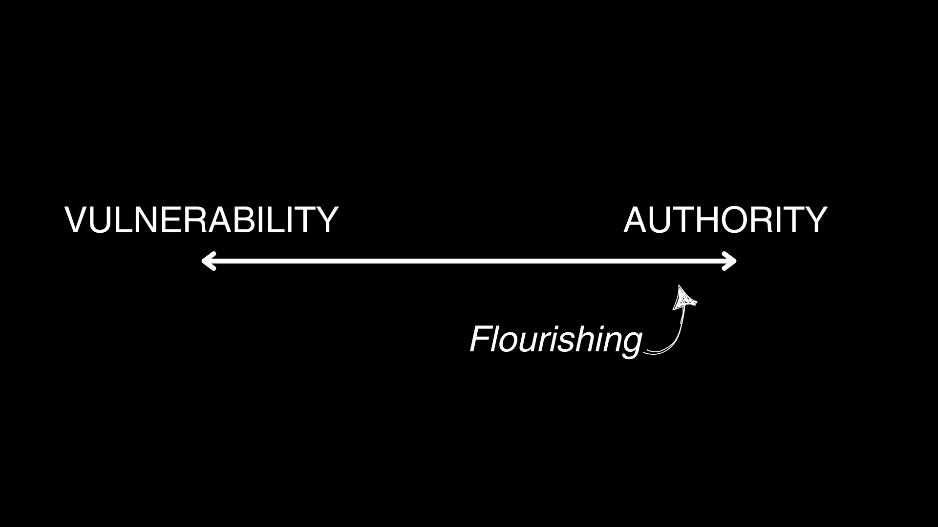
We witness this viewpoint in the swift outrage that comes from vulnerable groups when an abusive authority is exposed. And just to caveat, abusive authorities need to be exposed. But it has become customary to view vulnerability as the antithesis of authority when authority turns bad. In many cases people just view those in authority as bad across the board when you’re not the one in authority.

Biblically it is how King Herod responds to news that his kingly authority might be challenged when he hears from the wise men who were searching for the King of the Jews. His authority was exposed by vulnerability. So what did he do? He decreed that all boys under 2 years old were to be killed. That is unhealthy authority that is threatened by vulnerability.

And if vulnerability is viewed as a negative weakness then I need to seek authority by any means necessary. The more authority I have then the more I can flourish. Right? Well, not exactly.

Andy Crouch in his book Strong and Weak makes the case that true flourishing comes through exercising both authority and vulnerability. He doesn’t view them as opposites along a single axis. He views them as each having their own axis. (Flourishing exists in top right)

(see image two)
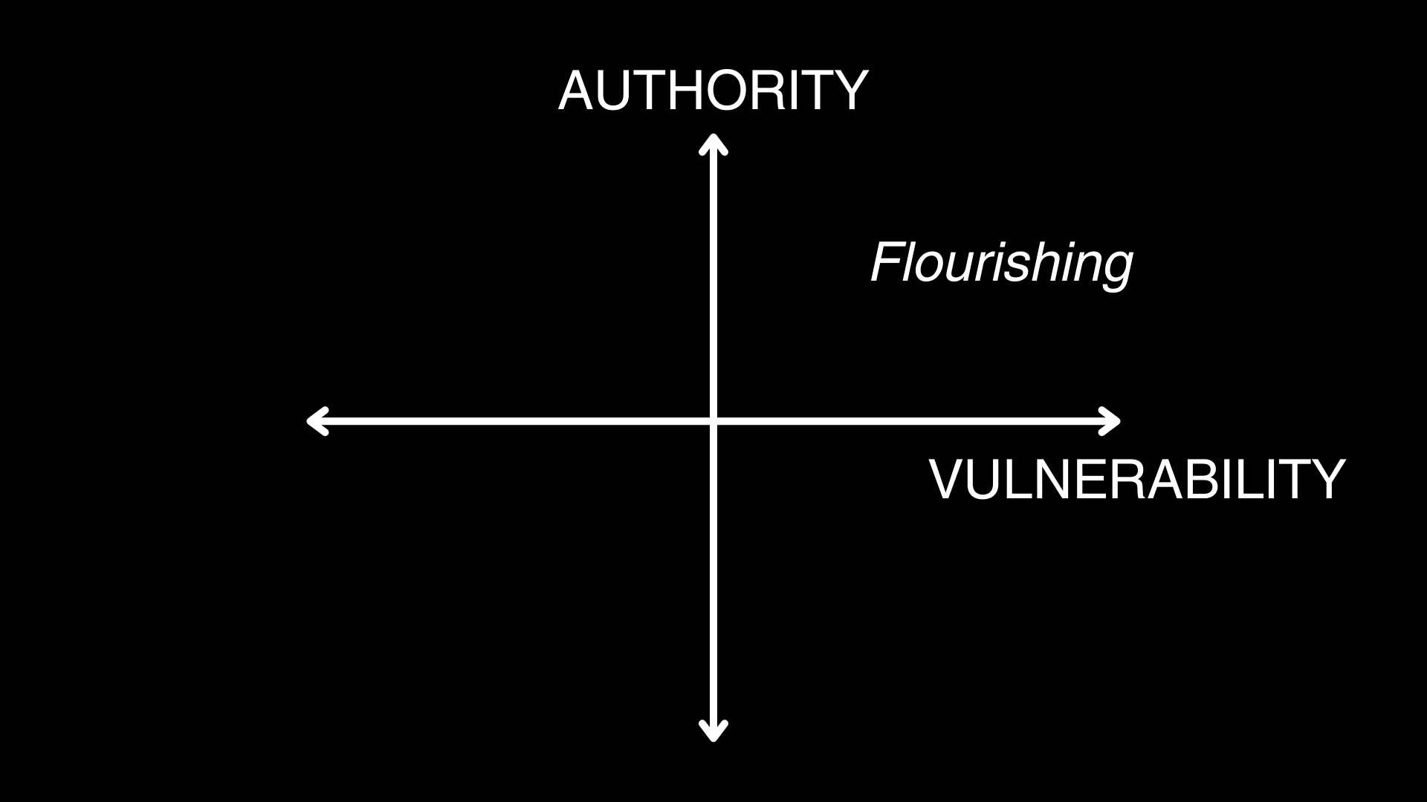

So how does vulnerability work? It means you take meaningful risk. You risk being exposed to the dangers inherent with using your authority. And to flourish it means acting and risking to help others flourish, not just yourself.

This is what we see with these four women, even in the midst of the broken situations they find themselves in. To be clear each of these women have sinful sides of their stories that expose them to the dangers of consequences. Yes, this means you have the authority to bring about good for others but it also means you have the capacity to ruin things, sin against people, be sinned against, and lose everything.

Flourishing means taking meaningful action and taking meaningful risk.

These women:
- Tamar was a widow and risked her life to get justice
- Rahab risked her life by hiding the spies and trusting them
- Ruth risked her life by sacrificing for Naomi rather than taking care of herself
- Bathsheba risked her life by boldly going before the King

Were these women perfect? No. They were sinful just like all the men they were connected to. But they were willing to put their authority on the line and make themselves vulnerable.

Their vulnerability become an opportunity to see the grace of God to work like how the Apostle Paul tells us:

2 CORINTHIANS 12:9a, 10b
“My grace is sufficient for you, for my power is perfected in weakness.”

For when I am weak, then I am strong.

Stepping into vulnerability is the chance to experience and multiply flourishing.

Examples:
- A woman goes to G4 and sticks with it- overcome the fear of being exposed
- A man steps up to lead a CityKids class- overcome the risk of not knowing how to teach or care for kids, risk to your time
- When a couple steps up to lead a new CG- risks loss of some close relationships, exposing your inexperience to
- Mission Teams- risk your summer break or paid time off
- Church Planting Team- risk of it not working out
  - Stories like Julio’s & Summit Collab planters
  - Our story- TX to TN (home, jobs, now)

What about you? Do you want to see your life flourish and do you want to be part of helping others flourish as well?

Then you need to embrace the life of authority and vulnerability. But even more you must see that:

- Jesus offers true flourishing through his sacrificial authority and vulnerability.

The ultimate vulnerability that we all have- the women (and men) in this genealogy, you, and me… is our sin. Our sin exposes us to the righteous authority of God. And we have no means to justify ourselves, to atone for our own sin.

So how do you deal with your sin? Do you exercise a false vulnerability that pushes people away? You see yourself as a pile of filthy wreckage. That sounds humble. But then you use that admission to push the very people away that have the capacity to call you to flourishing? Do you just run away?

What this genealogy and the story of Christmas reveals to us is that there is a God in heaven who will use his authority to run after you to give you abundant life. He isn’t ashamed of your name associated with him.

Jesus’ incarnation was made possible by his authority- the power to take meaningful action to run after you and deal with your sin. But it also made him vulnerable. A baby is the most vulnerable state of any human being. And yet he came as a child. And he led a life where he willingly gave his life on a cross to atone for your sin. He made himself vulnerable for you.

So how will you respond? Will you see that it is his goodness that sent him running after you?

Receive him. Worship him with a heart full from being fully known (fully exposed) but also fully loved (fully authorized). His gospel declares that you are both vulnerable- more sinful that you ever thought you were. But also you can find authority- you are more loved than you ever dared dream.

Closing Invitation
After I pray I want to invite you to linger and ponder while our worship team comes to lead us. Resist for 5 minutes the urge to go to the restroom or go check out your toddler from CityKids. Instead we ask that you remain seated. I invite you to ponder how you will respond to and receive the love of the Father who would send his Son to pursue you. Will you receive him today in faith? Will you take a next step of vulnerability in baptism, in giving, or in service?

Pray

