SOUTHERN WESLEYAN UNIVERSITY

Department of Music

Handbook and Policy Manual

Fall 2024

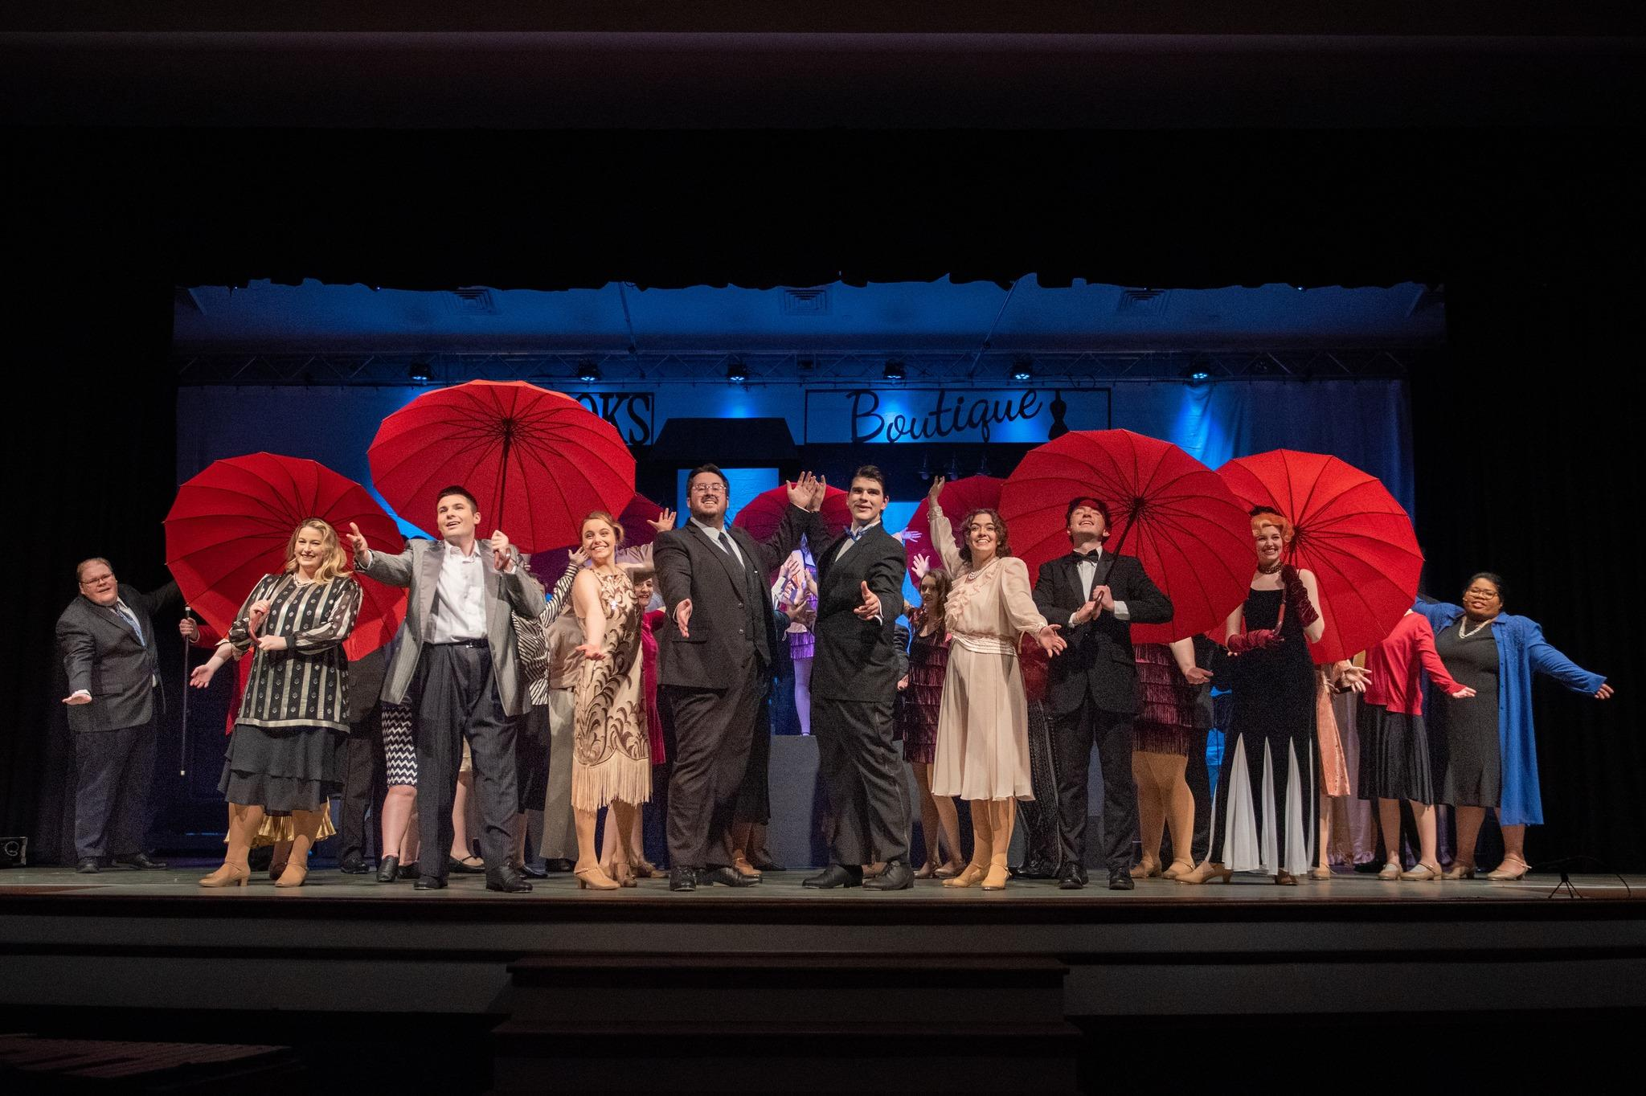

TABLE OF CONTENTS

Letter from Dr. James ……………………………………………………………………………..4
Mission Statement …..……………………………………………………………………………..5
Music Faculty ……….……………………………………………………………………………..6
Adjunct Faculty ……………………………………………………………………………………7
Facilities …………………………………………………………………………………………8
Organizations ...……………………………………………………………………………………8
Auditions …………………………………………………………………………………………..8
NafME, ACDA, NATS, AND SCMTNA …………………………………………9
SWU Music Department……………………………………………………….….9
Fine Arts Scholarships …………………………………………………………………………...10
Music Ensemble Scholarships ……………………………………………………10
Music Major Scholarships ………………………………………………………..10
Course Requirements for Full-Time Music Majors ……………………………………………...11
Ensemble Requirements ………………………………………………………………………….11
Campus Ensembles ………………………………………………………………………………11
Concert Choir …………………………………………………………………….11
Wind Ensemble …………………………………………………………………..11
Jazz Ensemble ……………………………………………………………………11
String Ensemble ………………………………………………………………….11
Chamber Ensembles ……………………………………………………………...11
Recital Attendance ……………………………………………………………………………….12
Recital Etiquette ………………………………………………………………………………….12
Applied Music Juries and Evaluations …………………………………………………………...12
Freshman/Sophomore Evaluation ………………………………………………………………..12
Senior Recital …………………………………………………………………………………13-15
Recital Date ………………………………………………………………………13
Procedure …………………………………………………………………………13
All Recitals and Hearings ………………………………………………………...13
Invitations ………………………………………………………………………...13
Programs …………………………………………………………………………13
Elements of the Senior Recital …………………………………………………...14
Senior Recital Checklist ………………………………………………………………………….15
Student Recitals - Additional Suggestions and Considerations ………………………………….15
Request to Perform a Senior Solo Full Recital …………………………………………………..16
Piano Proficiency Exam ………………………………………………………………………….17
Class Piano Levels ……………………………………………………………………………….17
Non-Major Levels of Private Instruction ………………………………………………………...18
Special Information …………………………………………………………………………..19-21
Protecting Your Hearing Health ………………………………………………….19
Protecting Your Vocal Health …………………………………………………….20
Protecting Your Neuromusculoskeletal Health …………………………………..21

Additional Information for the Department of Music ………………………………………...22-23
Bulletin Board ……………………………………………………………………22
Division Chapels …………………………………………………………………22
Lockers …………………………………………………………………………...22
Senior Exit Interview …………………………………………………………….22
On-Stage Performance Grand Piano ……………………………………………..22
Accompanying …………………………………………………………………...22
Off-Campus Representation ……………………………………………………...22
Study-Practice Habits …………………………………………………………….22
Recital Hour/Seminar …………………………………………………………….23
E-Mail ……………………………………………………………………………23
Curriculum ……………………………………………………………………………………24-33
Music B.A. Requirements ………………………………………………………..24
Music B.A. Vocal Guide ……………………………………………………...25-26
Music B.A. Instrumental Guide ………………………………………………27-28
Music Education B.A. Requirements …………………………………………….29
Music Education B.A. Vocal Guide …………………………………………..30-31
Music Education B.A. Instrumental Guide …………………………………...32-33



August 18, 2024

Dear music students,

Welcome (back) to Southern Wesleyan University’s Music Department! The music faculty and staff are looking forward to a year of academic success, growth in musicianship, and collaborative involvement as a department. The faculty will challenge you in your studies, guide you in your journey as a musician, and celebrate your successes with you.

As an aspiring professional musician, much will be required of you in your character, your words, and your actions.

- In all matters of student life, you are expected to know and follow all policies and procedures listed in the SWU Student Handbook found at https://www.swu.edu/student-handbook/.

- For all academic areas relevant to your major(s), minor, and overall studies, you are expected to know and follow all policies and procedures listed in the SWU 2024-2025 Undergraduate Bulletin found at http://catalog.swu.edu/.

- For all things pertaining to your specific degree in music, you are expected to know and follow all policies and procedures listed in this 2024-2025 SWU Music Department Handbook emailed to you and provided in a printed copy.

I know we will have a great year as we live and work together. Do not hesitate to reach out to any of the faculty if you need help in any area. We love you and we want you to succeed. Stay well and be safe. “My heart, O God is steadfast…I will sing and make music.” (Psalm 57:7)

Gratefully,
Dr. Amber James
Music Department Coordinator
Associate Professor of Music | Director of Student Productions | Director of University Singers

SWU DEPARTMENT OF MUSIC HANDBOOK AND POLICY MANUAL

Mission Statement

The mission of the Southern Wesleyan University (SWU) Department of Music is to provide a quality music curriculum within a Christian environment. To accomplish this mission, each program within the department will: 1) equip the student with the skills necessary to excel in a variety of musical settings and 2) integrate various aspects of the Christian faith into each course, attempting to instill within the student an awareness of the practical outworking of Biblical principles.

In In June 2008, the National Association of Schools of Music (NASM) voted to accept SWU as a member after reviewing the university and its music programs. This national recognition affirms the high quality of music programs at SWU and is a distinct advantage both for the reputation of its programs and for the recognition of its graduates. Accreditation was renewed in 2015, with the next full review taking place in April 2025.

The SWU Music Department offers degree programs leading to a B.A. in Music or Music Education as well as a minor in music.

The B.A. in Music, a general degree, provides the student with a foundation in musical studies while giving elective opportunities for study in a secondary area, which often integrates with music, e.g., business or computers. Students have the option of choosing from two (2) Advising Tracks, giving more focused study in an area of interest that integrates well with a B.A. in Music. These areas are Contemporary Commercial Music Production and Contemporary Commercial Music Business.

The B.A. in Music Education prepares students for certification as music teachers within the South Carolina schools. Students pursuing this degree may also teach in private school music programs and serve as applied music instructors.

Although an applied performance degree is not offered at SWU, some B.A. in Music majors concentrate in performance by taking additional hours in applied areas of study, particularly in their freshman and sophomore years, and they have been very successful in graduate school.

Programs offered in conjunction with the Department of Religion include a B.A. in Religion with a Christian Worship 3+1 Concentration and a minor in Christian Worship.

Private instruction, seminars, classes, recitals, and cultural events combine to develop the total musician. SWU strives to achieve a close teacher/student relationship. Faculty members are available for counseling and advising each student according to his or her needs.

The ultimate responsibility for successful completion of any degree program is in the hands of the student. Regular practice and diligent study will enable all students to achieve their own goals. The music faculty pledges its best effort to guide all students and expects the best from each one in terms of self-discipline and consistent striving toward those goals.

FULL-TIME MUSIC FACULTY



Amber James, Associate Professor of Music
B.A. in Music Education and Piano, Southern Wesleyan University; M.M. in Vocal Performance, University of Georgia; D.M.A. in Vocal Performance and Pedagogy, University of Southern Mississippi (joined SWU faculty in 2018).

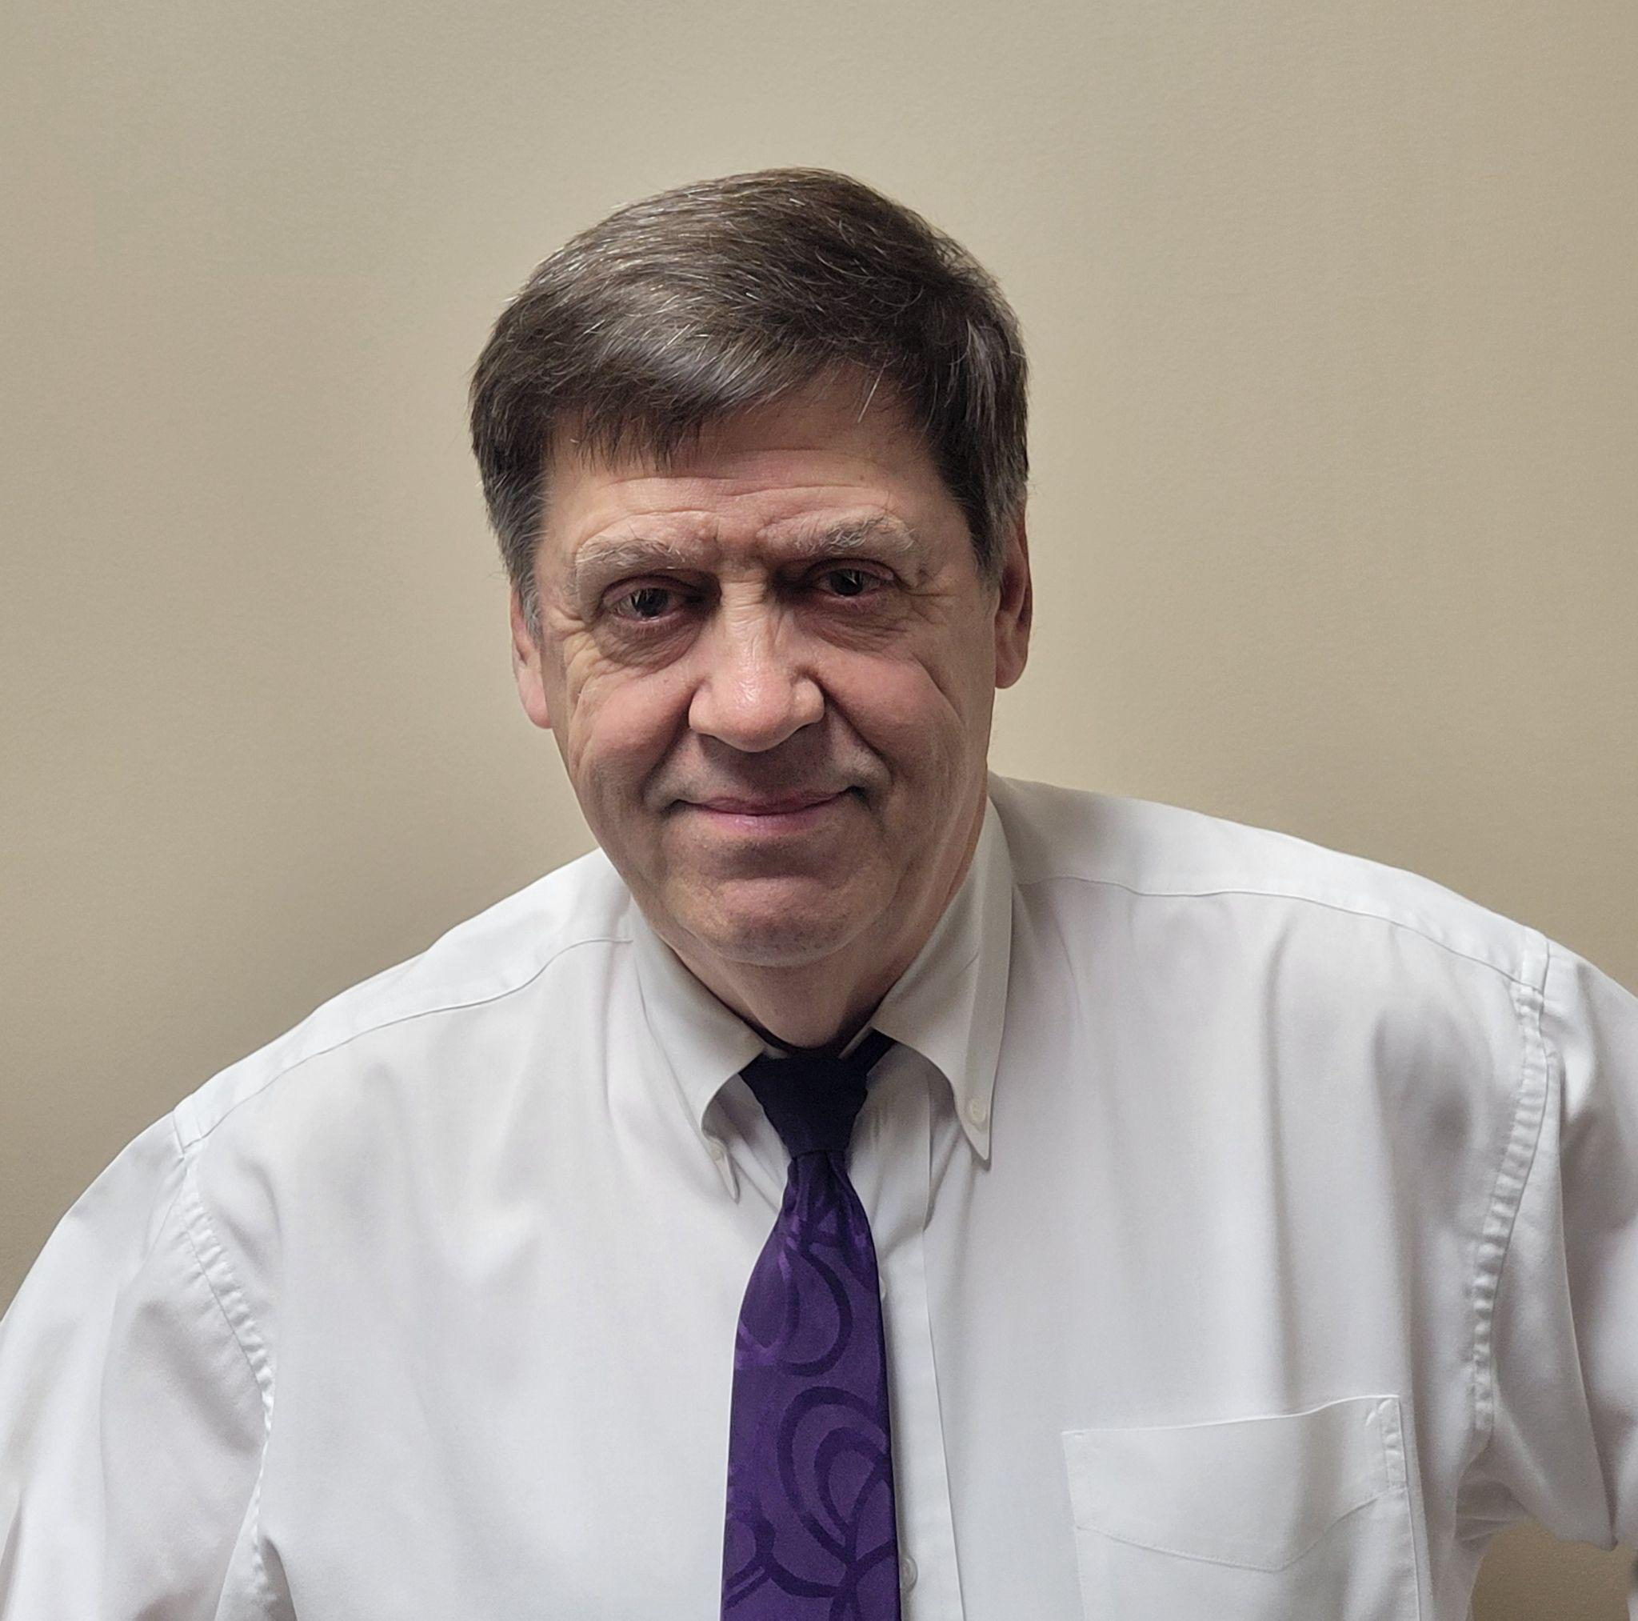

Greg Day, Associate Professor of Music
B.M. in Music Education, Furman University; M.M. in
Music Education, University of Southern
Mississippi (joined SWU faculty in 2000).
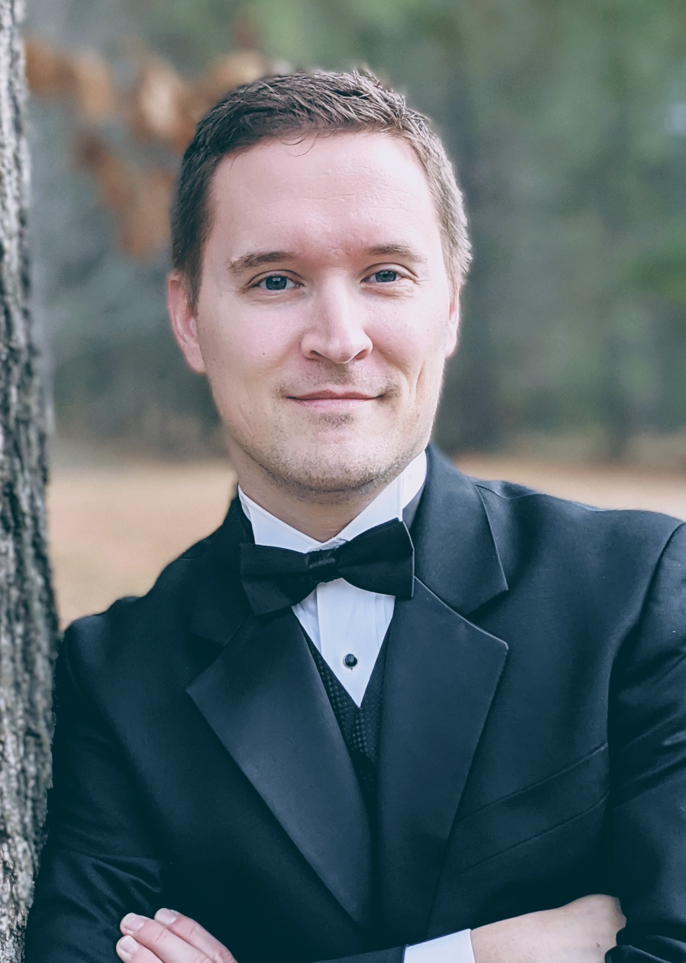

Samuel Miller, Assistant Professor of Music
B.M.Ed, Valdosta State University; M.M.Ed, University of Georgia; M.M. in Choral Conducting, Mercer University; D.M.A. in Choral Conducting, University of Kentucky (joined SWU faculty in 2023).

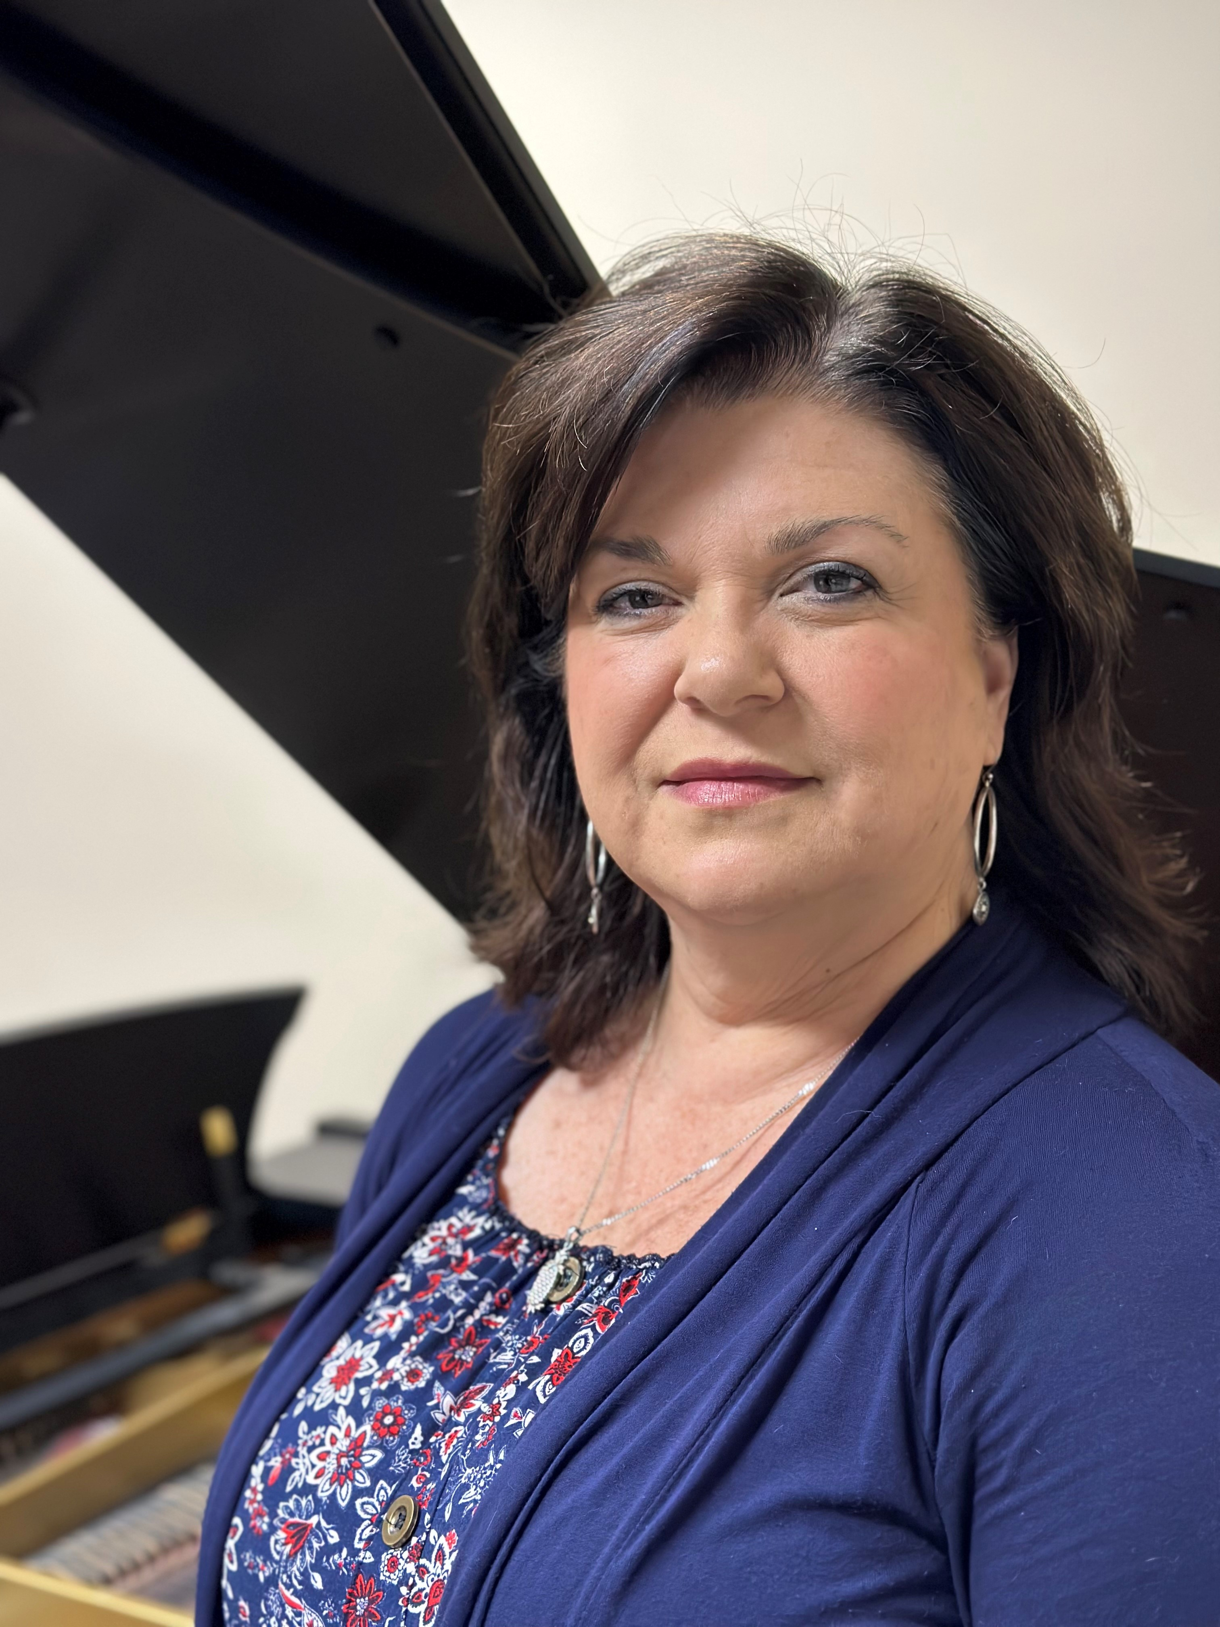

Lori Shelton, Assistant Professor of Piano and Collaborative University Pianist
B.M. in Piano Performance, University of Kentucky; M.M. in Piano Pedagogy, University of South Carolina; PhD candidate in Christian Worship, Liberty University (joined SWU faculty in 2017).

ADJUNCT MUSIC FACULTY

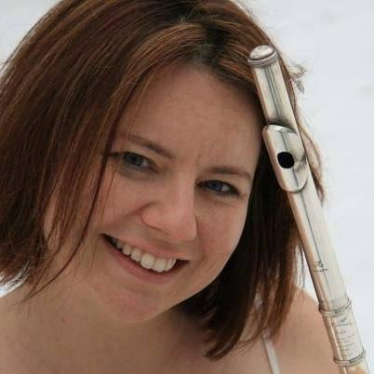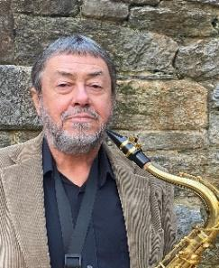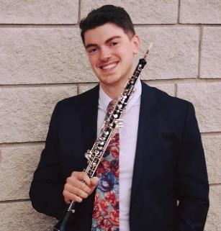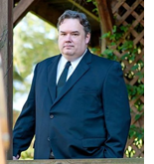
Rebecca Ashe Paul Buyer Bruce Caldwell Daniel Ellis Art Haecker
Flute, Music and Art Percussion Saxophone Oboe Low Brass
Appreciation
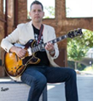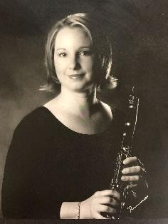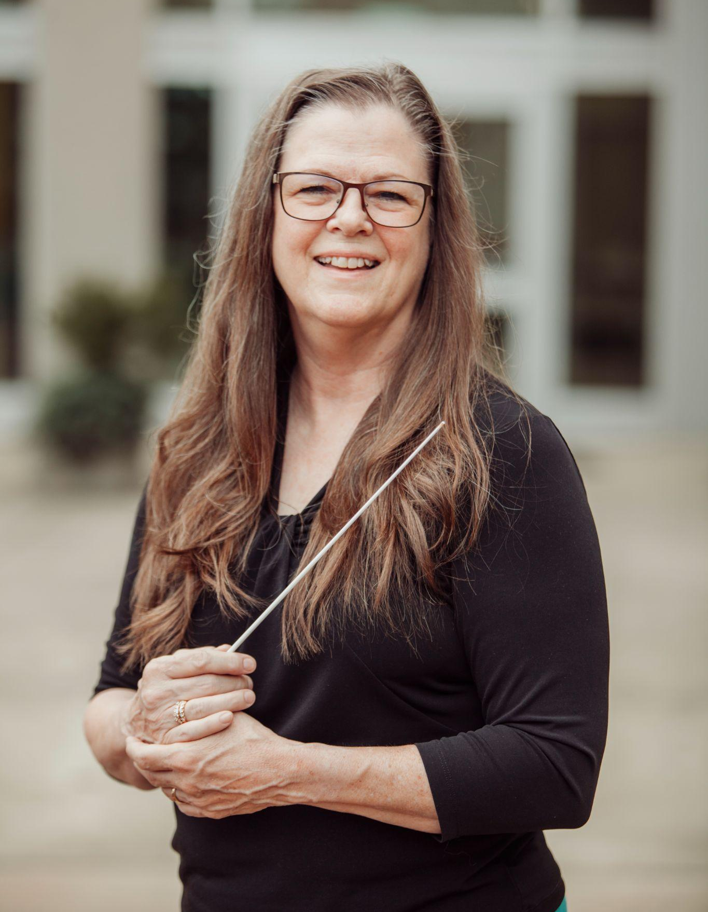
Heather Haithcock Adam Knight Laurie Parsons Désirée Werth Kathy Perry
Voice Guitar Horn Clarinet Artist-in-Residence
Strings

FACILITIES

The SWU Department of Music is housed in the Newton Hobson Chapel and Fine Arts Center, which is equipped with an auditorium, studios, classrooms, practice rooms, a computer room, ensemble rehearsal hall, recording studio, and piano lab. This building is open every day during normal operating hours and locked on nights and weekends. SWU music students will be able to gain access to Newton Hobson after hours by scanning their SWU ID cards in the card reader on the side door nearest the amphitheater. Everyone is expected to help maintain the appearance of music facilities. Personal belongings and student instruments should not be left unattended in classroom or practice areas; this space is needed for other equipment and activities. Neither the music faculty nor officials of the university will assume responsibility for damaged, lost, or stolen equipment or other personal belongings.
ORGANIZATIONS

NAfME: NAfME: The National Association for Music Education is the leading organization for music educators. Membership is encouraged for those desiring to become music teachers in a public or private school.

ACDA: ACDA: Student membership is available in the American Choral Directors Association. Those students with interest in this area are urged to join.

AUDITION OPPORTUNITIES
NATS: CLASSICAL SINGER: Each year, voice students with exceptional abilities may be
selected by voice instructors to audition for the Classical Singer Voice Competition.
SCMTNA: Students are encouraged to participate in auditions and/or regular meetings
of the South Carolina Music Teachers Association.

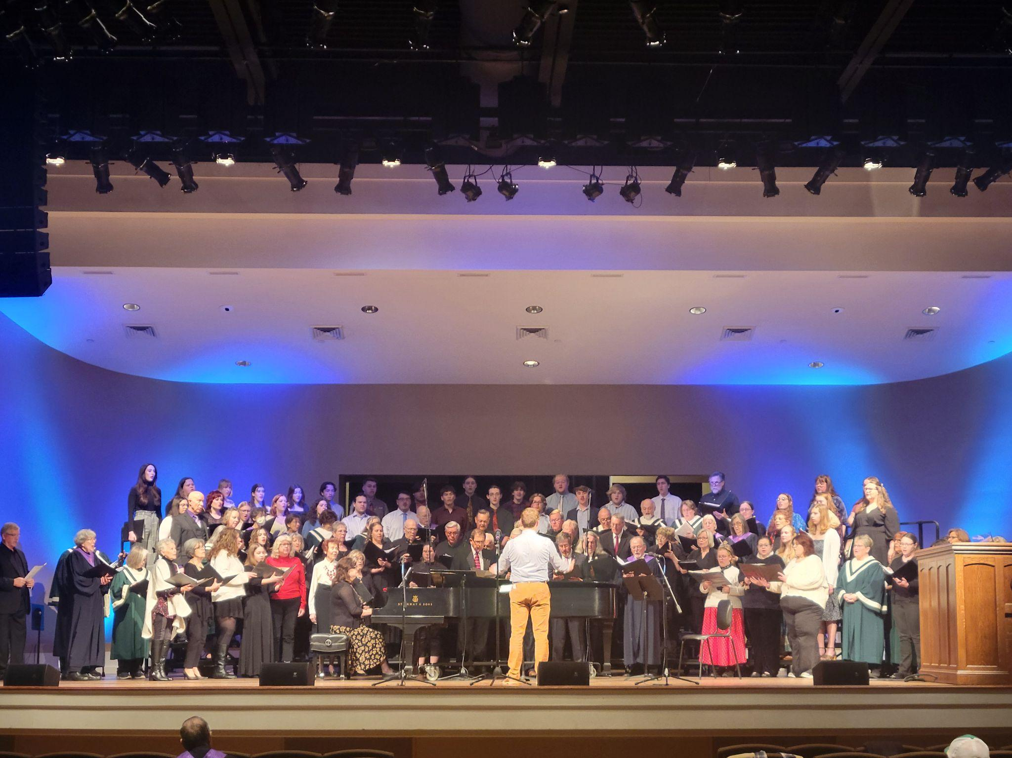

AUDITIONS—SWU MUSIC DEPARTMENT

All prospective music majors are required to audition for acceptance into the Music Department.
The audition is an opportunity to present studies or compositions that best represent a student’s performance capabilities. Additionally, all freshman music students will take a theory placement exam on the first day of class during Musicianship I. You must meet the minimum score required to stay enrolled in the class. If not, you will be removed from the class and enrolled in Music Fundamentals the following spring semester.

The following are guidelines for selecting audition material:

PIANO

Each prospective student should prepare two compositions in contrasting styles. Choose at least one composition from standard classical literature. At least one composition should be performed from memory. Sight-reading is also required. Following your formal audition, you will meet with Dr. Miller, the Director of Choral Activities, for choir placement.

VOICE

Each prospective student should prepare two songs in contrasting styles. Choose at least one selection from classical literature (All-State, Solo/Ensemble lists will provide a guideline). Both selections should be memorized. If possible, one song should be in a foreign language (Italian, French, German, Spanish, or Latin). Please bring your own accompanist or sheet music for our staff accompanist. Following your formal audition, you will meet with Dr. Miller, the Director of Choral Activities, for choir placement.

WIND, PERCUSSION AND STRINGS (including GUITAR)

Each prospective student should prepare two selections in contrasting styles. Play major scales preferably at the All-State Senior Band level, but at a minimum one octave. Play a chromatic scale over the entire working register of your instrument. Please bring your own accompanist or sheet music for our staff accompanist. Be prepared to sight read at least two selections. Following your formal audition, you will meet with Dr. Miller, the Director of Choral Activities, for choir placement.

FINE ARTS SCHOLARSHIPS

MUSIC ENSEMBLE SCHOLARSHIPS

The Division of Fine Arts supervises the awarding of scholarships to students based on their ability to participate in music ensembles at Southern Wesleyan University. Music majors and non-music majors are eligible for this scholarship. To learn more about the scholarship, please complete the form found at https://www.swu.edu/academics/division-of-fine-arts/fine-arts-scholarships/.

MUSIC MAJOR SCHOLARSHIPS

A music major who receives a high rating following an entrance audition will be eligible to receive a Phillippe Young Artist Award. It may be renewed annually based upon the following requirements:
- Maintain a minimum overall GPA of 2.0;
- Maintain a 2.5 GPA in all music courses;
- Acceptable progress and continuing enrollment in applied lessons;
- Enrollment as a full-time student in music each semester (minimum 12 semester hours);
- Enrollment and participation each semester in an appropriate ensemble (choir, wind ensemble, or jazz ensemble).

The music faculty will review the transcript of each recipient at the end of the school year to determine whether or not the award will be renewed.

If a student enters SWU as a Music Major, is awarded scholarship money, and later decides to change his/her major, the scholarship will be adjusted.

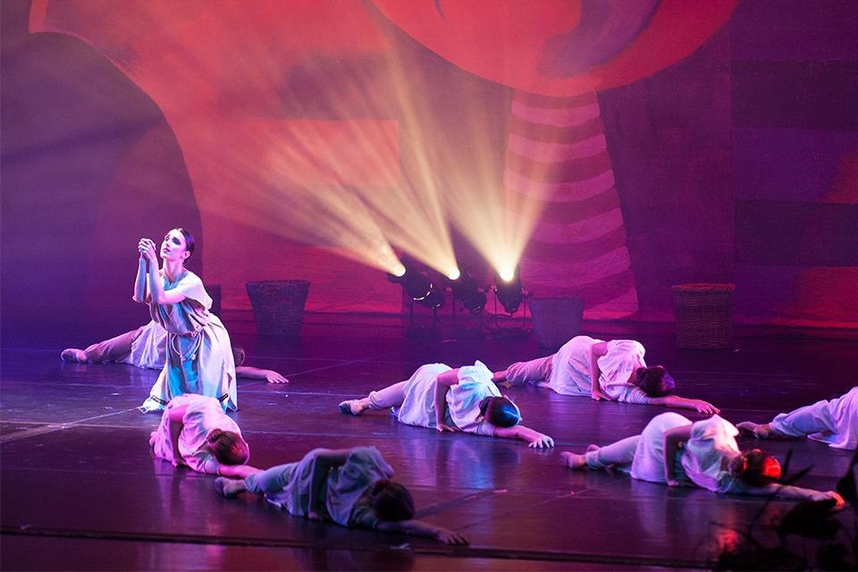

FULL-TIME MUSIC MAJOR COURSE REQUIREMENTS

A full-time music major at Southern Wesleyan is one who takes a minimum of 12 hours per semester and follows the sequence of core music courses as presented in the Music Department Handbook. Sequentially-oriented courses include Musicianship (Theory and Aural Fundamentals), Class Piano, Music Literature, and Music History. Until the student has performed in a senior recital, the full-time music major must take an applied major course of study each semester. Enrollment in either Concert Choir or an instrumental ensemble is also required per semester—each student must be in the ensemble that corresponds to their respective applied major as directed by the student’s advisor.

ENSEMBLE REQUIREMENTS

Ensemble participation is an important part of all music degree programs. At SWU, the music student has an opportunity to experience a wide range of standard ensemble literature. Each music major is required to enroll in Concert Choir or Wind Ensemble each semester of study. Music education students will also be required to participate in various small ensembles. Music minors are encouraged to participate in an ensemble each semester of study. Students auditing ensembles must fulfill syllabus and attendance requirements in order for an audit to appear on the transcript.

CAMPUS ENSEMBLES

CONCERT CHOIR

The Concert Choir is a required ensemble for vocal music majors. Membership will be selected by audition. Representative choral literature from each stylistic period, in addition to major choral works, will be rehearsed for touring and public performances.

WIND ENSEMBLE

The Wind Ensemble is open to all Southern Wesleyan students and is a required ensemble for all wind and percussion music majors. Membership will be selected by audition. The ensemble will meet two times per week. Representative literature from each stylistic period will be rehearsed for touring and public performances.

JAZZ ENSEMBLE

Membership for the jazz ensemble will be selected by audition. To enroll in jazz ensemble, all wind and percussion players will need to be registered for wind ensemble. This ensemble rehearses two times per week and performs a variety of literature in the jazz idiom. A significant campus outreach, the jazz ensemble performs in churches, schools, and at local events.

STRING ENSEMBLE

The String Ensemble is open to students with experience in string performance and based on an audition. The ensemble will play a variety of literature and perform for events such as Lessons and Carols and the Chamber Concert.

CHAMBER ENSEMBLES

The Music Department offers area-specific chamber ensembles that are mostly student-led and perform once a semester in a recital. The ensembles include vocal, brass, woodwind, percussion, and Bluegrass.

RECITAL ATTENDANCE

Music students should be acquainted with repertories beyond their area of specialization. Exposure to the large and varied body of music takes place through study and attendance at recitals, concerts, musical theatre productions, and other performances.

Music majors are required (minors are encouraged) to attend all concerts and recitals sponsored by the music department and/or Fine Arts Series. Unexcused absences from these events, including Recital Hour, will result in a lowering of the grade in the student’s applied major instrument. Students are also encouraged to attend off-campus cultural events as well. Notice of area concerts and other arts events will be posted on the bulletin boards in the lower level hallways of the Newton Hobson Chapel and Fine Arts Center.

RECITAL ETIQUETTE

Audiences at student, guest, ensemble, and faculty recitals are expected to behave in a cordial and mature manner. One should not enter the recital area after the program has begun until applause is heard between selections. Be aware that applause is not appropriate between movements of sonatas, cycles, or suites. Talking and whispering during a recital or yelling during applause is inappropriate behavior in an academic setting. Text messaging is inappropriate for this venue. Standing ovations are generally not acceptable for student and faculty recitals. Considerate behavior is appreciated by the performers and is the mark of a mature musician.

Formal student recitals, faculty recitals, and cultural arts programs should be given respect and appreciation through appropriate dress, including business-style dress for men and women (no blue jeans and/or flip-flops, please).

APPLIED MUSIC JURIES AND EVALUATIONS

All music majors are required to have an applied major and an applied minor. Recitals for freshman, sophomores and juniors will not constitute a substitute for the semester jury. Only one instrument of concentration is required for minors. A juried examination is held in the applied major at the end of each semester. However, the faculty may call for a jury with a two-day notice should they suspect a student in need of additional evaluation. Students may request a jury at any point in the semester for consideration of advancement in their applied standing. A minor is not required to take a jury unless requested by the respective applied instructor. Students should consult with their teachers concerning all jury arrangements.

FRESHMAN AND SOPHOMORE EVALUATION

Each music major will meet with the music faculty at the end of their freshman AND sophomore year of study. These meetings will be scheduled during exam week and discussion will cover the following items:
1. general application of learned skills
2. progress in applied major
3. practice habits
4. technical concepts to literature
5. level of achievement in relationship to standards required of the degree
6. overall standing in the music curriculum
7. procedures to be followed to bring work up to acceptable standards.

SENIOR RECITAL

RECITAL DATE – A recital date must be established in consultation with the respective private teacher and accompanist. This date must then be cleared with the Music Department Secretary and placed on the SWU master calendar.

PROCEDURE – A pre-recital hearing for the senior recital will be held approximately four weeks before the scheduled recital date. A student who feels unprepared should submit a written petition to the music faculty for a second hearing to be scheduled no later than two weeks before the recital date. A student who does not pass the four-week pre-recital hearing has the option of petitioning the music faculty for a second hearing that shall occur no later than two weeks prior to the scheduled recital. No additional hearing will be scheduled. An unsuccessful hearing that occurs two weeks before a scheduled recital date will result in the rescheduling of a new recital date in the following semester.

ALL RECITALS AND HEARINGS should be completed before the last two weeks of school (unless the music faculty approves differently). If a student is planning a recital for three weeks before the end of the semester, he/she must plan the hearing seven weeks before the end of the semester. Scheduling will be cleared by Dr. James in coordination with the school master calendar. For the music education major, it is preferred for the senior recital to take place the semester before student teaching. If this is not possible, the student is responsible for notifying the music faculty and student teaching coordinator in the Education department.

INVITATIONS – Written invitations to senior recitals are acceptable and appropriate but may be mailed only after successful completion of the pre-recital hearing.

PROGRAMS – The printed recital program is the responsibility of the student. The correct program copy must be delivered to the applied music professor for approval immediately after the hearing is passed. The composer’s dates of birth and death as well as first and last names must be included. Songs in a foreign language must be translated and incorporate appropriate symbols (e.g., accents) where necessary. The completed program must be submitted to and approved by the Music Department Coordinator at least three (3) weeks prior to the recital for printing.

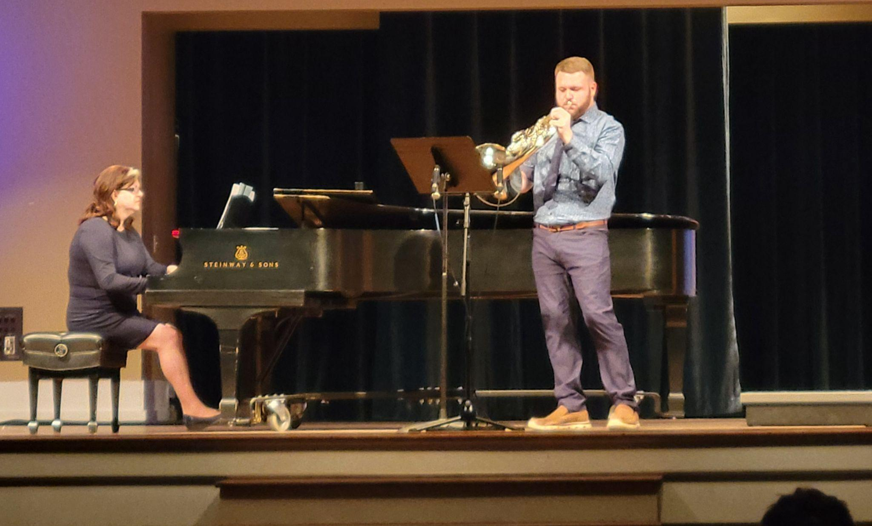

ELEMENTS OF THE SENIOR RECITAL

I. COMPLETE PREPARATION
A. Correct notes and rhythm
B. Dynamic shadings and phrasings
C. Correct technical approach to the work
D. Effective ensemble with the accompanist
E. Singers—correct diction

II. TOTAL UNDERSTANDING OF CONTENT
A. The text must be understood and have personal meaning.
B. The basic musical elements need to be absorbed and utilized.
C. Technique needs to be established so the performer is free of constantly “thinking technique.”
D The style of the period must also be evident.

III. INTERPRETATION AND COMMUNICATION
A. The performer must interpret literature:
1. in a style and manner appropriate to the period of its composition;
2. with expressiveness that communicates itself to the listener;
3. with understanding of the text (even in other languages) so the
central meaning of it is made clear through dramatic as well as musical expression.
B. If students have mastered points one and two above, they will be “free” to polish or refine the program and to ENJOY. In doing so, they cause their audience to enjoy the performance.

The senior recital is a culmination of four years of applied study synthesizing many aspects from many subject areas. It should reflect many of the understandings, skills, and attitudes that were acquired and developed in liberal arts and professional courses within the student’s major.

There are other culminating activities for music majors. In addition to a senior recital, the music education major will be involved in directed teaching and a practicum, respectively.

SENIOR RECITAL CHECKLIST

______Select a date for the hearing/recital with your applied teacher. Check the date with
the Music Department Secretary and your accompanist.

______Reserve the recital date through Conference Services for NH auditorium, ALIVE
Chapel, and/or the NH rehearsal hall; all rehearsals must also be cleared through
Conference Services.

______If planning for a reception on campus, check with Conference Services about
location, tables, and other needs.

______Check with your applied teacher concerning appropriate attire.

______Turn in program notes at the senior recital hearing to the applied teacher.

______Three (3) weeks before the recital—turn in all program material (program, program
notes, translations, acknowledgements, information about reception, etc.) to the Music Department Coordinator.

______One week before the recital—speak with the Head Sound Technician concerning
sound and lighting.

______Ask two friends to hand out programs, appropriately dressing well for the occasion.

______Check with the Music Department Coordinator about the recital introduction and prayer.

______A gift or other expression of thanks should be given to the teacher and accompanist.

______Secure a page turner for the accompanist during the hearing and recital.

STUDENT RECITALS – ADDITIONAL SUGGESTIONS and CONSIDERATIONS

1. Recital attire must reflect the standards of the university and will be discussed periodically during recital hours, seminars and applied lessons.

2. There will be no freshman, sophomore, or junior recitals on campus nor listed on the Music Department calendar.

3. All students are to present senior recitals in a joint format with 30 minutes per student, unless a petition to perform a one-hour solo recital is approved by the music faculty. A petition form, given on the next page, provides the policy with respect to the Senior Solo Full Recital.

4. Senior recitalists must perform only the music that was approved at the senior recital hearing.


Music Department
Request to Perform a Senior Solo Full Recital

The following student requests permission to perform a Senior Solo Full Recital:

Name:_________________________________________ Instrument:_______________________

Applied Level: ____________________ Semester Recital is to be given:_____________________

Signature of Student _____________________________________________ Date_____________

Signature of Applied Teacher ______________________________________ Date_____________

Please attach the following:
- A list of the probable/possible literature
- A copy of your unofficial transcript
- A letter stating your reason for requesting a full recital

Recommended action by the faculty __________________________________________________________________________

__________________________________________________________________________

Date of Recommendation _____________________________________________________

Senior Solo Full Recital Policy

- SWU music department policy is that all music students must give a joint recital as part of their graduation requirements. This is to maximize resources and budget the time of students and faculty.
- Students who want to be considered for a full, solo recital must petition the music faculty.
- The student must have this petition form completed and given to the Music Department Coordinator by the sixth week of the semester prior to the semester of the proposed recital.
- Approval for or denial of the full, solo recital will be returned to the student within the next two weeks after the petition form is submitted.
- Students who request to do a full, solo recital must:
- show exceptional promise as performers;
- have the desire to pursue a graduate performance degree;
- have shown diligence and professionalism in their undergraduate careers;
- have the full support from their teachers and a majority of support from the faculty.

PIANO PROFICIENCY EXAM

All music majors (vocal and instrumental) are required to pass a Piano Proficiency Examination, preferably during the sophomore year. These skills should be gained during the required hours of piano for each degree program. All vocal and instrumental (non-piano) majors will take the non-major levels of piano each semester until this requirement is met. This policy may require students to register for more than the number of hours of piano required for their major, depending upon their application of consistent practice and commitment to developing their skills. The proficiency exams are usually given during exam week at the end of each semester.

The Piano Proficiency Examination will be heard by the music faculty and will include the following as requested by the faculty panel:
  - Harmonization of a melody from a current music series using basic chords
(I, IV, V). This process involves the principle of improvisation.
2. Playing of America and The Star-Spangled Banner or chorales (hymns)
of similar difficulty.
3. Playing both major and minor scales, one octave, hands together.
4. Transposing of I-IV-V-I cadences into all major and minor keys.
5. Sight reading a vocal or instrumental accompaniment or a four-part chorale selected by the faculty.
6. Performance of one piece prepared by the student under the direction of a faculty
member.

CLASS PIANO LEVELS

MUSC 1411 Class Piano Level I
A lab course in piano designed to provide elementary-level students with fundamental skills in note-reading, technical studies, and theoretical concepts.

MUSC 1421 Class Piano Level II
A lab course in piano designed to resume elementary-level study began in MUSC 1411. Prerequisite: MUSC 1411 or qualifying audition.

MUSC 1431 Class Piano Level III
A lab course in piano designed to provide intermediate-level students with fundamental skills in note-reading, technical studies, and theoretical concepts. Students are also prepared for the keyboard proficiency examination. Intermediate level literature and hymns are included. Prerequisite: MUSC 1421 or qualifying audition.

MUSC 1441 Class Piano Level IV
A lab course in piano designed to resume study carried out in MUSC 1431. Students are also prepared for the keyboard proficiency examination.
Prerequisite: MUSC 1431 or qualifying audition.

MUSC 1451 Class Piano Level V
A lab course in piano designed to resume study carried out in MUSC 1441. Students continue to prepare for the keyboard proficiency examination. Appropriate levels of literature and hymns are also included. Prerequisite: MUSC 1441 or qualifying audition.

NON-MAJOR LEVELS OF PRIVATE INSTRUCTION

MUSC 1630 Non-major Applied Voice (hours to be determined)
Designed for the student whose level of vocal ability does not meet entering standards for MUSC 115 but whose potential merits a private lesson. There is no required performance on a recital or jury unless requested by the instructor. Basics of vocal technique and diction are studied in elementary literature. This level may not count toward graduation for the voice major.

MUSC 1640 Non-major Applied Piano (hours to be determined)
Private piano studies are designed for music majors wishing to receive piano proficiency level and for non-music majors whose level of ability does not permit them to enter MUSC 111, but whose potential merits a private lesson. There is no required performance on a recital or jury unless requested by the instructor. This level may not count toward graduation for the piano major.

MUSC 1650 Non-Major Applied Organ
Private study for music or non-music majors whose level of ability does not permit them to enter MUSC 113. Students are not required to perform on a recital or jury unless requested by the instructor. This level may not count toward graduation for the organ major.

MUSC 1660 Non-Major Applied Woodwinds
Private study for music or non-music majors whose level of ability does not permit them to enter MUSC 161. No performance on a recital or jury unless requested by the instructor. This level may not count toward graduation for the woodwinds major.

MUSC 1670 Non-Major Applied Brass
Private study for music or non-music majors whose level of ability does not permit them to enter MUSC 171. No performance on a recital or jury unless requested by the instructor. This level may not count toward graduation for the brass major.

MUSC 1680 Non-Major Applied Percussion
Private study for music or non-music majors whose level of ability does not permit them to enter MUSC 181. No performance on a recital or jury unless requested by the instructor. This level may not count toward graduation for the percussion major.

MUSC 1690 Non-Major Applied Strings
Private study for music or non-music majors whose level of ability does not permit them to enter MUSC 191. No performance on a recital or jury unless requested by the instructor. This level may not count toward graduation for the strings major.

SPECIAL INFORMATION

Protecting Your Hearing Health
A NASM – PAMA
Student Information Sheet

- Hearing health is essential to your lifelong success as a musician.

- Your hearing can be permanently damaged by loud sounds, including music. Technically, this is called Noise-Induced Hearing Loss (NIHL). Such danger is constant.

- Noise-induced hearing loss is generally preventable. You must avoid overexposure to loud sounds, especially for long periods of time.

- The closer you are to the source of a loud sound, the greater the risk of damage to your hearing mechanisms.

- Sounds over 85 cB (your typical vacuum cleaner) in intensity pose the greatest risk to your hearing.

- Risk of hearing loss is based on a combination of sound or loudness intensity and duration.

- Recommended maximum daily exposure times ( NIOSH) to sounds at or above 85 dB are as follows:
- 85 dB (vacuum cleaner, MP3 player at 1/3 volume) – 8 hours
- 90 dB (blender, hair dryer) – 2 hours
- 94 dB (MP3 player ½ volume) – 1 hour
- 100 dB (MP3 player at full volume, lawnmower) – 15 minutes
- 110 dB (rock concert, power tools) – 2 minutes
- 120 dB (jet planes at take-off) – without ear protection, sound damage is almost immediate

- Certain behaviors (controlling volume levels in practice and rehearsal, avoiding noisy environments, turning down the volume) reduce your risk of hearing loss. Be mindful of using MP3 earbuds in light of the MP3 information given above.

- The use of earplugs and earmuffs helps to protect your hearing health.

- Day-to-day decisions can affect your hearing health, both now and in the future. Since sound exposure occurs in and out of school, you also need to learn more and take care of your own hearing health on a daily, even hourly basis.
- It is important to follow basic hearing health guidelines.

- It is also important to study this issue and learn more.

- If you are concerned about your personal hearing health, talk with a medical professional.

- If you are concerned about your hearing health in relation to your program of study, consult the appropriate contact person at your institution.

- This information is provided by the National Association of Schools of Music (NASM) and the Performing Arts Medicine Association (PAMA). For more information, check out the other NASM – PAMA hearing health documents, located on the NASM website.
Protecting Your Hearing Health: Student Information sheet on Noise-Induced Hearing Loss NASM/PAMA: November 2011

Protecting Your Vocal Health
A NASM – PAMA
Student Information Sheet

- Vocal health is important for all musicians and essential to lifelong success for singers.

- Understanding basic care of the voice is essential for musicians who speak, sing, and rehearse or teach others.

- Practicing, rehearsing, and performing music is physically demanding.

- Musicians are susceptible to numerous vocal disorders.

- Many vocal disorders and conditions are preventable and/or treatable.

- Sufficient warm-up time is important.

- Begin warming up mid-range, and then slowly work outward to vocal pitch extremes.

- Proper alignment, adequate breath support, and correct physical technique are essential.

- Regular breaks during practice and rehearsal are vital to prevent undue physical or vocal stress and strain.

- It is important to set a reasonable limit on the amount of time you will practice in a day.

- Avoid sudden increases in practice times.

- Know your voice and its limits, and avoid overdoing it or misusing it.

- Maintain health habits. Safeguard your physical and mental health.

- Drink plenty of water to keep your vocal folds adequately lubricated. Limit your use of alcohol, and avoid smoking.

- Day-to-day decisions can impact your vocal health, both now and in the future. Because vocal strain and a myriad of other injuries can occur in and out of school, you also need to learn more and take care of your own vocal health on a daily basis. Avoid shouting, screaming, or other strenuous vocal use.

- If you are concerned about your personal vocal health, talk with a medical professional.

- If you are concerned about your vocal health in relation to your program of study, consult the appropriate contact person at your institution.

- This information is provided by the National Association of Schools of Music (NASM) and the Performing Arts Medicine Association (PAMA). For more information, check out the other NASM-PAMA neuromusculoskeletal health documents, located on the NASM website.

- See also the NASM/PAMA Student Information Sheet on “Protecting Your Neuromusculoskeletal Health.” Vocal health is an aspect of neuromusculoskeletal health.

Protecting Your Neuromusculoskeletal Health
A NASM – PAMA
Student Information Sheet
- Neuromusculoskeletal health is essential to your lifelong success as a musician.

- Practicing and performing music is physically demanding.

- Musicians are susceptible to numerous neuromusculoskeletal disorders.

- Some musculoskeletal disorders are related to behavior; others are genetic; still others are the result of trauma or injury. Some genetic conditions can increase a person’s risk of developing certain behavior-related neuromusculoskeletal disorders.

- Many neuromusculoskeletal disorders and conditions are preventable and/or treatable.

- Sufficient physical and musical warm-up time is important.

- Proper body alignments and correct physical technique are essential

- Regular breaks during practice and rehearsal are vital in order to prevent undue physical stress and strain.

- It is important to set a reasonable limit on the amount of time that you will practice in a day.

- Avoid sudden increases in practice times.

- Know your body and its limits and avoid “overdoing” it.

- Maintain healthy habits. Safeguard your physical and mental health.

- Day-to-day decisions can affect your neuromusculoskeletal health, both now and in the future. Because muscle and joint strains and a myriad of other injuries can occur in and out of school, you also need to learn more and take care of your own neuromusculoskeletal health on a daily basis, particularly with regard to your performing medium and area of specialization.

- If you are concerned about your personal neuromusculoskeletal health in relation to your program of study, consult the appropriate contact person at your institution.

- This information is provided by the National Association of Schools of Music (NASM) and the Performing Arts Medicine Association (PAMA). For more information, check out the other NASM-PAMA neuromusculoskeletal health documents located on the NASM website.

- See also the NASM/PAMA Student Information Sheet on “Protecting Your Vocal Health.” Vocal health is an aspect of neuromusculoskeletal health.

ADDITIONAL INFORMATION FOR DEPARTMENT OF MUSIC

BULLETIN BOARD
All major announcements such as concert and recital information, class announcements, and time changes will be posted on the main bulletin board in the lower level of the Newton Hobson Chapel and Fine Arts Center. All students should check this board each day for information that may concern them.

DIVISION CHAPELS
Fine Arts Division chapels occur one to two times per semester and will help the student understand basic interrelationships among the various professions and activities that make up the musical enterprise. They will also serve to spiritually enrich the student from a musical perspective.

LOCKERS
Each instrumental music student will be assigned a locker and lock after the music major/minor meeting held at the beginning of the fall semester. Locks are to be used only on the student’s assigned locker located in the lower level hallway of the Newton Hobson Chapel and Fine Arts Center. Additional lockers, if available, may be assigned to students on a seniority-level basis for materials such as music and textbooks. If you use a lock other than a SWU-issued lock, you must give the combination or a key to Mr. Day. Previous years’ locker assignment will continue into subsequent years.

SENIOR EXIT INTERVIEW
This interview takes place immediately prior to graduation. Music faculty will consult the student in areas such as strengths and weaknesses in the SWU curriculum and will discuss issues in regard to the student’s spiritual and professional development.

ON-STAGE PERFORMANCE GRAND PIANO
The nine-foot Steinway Artist Series Concert Grand Piano in the auditorium of Newton Hobson is to be used by a music faculty member, staff accompanist, or with permission from a music faculty member. The piano is used primarily for chapel, recital hour, student recitals, and fine arts events. When not in use, the piano will remain locked and covered at all times. Anyone desiring to use the piano should contact the Music Department Coordinator to schedule a rehearsal.

ACCOMPANYING
The art of accompanying is acquired only through experience. Upon recommendation of Professor Shelton, piano majors may accompany one or more vocal or instrumental students each semester.

OFF-CAMPUS REPRESENTATION
Any student who is asked to represent SWU in an off-campus event should work with his or her applied music instructor beforehand.

STUDY-PRACTICE HABITS
In choosing music as your major, you have selected a challenge that can be both exhilarating and demanding. You must develop a regular schedule for study and practice. Your major is much more time-consuming than many others and will require you to discipline yourself. You are expected to practice one hour daily per credit hour. These habits are necessary if you are to develop maturity as a musician.

RECITAL HOUR/SEMINAR
This activity is required of all music majors and minors registered for instrumental, piano or vocal instruction. Recital Hour takes place every Wednesday at 2:00 p.m. The event is divided into two opportunities that alternate Wednesdays. “Recital Hour” is when the whole Music Department meets together and students selected by the applied teachers perform. “Seminar” is when the individual areas (voice, winds, strings, piano) meet separately and perform for each other with attention to correcting specific problems. Students will have opportunities to assess performances in both combined and area-specific venues.

E-MAIL
Students should check SWU email at least as often as you eat!

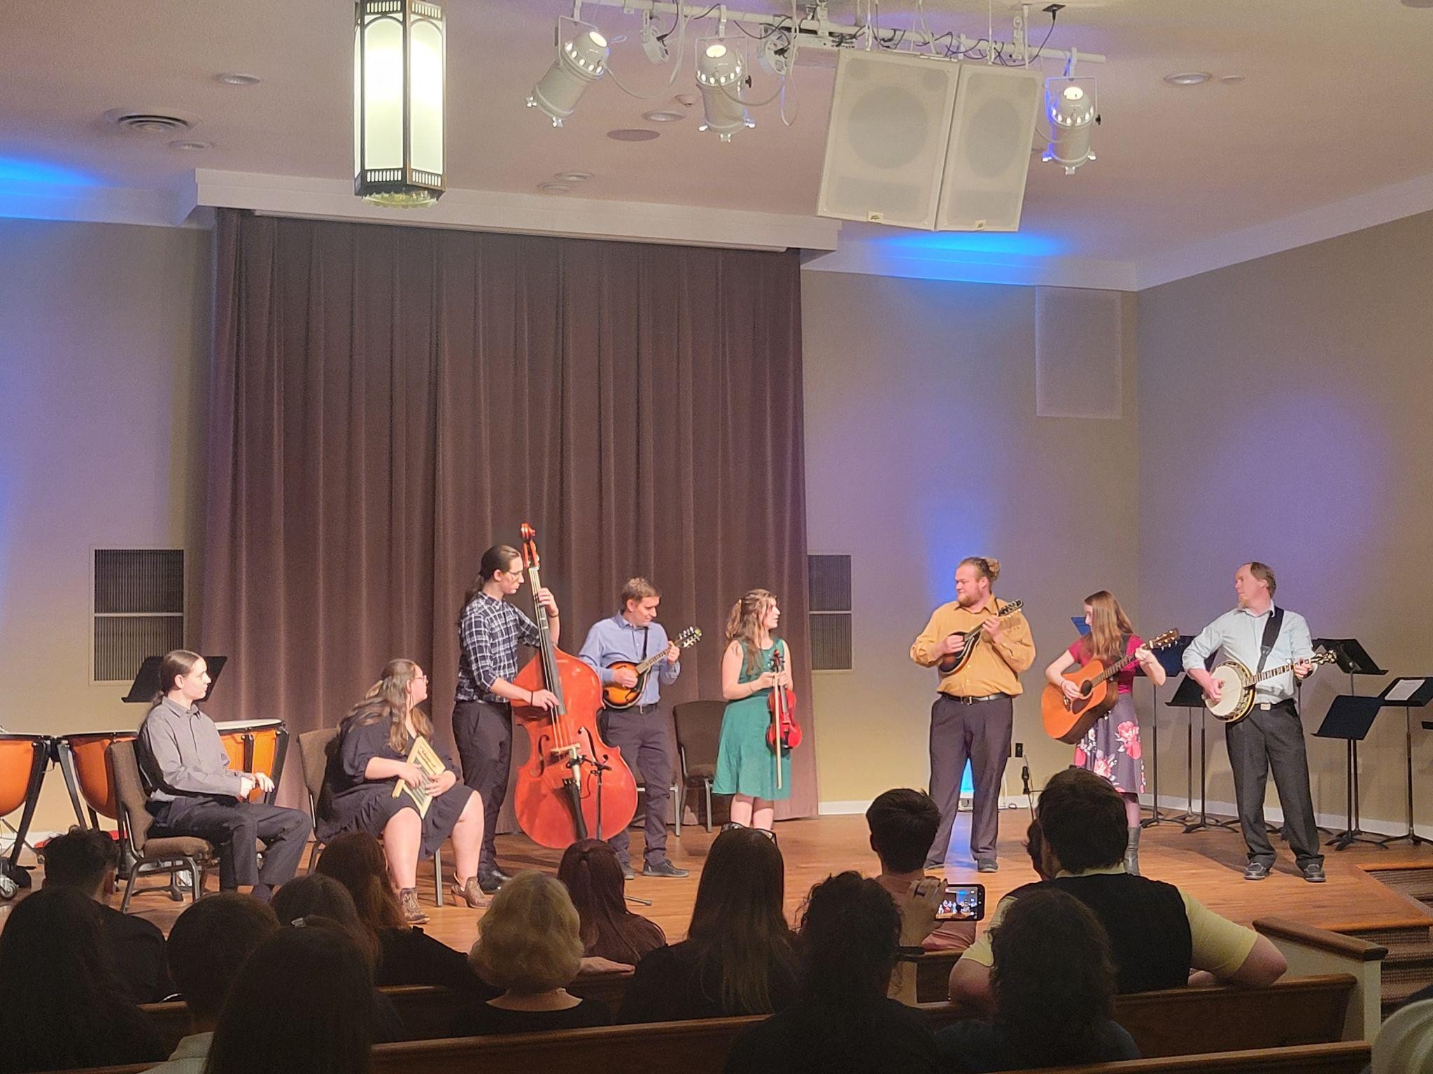

CURRICULUM

Each student should maintain a checklist of courses to be taken and courses completed. Each student and advisor should agree on courses required and completed. Advisors and advisees should look ahead at the SWU schedule to be aware of courses that are only offered every other semester, year, or bi-yearly. It is the student’s responsibility to make sure they are successfully taking required courses needed for graduation.

The Department of Music offers a B.A. degree in Music or Music Education.

MUSIC B.A. REQUIREMENTS

Major Courses (Core Curriculum) Hours
MUSC 1033 Musicianship I 3
MUSC 1043 Musicianship II 3
MUSC 2033 Musicianship III 3
MUSC 2043 Musicianship IV 3
MUSC 3052 Basic Conducting 2
MUSC 4062 Orchestration 2
MUSC 2073 History of Western Music I 3
MUSC 3083 History of Western Music II 3
MUSC 4093 History of Western Music III 3
MUSC 4352 Vocal Pedagogy (vocalists) 2
or
Instrumental Methods
(instrumentalists take two courses from the following options)
MUSC 2211 String Methods 1
MUSC 2241 Woodwinds Methods 1
MUSC 2251 Brass Methods 1
MUSC 2261 Percussion Methods 1
MUSC Private Voice/Instrument* 13
MUSC Applied Minor 4
MUSC Ensemble 8
30-Minute Recital in Applied Major (Senior Year)
Piano Proficiency
Total = 52
*Includes Recital Hour; vocal majors will also take 4 semesters of Diction Lab.
**Twenty-eight hours in electives are also required to receive the B.A. in music.

B.A. in MUSIC – VOCAL
***Suggested Curriculum Guide***

FRESHMAN YEAR
FIRST SEMESTER |  |  |  |  | SECOND SEMESTER
CPSC | 110 | 3 | Intro. to Computers w/Lab |  | BIBL | 101 | 3 | Old Testament
ENGL | 100 | 3 | Freshman English I |  | ENGL | 101 | 3 | Freshman English II
SEMR | 232 | 3 | Foundations of Success |  | MATH | 105 | 3 | Quantitative Reasoning
MUSC | 103 | 3 | Musicianship I |  | MUSC | 104 | 3 | Musicianship II
MUSC | 115 | 1 | Applied Major |  | MUSC | 116 | 1 | Applied Major
MUSC | 124 | L | Diction Lab |  | MUSC | xxx | L | Applied Minor or Class Piano
MUSC | xxx | 1 | Applied Minor or Class Piano |  | MUSC | 124 | 1 | Diction Lab
MUSC | 151 | 1 | Concert Choir |  | MUSC | 151 | 1 | Concert Choir
MUSC | 134 | 1 | Chamber Vocal |  | MUSC | 134 | 1 | Chamber Vocal
 |  | 16 |  |  |  |  | 16
SOPHOMORE YEAR
FIRST SEMESTER |  |  |  |  | SECOND SEMESTER
ENGL | 210 | 3 | Speech Communication |  | XXXX | xxx | 3 | Elective
BIBL | 102 | 3 | New Testament |  | PSYC | 200 | 3 | Social Science
XXXX | xxx | 4 | Lab Science |  | MUSC | 204 | 3 | Musicianship IV
MUSC | 203 | 3 | Musicianship III |  | MUSC | 207 | 3 | History of Western Music I | Spring only
MUSC | 215 | 1 | Applied Major |  | MUSC | 216 | 2 | Applied Major
MUSC | 124 | L | Diction Lab |  | MUSC | 124 | L | Diction Lab
MUSC | xxx | 1 | Applied Minor or Class Piano |  | MUSC | xxx | 1 | Applied Minor or Class Piano
MUSC | 151 | 1 | Concert Choir |  | MUSC | 151 | 1 | Concert Choir
MUSC | 134 | 1 | Chamber Vocal |  | MUSC | 134 | 1 | Chamber Vocal
 |  | 17 |  |  |  |  | 17
JUNIOR YEAR
FIRST SEMESTER |  |  |  |  | SECOND SEMESTER
MUSC | 305 | 2 | Basic Conducting | Fall only | RELG | 240 | 3 | Basic Christian Beliefs
MUSC | 308 | 3 | History of Western Music II | Fall only | MUSC | 409 | 3 | History of Western Music III | Spring only
MUSC | 406 | 2 | Orchestration | Fall only | MUSC | 316 | 2 | Applied Major
MUSC | 151 | 1 | Concert Choir |  | MUSC | 151 | 1 | Concert Choir
MUSC | 315 | 2 | Applied Major |  | MUSC | 134 | 1 | Chamber Vocal
MUSC | 134 | 1 | Chamber Vocal |  | XXXX | xxx | 3 | Elective
XXXX | xxx | 3 | Elective |  | XXXX | xxx | 3 | Elective
MUSC | 435 | 2 | Vocal Pedagogy | Fall only
 |  | 64 |  |  |  |  | 16
SENIOR YEAR
FIRST SEMESTER |  |  |  |  | SECOND SEMESTER
XXXX | xxx | 3 | Elective |  | MUSC | 416 | 2 | Applied Major – Senior Recital
 |  |  |  |  | MUSC | 151 | 1 | Concert Choir
XXXX | xxx | 3 | Elective |  | MUSC | 134 | 1 | Chamber Vocal
MUSC | 415 | 2 | Applied Major |  | XXXX | xxx | 3 | Elective
MUSC | 151 | 1 | Concert Choir |  | XXXX | xxx | 3 | Elective
MUSC | 134 | 1 | Chamber Vocal |  | XXXX | xxx | 3 | Elective
XXXX | xxx | 3 | Elective |  | XXXX | xxx | 3 | Elective
 |  | 13 |  |  |  |  | 16
*See General Education course listings in SWU Bulletin for options |  |  |  |  |  |  | 127 | TOTAL CREDIT HOURS

B. A. in MUSIC – INSTRUMENTAL
***Suggested Curriculum Guide***
FRESHMAN YEAR
FIRST SEMESTER |  |  |  |  | SECOND SEMESTER
CPSC | 110 | 3 | Introduction to Computers w/Lab |  | BIBL | 101 | 3 | Old Testament
ENGL | 100 | 3 | Freshman English I |  | ENGL | 101 | 3 | Freshman English II
SEMR | 232 | 3 | Foundations for Success |  | MATH | 105 | 3 | Quantitative Reasoning
MUSC | 103 | 3 | Musicianship I |  | MUSC | 104 | 3 | Musicianship II
MUSC | xxx | 1 | Applied Major |  | MUSC | xxx | 1 | Applied Major
MUSC | xxx | 1 | Applied Minor or Class Piano |  | MUSC | xxx | 1 | Applied Minor or Class Piano
MUSC | 152 | 1 | Wind Ensemble |  | MUSC | 152 | 1 | Wind Ensemble
MUSC | xxx | 1 | Chamber |  | MUSC | xxx | 1 | Chamber
MUSC | 151 | 1 | Concert Choir |  | MUSC | 151 | 1 | Concert Choir
 |  | 17 |  |  |  |  | 17
SOPHOMORE YEAR
FIRST SEMESTER |  |  |  |  | SECOND SEMESTER
ENGL | 210 | 3 | Speech Communication |  | XXXX | xxx | 3 | Elective
BIBL | 102 | 3 | New Testament |  | PSYC | 200 | 3 | Social Science
XXXX | xxx | 4 | Lab Science |  | MUSC | 204 | 3 | Musicianship IV
MUSC | 203 | 3 | Musicianship III |  | MUSC | 207 | 3 | History of Western Music I | Spring only
MUSC | xxx | 1 | Applied Major |  | MUSC | xxx | 2 | Applied Major
MUSC | xxx | 1 | Applied Minor or Class Piano |  | MUSC | xxx | 1 | Applied Minor or Class Piano
MUSC | 152 | 1 | Wind Ensemble |  | MUSC | xxx | 1 | Chamber
XXXX | xxx | 1 | Chamber |  | MUSC | 152 | 1 | Wind Ensemble
 |  | 17 |  |  |  |  | 17
JUNIOR YEAR
FIRST SEMESTER |  |  |  |  | SECOND SEMESTER
MUSC | 305 | 2 | Basic Conducting | Fall only | RELG | 240 | 3 | Basic Christian Beliefs
MUSC | 308 | 2 | History of Western Music II | Fall only | MUSC | 409 | 3 | History of Western Music III | Spring only
MUSC | xxx | 2 | Applied Major |  | MUSC | xxx | 2 | Applied Major
MUSC | 152 | 1 | Wind Ensemble |  | MUSC | 152 | 1 | Wind Ensemble
MUSC | xxx | 1 | Chamber |  | XXXX | xxx | 3 | Elective
MUSC | 406 | 2 | Orchestration | Fall only | XXXX | xxx | 3 | Elective
XXXX | xxx | 3 | Elective |  | XXXX | xxx | 1 | Chamber
 |  | 13 |  |  |  |  | 16
SENIOR YEAR
FIRST SEMESTER |  |  |  |  | SECOND SEMESTER
XXXX | xxx | 3 | Elective |  | MUSC | xxx | 2 | Applied Major - Senior Recital
MUSC | 221/224 | 1 | *Strings or Woodwinds Methods | Fall only | MUSC | 152 | 1 | Wind Ensemble
XXXX | xxx | 3 | Elective |  | MUSC | 225/226 | 1 | *Brass or Percussion Methods | Spring only
MUSC | xxx | 2 | Applied Major |  | MUSC | xxx | 1 | Chamber
MUSC | 152 | 1 | Wind Ensemble |  | XXXX | xxx | 3 | Elective
XXXX | xxx | 3 | Elective |  | XXXX | xxx | 3 | Elective
MUSC | xxx | 1 | Chamber |  | XXXX | xxx | 3 | Elective
XXXX | xxx | 3 | Elective
 |  | 17 |  |  |  |  | 14
*Taught on an alternating-year basis |  |  |  |  |  |  | 128 | TOTAL CREDIT HOURS
**See General Education course listings in SWU Bulletin for options

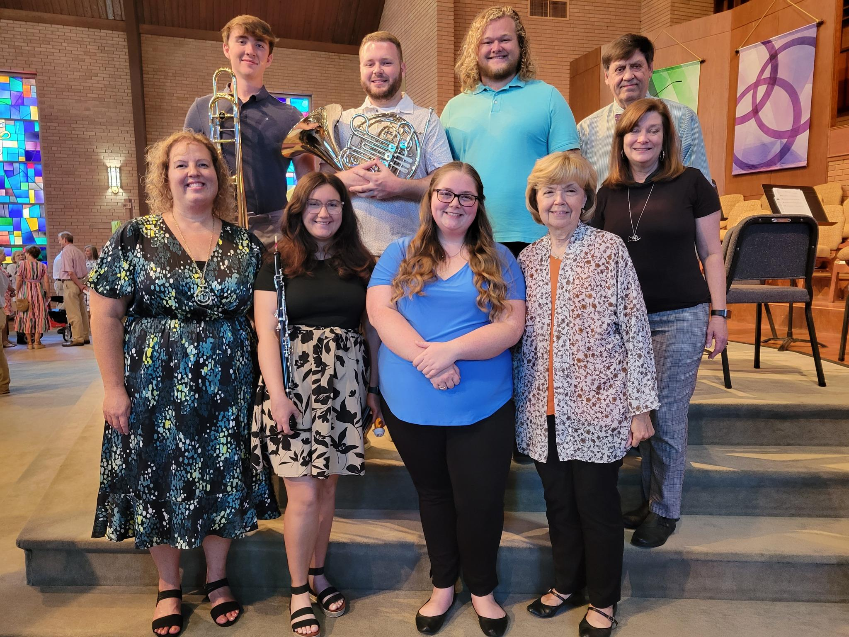

MUSIC EDUCATION B.A. REQUIREMENTS

Major Courses Hours

Major Courses (Core Curriculum) listed on p. 24 52 Additional Courses Required
MUSC 3032 Form and Analysis 2
MUSC 3062 Advanced Conducting 2

Instrumentalists—two additional instrumental methods classes
and two semesters of choir 4
Vocalists— four instrumental methods classes 4

8

Professional Education Courses Hours

EDUC 1201 Cornerstone in Education 1
EDUC 2113 Foundations of Education 3
EDUC 2003 Eff. Meth. For the Elem. School w/ Field Exp. 3
EDUC 3183 Ethics in Education 3
EDUC 3203 Introduction to the Exceptional Child 3
EDUC 3273 Teaching Reading in the Secondary School w/ Field Experience 3
EDUC 3292 Classroom Management 2

EDUC 3423 Instructional Technology 3
PSYC 3123 Human Growth and Development 3
EDUC 4412 Elementary Music Methods 2
EDUC 4422 Secondary Choral Music Methods and Materials 2
or EDUC 4432 Sec. Instrumental Music Methods and Materials
EDUC 4502 Preclinical Experience 2
EDUC 4626 Clinical Experience I 6
EDUC 4636 Clinical Experience II 6

42

B.A. in MUSIC EDUCATION – VOCAL
***Suggested Curriculum Guide***

FRESHMAN YEAR
FIRST SEMESTER |  |  |  |  | SECOND SEMESTER
EDUC | 120 | 1 | Cornerstone to Education |  | BIBL | 101 | 3 | Old Testament
ENGL | 100 | 3 | Freshman English I |  | ENGL | 101 | 3 | Freshman English II
SEMR | 232 | 3 | Foundations of Success |  | EDUC | 211 | 3 | Foundations of Education
MUSC | 103 | 3 | Musicianship I |  | MUSC | 104 | 3 | Musicianship II
MUSC | 115 | 1 | Applied Major |  | MUSC | 116 | 1 | Applied Major
MUSC | 124 | L | Diction Lab |  | MUSC | xxx | 1 | Applied Minor or Class Piano
MUSC | xxx | 1 | Applied Minor or Class Piano |  | MUSC | 124 | L | Diction Lab
MUSC | 151 | 1 | Concert Choir |  | MUSC | 151 | 1 | Concert Choir
MUSC | 134 | 1 | Chamber Vocal |  | MUSC | 134 | 1 | Chamber Vocal
MATH | 105 | 3 | Quantitative Reasoning
 |  | 17 |  |  |  |  | 16
SOPHOMORE YEAR
FIRST SEMESTER |  |  |  |  | SECOND SEMESTER
PSYC | 200 | 3 | Social Science |  | MUSC | 441 | 2 | Elementary Music Methods | Spring only
BIBL | 102 | 3 | New Testament |  | EDUC | 318 | 3 | Ethics in Education
XXXX | xxx | 4 | Lab Science |  | MUSC | 204 | 3 | Musicianship IV
MUSC | 203 | 3 | Musicianship III |  | MUSC | 207 | 3 | History of Western Music I | Spring only
MUSC | 215 | 1 | Applied Major |  | MUSC | 216 | 2 | Applied Major
MUSC | 124 | L | Diction Lab |  | MUSC | 124 | L | Diction Lab
MUSC | xxx | 1 | Applied Minor or Class Piano |  | MUSC | xxx | 1 | Applied Minor or Class Piano
MUSC | 151 | 1 | Concert Choir |  | MUSC | 151 | 1 | Concert Choir
MUSC | 134 | 1 | Chamber Vocal |  | MUSC | 134 | 1 | Chamber Vocal
ENGL | 210 | 3 | Speech Communication |  | MUSC | 225 | 1 | Brass Methods | Spring odd
 |  |  |  |  | MUSC | 226 | 1 | Percussion Methods | Spring odd
 |  | 20 |  |  |  |  | 18
JUNIOR YEAR
FIRST SEMESTER |  |  |  |  | SECOND SEMESTER
MUSC | 305 | 2 | Basic Conducting | Fall only | RELG | 240 | 3 | Basic Christian Beliefs
MUSC | 308 | 3 | History of Western Music II | Fall only | MUSC | 409 | 3 | History of Western Music III | Spring only
MUSC | 442 | 2 | Sec. Choral Methods | Fall only | MUSC | 316 | 2 | Applied Major
MUSC | 151 | 1 | Concert Choir |  | MUSC | 151 | 1 | Concert Choir
MUSC | 315 | 2 | Applied Major |  | MUSC | 134 | 1 | Chamber Vocal
MUSC | 134 | 1 | Chamber Vocal |  | MUSC | 306 | 2 | Advanced Conducting
 |  |  |  | Fall only | PSYC | 312 | 3 | Human Growth & Development | Spring only
MUSC | 435 | 2 | Vocal Pedagogy |  | EDUC | 342 | 3 | Instructional Technology
EDUC | 320 | 3 | Intro. to Exceptional Child
 |  | 16 |  |  |  |  | 18
SENIOR YEAR
FIRST SEMESTER |  |  |  |  | SECOND SEMESTER
MUSC | 406 | 2 | Orchestration |  | MUSC | 416 | 2 | Applied Major – Senior Recital
EDUC | 342 | 3 | Instructional Technology |  | EDUC | 462 | 6 | Clinical Experience I
MUSC | 415 | 2 | Applied Major |  | EDUC | 463 | 6 | Clinical Experience II
MUSC | 151 | 1 | Concert Choir
MUSC | 134 | 1 | Chamber Vocal
EDUC | 450 | 2 | Pre-Clinical Experience
EDUC | 327 | 3 | Teaching Reading in the Sec. School | Fall only
MUSC | 221  224 | 1  1 | String/Woodwind Methods | Fall
EDUC | 329 | 2 | Classroom Management
 |  | 18 |  |  |  |  | 14
*See General Education course listings in SWU Bulletin for options |  |  |  |  |  |  | 140 | TOTAL CREDIT HOURS

B.A. in MUSIC EDUCATION– Instrumental
***Suggested Curriculum Guide***
FRESHMAN YEAR
FIRST SEMESTER |  |  |  |  | SECOND SEMESTER
EDUC | 120 | 1 | Cornerstone to Education |  | BIBL | 101 | 3 | Old Testament
ENGL | 100 | 3 | Freshman English I |  | ENGL | 101 | 3 | Freshman English II
SEMR | 232 | 3 | Foundations of Success |  | EDUC | 211 | 3 | Foundations of Education
MUSC | 103 | 3 | Musicianship I |  | MUSC | 104 | 3 | Musicianship II
MUSC | 115 | 1 | Applied Major |  | MUSC | 116 | 1 | Applied Major
MATH | 105 | 3 | Quantitative Reasoning |  | MUSC | xxx | 1 | Applied Minor or Class Piano
MUSC | xxx | 1 | Applied Minor or Class Piano |  | MUSC | 152 | 1 | Wind Ensemble
MUSC | 151 | 1 | Concert Choir |  | MUSC | 151 | 1 | Concert Choir
MUSC | xxx | 1 | Chamber |  | MUSC | xxx | 1 | Chamber
MUSC | 152 | 1 | Wind Ensemble
 |  | 18 |  |  |  |  | 17
SOPHOMORE YEAR
FIRST SEMESTER |  |  |  |  | SECOND SEMESTER
EDUC | 200 | 3 | Eff. Methods for Elem. School |  | EDUC | 318 | 3 | Ethics in Education
BIBL | 102 | 3 | New Testament |  | PSYC | 200 | 3 | Social Science
XXXX | xxx | 4 | Lab Science |  | MUSC | 204 | 3 | Musicianship IV
MUSC | 203 | 3 | Musicianship III |  | MUSC | 207 | 3 | History of Western Music I | Spring only
MUSC | 215 | 1 | Applied Major |  | MUSC | 216 | 2 | Applied Major
MUSC | xxx | 1 | Chamber |  | MUSC | xxx | 1 | Applied Minor or Class Piano
MUSC | xxx | 1 | Applied Minor or Class Piano |  | MUSC | 225 | 1 | Brass Methods | Spring odd
MUSC | 152 | 1 | Wind Ensemble |  | MUSC | 226 | 1 | Percussion Methods | Spring odd
ENGL | 210 | 3 | Speech Communication |  | MUSC | xxx | 1 | Chamber
 |  |  |  |  | MUSC | 152 | 1 | Wind Ensemble
 |  | 20 |  |  |  |  | 19
JUNIOR YEAR
FIRST SEMESTER |  |  |  |  | SECOND SEMESTER
MUSC | 305 | 2 | Basic Conducting | Fall only | RELG | 240 | 3 | Basic Christian Beliefs
MUSC | 308 | 3 | History of Western Music II | Fall only | MUSC | 409 | 3 | History of Western Music III | Spring only
MUSC | 443 | 2 | Sec. Instrumental Methods | Fall only | MUSC | xxx | 2 | Applied Major
MUSC | 152 | 1 | Wind Ensemble |  | MUSC | 152 | 1 | Wind Ensemble
MUSC | xxx | 2 | Applied Major |  | MUSC | xxx | 1 | Chamber
MUSC | xxx | 1 | Chamber |  | MUSC | 306 | 2 | Advanced Conducting
MUSC | 303 | 2 | Form and Analysis | Fall only | PSYC | 312 | 3 | Human Growth & Development | Spring only
MUSC | 224 | 1 | Woodwind Methods | Fall odd | EDUC | 329 | 2 | Classroom Management
EDUC | 320 | 3 | Intro. to Exceptional Child |  | MUSC | 441 | 2 | Elementary Music Methods | Spring only
 |  | 17 |  |  |  |  | 19
SENIOR YEAR
FIRST SEMESTER |  |  |  |  | SECOND SEMESTER
MUSC | 406 | 2 | Orchestration |  | MUSC | xxx | 2 | Applied Major – Senior Recital
MUSC | 221  224 | 1  1 | String/Woodwind Methods | Fall only | EDUC | 462 | 6 | Clinical Experience I
EDUC | 342 | 3 | Instructional Technology |  | EDUC | 463 | 6 | Clinical Experience II
MUSC | xxx | 2 | Applied Major
MUSC | 152 | 1 | Wind Ensemble
MUSC | xxx | 1 | Chamber
EDUC | 450 | 2 | Pre-Clinical Experience
EDUC | 327 | 3 | Teaching Reading in the Sec. School | Fall only
 |  | 14 |  |  |  |  | 14
*See General Education course listings in SWU Bulletin for options |  |  |  |  |  |  | 139 | TOTAL CREDIT HOURS

INDEX
PAGE
Accompanying ……………………………………………………………………………………22
Applied Music Juries And Evaluations …………………………………………………………..12
Audition Opportunities …………………………………………………………………………….8
Auditions—SWU Music Department ……………………………………………………………..9
Bulletin Board ……………………………………………………………………………………22
Campus Ensembles ………………………………………………………………………………11
Chamber Ensemble ………………………………………………………………………………11
Class Piano Levels ……………………………………………………………………………….17
Concert Choir …………………………………………………………………………………….11
Curriculum ……………………………………………………………………………………24-33
B.A. in Music …………………………………………………………………24-26
B.A. in Music/Vocal …………………………………………………………..24-26
B.A. in Music/Instrumental ………………………………………………24, 27-28
B.A. in Music Education/Vocal ………………………………………………29-31
B.A. in Music Education/Instrumental …………………………………...29, 32-33
Division Chapel ………………………………………………………………………………….22
E-mail …………………………………………………………………………………………….23
Ensemble Requirements …………………………………………………………………………11
Facilities …………………………………………………………………………………………...8
Faculty …………………………………………………………………………………………..6-7
Freshman & Sophomore Evaluation ……………………………………………………………..12
Full-Time Music Major Course Requirements …………………………………………………..11
Introduction to Handbook and Policy Manual ………………………………………………….1-3
Jazz Ensemble ……………………………………………………………………………………11
Lockers …………………………………………………………………………………………...22
Mission Statement …………………………………………………………………………………5
Off-Campus Representation ……………………………………………………………………..22
Non-Major Levels of Private Instruction ………………………………………………………...18
On-Stage Performance Grand Piano …………………………………………………………….22
Organizations ……………………………………………………………………………………...8
Piano Proficiency Exam …………………………………………………………………………17
Protecting Your Hearing Health ………………………………………………………………….19
Protecting Your Neuromusculoskeletal Health …………………………………………………..21
Protecting Your Vocal Health …………………………………………………………………….20
Recital Attendance ……………………………………………………………………………….12
Recital Etiquette ………………………………………………………………………………….12
Recital Hour/Seminar ……………………………………………………………………………23
Scholarships, Fine Arts …………………………………………………………………………..10
Music Ensemble Scholarships ……………………………………………………10
Music Major Scholarships ……………………………………………………….10
Senior Exit Interview …………………………………………………………………………….22
Senior Solo Full Recital Request ………………………………………………………………...16
Senior Recital …………………………………………………………………………………13-14
Senior Recital Checklist ………………………………………………………………………….15
String Ensemble ………………………………………………………………………………….11
Student Recitals– Additional Suggestions/Considerations ………………………………………15
Study-Practice Habits …………………………………………………………………………….22
Welcome Letter ……………………………………………………………………………………4
Wind Ensemble …………………………………………………………………………………..11

