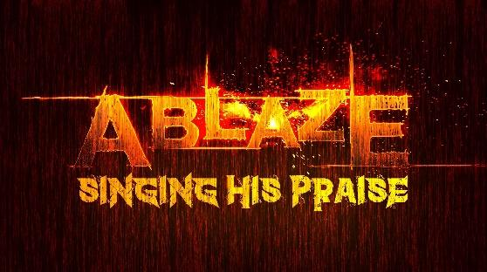
Senior Challenge 2025-2026
This senior challenge is something that is very “extra” and is from me to you. It will take quite a commitment! If you don’t have the desire or the margin in your life’s schedule right now, I completely understand. And, you should absolutely know that I would never think less of any of you for not accepting what I know is truly a challenge. I am here to help you and encourage you in any way that I can, whether you begin this, finish it, or neither. We have so few Christian young people in our society who truly exhibit character and a Godly example to their peers. I’m hoping some, or all of you, can be a part of the very small minority of students who can lead by example to show what it means to truly be a disciple of Christ! Here are the requirements:
- Quote to me, or one of the other adult leaders, the Five-Finger Gospel Presentation.
- Quote all 7 years of the verses for Ablaze. You can quote these to any leader any time during the entire year. You cannot do them one verse at a time. But, you can do them by one year at a time. You may also quote them from any translation that is first approved by me. So, you could quote all of the year 4 verses at one time and then do other years separately. If you can quote all of these, you will put yourself in the 99th percentile of those who have put Scripture to memory.
- Have a 90% or greater attendance record for all Ablaze related dates. (If you miss, just get me a written/texted excuse from a parent for it not to count against you)
- Attend and faithfully serve during the mission trip, May 31-June 4, 2026.
- Recite the 26 core attributes of God.
- Recite the entire “ABC Bible Verses” document, including the references. (This is new in 2025-2026)
- Read the books that I will give you. There will be 4 during the year, and here is the very specific plan for reading them and reporting on them:
READING SCHEDULE
(For each due date, please turn in a very short response stating 3 ideas, thoughts, or realizations you had as a result of the reading assigned. It can be hand-written or typed, and it can be as short as 3 sentences. You can tell me an idea that you had as a result of the reading. You can simply list a direct quote from the book that appealed to you. I don’t mean for this to be long or complicated.)

September 2025
7 – Receive First Book – The Reset by Jeremy Riddle
14 - Intro. and Chapters 1-2 of first book, The Reset, should be read and response turned in
21 – Chapters 3 - 5 read and response turned in
28 – Chapters 6 - 8 read and response turned in
October 2025
5 – Receive second book, Fresh Wind, Fresh Fire by Jim Cymbala

19 – Chapters 1 and 2 response due

26 – Chapters 3 and 4 response due

November 2025
2 – Chapters 5 and 6 response due

9 - Chapters 7 and 8 response due

16 – Chapters 9 and 10 response due

30 – Chapter 11 response due AND Receive third book, Don’t Waste Your Life by JD Greear
January 2026
11 – Intro and Chapter 1 of third book, Don’t Waste Your Life, and response due
18 – Chapters 2 and 3 response due
25 – Chapters 4 and 5 response due
February 2026
1 – NO REHEARSAL (D-Now) – SPECIAL PROJECT NIGHT (Make-Up Night for Attendance)

8 – Chapters 6 and 7 response due

15 – Chapter 8 response due

22 – Chapter 9 response due

March 2026

1 – Receive Final book, Do Hard Things

8 – Chapters 1 and 2 response due

22 – Chapters 3 and 4 response due

29 – Chapters 5 and 6 response due

April 2026

5 – Chapters 7 and 8 response due

12 – Chapters 9 and 10 response due

26 – Chapters 11 and 12 response due

May 2026

3 – NOTHING DUE TODAY – WORKING TO FINISH ALL COMPONENTS!

17 – All parts of the “Senior Challenge” must be completed by this date. You can quote verses and the
“Jesus Is” memory portions of the challenge to any adult sponsor at any time that they are
available.

Here to help as needed!
Love you all!

Mr. Ash

