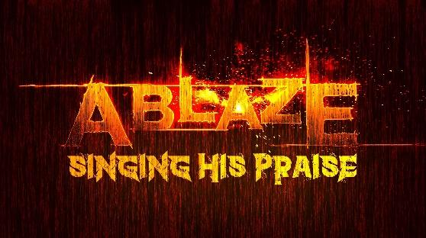
Fall 2025 Dates / Events
(All rehearsals will be in the Choir Room at 5 p.m.)
(Supper each week from 6 to 6:20 p.m.)

September 2025
7 - Kick-Off Meeting (5 p.m.) – NEW SONGS / NEW GOALS / NEW LEADERS
14 – Rehearsal
21 – Rehearsal
28 - Rehearsal
October 2025
5 – (A.M.) Sing for the Morning Services (Times to Meet in Choir Room – 9:00 a.m. and 10:30 a.m.)
“Victor’s Crown”
5 – (P.M.) Rehearsal

12 – NO REHEARSAL – Fall Break

19 - Rehearsal

26 – Rehearsal

November 2025
2 – Rehearsal

9 – Rehearsal

16 - (A.M.) Sing for the Morning Services (Times to Meet in Choir Room – 9:10 a.m. and 10:40 a.m.)
“There’s Nothing That Our God Can’t Do”

16 – (P.M.) Rehearsal

23 – NO REHEARSAL – HAPPY THANKSGIVING!

30 – Rehearsal

December 2025
7 - (A.M.) –Sing at End of the Morning Services (Times to Meet in Choir Room – 9:10 a.m. and
11:45 a.m.)
7 - (P.M.) - SINGING IN THE COMMUNITY – BACK HERE FOR HOT CHOCOLATE AND COOKIES! - AT
OUR REGULAR TIME 5 P.M. TO 6 P.M.. Meet in the Choir Room as normal.

14 – (P.M.) - For those who have signed up, sing in the student Christmas musical - Times to be
announced

WEDNESDAY, December 24th, sing in the Christmas Eve Services with the Worship Choir and Orchestra

HOLIDAY BREAK – MERRY CHRISTMAS AND HAPPY NEW YEAR! See you in 2026!

