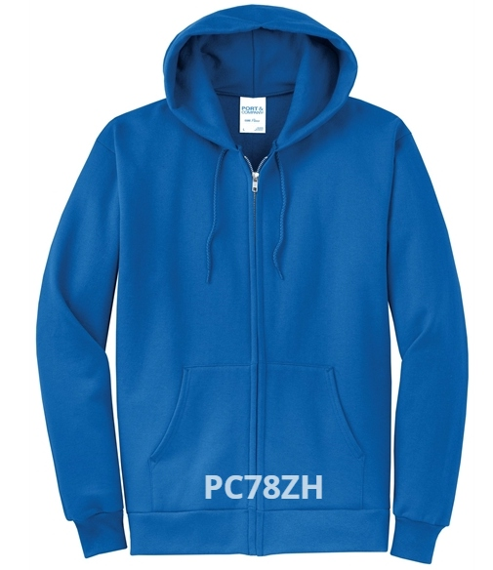

ZIP FRONT HOODIE
$32.00 (S-XL) Must order (2X AND UP)
Colors: Gray Heather; Dark Green; Maroon; Navy; Red; Royal; Ash; Carolina Blue; Charcoal; Dark Chocolate Brown; Orange; Jet Black; Kelly Green; Lime; Neon Blue; Neon Green; Neon Orange; Neon Yellow; Purple; True Royal

