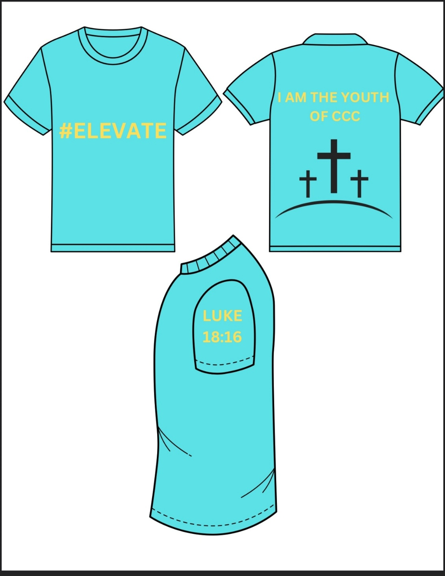

Youth ELEVATE T-Shirt $10.00
Sizes-Youth S-XL

